
02/2010

ON A SAFE NOTE

SYMBOLIC SAFETY SIGNS

KNOW THESE SIGNS IN CASE OF AN EMERGENCY!

 | (A)  INDICATE LOCATION OF EITHER AN EMERGENCY EXIT OR A FIRST AID FACILITY. |  | (B)  EMERGENCY EXIT TO THE LEFT.
 | (C)  EMERGENCY EXIT TO THE RIGHT |  | (D)  FIRST AID BOX AND/OR QUALIFIED FIRST AIDER AVAILABLE.
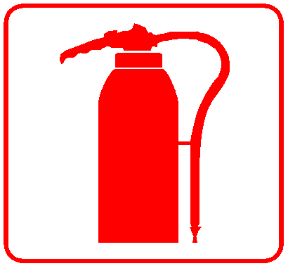 | (E)  FIRE EXTINGUISHER AVAILABLE. |  | (F)  WATER FIRE HOSE AVAILABLE
 | (G)  INDICATE THE LOCATION OF EITHER A FIRE HOSE, OR A FIRE EXTINGUISHER, OR A FIRE ALARM. |  | (H)  FIRE ALARM AVAILABLE

