

ON A SAFE NOTE

Preventing Slips, Trips and Falls

What can happen? Cuts, bruises, concussions, sprains, strains and broken bones.

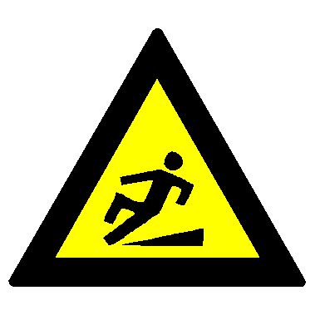

Shoes
- Wear safe shoes or boots, with low heels and a good fit – avoid slippery soles.
- Be sure to wear shoes or boots with adequate tread when walking on greasy or wet surfaces.
- Keep your boots and shoes in good repair – a defect like a nail coming through the heel can cause you to slip.
- Take extra care when you come indoors with wet shoes or boots.
Working
- Carry small loads close to your body and below chest level so you can see over or around what you are carrying.
- Close cabinet drawers and doors as soon as you are finished with them.
- Adjust your walking to the surface you are travelling on, and don’t run.
- Slow down and take small careful steps if the surface is rough, cluttered, slippery or at a angle.
- Hold the handrail when you go up or down stairs.
If you do fall
- Don’t move if you think you have hurt yourself – wait for help.

Housekeeping
- Watch for the slip and trip hazards (e.g. loose tiles or torn carpets) in your work area and wherever you walk.
- Immediately correct any hazard that might cause a fall or report it to your supervisor or SHE Rep.
- Clean up spills immediately.
- Take extra care whenever you see a wet floor sign.
- Keep walkways and floors clear of boxes, extension cords and litter.
- Immediately move anything that is stored on or near stairways, or report the hazard to your supervisor or SHE Rep.
- Notify your supervisor if there is nowhere to store new materials properly.

