
Leadership Development Workshops 2011

Each workshop is specifically designed to give leaders practical tools that can be applied to their leadership style empowering them to lead at a new level. These one-day experiential workshops are not to be missed as part of the transformation of your department.

All workshops can be presented on an in-house basis for groups between 8-20 people. For individuals who are interested in attending an open-enrolment workshop, please forward your name and the workshop you are interested in to Henda Britz at britzsh@tut.ac.za.

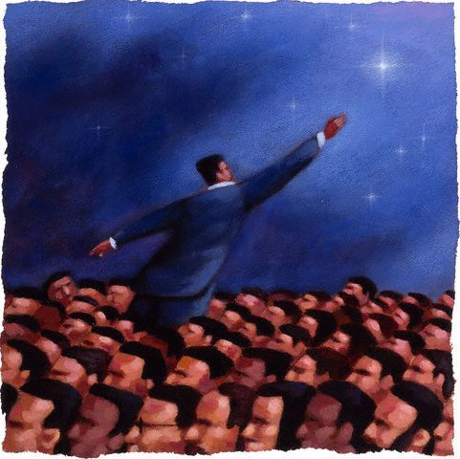

If your actions inspire others to dream more, learn more, do more and become more, you are a leader.
John Quincy Adams
Conflict Resolution - The Emotional Intelligent Way

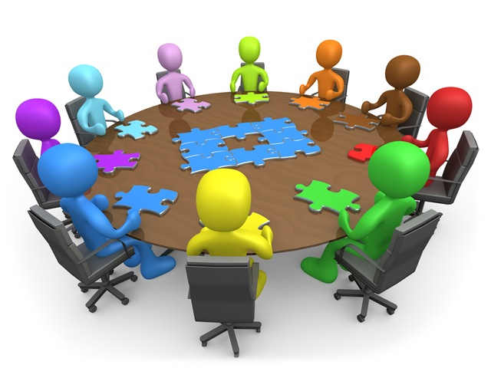
Leaders are responsible for creating a work environment that enables people to thrive. If disagreements and differences of opinion escalate into interpersonal conflict, you must intervene immediately. Managed well, conflict can lead to better decisions, more creative ideas and higher quality output from the team. Managed badly, it can stop teamwork and hinder individuals from achieving their personal goals. Effective conflict management comes from the successful application of several emotional intelligence abilities. Through this workshop people can learn how to work with conflict in an emotionally intelligent way that leads directly to more productive outcomes and stronger relationships. Literally everyone would benefit from this workshop, although managers and supervisors are a priority.

OUTCOMES OF THIS WORKSHOP
By the end of this workshop you should be able to:
- Describe the three ego states (adult, parent, child) and the impact thereof on interpersonal effectiveness
- Identify your own dominant ego state and the impact it has on your communication style as well as your ability to deal with conflict effectively
- Identify the differences among passive, aggressive and assertive behaviour in handling conflict
- Identify your own style in dealing with conflict
- Assess the effectiveness of your conflict management style and practice more effective styles in dealing with conflict
- Understand emotional intelligence and why it is an important ability in handling conflict effectively
- Interpret an assessment of your emotional intelligence and the impact thereof on your ability to deal with conflict effectively
- Apply the emotional intelligence abilities to improve your ability to resolve conflict effectively
- Understand the emotional dynamics that are at the heart of the conflict for the others involved
- Move others through a process where everyone feels that their needs are met in a respectful manner.
- Use appropriate techniques for identifying and managing negative emotional reactions that accompany a conflict

------------------------------------------

The Five Practices of Exemplary Leadership Workshop

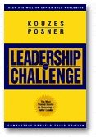
How do you make it possible for ordinary people to accomplish the extra-ordinary? How do you get people to follow you to places they’ve never been before? How do you get other people to move forward on a common purpose? Thoroughly researched and documented by Kouzes & Posner, learn how to Challenge The Process, Inspire A Shared Vision, Enable Others to Act, Model The Way, and Encourage The Heart. This one-day workshop applies the proven best practices of leadership to accomplish extraordinary results.

This workshop is based on the results of your LPI assessment report on the Leadership Practices Inventory (LPI) - a 360-degree assessment of your leadership behaviour based on the 5 practices of effective leaders. Before the workshop you will complete a Self assessment of your own leadership behaviour and will also nominate observers (peers, direct reports, and your manager) to complete the Observer version.

MBTI Leadership Workshop:
Unleashing the power of personality

Leadership today faces a profound paradigm shift and the old paradigms for managing effectively are no longer enough. To meet the needs of this changing paradigm, leaders must know how to support and develop the intelligence around him or her in a dynamic, systems-oriented way. In this one-day workshop we will explore the leadership paradigm in the context of sixteen different mental patterns, or personality types, including leadership strengths and weaknesses as well as preferred modes of perception and judgement. These sixteen mental patterns are based on Jungian psychological type theory and correspond to the sixteen personality types used in the Myers-Briggs Type Indicator (MBTI) personality inventory, the most widely used personality assessment in the world.
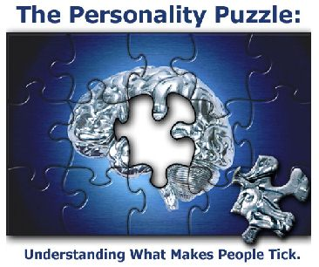
During this workshop we will explore the psychology of leadership and discover how the way we think, the nature of our perceptions, and the manner in which we are perceived by others become important variables in understanding leadership. How the sixteen personality types adapt to change, respond to challenge, and interact with other people will be explored. The goal is to help each leader find his or her pattern and achieve excellence in work and relations.

As a leader, you may find the workshop very insightful about how to engage all of your people to do their best work - when you know their MBTI preferences...you are able to communicate to them so that they can hear you.

The workshop will enable you to:
- Build a management framework that affirms differences and allows for them
- Increase your self-awareness. Self-awareness alone is a compelling predictor of success at work and accounts for one-third of job performance. Awareness of your unique personality profile is an essential starting point.
- Understand individual differences. Social awareness is the key to working well with others and the MBTI helps people understand the differences in how people work and interact.
- Understand how personality affect how you communicate, interact, make decisions, solve problems and manage conflict as well as shaping your overall work style.
- Communicate in a way that encourages trust and a sense of being treated fairly.
- Compare and contrast different leadership style tendencies based on your personality for a better understanding of how others may perceive your leadership style in contrast to how you see yourself.

LEADING WITH EMOTIONAL INTELLIGENCE – IMPROVING YOUR INTERPERSONAL EFFECTIVENESS

OUTCOMES OF THIS WORKSHOP
Upon completion of this workshop, you will be able to:

- Explain the role of emotions in leadership
- Describe what is meant by the term “emotional intelligence”
- Describe the relationship between emotional intelligence and leadership
- Understand the term “emotional high jacking” and the role it plays in your ability to lead in an emotionally intelligent way
- Understand the structure and function of the brain regarding emotional processing and behaviours
- Understand the emotional intelligence abilities and how it related to leadership
- Apply the emotional blueprint to improve your ability to lead with emotional intelligence
- Apply the emotional intelligence skills to build trusting relationships with your team members
- Apply the emotional intelligence skills to influence your team members towards achieving your department’s vision
- Apply the emotional intelligence skills to promote change within your department

SITUATIONAL LEADERSHIP

Situational Leadership is a dynamic, engaging
½ workshop that provides the fundamentals of a time – tested, behavioural model of how to best influence the performance of people. The Situational Leadership Model is an essential tool for people wanting to lead in a way that yields top performance and fosters a positive work environment. Situational Leadership helps leaders to identify which influence behaviours to use in which situations to achieve maximum success and effectiveness

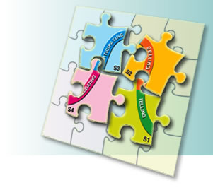
OUTCOMES OF THIS WORKSHOP
Upon completion of this workshop, you will be able to:
- Understand why leadership is situational
- Understand the importance of flexibility, adaptability and the concept of “no best style”
- Improve communication and become a more trusted and credible leader
- Use situational leadership to achieve greater productivity by infusing energy, self-reliance and drive within your employees
- Assess and understand the need for a specific leadership style based on the individual’s needs in any given situation
- Create a collaborative work environment to achieve faster sustainable results
Increase your effectiveness in setting goals, providing clear direction, listening, observing, monitoring and giving feedback
- Retain your most talented employees by being more responsive to their development needs
- Understand how to empower people to contribute their best to your organization’s success
- Apply your new awareness and situational leadership skills into your work relationships and leadership responsibilities
TEAM BUILDING WORKSHOPS

This workshop (1 or 2 days) is provided to work groups who seek one or more of the following outcomes:
- Increased interpersonal communication skills,
- Alignment with a common vision and purpose
- Getting to know and understand one another better
- Improved trust
- Decreased conflict,
- Improved team decision-making skills,
- Heightened sensitivity of interpersonal issues,
- Increased awareness of team culture, and
- Improved team effectiveness and productivity
- A better understanding of the roles people play in teams
- A better understanding of the strengths and weaknesses of the team

Each workshop's objectives are developed based on a diagnostic assessment of the current functioning of the team to ensure that team’s specific goals and needs are met. This workshop provides a fun, interactive team building experience that enhances relationships and communication.

About the presenter: Dr Tessie Herbst
Tessie is a registered psychologist at the Human Resource Development Department, where she is responsible for Management and Leadership Development. She has a special interest in leadership and neuropsychology as well as emotional intelligence and is involved in a number of research projects in the field of leadership. She is also a licensed associate of the 6seconds international emotional intelligence network and a certified trained of the MSCEIT (an ability measure of emotional intelligence) as well as the Bar-On EQ-i. She is the author of various peer reviewed articles and chapters in books in the field of management and leadership development and also presented papers and workshops at several national and international conferences.

