**ASSESSMENT MANAGEMENT COURSE BOOKINGS**

**ITS TRAINING**

Follow this link: <https://dev-sps-staff.tut.ac.za/SiteDirectory/AMCourseBookings/default.aspx>

Click on **My courses** and select the preferred date to attend training

**PLEASE NOTE THE ANNOUNCEMENT**

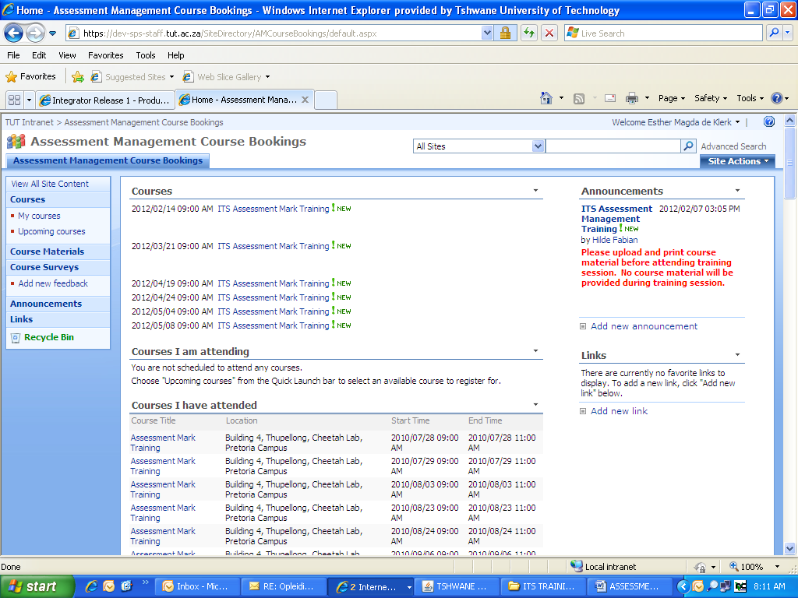

To register, click on **My Registration,** then Click on **OK**

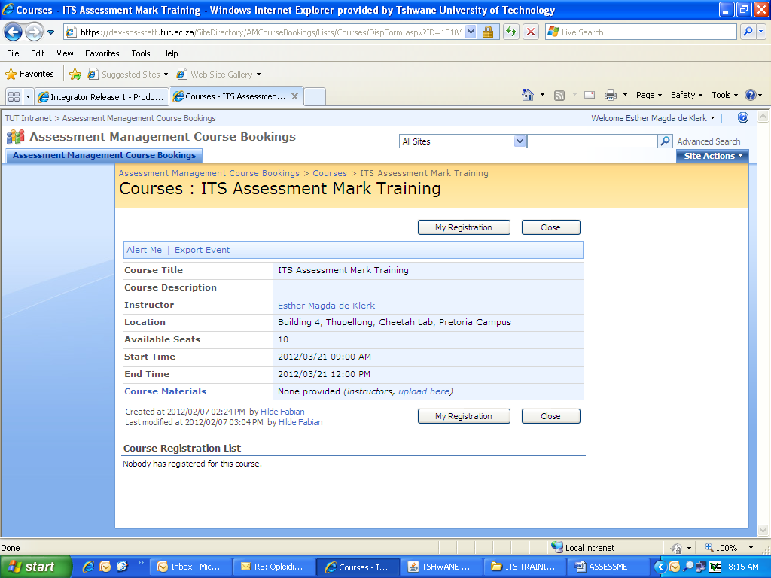

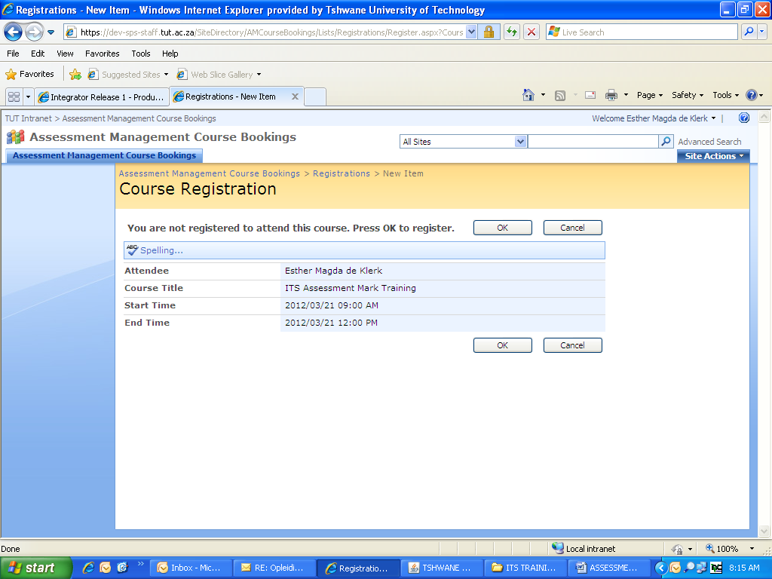

An e-mail will be sent to your inbox to confirm your booking.

To print the course material, click next to any date

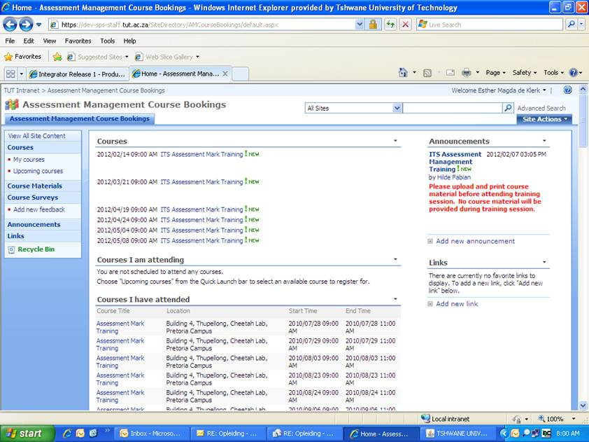

Click on **Course Materials**

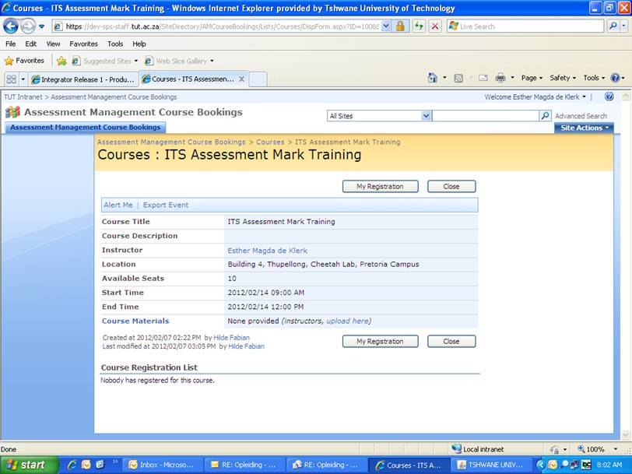

Open document and print. NS: Bring this document along to the training session.

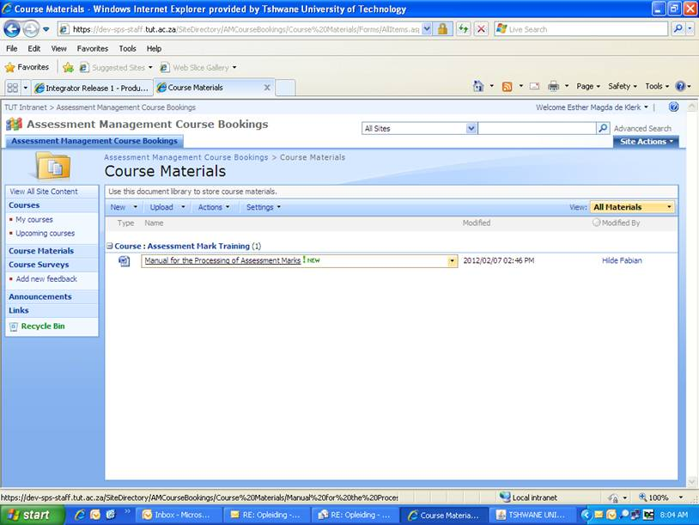

To unregister for a course, click on **My courses**

Under **Courses I am attending**, click on **Remove**, then click on **OK**



