
LECTURER iENABLER
(ENTER ASSESSMENT MARKS OFF-CAMPUS)

(AM007)

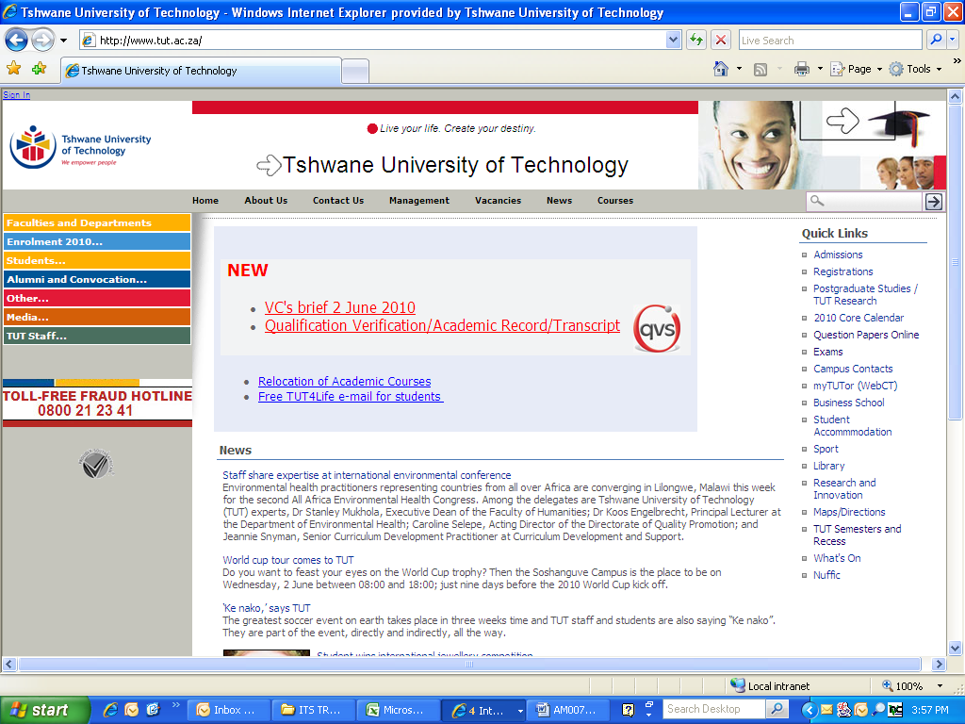

IMPORTANT INFORMATION

By making use of the iEnabler you will be able to print up-to-date class lists and capture assessment marks which will be saved onto the ITS server. It is important to note that all calculation must be done on the ITS and cannot be done on iEnabler.

- You need a TUT e-mail address to register on StaffPortal. Your Departmental Administrator can send an e-mail to Charlotte Smit (SmitC@tut.ac.za) and provide her with:

- Name and Surname as it should appear on MS Outlook
- Personnel number
- Department
- Telephone and fax number
- Campus

- To link your subject to your personnel number, send an e-mail to Leandra Godefroy (GodefroyL@tut.ac.za).

- Assessment calculation criteria must be set-up on the ITS (Responsibility of Dept Admin).

- Assessment marks can be captured via iEnabler onto the ITS server.

- Calculation (computing) of predicate/final marks must be captured on the ITS.

- You can also print a class list or export the class list to MS Excel.

Open Internet connection
www.tut.ac.za
Click on TUT Staff

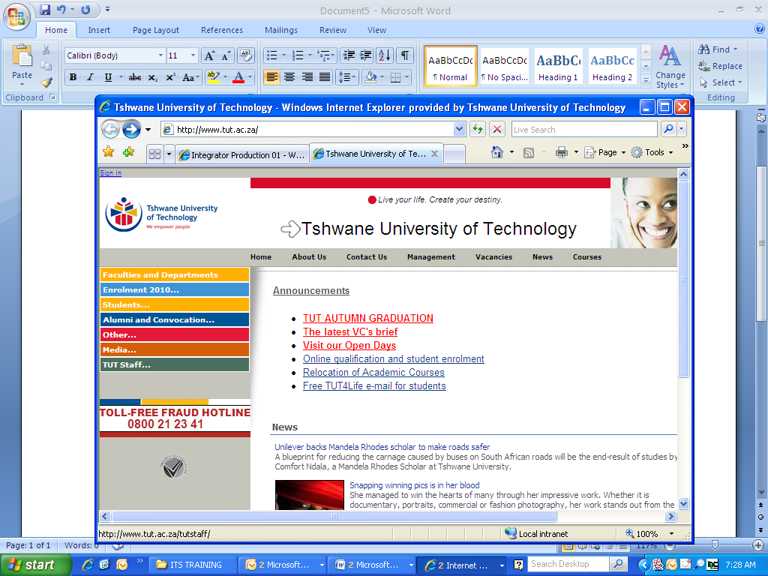

Click on Staff Portal/e-Tutor
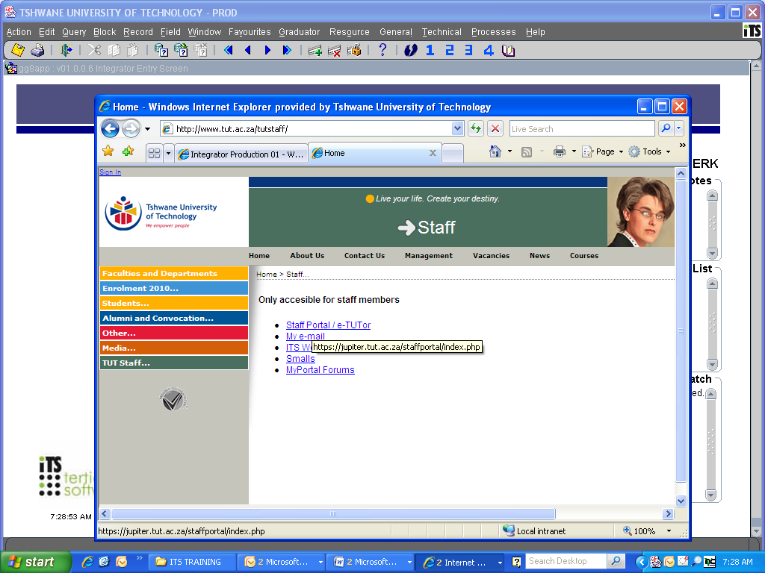
If you have not registered on the new MyPortal system before, then click as indicated below:

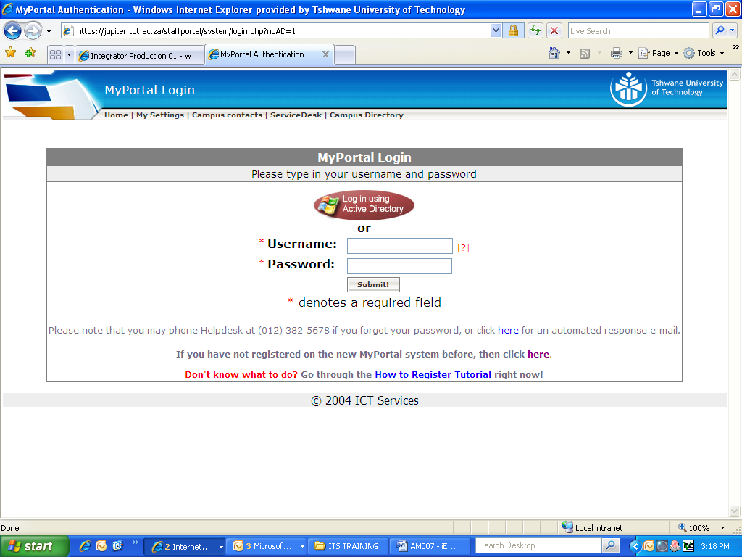

Complete the required information and click on Submit

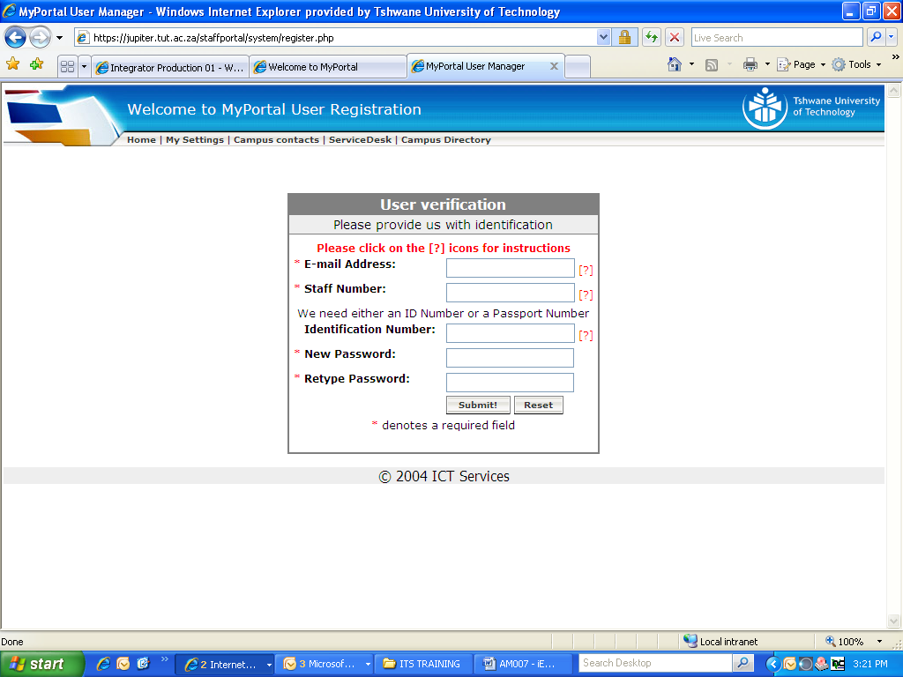
You will receive an e-mail confirming your registration on MyPortal.

Log-in by using your username and password.

Click on TUT Staff

Click on Staff Portal/e-Tutor
Click on ITS Web Leave Application

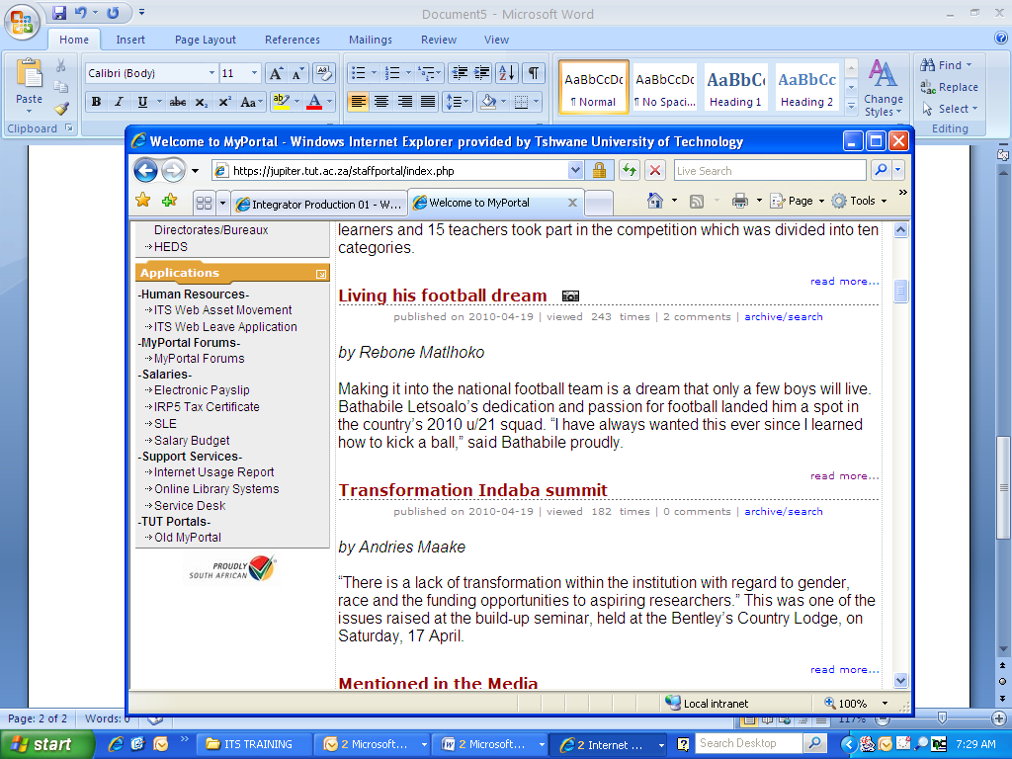

Click on Apply for leave: myself
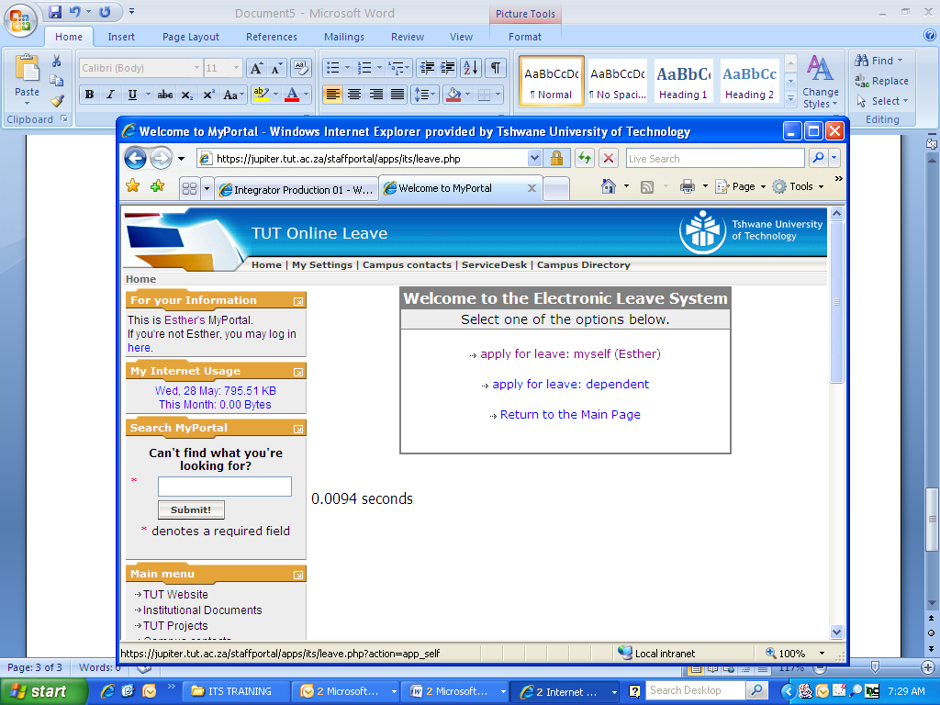

Click on Lecturer iEnabler

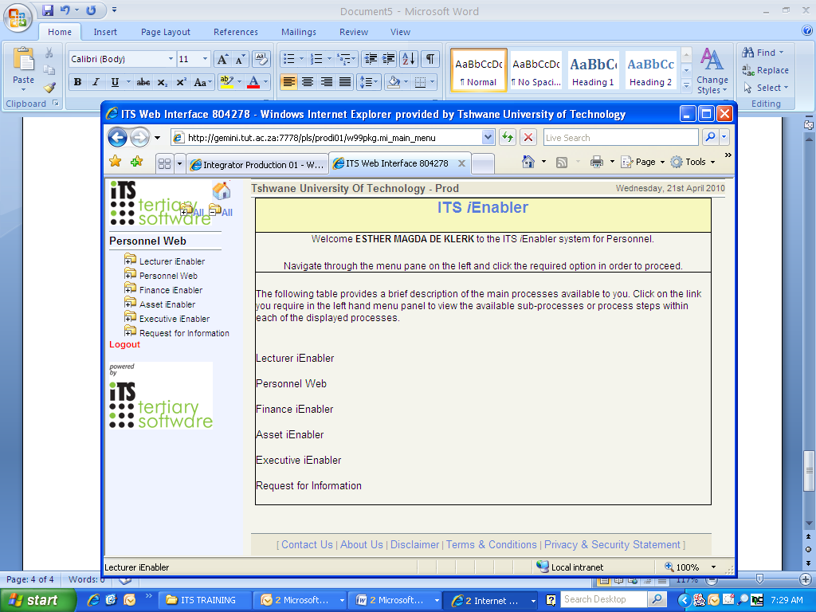

Click on Class List

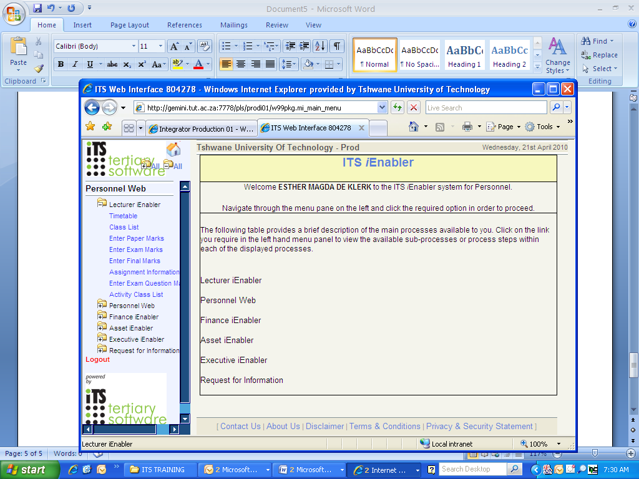
Subjects linked to your name will appear
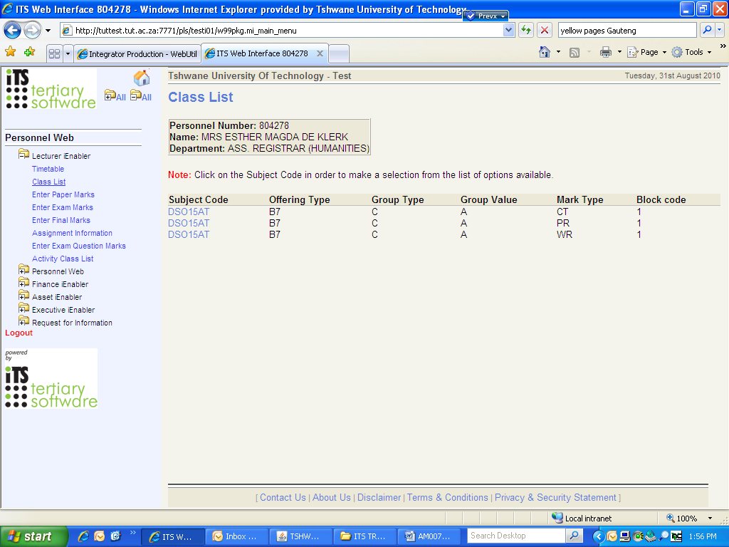
Click on the specific subject and mark the type you want to enter. A list of options will appear.
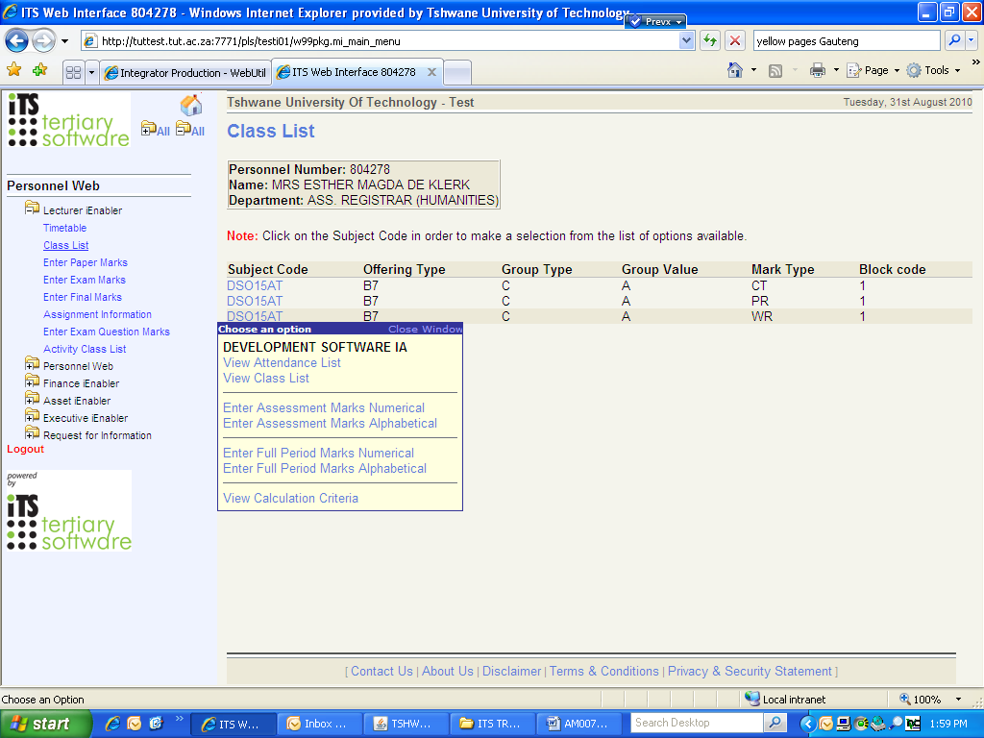
Click on Enter Assessment Marks (Numerical/Alphabetical)
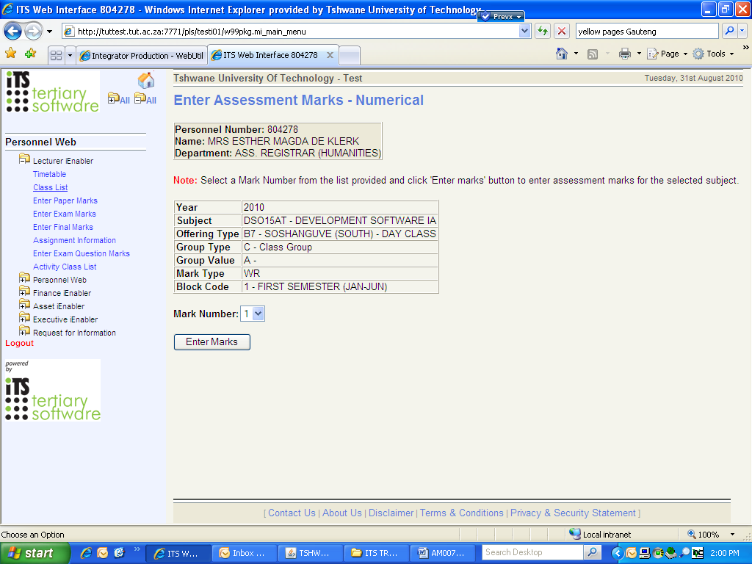
Select the Mark Number and Click on Enter Marks
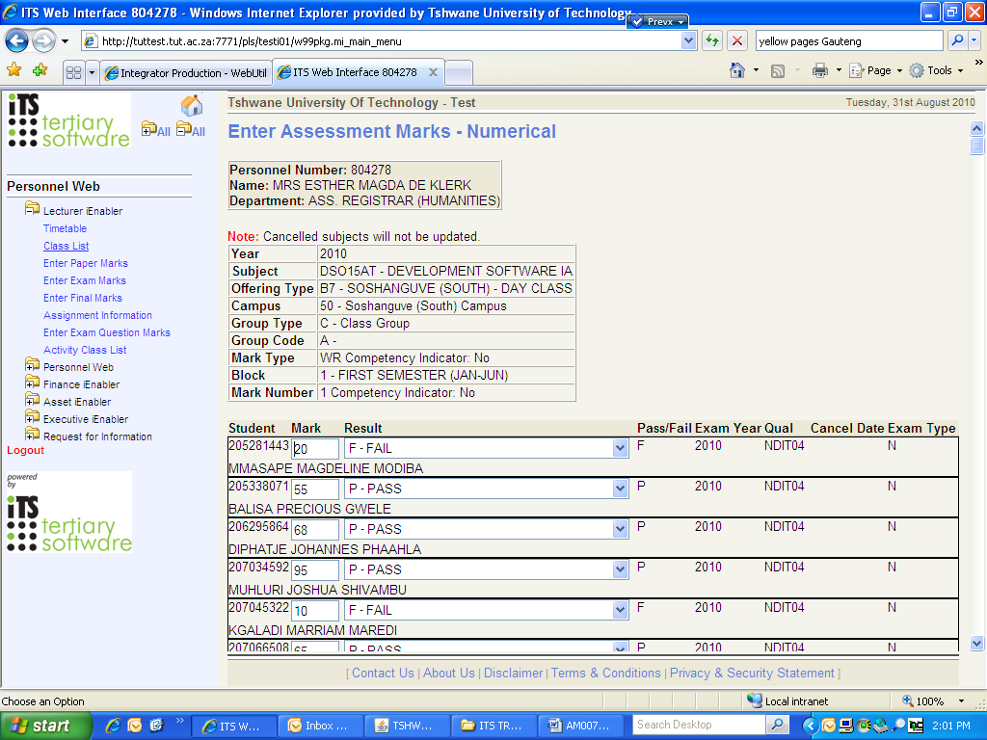

At the end of the list, Click on Save
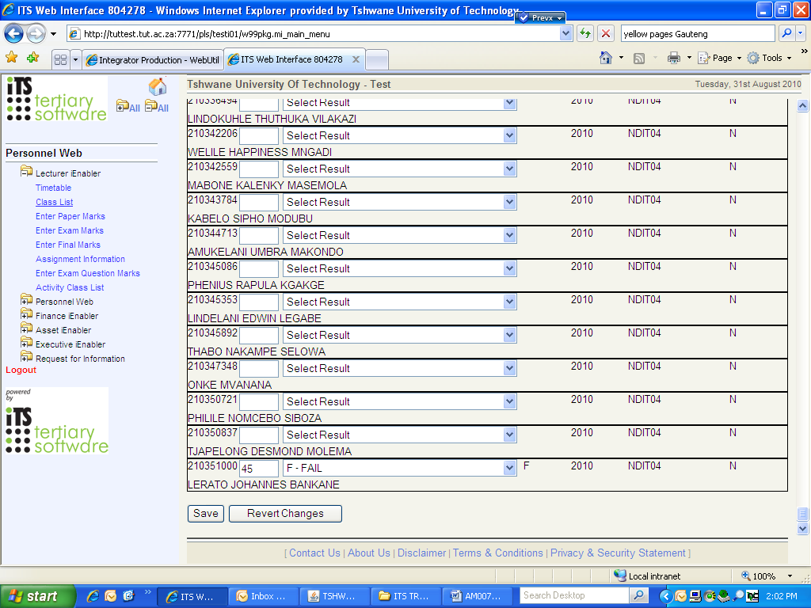
The assessment marks were saved onto the ITS server.

TUT SSL VPN CONNECTION GUIDE
(as published via TUT Webmail on 4 March 2011)

This document serves as a guideline on creating a VPN connection to the TUT private network and is for use by TUT internal staff members and external partners that have been granted the right to VPN into the TUT network.
TUT has put in a new system that allows staff members with Active Directory accounts to remotely connect to the TUT private network from anywhere for as long as they are connected to the internet, users will have access to the network resources like shared files, intranet, ITS and other internal systems.

The following steps will guide you through the process of creating/connecting to the TUT VPN, before you continue with the steps; you need to verify that your computer is connected to the internet.

PLEASE NOTE: you should have administrative rights on the workstation to configure the VPN connection.

1. Open a web browser on your computer, browse to this address https://vpn.tut.ac.za

2. When you are prompted for your user name and password:
• In the Name field, type your TUT Active Directory username that you normally use to login to your computer. PLEASE NOTE: don’t put TUT\ before your username
• In the Password field, type your TUT Active Directory password and click the ‘Login’ button

Note: A second message may be displayed to inform you that the FortiGate firewall certificate distinguished name differs from the original request. This message is displayed because the firewall unit is attempting to redirect your web browser connection you can ignore the message, and just click on “Continue to the website” TUT VPN Connection Guide

3. You will be redirected to the FortiGate SSL VPN web portal home page automatically. If you are connecting to the TUT VPN for the first time, you will need to download and install the SSL VPN client, you may do so by clicking ‘Click here to download and install it’.

Once the SSL VPN Client is installed, close the web browser, re-open it and follow steps 1, 2 and jump to 4

4. After installing the Fortinet SSL client, a message blocking a required add-on might be displayed, this will all depend on your Internet Explorer security settings.

If the message appears, please right click on it and choose “Run add-on”. This will let Internet Explorer use the SSL Client Add – On securely.

- Click the ‘Connect’ button and once the VPN tunnel is up, you will see that the Forticlient SSL VPN is connected.

You are now connected to the TUT network.

Note: Do not close the page while you are connected.

Click ‘Disconnect’ to close your VPN connection to the TUT network

Important Note:

This section only applies to workstations that connect via VPN and aren’t TUT domain workstations or doesn’t receive any TUT group policies. You’ll be required to change some security settings on Internet Explorer. Please follow the procedure below:

Open Internet Explorer → Go to Tools → Scroll down and Click on Internet Options

The Internet options window will appear,

➔ select the Security TAB, then highlight the Local Intranet Zones, and → Click on Sites

In the Local Intranet settings Window, click on Advanced.

A window will be displayed asking you to add specific websites. These websites will be considered as being secure.

If none of the fields are populated as per the screenshot below, you’ll have to add the two websites as shown in the steps below.

In the field “Add this website to the zone”,

➔ Write *.tut.ac.za and click on Add.
➔ Also *.techpta.ac.za and click on Add.

After adding all required data, accept all changes by pressing Close or OK on each open window.

