
LECTURER iENABLER
(ACCESS ITS OFF-CAMPUS)

(AM007)

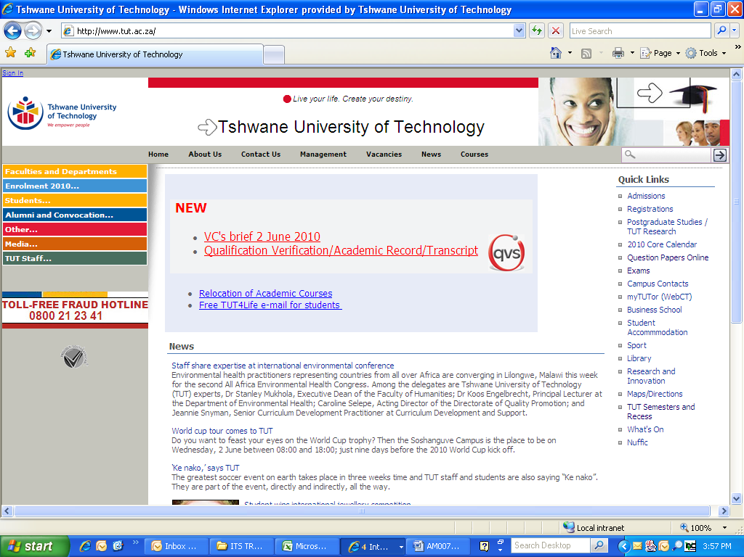

IMPORTANT INFORMATION

By making use of the iEnabler you will be able to print up-to-date class lists and capture assessment marks which will be saved onto the ITS server. It is important to note that the calculation of the predicate/final mark must be done on the ITS.

- You need a TUT e-mail address to register on StaffPortal. Your Departmental Administrator can send an e-mail to Charlotte Smit (SmitC@tut.ac.za) and provide her with:

- Name and Surname as it should appear on MS Outlook
- Personnel number
- Department
- Telephone and fax number
- Campus

- To link your subject to your personnel number, send an e-mail to Leandra Godefroy (GodefroyL@tut.ac.za).

- Assessment calculation criteria must be set-up on the ITS (Responsibility of Dept Admin).

- Assessment marks can be captured via iEnabler onto the ITS server.

- Calculation (computing) of predicate/final marks must be captured on the ITS.

- You can also print a class list or export the class list to MS Excel.

Open Internet connection
www.tut.ac.za
Click on TUT Staff

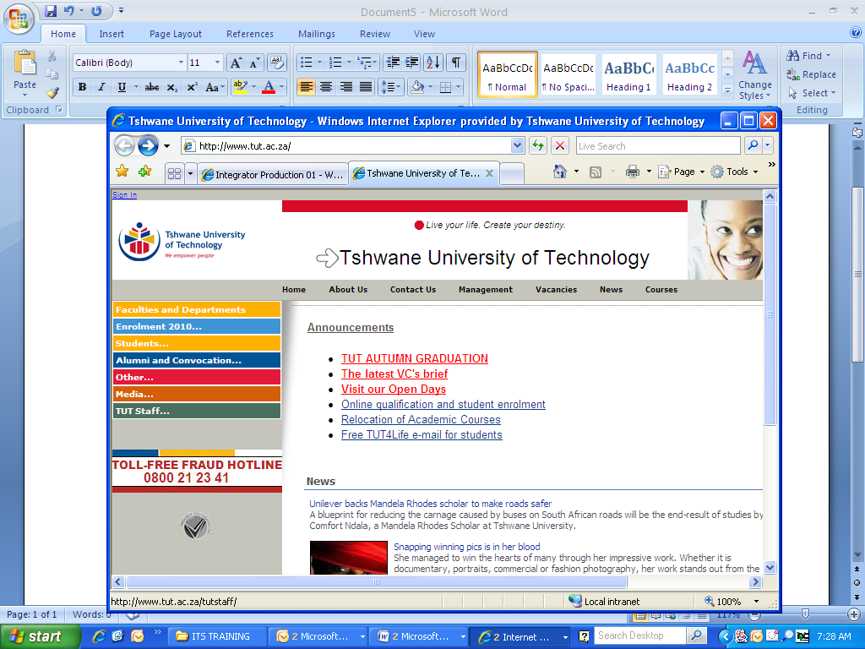

Click on Staff Portal/e-Tutor
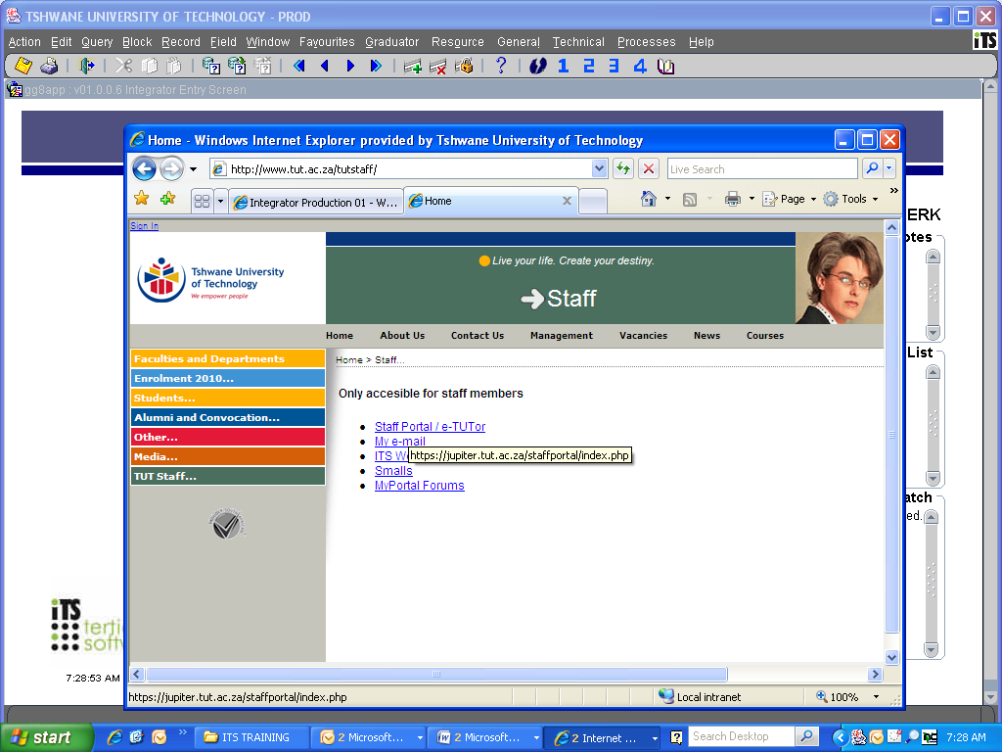
If you have not registered on the new MyPortal system before, then click as indicated below:

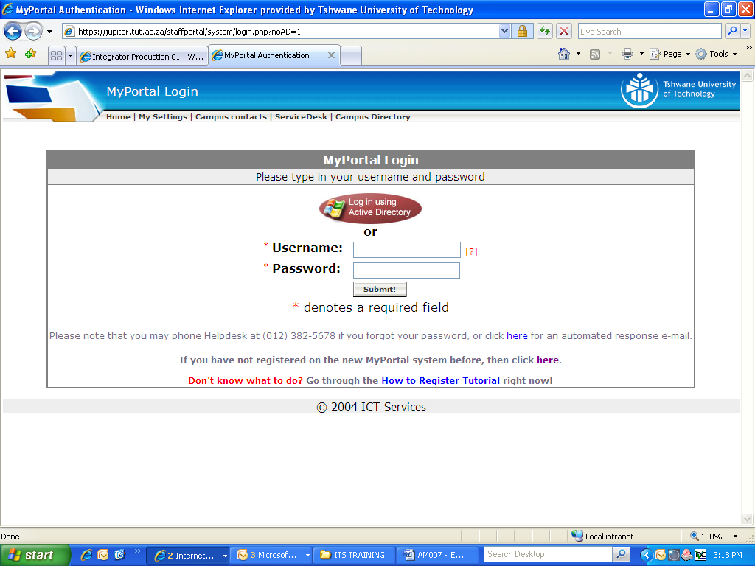

Complete the required information and click on Submit

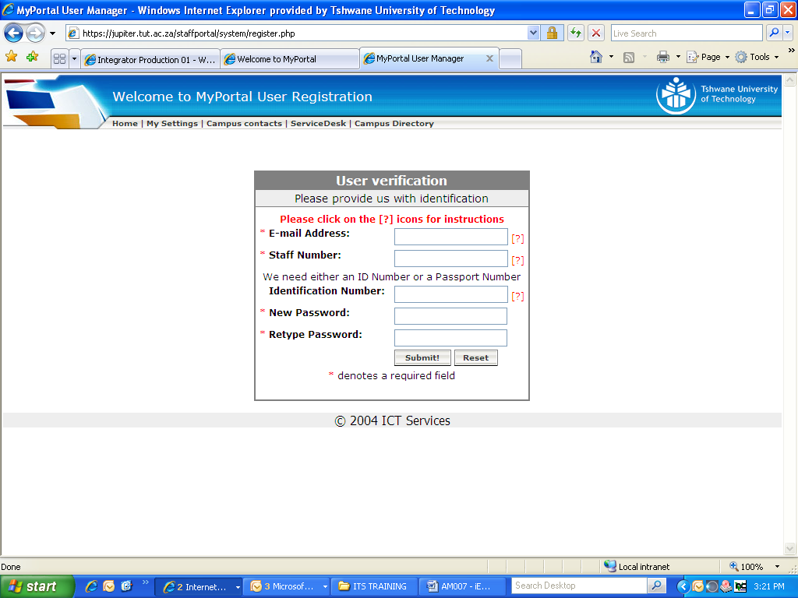
You will receive an e-mail confirming your registration on MyPortal.

Log-in by using your username and password.

Click on TUT Staff

Click on Staff Portal/e-Tutor
Click on ITS Web Leave Application

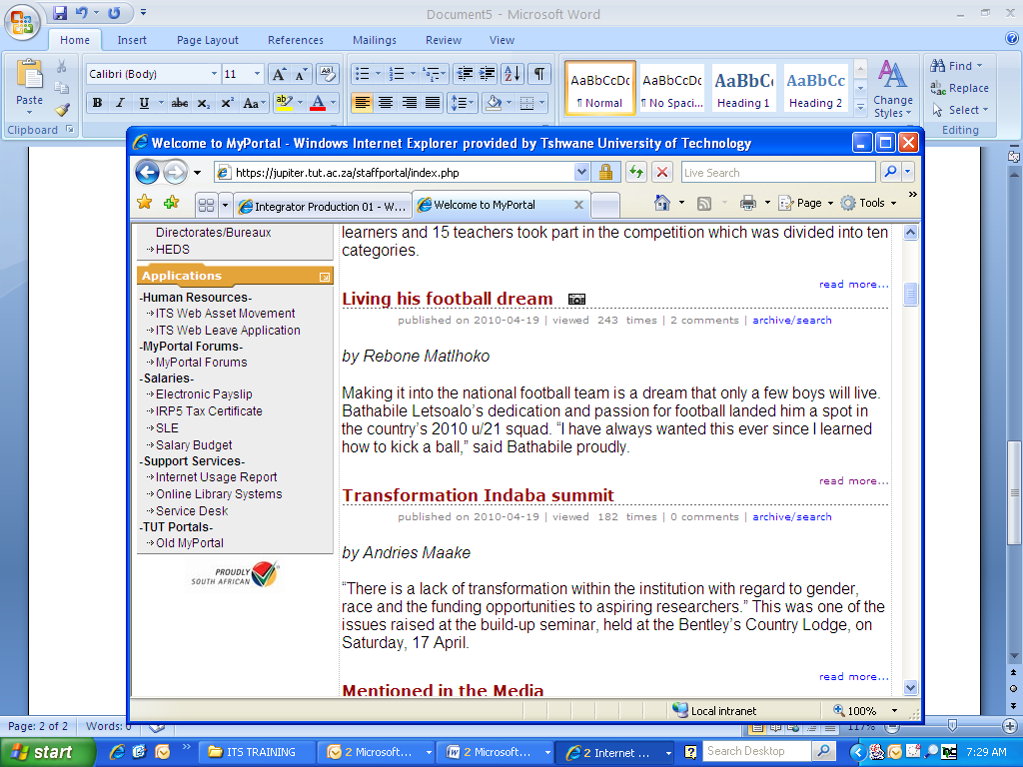

Click on Apply for leave: myself
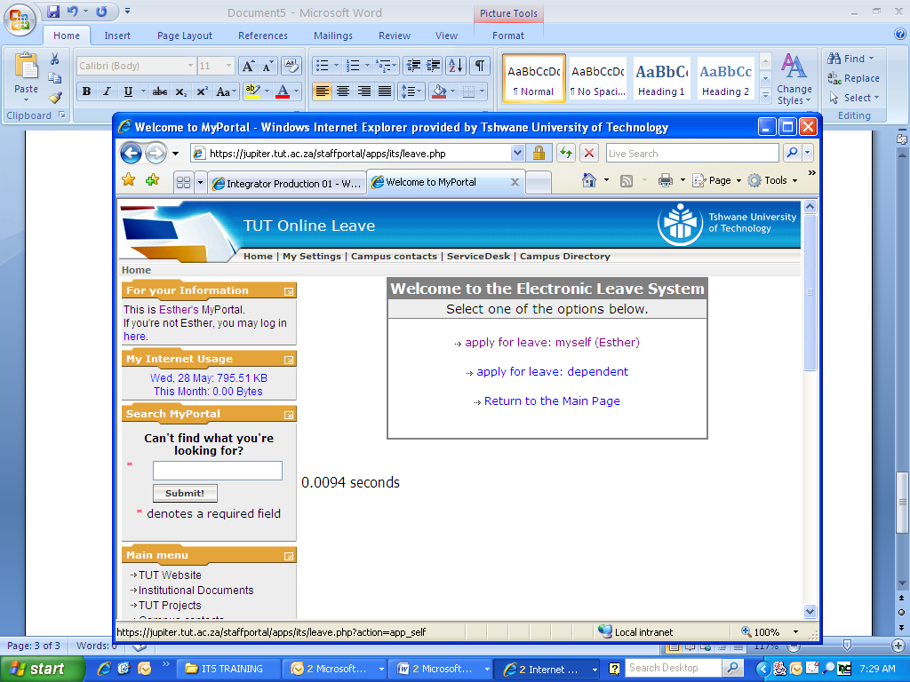

Click on Lecturer iEnabler

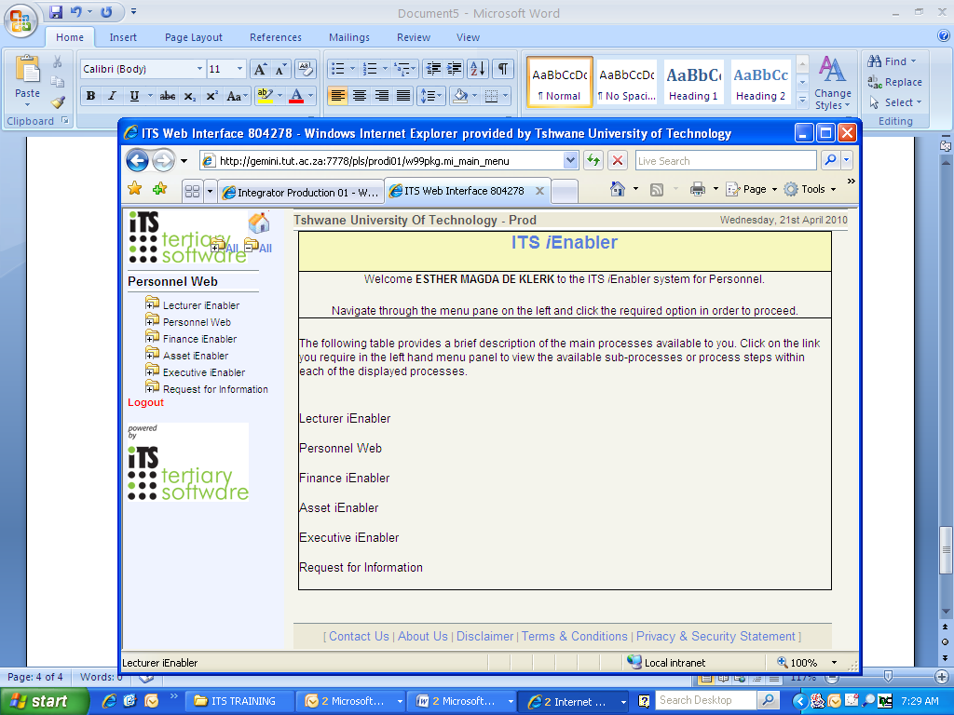

Click on Class List

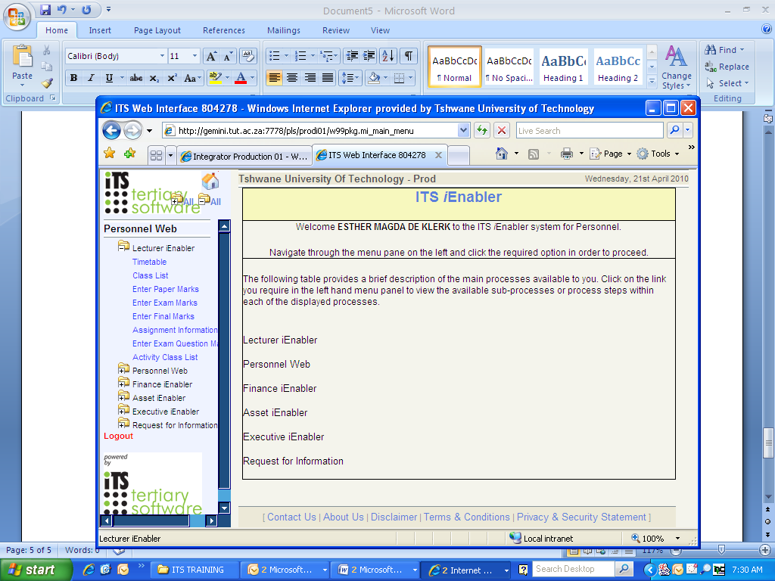
Subjects linked to your name will appear
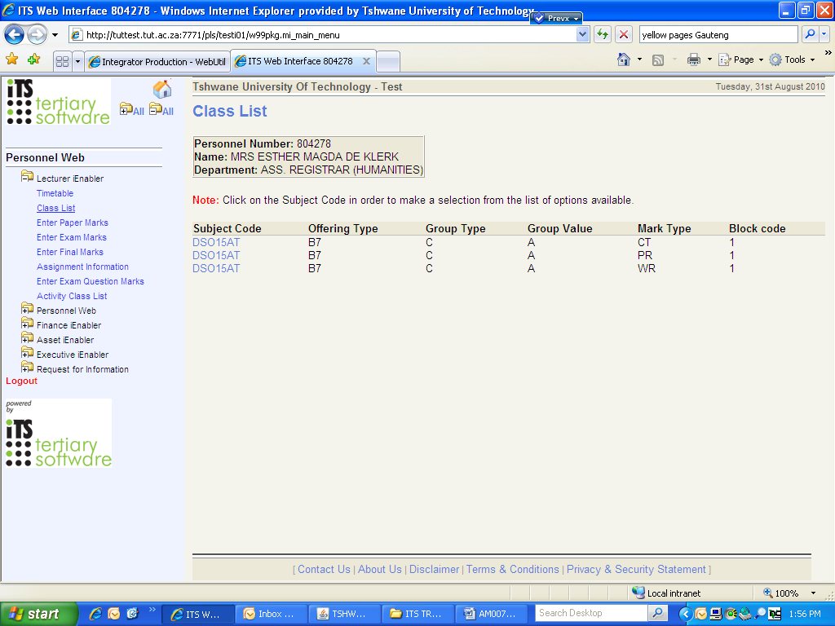
Click on the specific subject and mark the type you want to enter. A list of options will appear.
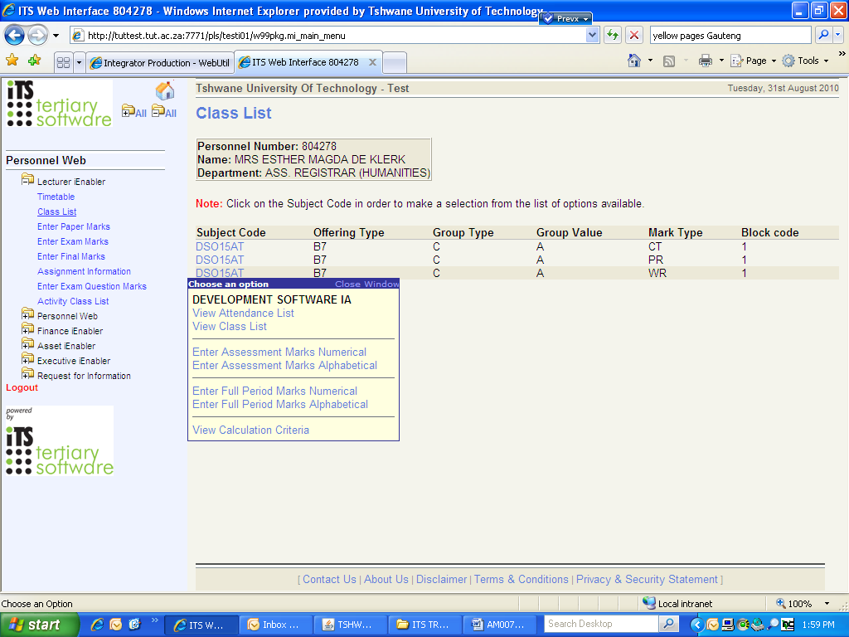
Click on Enter Assessment Marks (Numerical/Alphabetical)
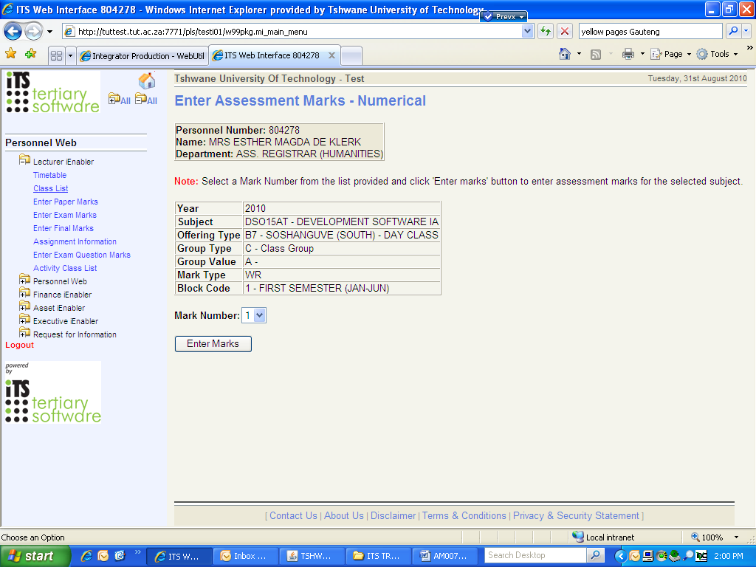
Select the Mark Number and Click on Enter Marks
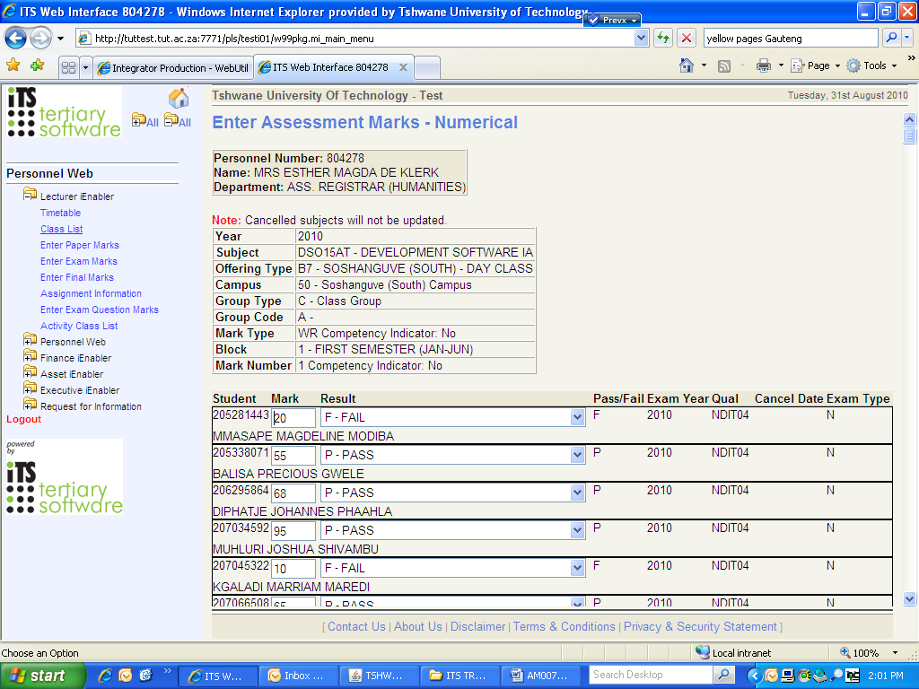

At the end of the list, Click on Save
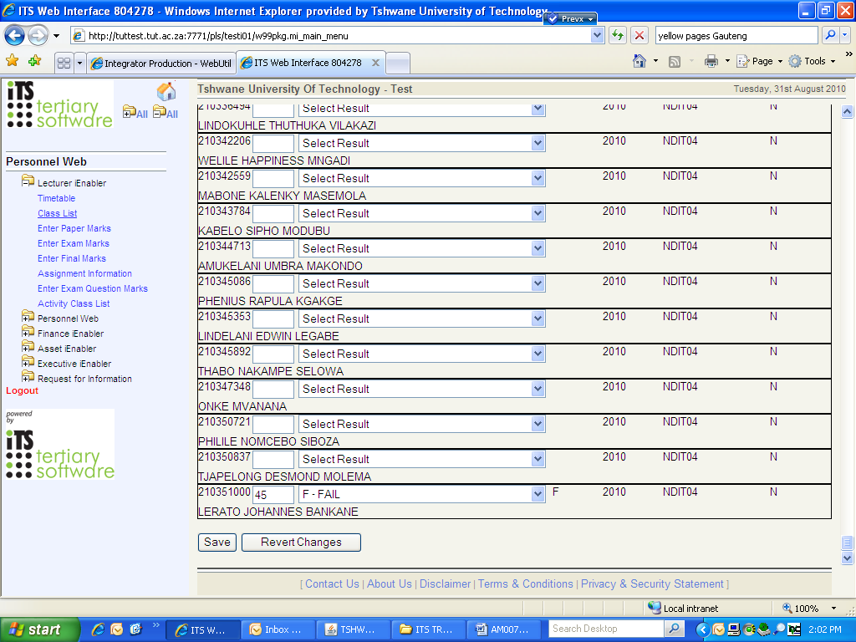
The assessment marks were saved onto the ITS server.

