

MANUAL FOR THE PROCESSING OF ASSESSMENT MARKS

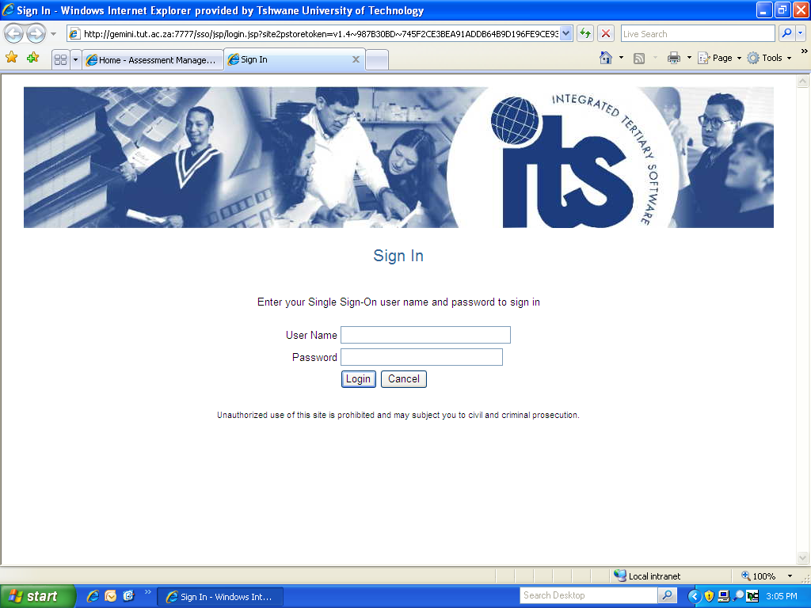

Assessment Management information (e.g. ITS training bookings, Assessment Circulars, Assessment Forms, Question Paper Archive, the Policy on Assessment and Moderation) is available on https://jupiter.tut.ac.za/staffportal/index.php?struc=447

Contact Details:
Esther de Klerk
E-mail: deklerkEM@tut.ac.za
Office: (012) 382 4871
Compiled by Esther de Klerk
Revised Apr 2013

TABLE OF CONTENTS
Page

USEFUL INFORMATION 4
LIST OF CODES 6
LIST OF MARK TYPES 11
ENTER MARK TYPE ASSESSMENT MARKS ON ITS 13
LECTURER iENABLER (ENTER ASSESSMENT MARKS AND PRINT CLASS LIST VIA STAFF PORTAL) 19
PRINT CLASS LIST FROM ITS 33
PRINT CLASS LIST FROM MIS 41
COMPUTE ASSESSMENT MARKS TO A FULL PERIOD MARK (INCLUDING NON-EXAMINATION SUBJECTS, e.g CONTINUOUS EVALUATION) 53
DETAILS OF REGISTRATION/RESULTS (QUERY STUDENT OR SUBJECT INFORMATION) 63
ALLOCATE CLASS GROUPS 69

USEFUL INFORMATION

- Open Internet Explorer, type this address in the URL and press Enter
http://papp.tut.ac.za:7778/forms/frmservlet?config=prodi01
(You can also create a shortcut on your computer desktop)

- Log on to the ITS with your User ID and Password
(Please keep this information confidential as you remain responsible for all transactions linked to your name)

- Enter assessment marks and compute to a full period mark
All assessment marks MUST be entered and calculation of full period marks must be done on the ITS, except for experiential learning (ET) and research (RS) subject types. No full period marks will be entered by Student Services.

- Process to be followed for non-examination subjects
All assessment marks must be entered and calculation of full period marks must be done on the ITS. A class list should be printed and the marks appearing under the full period mark column must be verified. When you agree with the printed marks, the class list must be signed-off by the examiner and HOD. Exit level subjects must also be signed-off by the external moderator. This list must be submitted to Student Services for finalisation of the final marks. If a class list is not submitted, the students will not receive their final marks.

- DESCRIPTION OF ICONS USED

Descriptive name ITS Icon Description (Shortcut on keyboard)
1. Thunder bolt - Quick Menu (F1)
2. Yellow disc - Save (F10)
3. Green door - Exit (Esc)
4. Double arrow to the left - Previous Block (Page Up)
5. Double arrow to the right - Next Block (Page Down)
6. Bin with question mark - Enter Query (F11)
7. Bin with arrow and question mark - Execute Query (F12)
8 Shortcuts - Favourites (See next page)
9. Red cross - Remove record (Ctrl & Delete)
9
6
7
1
8
2

5
4
3

CREATE FAVOURITES (SHORTCUTS) ON YOUR TOOLBAR

Each user of the ITS Integrator can set up an individual list of favourite menu options in the order of preference. These options are accessible via the Favourites menu on the Menu Bar. In addition, the first 4 favourites can be accessed more quickly, using numeral icons 1 to 4 from the Toolbar.

To Add an option to Favourites:
- Open the option you want to add, and then from the Menu Bar choose Favourites -> Add from the drop down menu. Note: the Add option will only be available if the user is trying to create an entry from the option that is not already on the user’s "Favourites" list.
- Alternatively, at any point, choosing the ”Edit" option from Favourites drop-down will enable the user to Add new or Edit existing entries.

To Remove an option from Favourites:
- When the user is in the option, he / she should choose Favourites -> Remove.
- Alternatively, at any point, entries from Favourites can also be removed via Favourites -> Edit. Simply Delete the record and Save.

To Edit Favourites:
- Click on Favourites.
- Click on Edit.
- The following screen will appear allowing full maintenance of the personal Favourites list.

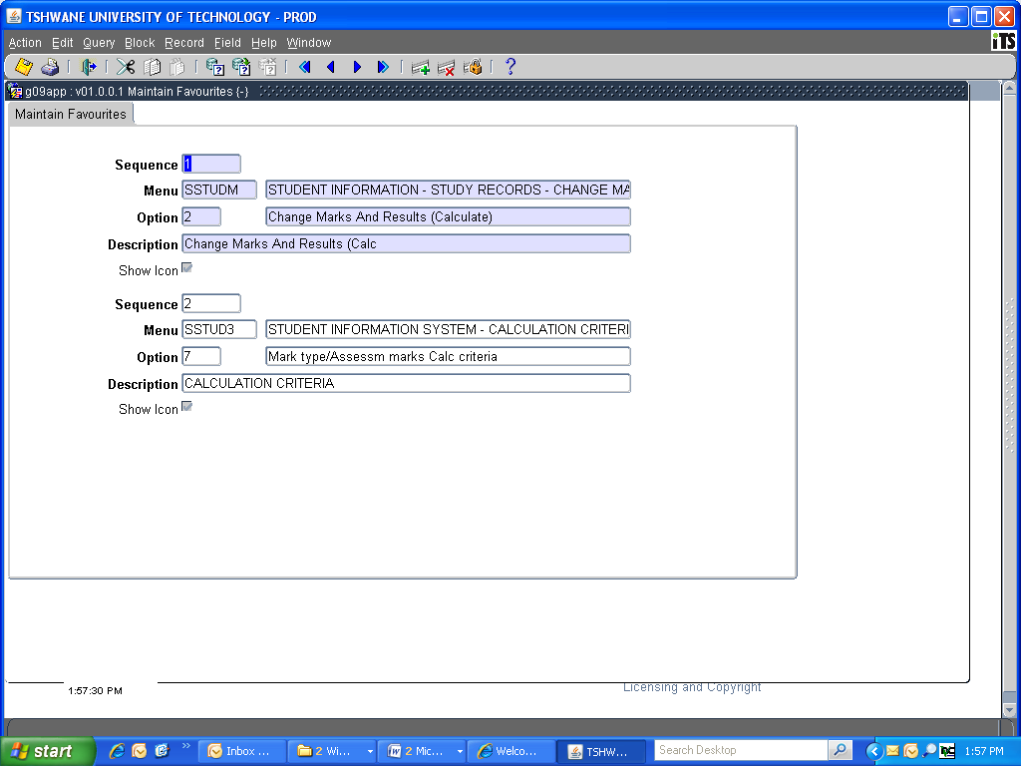

LIST OF CODES
CAMPUS CODE | CAMPUS DESCRIPTION | OFFERING TYPE CODE | OFFERING TYPE | ACADEMIC BLOCK CODE | ACADEMIC BLOCK NAME DESCRIPTION | EXAM MONTH
1 | Pretoria Campus (1) | A1 | PRETORIA - FULL TIME (A1) | 0 | YEAR (JAN-DEC) (0) | 10
1 | Pretoria Campus (1) | A1 | PRETORIA - FULL TIME (A1) | 1 | FIRST SEMESTER (JAN-JUN) (1) | 5
1 | Pretoria Campus (1) | A1 | PRETORIA - FULL TIME (A1) | 2 | SECOND SEMESTER (JUL-DEC) (2) | 10
1 | Pretoria Campus (1) | A1 | PRETORIA - FULL TIME (A1) | 4 | YEAR (JUL-JUN) (4) | 5
1 | Pretoria Campus (1) | A1 | PRETORIA - FULL TIME (A1) | 4 | YEAR (JUL-JUN) (4) | 6
1 | Pretoria Campus (1) | A1 | PRETORIA - FULL TIME (A1) | C1 | BLOCK 1 CONTACT CENTRE NORMAL (C1) | 3
1 | Pretoria Campus (1) | A1 | PRETORIA - FULL TIME (A1) | C4 | BLOCK 2 CONTACT CENTRE NORMAL (C4) | 7
1 | Pretoria Campus (1) | A1 | PRETORIA - FULL TIME (A1) | C7 | BLOCK 3 CONTACT CENTRE NORMAL (C7) | 5
1 | Pretoria Campus (1) | A1 | PRETORIA - FULL TIME (A1) | CA | BLOCK 4 CONTACT CENTRE NORMAL (CA) | 9
1 | Pretoria Campus (1) | A1 | PRETORIA - FULL TIME (A1) | CD | BLOCK 5 CONTACT CENTRE NORMAL (CD) | 11
1 | Pretoria Campus (1) | A2 | PRETORIA - PART TIME (A2) | 0 | YEAR (JAN-DEC) (0) | 10
1 | Pretoria Campus (1) | A2 | PRETORIA - PART TIME (A2) | 1 | FIRST SEMESTER (JAN-JUN) (1) | 5
1 | Pretoria Campus (1) | A2 | PRETORIA - PART TIME (A2) | 2 | SECOND SEMESTER (JUL-DEC) (2) | 10
1 | Pretoria Campus (1) | A3 | PRETORIA - BLOCK (A3) | 0 | YEAR (JAN-DEC) (0) | 10
1 | Pretoria Campus (1) | A3 | PRETORIA - BLOCK (A3) | 1 | FIRST SEMESTER (JAN-JUN) (1) | 5
1 | Pretoria Campus (1) | A3 | PRETORIA - BLOCK (A3) | 2 | SECOND SEMESTER (JUL-DEC) (2) | 10
1 | Pretoria Campus (1) | A3 | PRETORIA - BLOCK (A3) | 4 | YEAR (JUL-JUN) (4) | 5
1 | Pretoria Campus (1) | A3 | PRETORIA - BLOCK (A3) | 32 | 1ST TRI-SEMESTER (32) | 3
1 | Pretoria Campus (1) | A3 | PRETORIA - BLOCK (A3) | 32 | 1ST TRI-SEMESTER (32) | 5
1 | Pretoria Campus (1) | A3 | PRETORIA - BLOCK (A3) | 33 | 2ND TRI-SEMESTER (33) | 7
1 | Pretoria Campus (1) | A3 | PRETORIA - BLOCK (A3) | 33 | 2ND TRI-SEMESTER (33) | 8
1 | Pretoria Campus (1) | A3 | PRETORIA - BLOCK (A3) | 34 | 3RD TRI-SEMESTER (34) | 10
1 | Pretoria Campus (1) | A3 | PRETORIA - BLOCK (A3) | 7C | 1ST TRI-SEMESTER (PEOPLE) (7C) | 5
1 | Pretoria Campus (1) | A3 | PRETORIA - BLOCK (A3) | 7D | 2ND TRI-SEMESTER (PEOPLE) (7D) | 8
1 | Pretoria Campus (1) | A3 | PRETORIA - BLOCK (A3) | 7E | 3RD TRI-SEMESTER (PEOPLE) (7E) | 10
CAMPUS CODE | CAMPUS DESCRIPTION | OFFERING TYPE CODE | OFFERING TYPE | ACADEMIC BLOCK CODE | ACADEMIC BLOCK NAME DESCRIPTION | EXAM MONTH
1 | Pretoria Campus (1) | A4 | PRETORIA - POSTGRADUATE (A4) | 0 | YEAR (JAN-DEC) (0) | 10
1 | Pretoria Campus (1) | A4 | PRETORIA - POSTGRADUATE (A4) | 1 | FIRST SEMESTER (JAN-JUN) (1) | 5
1 | Pretoria Campus (1) | A7 | GOLF ACADEMY - FULL TIME (A7) | 0 | YEAR (JAN-DEC) (0) | 10
1 | Pretoria Campus (1) | EB | PRETORIA - EXT CURR - BLOCK (EB) | 1A | BLOCK 1 - DEPT 104 (1A) | 3
1 | Pretoria Campus (1) | EB | PRETORIA - EXT CURR - BLOCK (EB) | 2A | BLOCK 2 - DEPT 104 (2A) | 5
1 | Pretoria Campus (1) | EB | PRETORIA - EXT CURR - BLOCK (EB) | 3A | BLOCK 3 - DEPT 104 (3A) | 8
1 | Pretoria Campus (1) | EB | PRETORIA - EXT CURR - BLOCK (EB) | 4A | BLOCK 4 - DEPT 104 (4A) | 7
1 | Pretoria Campus (1) | EB | PRETORIA - EXT CURR - BLOCK (EB) | 5A | BLOCK 5 - DEPT 104 (5A) | 10
1 | Pretoria Campus (1) | EP | PRETORIA - EXTENDED CURRICULUM (EP) | 0 | YEAR (JAN-DEC) (0) | 10
1 | Pretoria Campus (1) | EP | PRETORIA - EXTENDED CURRICULUM (EP) | 1 | FIRST SEMESTER (JAN-JUN) (1) | 5
1 | Pretoria Campus (1) | EP | PRETORIA - EXTENDED CURRICULUM (EP) | 2 | SECOND SEMESTER (JUL-DEC) (2) | 10
1 | Pretoria Campus (1) | F0 | PRETORIA - BLOCK (FAC 70) (F0) | 1A | BLOCK 1 - DEPT 104 (1A) | 3
1 | Pretoria Campus (1) | F0 | PRETORIA - BLOCK (FAC 70) (F0) | 2A | BLOCK 2 - DEPT 104 (2A) | 5
1 | Pretoria Campus (1) | F0 | PRETORIA - BLOCK (FAC 70) (F0) | 3A | BLOCK 3 - DEPT 104 (3A) | 8
1 | Pretoria Campus (1) | F0 | PRETORIA - BLOCK (FAC 70) (F0) | 4A | BLOCK 4 - DEPT 104 (4A) | 7
1 | Pretoria Campus (1) | F0 | PRETORIA - BLOCK (FAC 70) (F0) | 5A | BLOCK 5 - DEPT 104 (5A) | 10
1 | Pretoria Campus (1) | F0 | PRETORIA - BLOCK (FAC 70) (F0) | 6D | BLOCK 6 - DEPT 104 (NORMAL) (6D) | 11
1 | Pretoria Campus (1) | F0 | PRETORIA - BLOCK (FAC 70) (F0) | C1 | BLOCK 1 CONTACT CENTRE NORMAL (C1) | 3
1 | Pretoria Campus (1) | F0 | PRETORIA - BLOCK (FAC 70) (F0) | C4 | BLOCK 2 CONTACT CENTRE NORMAL (C4) | 7
1 | Pretoria Campus (1) | F0 | PRETORIA - BLOCK (FAC 70) (F0) | C7 | BLOCK 3 CONTACT CENTRE NORMAL (C7) | 5
1 | Pretoria Campus (1) | F0 | PRETORIA - BLOCK (FAC 70) (F0) | CA | BLOCK 4 CONTACT CENTRE NORMAL (CA) | 9
1 | Pretoria Campus (1) | F0 | PRETORIA - BLOCK (FAC 70) (F0) | CD | BLOCK 5 CONTACT CENTRE NORMAL (CD) | 11
1 | Pretoria Campus (1) | F0 | PRETORIA - BLOCK (FAC 70) (F0) | CG | BLOCK 6 CONTACT CENTRE NORMAL (CG) | 7
CAMPUS CODE | CAMPUS DESCRIPTION | OFFERING TYPE CODE | OFFERING TYPE | ACADEMIC BLOCK CODE | ACADEMIC BLOCK NAME DESCRIPTION | EXAM MONTH
1 | Pretoria Campus (1) | F0 | PRETORIA - BLOCK (FAC 70) (F0) | CJ | BLOCK 1 CONTACT CENTRE NORMAL (CJ) | 4
1 | Pretoria Campus (1) | F0 | PRETORIA - BLOCK (FAC 70) (F0) | CK | BLOCK 4 CONTACT CENTRE NORMAL (CK) | 10
1 | Pretoria Campus (1) | V1 | SCIENCE - POLOKWANE (V1) | 0 | YEAR (JAN-DEC) (0) | 10
1 | Pretoria Campus (1) | V2 | SCIENCE - MBOMBELA (V2) | 0 | YEAR (JAN-DEC) (0) | 10
1 | Pretoria Campus (1) | V3 | SCIENCE - KLERKSDORP (V3) | 0 | YEAR (JAN-DEC) (0) | 10
2 | Arts Campus (Pretoria) (2) | B1 | ART - FULL TIME (B1) | 0 | YEAR (JAN-DEC) (0) | 10
2 | Arts Campus (Pretoria) (2) | B1 | ART - FULL TIME (B1) | 1 | FIRST SEMESTER (JAN-JUN) (1) | 5
2 | Arts Campus (Pretoria) (2) | B1 | ART - FULL TIME (B1) | 5C | FIRST SEMESTER (JAN-JUN) (5C) | 5
2 | Arts Campus (Pretoria) (2) | B1 | ART - FULL TIME (B1) | 2 | SECOND SEMESTER (JUL-DEC) (2) | 10
2 | Arts Campus (Pretoria) (2) | B4 | ARTS - POSTGRADUATE (B4) | 0 | YEAR (JAN-DEC) (0) | 10
3 | Arcadia Campus (Pretoria) (3) | C1 | ARCADIA - FULL TIME (C1) | 0 | YEAR (JAN-DEC) (0) | 10
3 | Arcadia Campus (Pretoria) (3) | C1 | ARCADIA - FULL TIME (C1) | 1 | FIRST SEMESTER (JAN-JUN) (1) | 5
3 | Arcadia Campus (Pretoria) (3) | C1 | ARCADIA - FULL TIME (C1) | 2 | SECOND SEMESTER (JUL-DEC) (2) | 10
3 | Arcadia Campus (Pretoria) (3) | C2 | ARCADIA - PART TIME (C2) | 0 | YEAR (JAN-DEC) (0) | 10
3 | Arcadia Campus (Pretoria) (3) | C2 | ARCADIA - PART TIME (C2) | 1 | FIRST SEMESTER (JAN-JUN) (1) | 5
3 | Arcadia Campus (Pretoria) (3) | C3 | ARCADIA - BLOCK (C3) | 0 | YEAR (JAN-DEC) (0) | 10
3 | Arcadia Campus (Pretoria) (3) | C3 | ARCADIA - BLOCK (C3) | 1 | FIRST SEMESTER (JAN-JUN) (1) | 5
3 | Arcadia Campus (Pretoria) (3) | C4 | ARCADIA - POSTGRADUATE (C4) | 0 | YEAR (JAN-DEC) (0) | 10
3 | Arcadia Campus (Pretoria) (3) | EA | ARCADIA - EXTENDED CURRICULUM (EA) | 0 | YEAR (JAN-DEC) (0) | 10
3 | Arcadia Campus (Pretoria) (3) | EA | ARCADIA - EXTENDED CURRICULUM (EA) | 1 | FIRST SEMESTER (JAN-JUN) (1) | 5
3 | Arcadia Campus (Pretoria) (3) | EA | ARCADIA - EXTENDED CURRICULUM (EA) | 2 | SECOND SEMESTER (JUL-DEC) (2) | 10
4 | Emalahleni (Witbank) Campus (4) | D1 | EMALAHLENI - FULL TIME (D1) | 0 | YEAR (JAN-DEC) (0) | 10
4 | Emalahleni (Witbank) Campus (4) | D1 | EMALAHLENI - FULL TIME (D1) | 1 | FIRST SEMESTER (JAN-JUN) (1) | 5
CAMPUS CODE | CAMPUS DESCRIPTION | OFFERING TYPE CODE | OFFERING TYPE | ACADEMIC BLOCK CODE | ACADEMIC BLOCK NAME DESCRIPTION | EXAM MONTH
4 | Emalahleni (Witbank) Campus (4) | D1 | EMALAHLENI - FULL TIME (D1) | 2 | SECOND SEMESTER (JUL-DEC) (2) | 10
4 | Emalahleni (Witbank) Campus (4) | D2 | EMALAHLENI - PART TIME (D2) | 0 | YEAR (JAN-DEC) (0) | 10
4 | Emalahleni (Witbank) Campus (4) | D2 | EMALAHLENI - PART TIME (D2) | 1 | FIRST SEMESTER (JAN-JUN) (1) | 5
4 | Emalahleni (Witbank) Campus (4) | D2 | EMALAHLENI - PART TIME (D2) | 4 | YEAR (JUL-JUN) (4) | 5
4 | Emalahleni (Witbank) Campus (4) | D3 | EMALAHLENI - BLOCK (D3) | 0 | YEAR (JAN-DEC) (0) | 10
4 | Emalahleni (Witbank) Campus (4) | EE | EMALAHLENI EXTENDED CURRICULUM (EE) | 0 | YEAR (JAN-DEC) (0) | 10
4 | Emalahleni (Witbank) Campus (4) | EE | EMALAHLENI EXTENDED CURRICULUM (EE) | 1 | FIRST SEMESTER (JAN-JUN) (1) | 5
5 | Nelspruit Campus (5) | E0 | MBOMBELA - BLOCK (E0) | 1 | FIRST SEMESTER (JAN-JUN) (1) | 5
5 | Nelspruit Campus (5) | E1 | MBOMBELA - FULL TIME (E1) | 0 | YEAR (JAN-DEC) (0) | 10
5 | Nelspruit Campus (5) | E1 | MBOMBELA - FULL TIME (E1) | 2 | SECOND SEMESTER (JUL-DEC) (2) | 10
5 | Nelspruit Campus (5) | E1 | MBOMBELA - FULL TIME (E1) | 1 | FIRST SEMESTER (JAN-JUN) (1) | 5
5 | Nelspruit Campus (5) | E2 | MBOMBELA - PART TIME (E2) | 0 | YEAR (JAN-DEC) (0) | 10
5 | Nelspruit Campus (5) | EN | MBOMBELA EXTENDED CURRICULUM (EN) | 0 | YEAR (JAN-DEC) (0) | 10
5 | Nelspruit Campus (5) | EN | MBOMBELA EXTENDED CURRICULUM (EN) | 1 | FIRST SEMESTER (JAN-JUN) (1) | 5
5 | Nelspruit Campus (5) | EN | MBOMBELA - FULL TIME (EN) | 2 | SECOND SEMESTER (JUL-DEC) (2) | 10
7 | Polokwane Campus (7) | EK | POLOKWANE EXTENDED CURRICULUM (EK) | 0 | YEAR (JAN-DEC) (0) | 10
7 | Polokwane Campus (7) | EK | POLOKWANE EXTENDED CURRICULUM (EK) | 1 | FIRST SEMESTER (JAN-JUN) (1) | 5
7 | Polokwane Campus (7) | G1 | POLOKWANE - FULL TIME (G1) | 0 | YEAR (JAN-DEC) (0) | 10
7 | Polokwane Campus (7) | G1 | POLOKWANE - FULL TIME (G1) | 1 | FIRST SEMESTER (JAN-JUN) (1) | 5
7 | Polokwane Campus (7) | G1 | POLOKWANE - FULL TIME (G1) | 2 | SECOND SEMESTER (JUL-DEC) (2) | 10
40 | Ga-Rankuwa Campus (40) | B6 | GA-RANKUWA - FULL TIME (B6) | 0 | YEAR (JAN-DEC) (0) | 10
40 | Ga-Rankuwa Campus (40) | B6 | GA-RANKUWA - FULL TIME (B6) | 1 | FIRST SEMESTER (JAN-JUN) (1) | 5
40 | Ga-Rankuwa Campus (40) | B6 | GA-RANKUWA - FULL TIME (B6) | 2 | SECOND SEMESTER (JUL-DEC) (2) | 10
CAMPUS CODE | CAMPUS DESCRIPTION | OFFERING TYPE CODE | OFFERING TYPE | ACADEMIC BLOCK CODE | ACADEMIC BLOCK NAME DESCRIPTION | EXAM MONTH
40 | Ga-Rankuwa Campus (40) | G9 | GA-RANKUWA - POSTGRADUATE (G9) | 0 | YEAR (JAN-DEC) (0) | 10
50 | Soshanguve (South) Campus (50) | B7 | SOSHANGUVE (SOUTH) - FULL TIME (B7) | 0 | YEAR (JAN-DEC) (0) | 10
50 | Soshanguve (South) Campus (50) | B7 | SOSHANGUVE (SOUTH) - FULL TIME (B7) | 1 | FIRST SEMESTER (JAN-JUN) (1) | 5
50 | Soshanguve (South) Campus (50) | B8 | SOSHANGUVE (SOUTH) - PART TIME (B8) | 0 | YEAR (JAN-DEC) (0) | 10
50 | Soshanguve (South) Campus (50) | B7 | SOSHANGUVE (SOUTH) - FULL TIME (B7) | 2 | SECOND SEMESTER (JUL-DEC) (2) | 10
50 | Soshanguve (South) Campus (50) | B8 | SOSHANGUVE (SOUTH) - PART TIME (B8) | 1 | FIRST SEMESTER (JAN-JUN) (1) | 5
50 | Soshanguve (South) Campus (50) | B9 | SOSHANGUVE (SOUTH) - POSTGRAD (B9) | 0 | YEAR (JAN-DEC) (0) | 10
50 | Soshanguve (South) Campus (50) | B9 | SOSHANGUVE (SOUTH) - POSTGRAD (B9) | 1 | FIRST SEMESTER (JAN-JUN) (1) | 5
50 | Soshanguve (South) Campus (50) | BA | SOSHANGUVE (SOUTH) - SATURDAYS (BA) | 0 | YEAR (JAN-DEC) (0) | 10
50 | Soshanguve (South) Campus (50) | BA | SOSHANGUVE (SOUTH) - SATURDAYS (BA) | 1 | FIRST SEMESTER (JAN-JUN) (1) | 5
50 | Soshanguve (South) Campus (50) | BA | SOSHANGUVE (SOUTH) - SATURDAYS (BA) | 4 | YEAR (JUL-JUN) (4) | 5
50 | Soshanguve (South) Campus (50) | BA | SOSHANGUVE (SOUTH) - SATURDAYS (BA) | 4 | YEAR (JUL-JUN) (4) | 6
50 | Soshanguve (South) Campus (50) | ES | SOSHANGUVE EXTENDED CURRICULUM (ES) | 1 | FIRST SEMESTER (JAN-JUN) (1) | 5
50 | Soshanguve (South) Campus (50) | F8 | KLERKSDORP - BLOCK (F8) | 0 | YEAR (JAN-DEC) (0) | 10
50 | Soshanguve (South) Campus (50) | G7 | SOSHANGUVE (SOUTH) - BLOCK (G7) | 1 | FIRST SEMESTER (JAN-JUN) (1) | 5
89 | Soshanguve (North) Campus (89) | P2 | SOSHANGUVE - (NORTH) FULL TIME (P2) | 0 | YEAR (JAN-DEC) (0) | 10
89 | Soshanguve (North) Campus (89) | P2 | SOSHANGUVE - (NORTH) FULL TIME (P2) | 1 | FIRST SEMESTER (JAN-JUN) (1) | 5
89 | Soshanguve (North) Campus (89) | P2 | SOSHANGUVE (NORTH) - BLOCK/SAT (P2) | 2 | SECOND SEMESTER (JUL-DEC) (2) | 10
89 | Soshanguve (North) Campus (89) | P4 | SOSHANGUVE (NORTH) - BLOCK/SAT (P4) | 0 | YEAR (JAN-DEC) (0) | 10
89 | Soshanguve (North) Campus (89) | P4 | SOSHANGUVE (NORTH) - BLOCK/SAT (P4) | 1 | FIRST SEMESTER (JAN-JUN) (1) | 5
89 | Soshanguve (North) Campus (89) | P4 | SOSHANGUVE (NORTH) - BLOCK/SAT (P4) | 5 | YEAR (JAN-DEC) (5) | 10
89 | Soshanguve (North) Campus (89) | P5 | SOSHANGUVE (NORTH) - POSTGRAD (P5) | 0 | YEAR (JAN-DEC) (0) | 10

LIST OF MARK TYPES

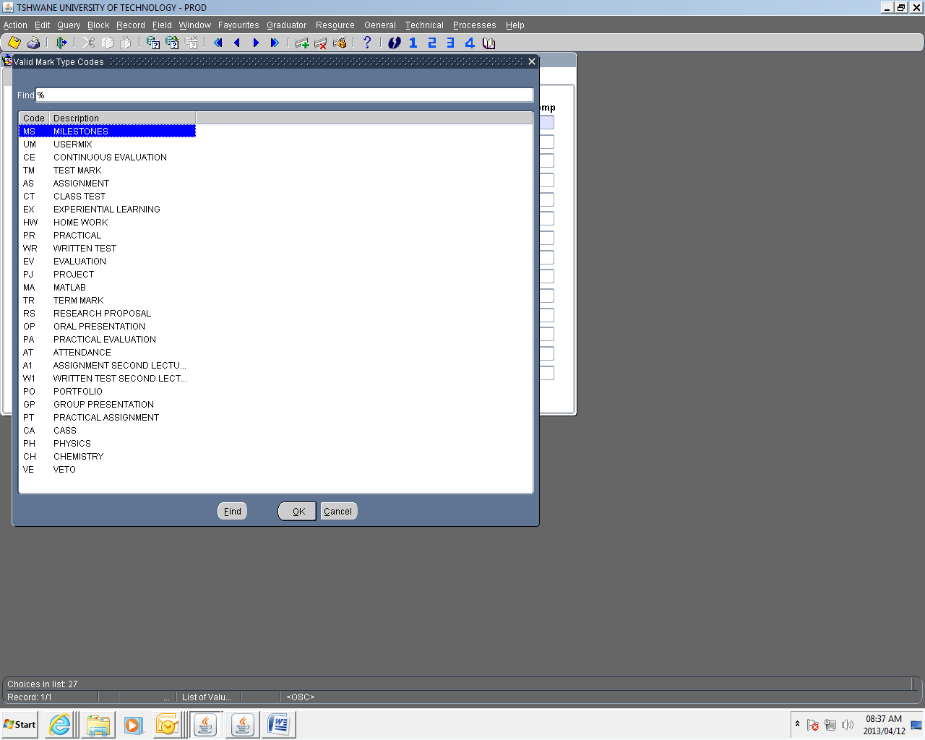



ENTER MARK TYPE ASSESSMENT MARKS ON ITS
(SSTUD1-2)
(AM004)

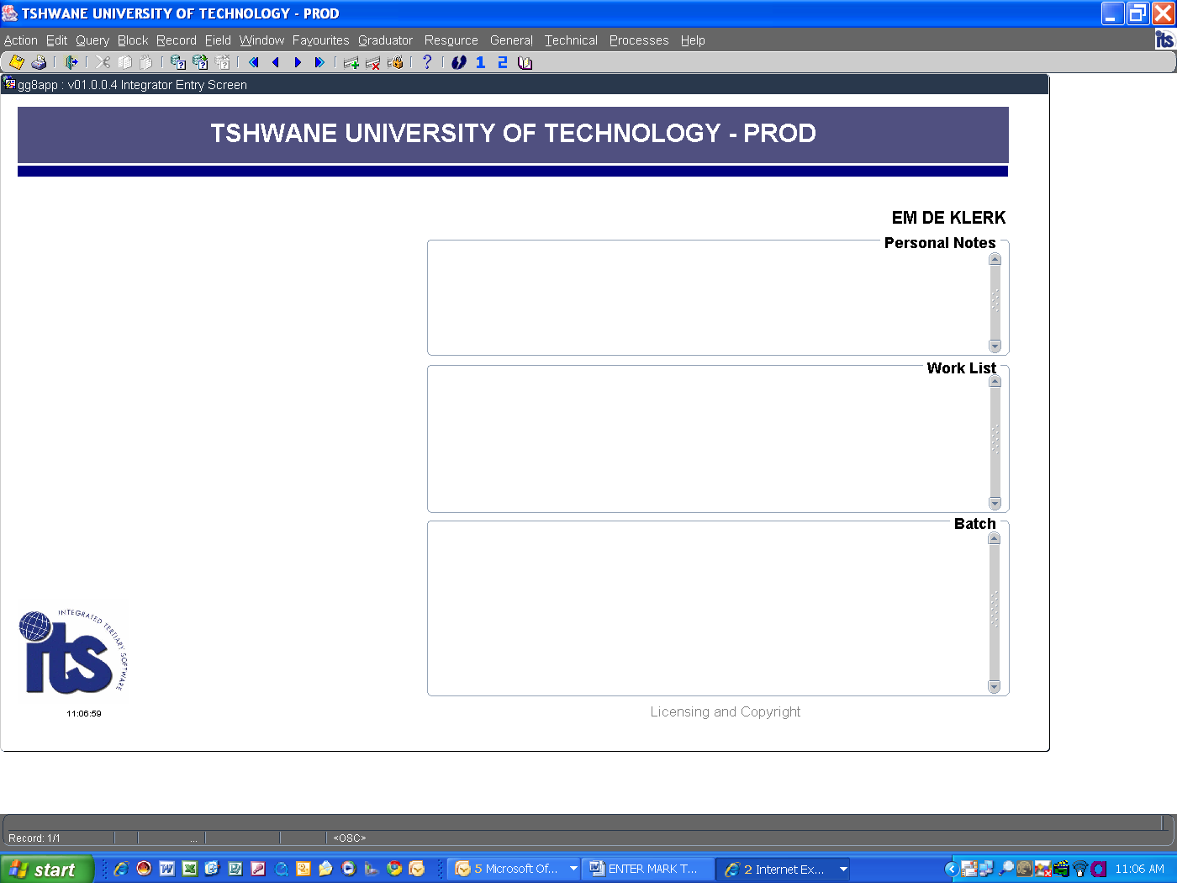

IMPORTANT INFORMATION

- The following needs to be in place before any assessment marks can be captured on the ITS:
- Students must be registered
- All linked subjects (subject with same/more or less the same content) should be treated equally, i.e. same number of assessments and weight per assessment. Agreement must be reached by all lecturing staff on all campuses offering the same subject.
- The assessment calculation criteria (weights) must have been set-up by the Departmental Administrator.
- Any changes to the assessment calculation criteria must be forwarded to the Departmental Administrator, where after all campuses involved should be notified.

- Capture assessment marks on the ITS promptly after every class assessment/assignment - including Continuous Evaluation (CE), Practical Evaluation (PE) examination types.

- Print a class list for the students to verify the correctness of the marks captured on the system. This will also help identifying students not registered attending your class.

- Do the necessary changes without delay.

- If a student did not write an assessment or did not submit an assignment, either a “0” (zero) or you may leave the field empty.

A “0” will penalise the student in that the mark will be processed as a 0, whilst an empty field will cause the particular assessment to be ignored in the calculation of Mark Type marks for that individual student.

- If you leave the space open, the student’s full period mark (or final mark in the case of Continuous Evaluation subjects) will only be calculated from the number of assessment marks entered (e.g. only 3 of the 4 marks will be considered and the full period mark will be the average of only the 3 assessments entered).

Press <F1> (or click on Quick Menu icon)

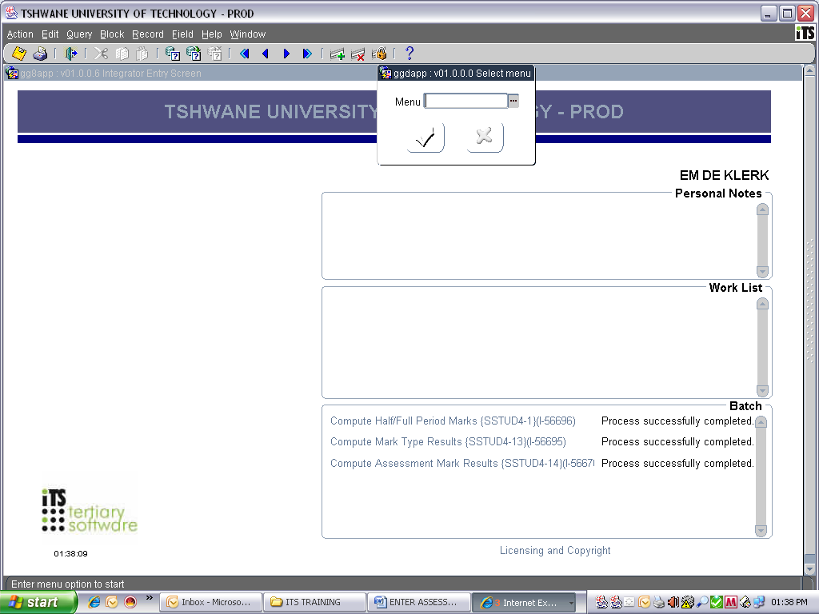

Type in SSTUD1-2

The following screen will appear:

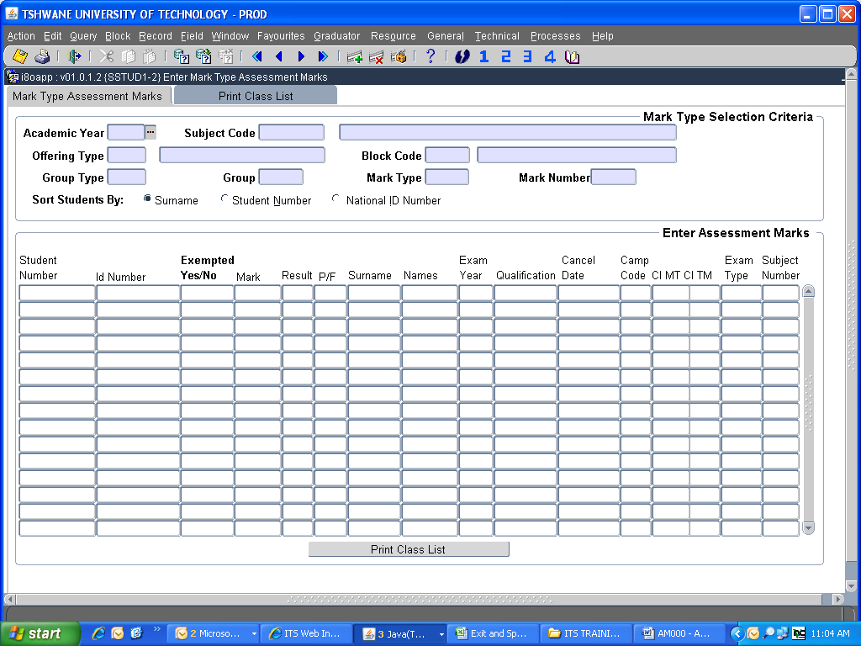
1. Enter Academic Year, Press <Tab> or <Enter>
2. Enter Subject Code, Press <Tab> or <Enter>
3. Enter Offering Type, Press <Tab> or <Enter>
4. Enter Block Code, Press <Tab> or <Enter>
5. Enter Group Type, Press <Tab> or <Enter>
6. Enter (Class) Group, Press <Tab> or <Enter>
7. Enter Mark Type, Press <Tab> or <Enter>
8. Enter Mark Number, Press <Tab> or <Enter>
9. Select option to sort students by Surname, Student Number or National ID Number

The moment you get stuck in one of these fields, it means that the assessment calculation criteria need to be set-up. Contact your Departmental Administrator.

Press <Page down> (or click on Next block icon) to get the list of registered students

The following screen will appear the first time you specify a new mark type or assessment number:

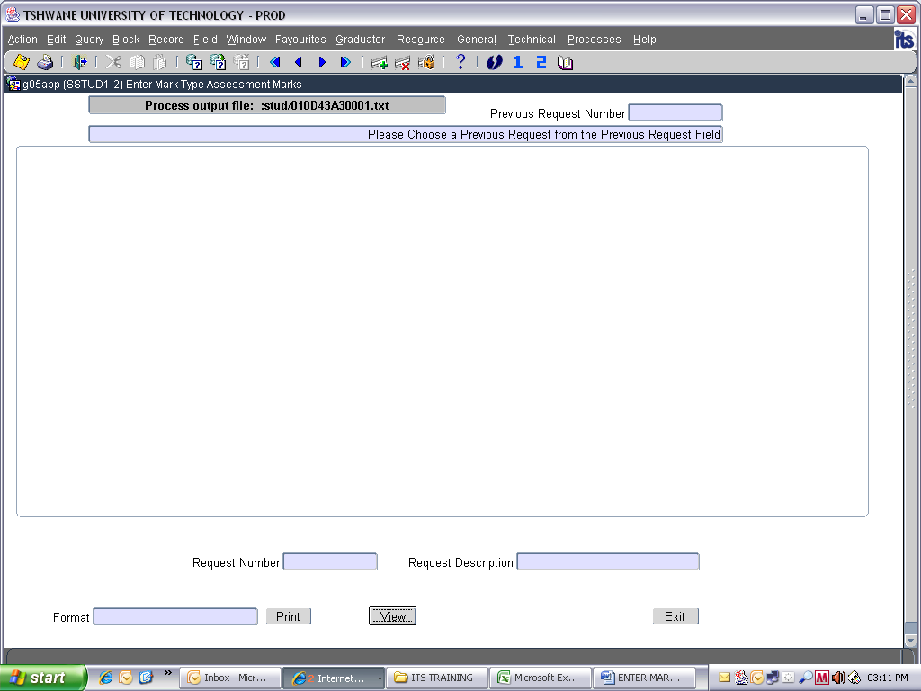

Click on Exit

The following screen will appear:
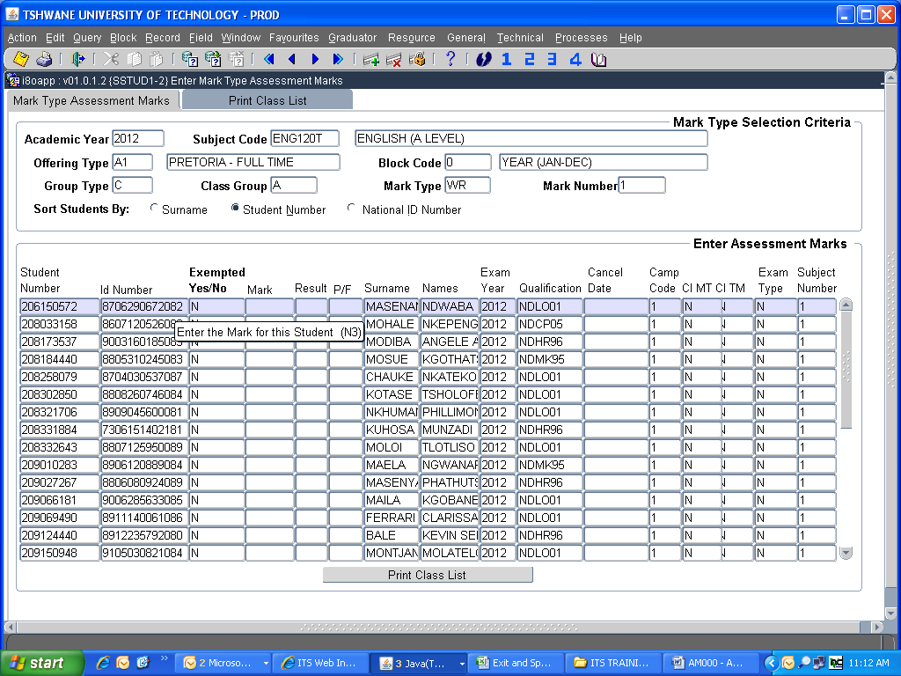

  - Enter assessment mark (use down arrow to move down to the next student)
  - Before you save, make sure your cursor is on one of the students (not a blank line)
  - Press <F10> to save (or click on the Save icon)
  - “xxx records applied and saved” will display in the bottom left hand corner of the screen
  - Print a class list to verify marks entered (using SSTURL-1 or Click on the “Print Class List” button)
  - To use the button, your username needs to be linked to a default ITS printer. Consult ServiceDesk for assistance.
  - When you click on “Print Class List” button, the screen below will display.

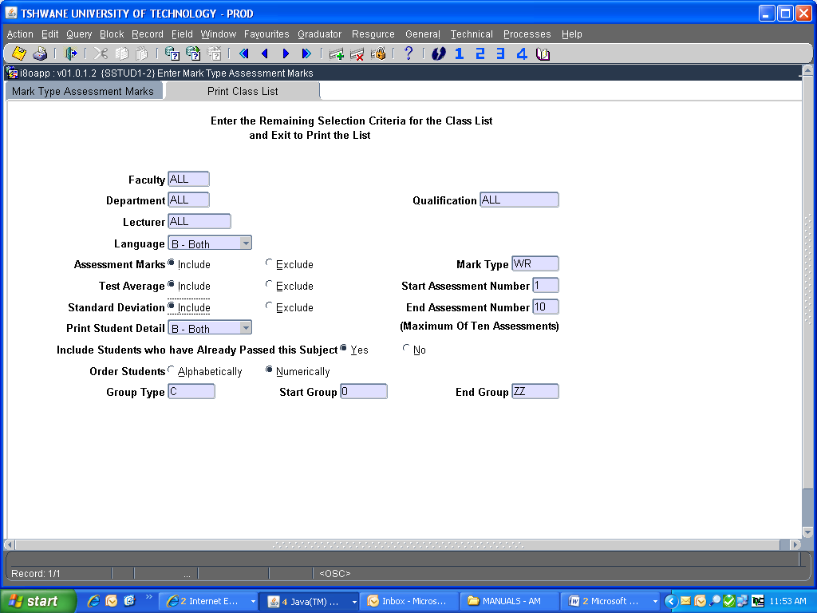

  - Enter the Mark Type and tick the relevant boxes to ‘Include’ the Assessment marks, Average and Standard Deviation. On exit, the program will process the class list in the background and print to the printer linked to your username.

To correct an individual student’s marks:

- Complete the first block (Academic year, Subject code, Offering type, Block code, etc.)
- Press <Page down> (or click on Next block icon)
- Press <F11> (or click on Enter Query icon)
- Type in the student number
- Press <F12>
- Only the specific student’s information will be displayed on the screen
- Do the necessary change
- Press <F10> to save (or click on the Save icon)
- To see all students on the screen, press <F12> again

LECTURER iENABLER (ENTER ASSESSMENT MARKS AND PRINT CLASS LIST VIA STAFF PORTAL)

(AM007)

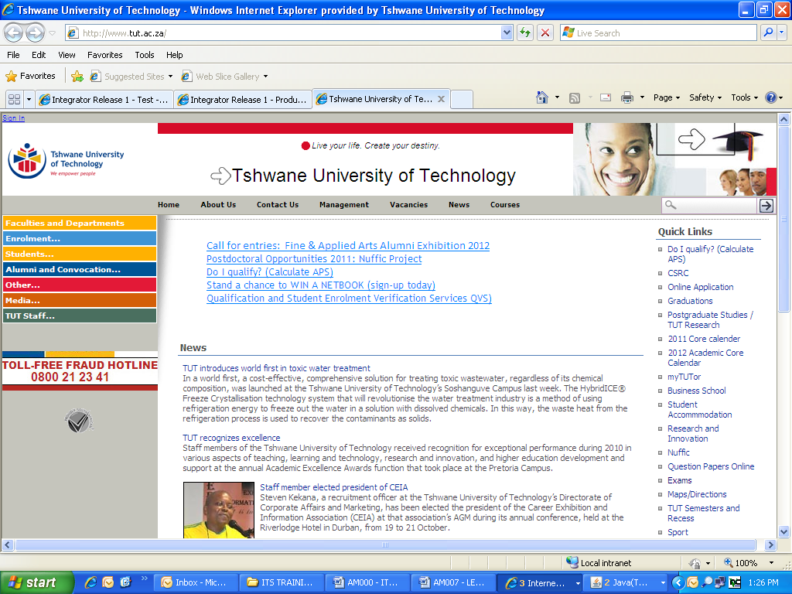

IMPORTANT INFORMATION

By making use of the iEnabler you will be able to print up-to-date class lists and capture assessment marks which will be saved onto the ITS server.

It is important to note that all calculation must be done on the ITS and cannot be done on iEnabler.

- You need a TUT e-mail address to register on StaffPortal. Your Departmental Administrator can send an e-mail to Helpdesk (Servicedesk@tut.ac.za / Servicedesk2@tut.ac.za) and provide:

- Name and Surname as it should appear on MS Outlook
- Personnel number
- Department
- Telephone and fax number
- Campus

- To link subject code(s) to your personnel number, send an e-mail to Leandra Godefroy (GodefroyL@tut.ac.za) and Tebogo Thantsa (ThantsaTU@tut.ac.za). Provide your staff number, subject code(s), offering type and class group(s).

- Only 1 lecturer can be linked to a subject code as the Primary Lecturer. If you share a subject and you are not the primary lecturer, you will not be able to use iEnabler to capture assessment marks.

- Assessment calculation criteria must be set-up on the ITS (Responsibility of Dept Admin).

- Assessment marks can be captured via iEnabler onto the ITS server.

- Calculation (computing) of full period marks/final marks must be done on the ITS.

- You can also print a class list or export the class list to MS Excel.

Open Internet connection
www.tut.ac.za

Click on TUT Staff

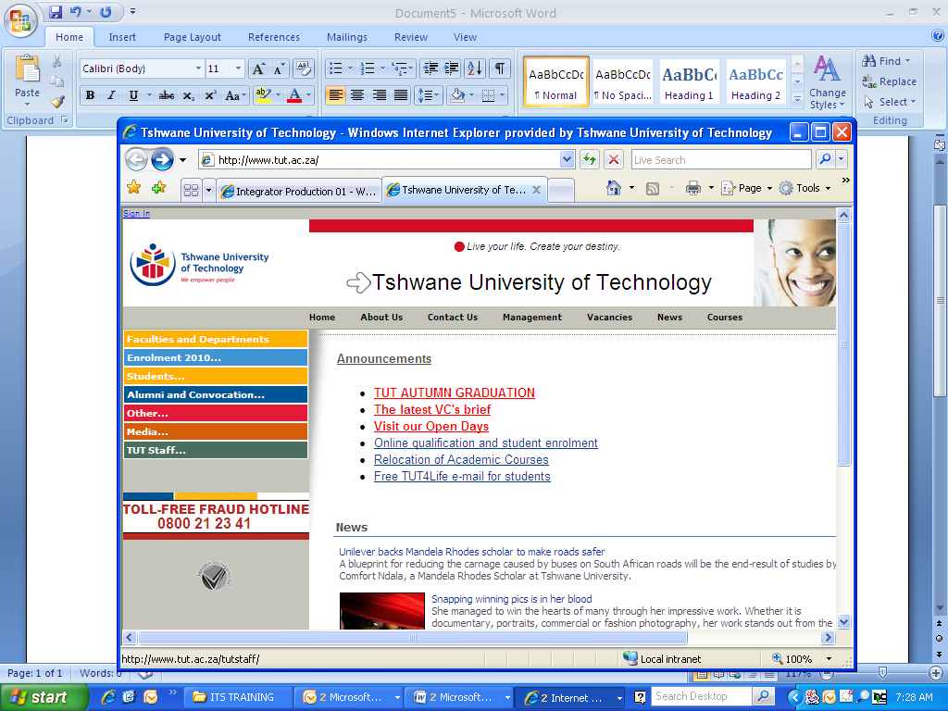
Click on Staff Portal/e-Tutor
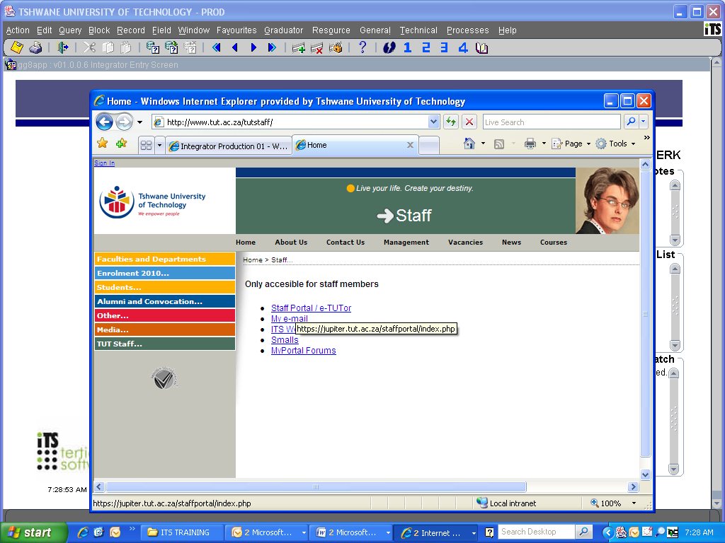
If you have not registered on the new MyPortal system before, then click as indicated below:

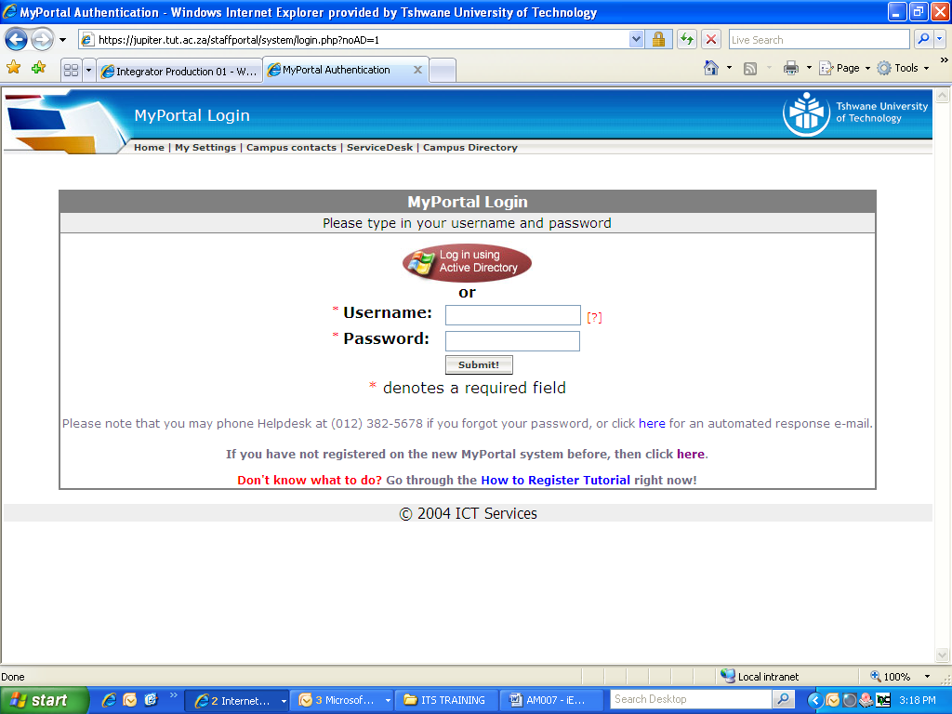
Complete the required information and click on Submit

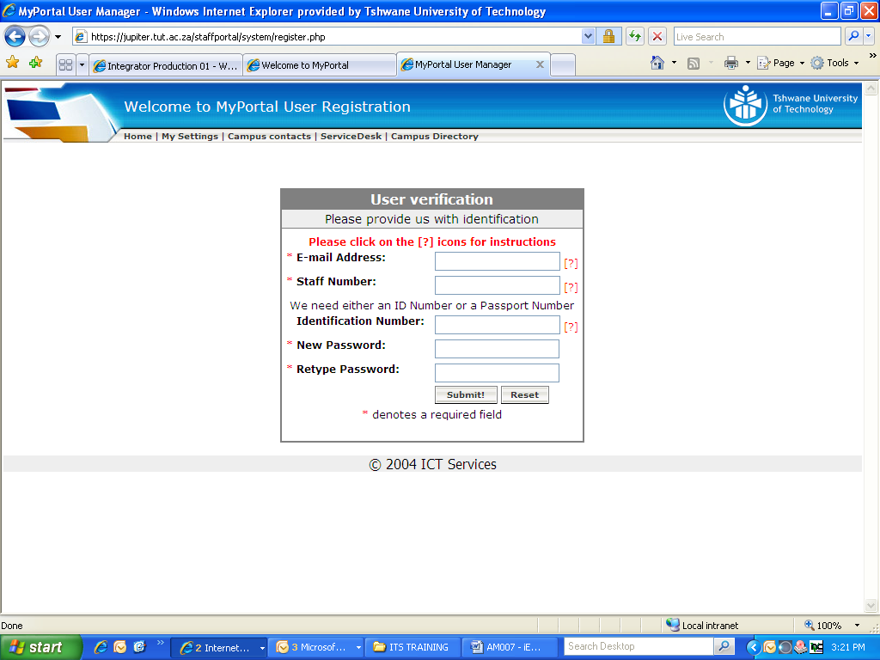
You will receive an e-mail confirming your registration on MyPortal.
Log-in by using your username and password.
Click on TUT Staff

Click on Staff Portal/e-Tutor
Click on ITS Web Leave Application

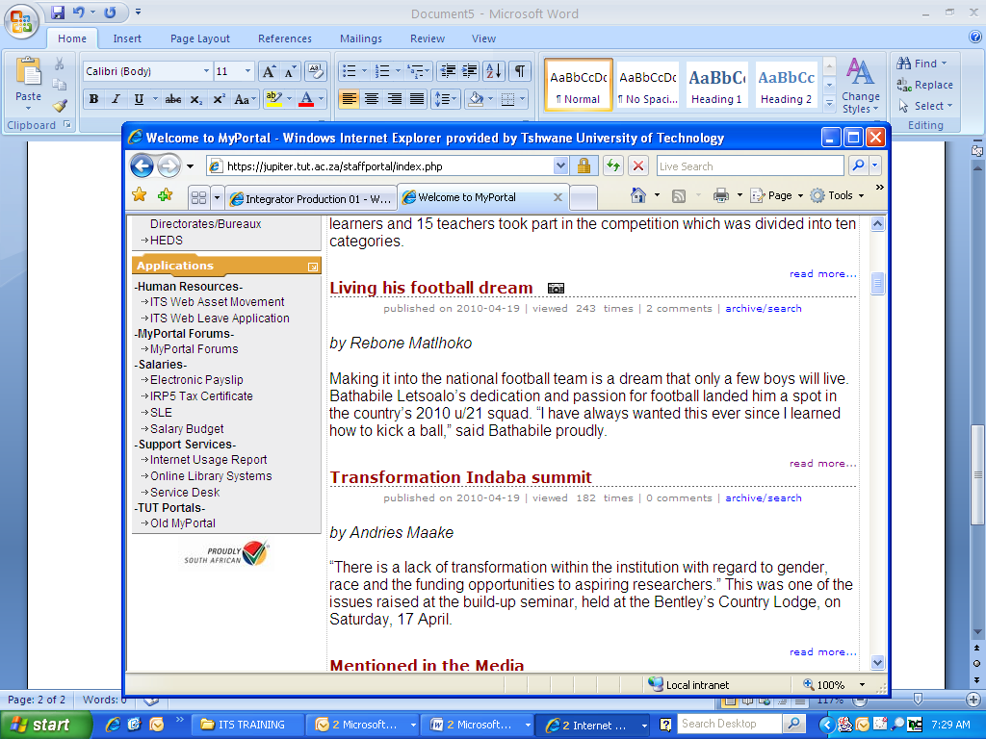
Click on Apply for leave: myself

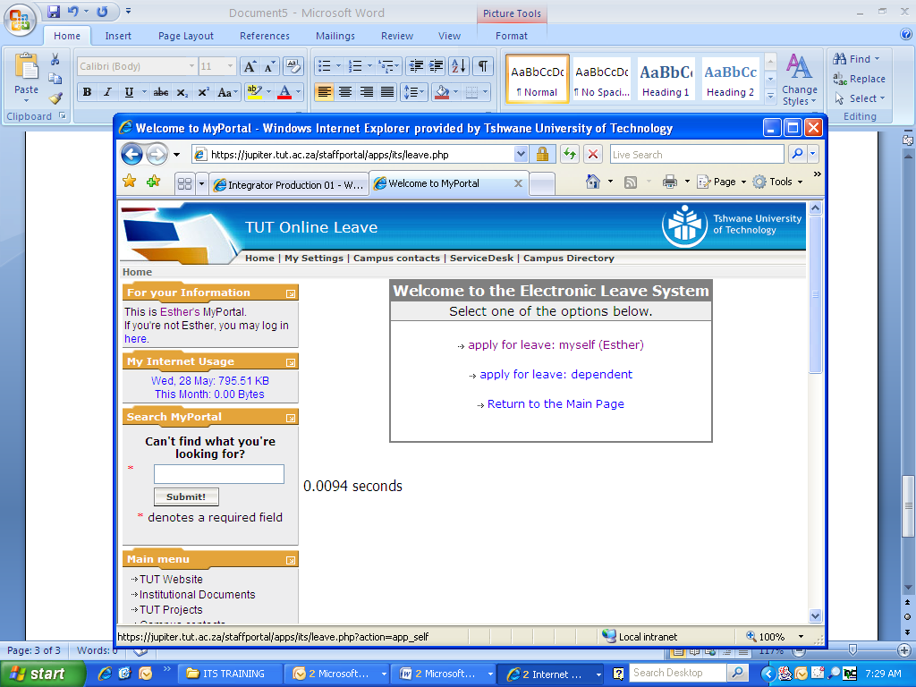
Click on Lecturer iEnabler

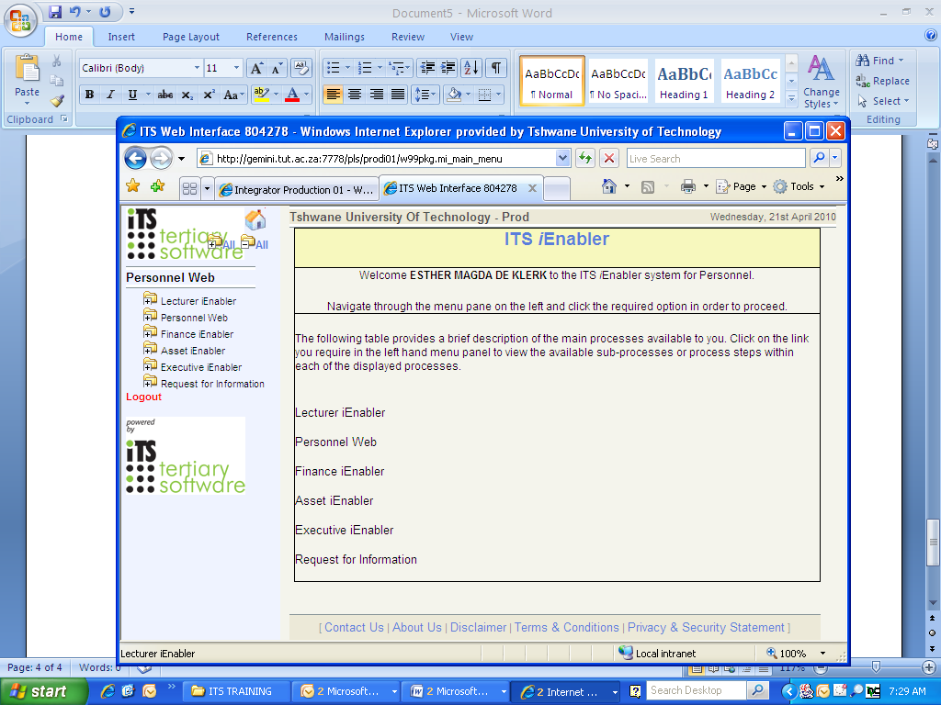
Click on Class List

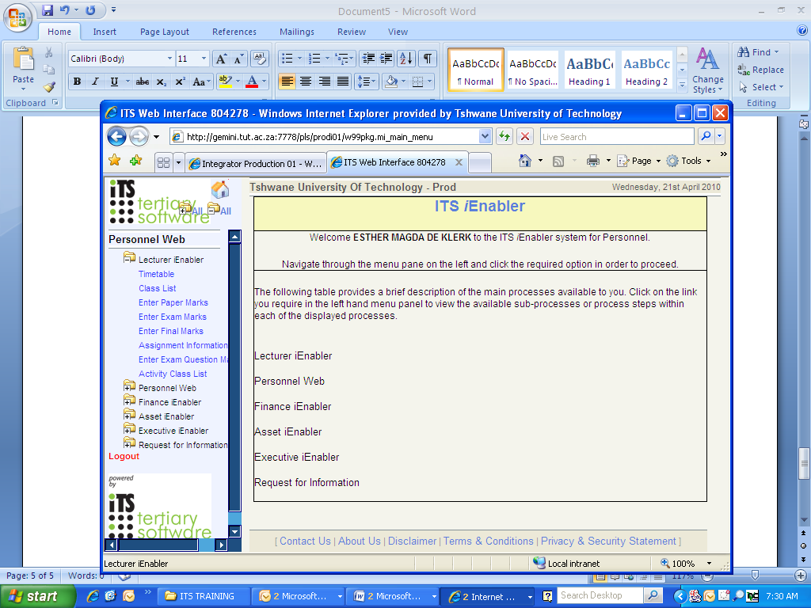
Subjects linked to your name will appear

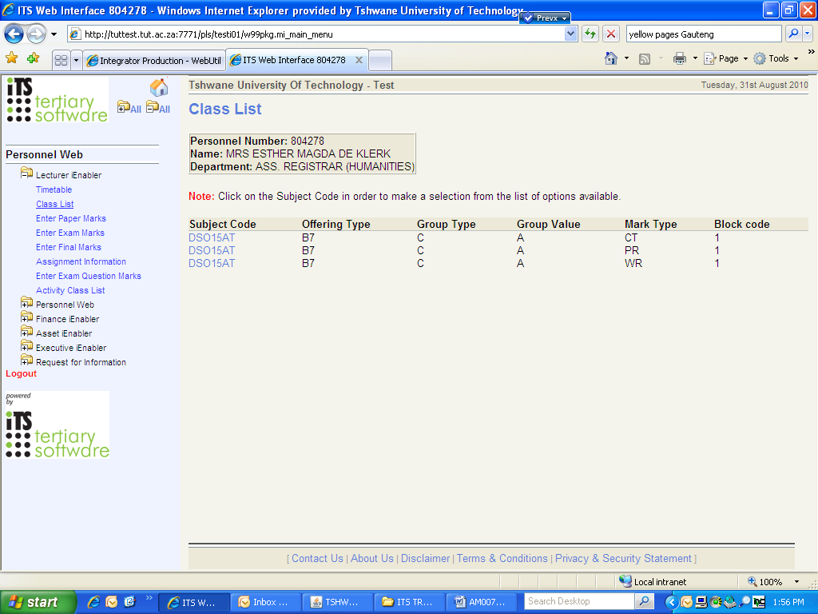
Click on the specific subject and mark type you want to enter. A list of options will appear.
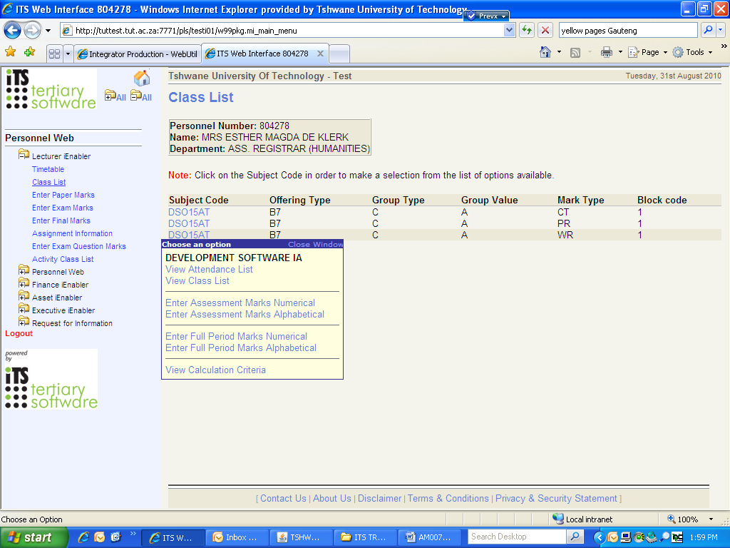
Click on Enter Assessment Marks (Numerical/Alphabetical)
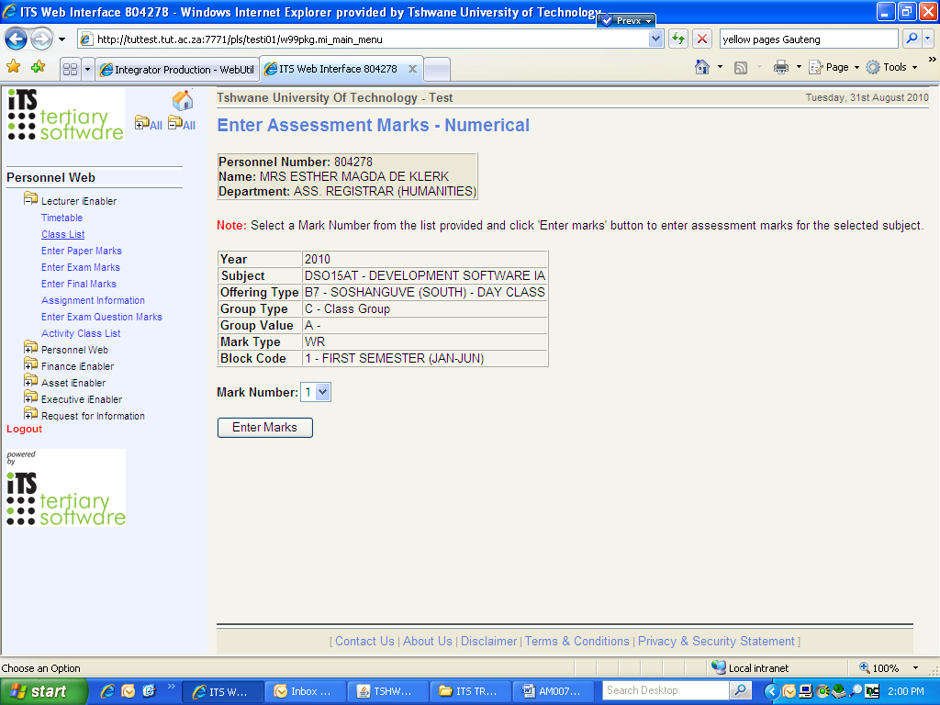
Select the Mark Number and Click on Enter Marks
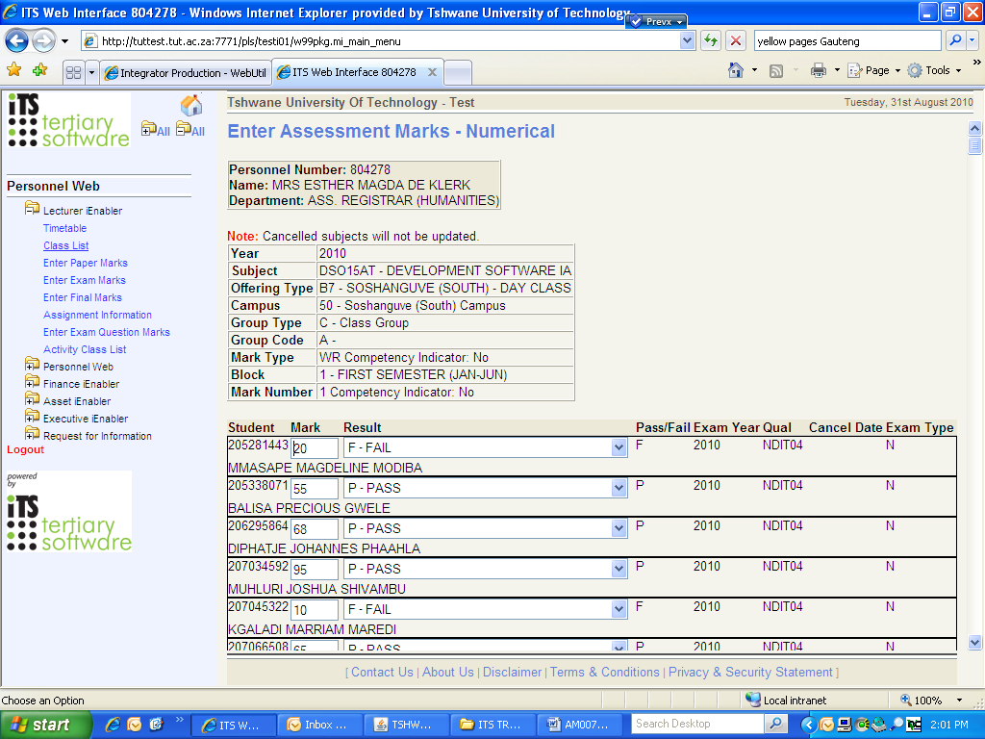
At the end of the list, Click on Save
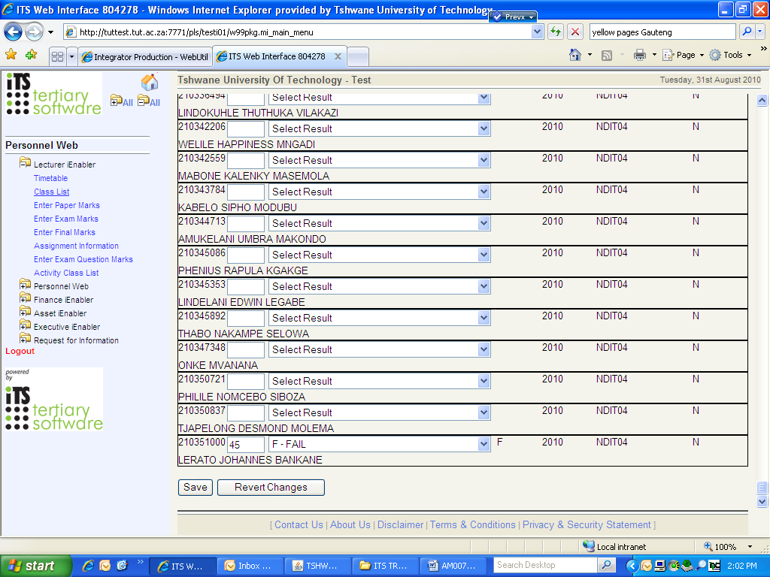
The assessment marks were saved onto the ITS server.
You can also print a class list.
Go back to the list of subjects linked to your name
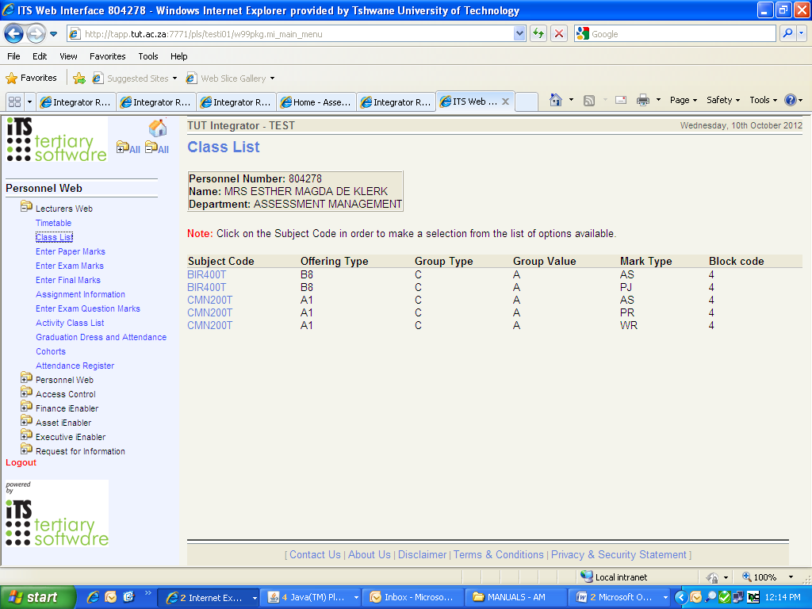
Click on the specific subject and mark type. A list of options will appear.
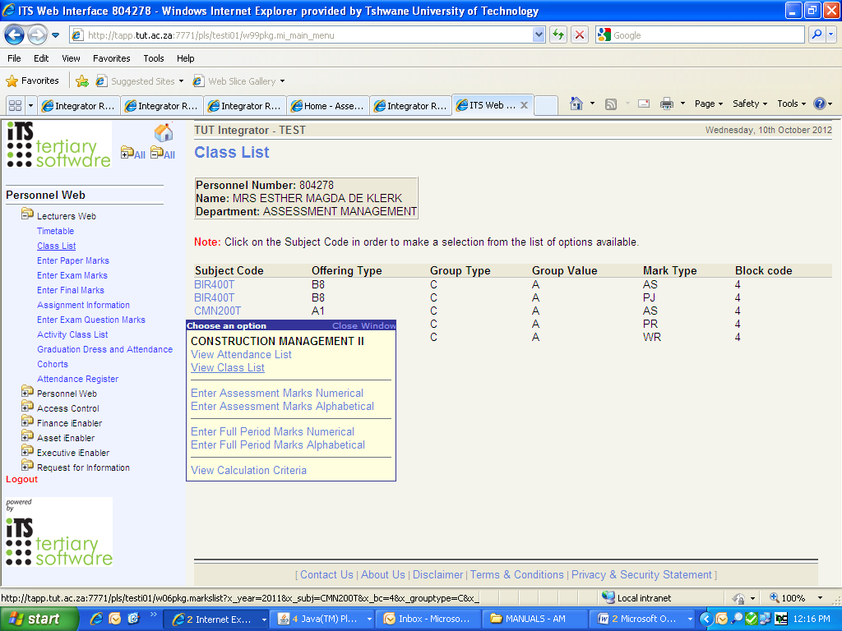
Click on View Class List
You can sort the list according to the student numbers OR student name by clicking on the relevant heading.
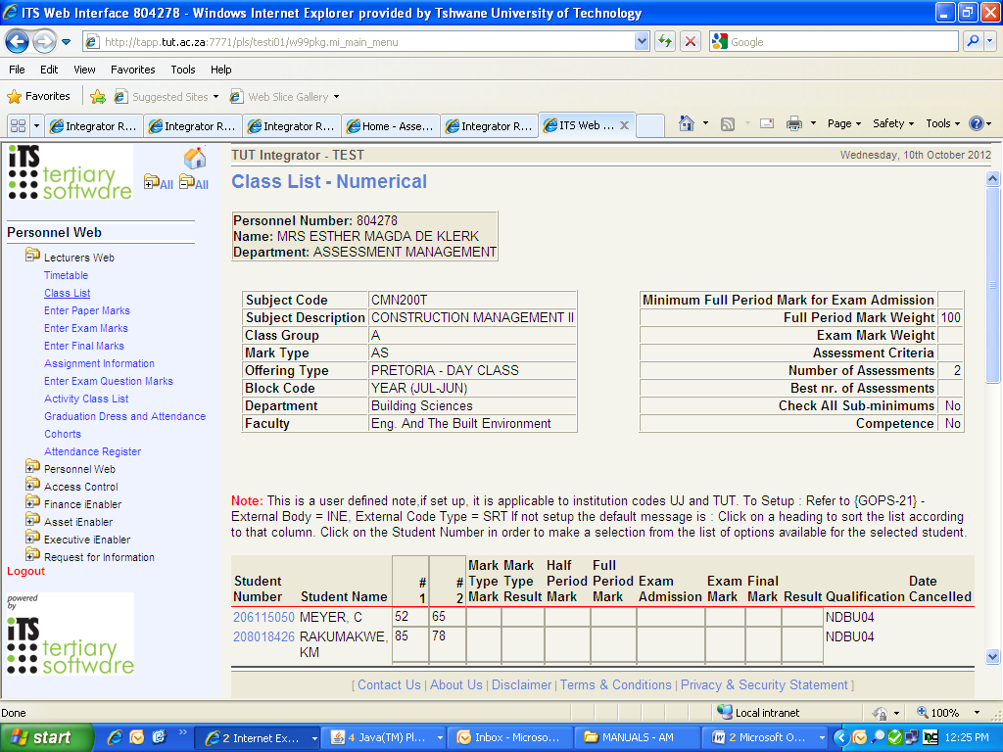
At the end of the list you get the option to open the class list in MS Excel format or Print the report.
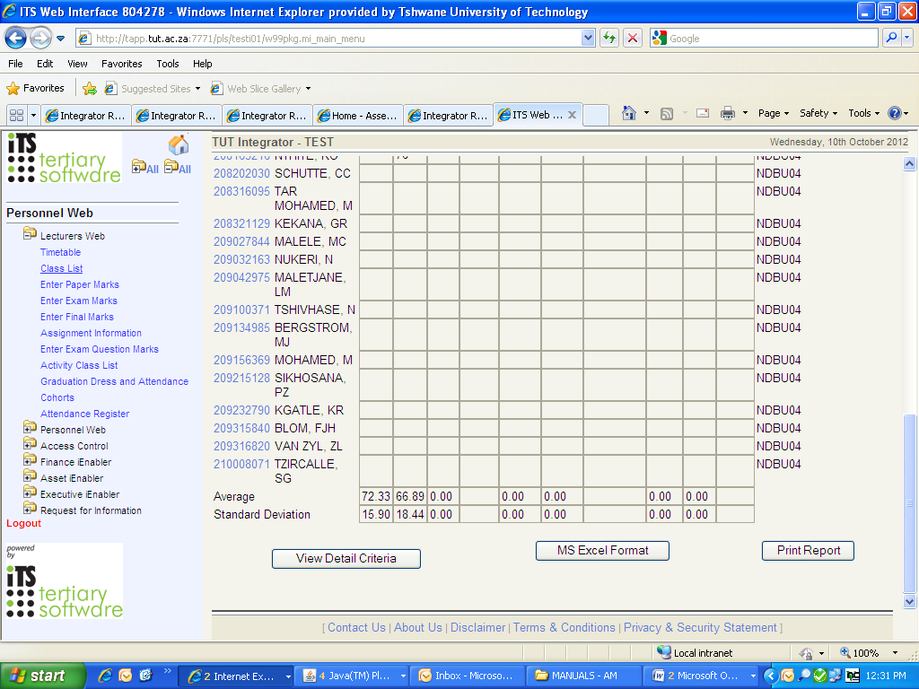

PRINT CLASS LIST FROM ITS
(SSTURL-1)
(AM002)

IMPORTANT INFORMATION

- Print class lists on a regular basis.
- A cancellation date will be printed next to a student’s name/number as soon as a student’s subject registration was cancelled.
- Make sure all students in your class are registered. This will minimize queries at a later stage.
- If a student is attending your class but does not reflect on your class list, please refer the student to Academic Administration/Student Services to correct the registration/ offering type without delay.
- A separate class list must be generated per mark type (e.g. WR/AS/PJ) to reflect the individual assessment marks. A class list can also be generated from the MIS system (See Manual AS015 in this manual).
- NUMERICAL class lists should be submitted on request to Academic Administration/Student Services.
- To update the responsible lecturer on the class list, send an e-mail to Tebogo Thantsa at the Academic Qualification Structure office.

Press <F1> (Quick menu)

Type in SSTURL-1 and press <Enter>

The following screen will appear:

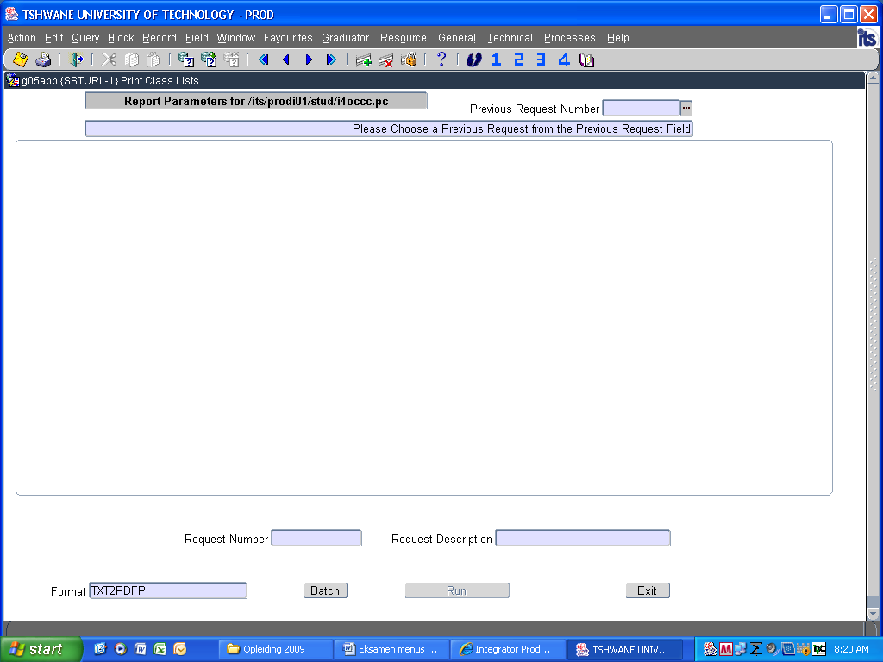

Press <Enter> on your keyboard
NOTE: Every time you press <Enter>, a new line/lines will appear
Make sure to enter the correct block code, subject code and offering type (e.g. A1, B1, C1, B7,B6)
1. Enter the academic year and press <Enter>
2. Enter block code (e.g. 1 for 1st Semester / 2 for 2nd Semester / 0 for year subjects) and press <Enter>
3. Press <Enter> to continue
4. Leave the Faculty and Dept codes as per default
5. IMPORTANT: Enter First Subject Code and press <Enter> (make sure the cursor is on the correct line before entering the subject code)
6. Press <Enter> to continue
7. Specify the offering type (eg. A1/B6/C1/B1)
8. Press <Enter> to continue up to the point where you must Enter your choice
IMPORTANT: You must “Enter your choice” (1/2/3/4/5) to select the kind of information to appear on your class list. If you leave this field blank, only the student number will print.
9. Press <Enter> until your cursor is in Request Description
10. Click on Run

(See screen dumps below as example)
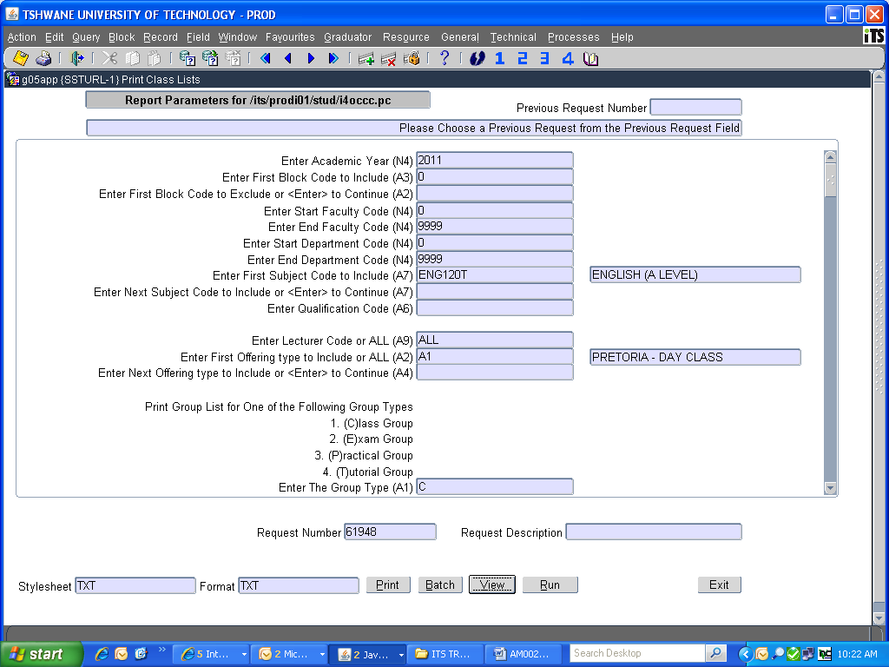

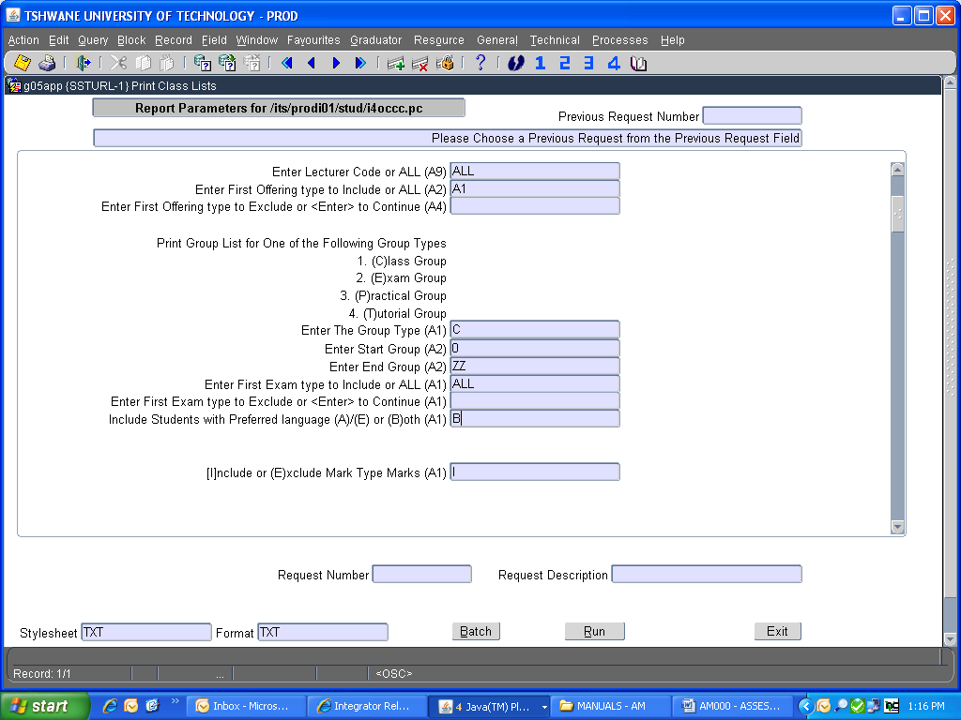

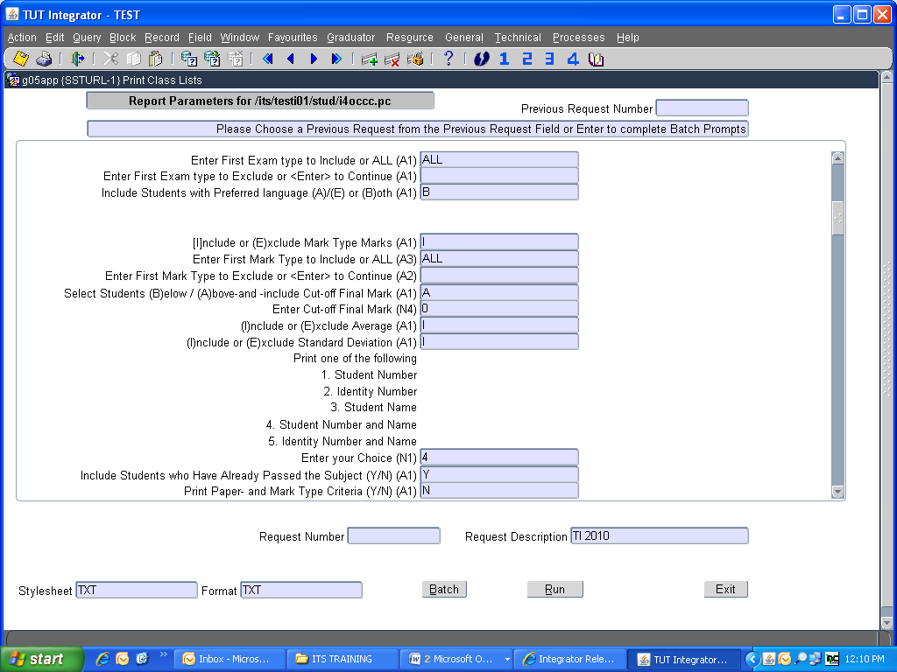
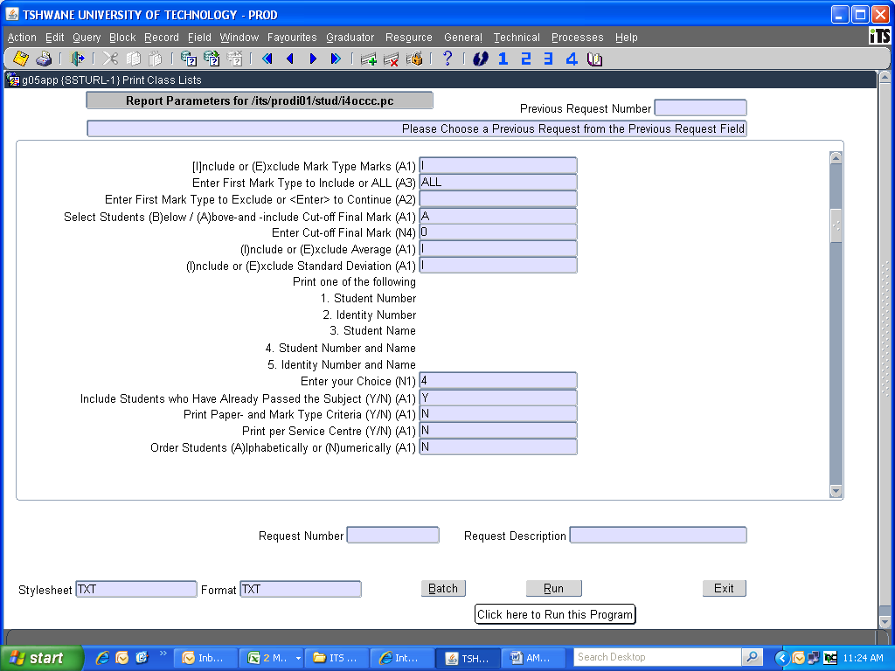

11. Click on View
Your class list will then display as:
EXAMPLE: INCLUDE MARK TYPE MARKS
Faculty : 50 - HUMANITIES
Dept : 6501 - APPLIED LANGUAGES
Subject : ENG120T - ENGLISH (A LEVEL)
Offering Type: A1 - PRETORIA - FULL TIME Block Code: 0 - YEAR (JAN-DEC)

Class Group : A
Responsible Lecturer(s): 606316 MS S NAIDOO (Primary)
607126 MRS G BRINK
Student Mark Type Per Mark Exam Exam Final
Name and Number AS WR Half Full Admit Mark Mark Res Qualif Cancelled
----------------------------------------------- ------- ------- ---- ---- ----- ----- ----- --- ------- ---------
96106637 MAKGAKA,M | | | | | | | | | NDMK95|31-JAN-11|
----------------------------------------------- ------ ------ ---- ---- ----- ----- ----- --- ------- ---------
97104247 NTHANGENI,NB | | | | | | | | | NDLO01|31-JAN-11|
----------------------------------------------- ------ ------ ---- ---- ----- ----- ----- --- ------- ---------
97142203 MOSHWANA,IS | 43 F| 47 F| 35| 46| Y | 34| 40|F | NDHR96| |
----------------------------------------------- ------ ------ ---- ---- ----- ----- ----- --- ------- ---------
200205729 NTSOANE,HN | | | | | N | | |FA | NDHR96| |
----------------------------------------------- ------ ------ ---- ---- ----- ----- ----- --- ------- ---------
202027865 NCHABELENG,NM | 66 P| 63 P| 64| 64| Y | 60| 62|P | NDLO01| |
----------------------------------------------- ------ ------ ---- ---- ----- ----- ----- --- ------- ---------

whereby the AVERAGE of each MARK TYPE (WR, PR, AS) will be displayed.

B U T ! ! !

If you need to see the INDIVIDUAL assessment marks PER MARK TYPE (WR 1, 2, 3 or AS 1, 2), you need to Exclude Mark Type Marks (see screen dump below) and specify the specific mark type.
IMPORTANT NOTE: You have to print a separate class list for each Mark Type from the ITS. You can also print a class list from the MIS whereby all the mark types and assessment marks appear on one page (see manual AM015 attached).
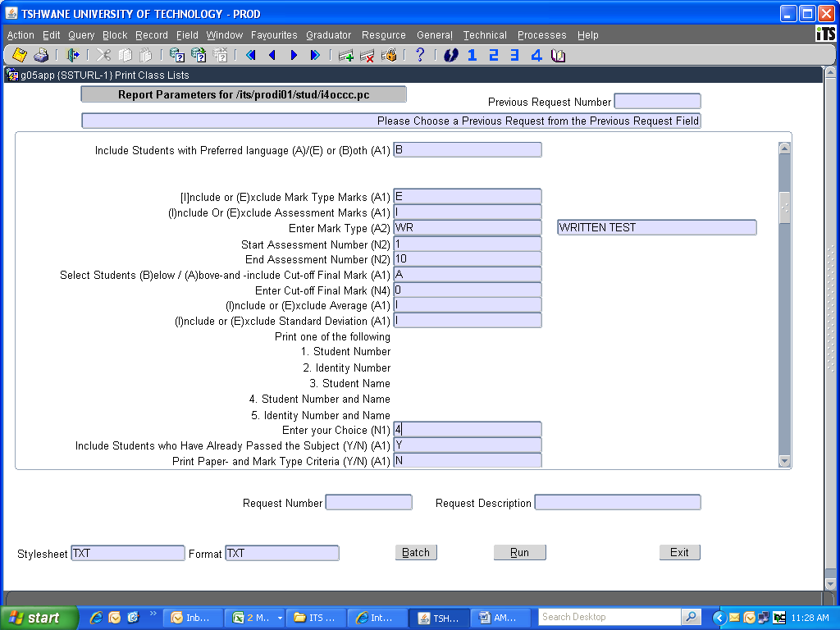
Enter the number of your choice
See note above
EXAMPLE: EXCLUDE MARK TYPE MARKS
Faculty : 50 - HUMANITIES
Dept : 6501 - APPLIED LANGUAGES
Subject : ENG120T - ENGLISH (A LEVEL)
Offering Type: A1 - PRETORIA - FULL TIME Block Code: 0 - YEAR (JAN-DEC)
Mark Type : WR - WRITTEN TEST

Class Group : A
Responsible Lecturer(s): 606316 MS S NAIDOO (Primary)
607126 MRS G BRINK
Student Assessment Mark Type Per Mark Exam Exam Final
Name and Number 1 2 3 Mark Res Half Full Admit Mark Mark Res Qualif Cancelled
--------------------------- ---- ---- ---- ---- ---- ---- ---- ----- ----- ----- --- ------- ---------
96106637 MAKGAKA,M | | | | | | | | | | | | NDMK95|31-JAN-11|
--------------------------- ---- ---- ---- ---- ---- ---- ---- ----- ----- ----- --- ------- ---------
97104247 NTHANGENI,NB | | | | | | | | | | | | NDLO01|31-JAN-11|
--------------------------- ---- ---- ---- ---- ---- ---- ---- ----- ----- ----- --- ------- ---------
97142203 MOSHWANA,IS | 32| 53| 46| 47| F | 35| 46| Y | 34| 40|F | NDHR96| |
--------------------------- ---- ---- ---- ---- ---- ---- ---- ----- ----- ----- --- ------- ---------
200205729 NTSOANE,HN | | | | | | | | N | | |FA | NDHR96| |
--------------------------- ---- ---- ---- ---- ---- ---- ---- ----- ----- ----- --- ------- ---------
202027865 NCHABELENG,NM | 53| 71| 52| 63| P | 64| 64| Y | 60| 62|P | NDLO01| |

PRINT CLASS LIST FROM MIS
(AM010)

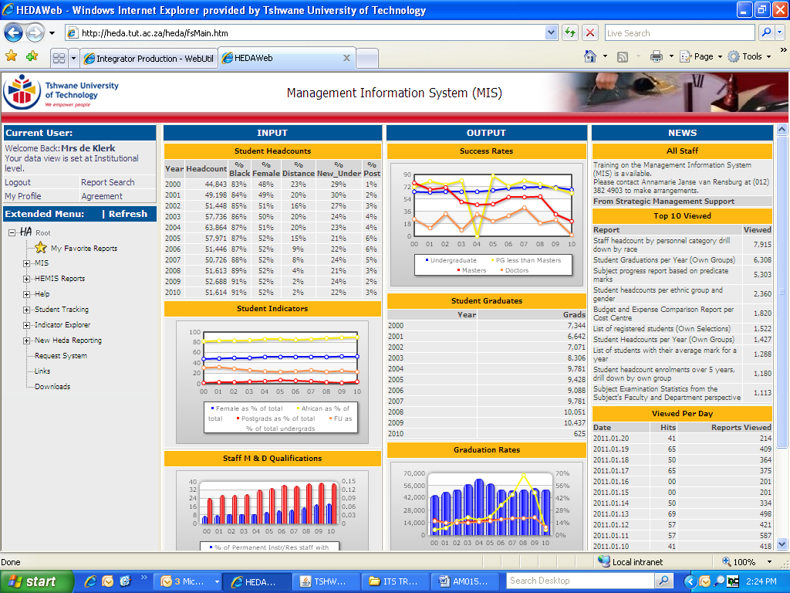

IMPORTANT INFORMATION

- All MIS reports (e.g. class lists) are compiled from ITS information.
- MIS Helpdesk contact number: (012) 382 5891/5698/5955.
- Any changes done on students’ marks will only reflect on the MIS class list the following day.
- All assessment marks (all mark types) are displayed on 1 page.
- The MIS class lists can be used for control/verification purposes. When Student Services/Academic Administration requires a class list for examination purposes, a numerical ITS class list (see manual AM002) must be submitted.

Open www.tut.ac.za
Click on TUT Staff

Click on Staff Portal/e-Tutor
Use your username and password to login

Click on MIS

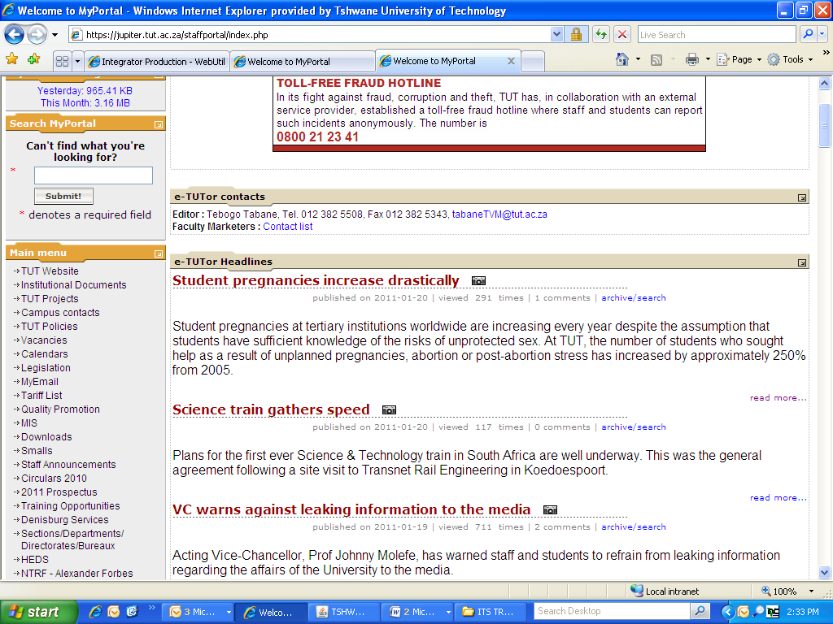
Provide MIS login details (if not registered, click on Register)
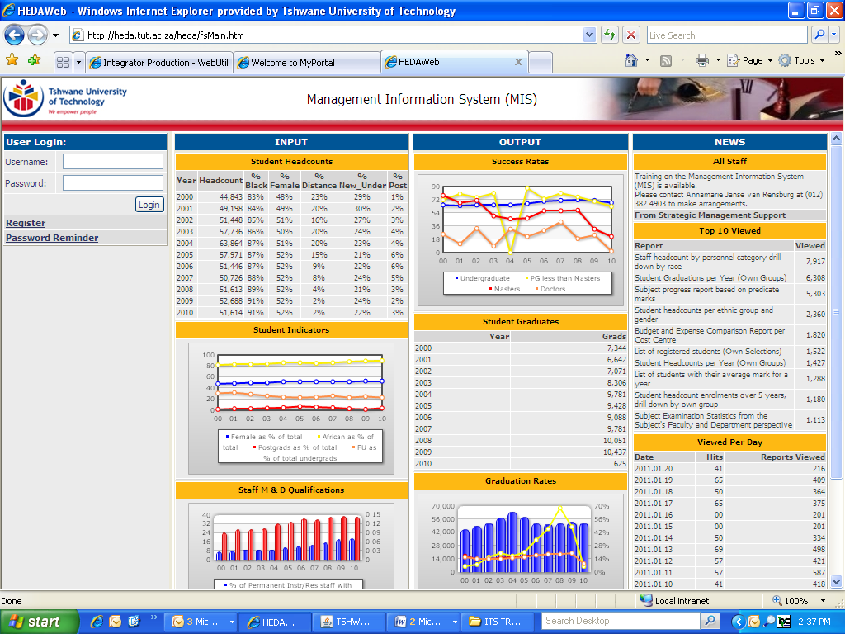
Once registered, Click on MIS
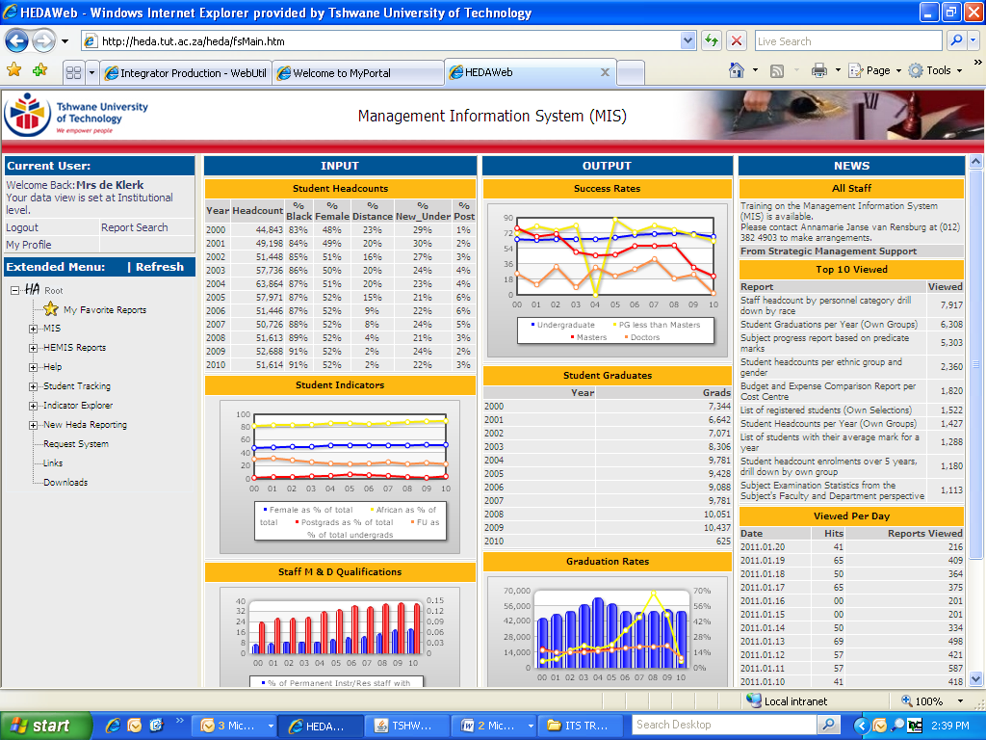
Click on Students
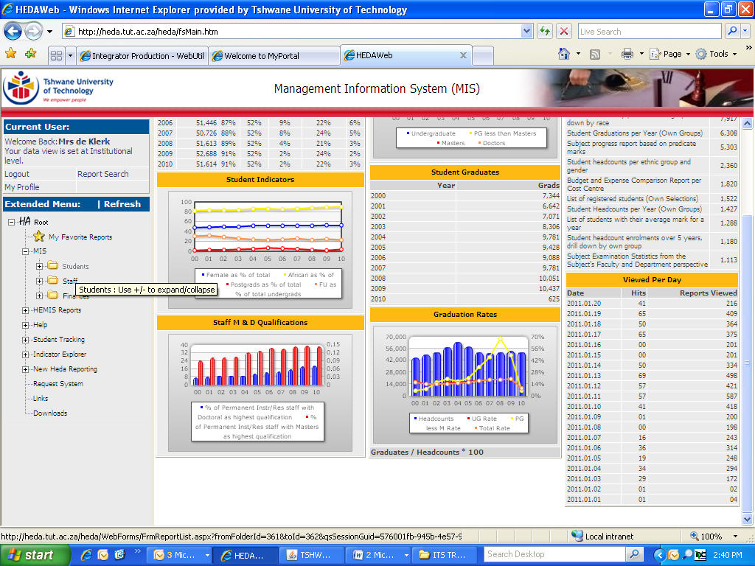
Click on Ad Hoc Reports
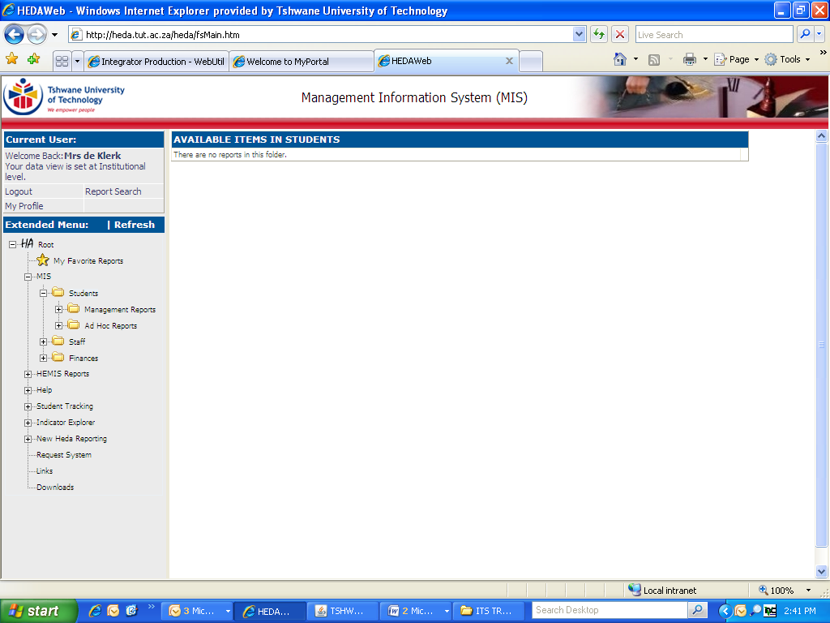
Click on Subject Registration
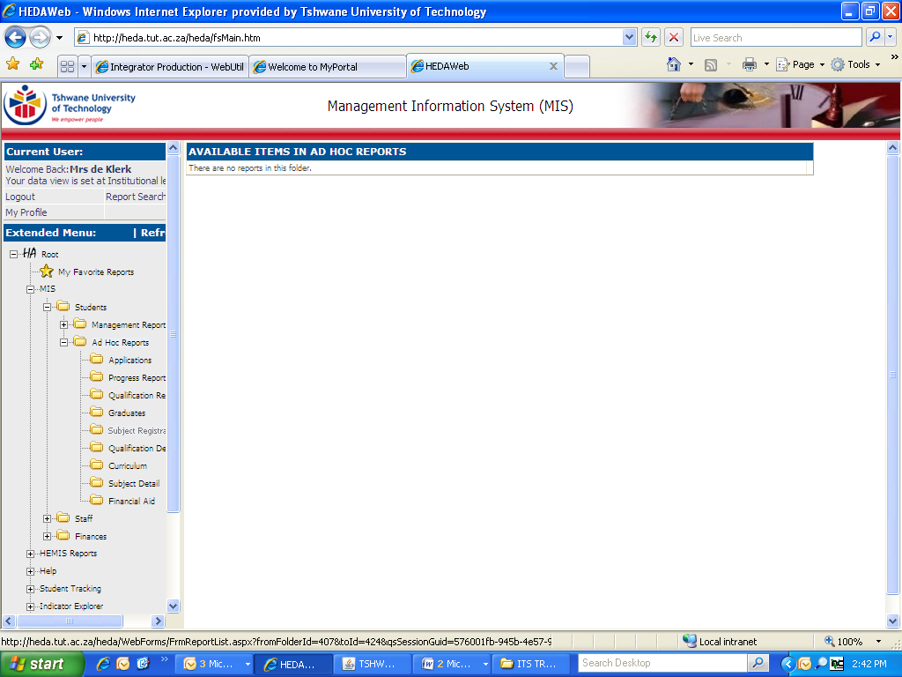
Click on Class lists with marks per mark type (Assessment Marks)
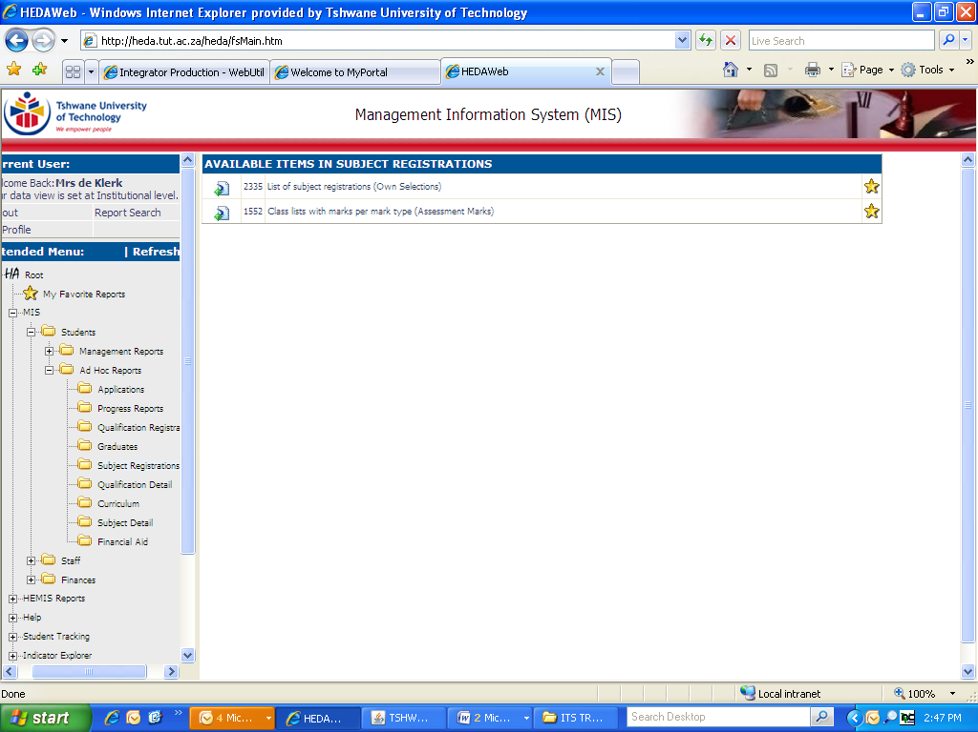
Click on Optional Parameters ...
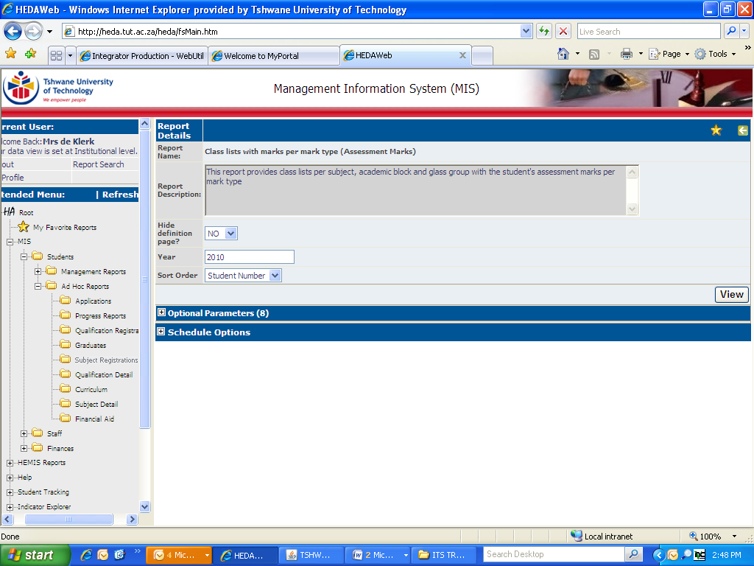
... and complete all the required fields and click on View
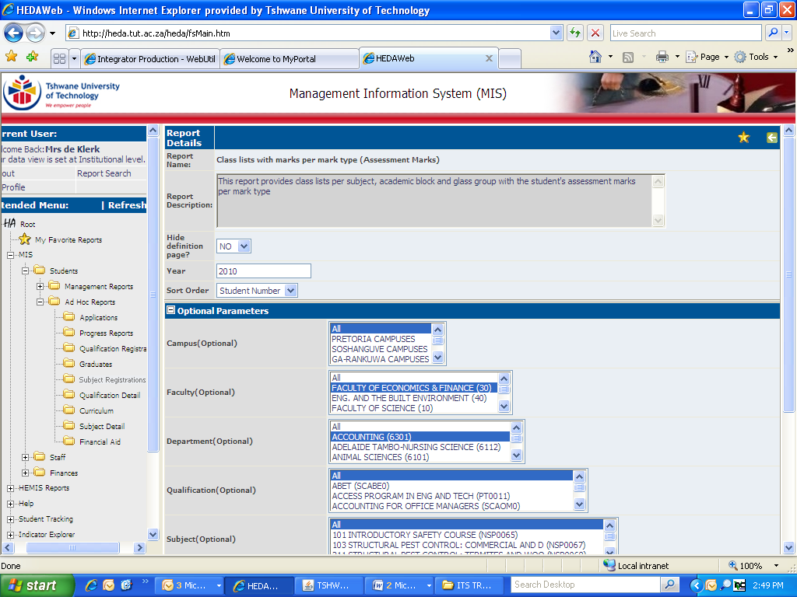
Layout of Report
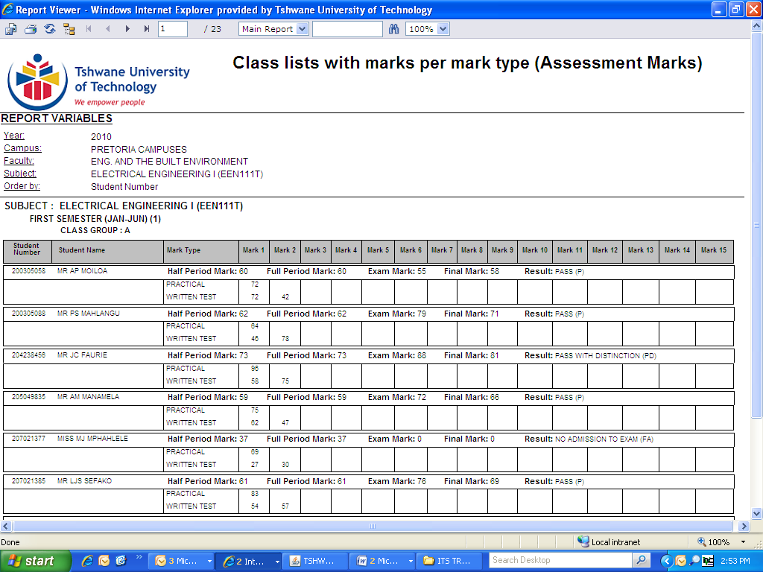

To export this report, click on the Export Icon OR print this report by clicking on the Printer Icon
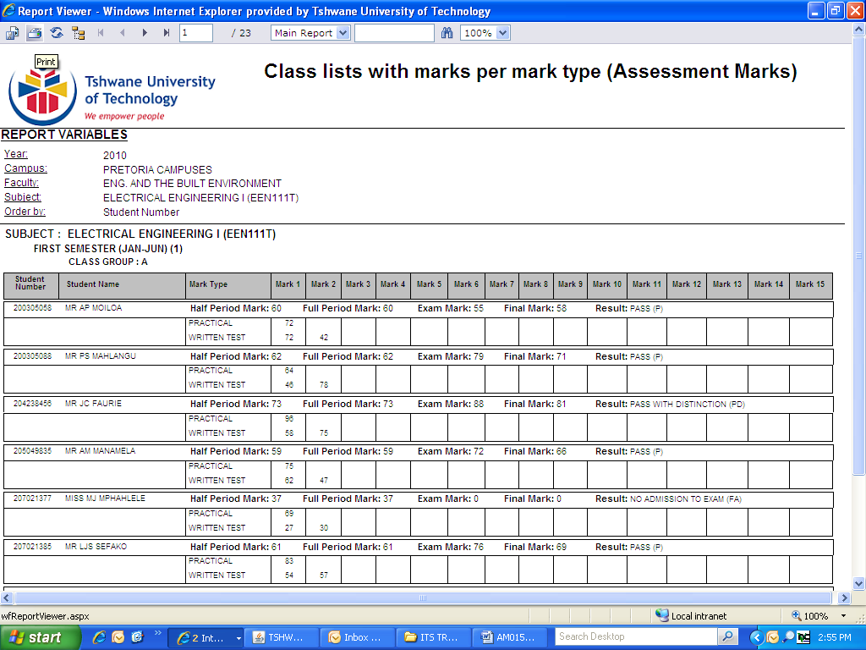
To export, select the file format and click on OK. Open or Save the document.
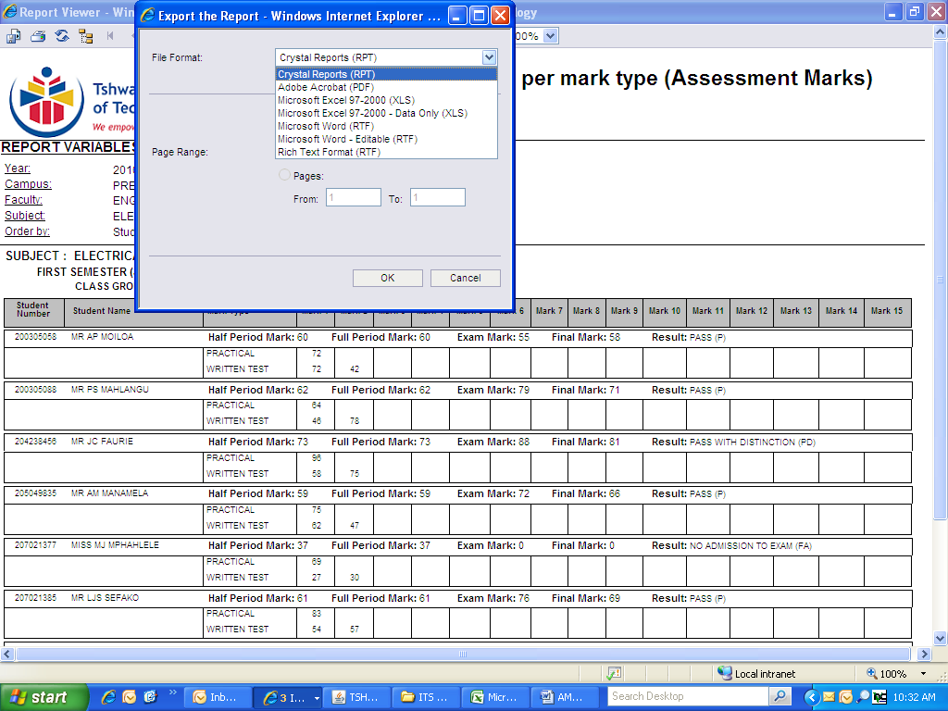

COMPUTE ASSESSMENT MARKS TO A FULL PERIOD MARK (INCLUDING NON-EXAMINATION SUBJECTS, e.g CONTINUOUS EVALUATION)
(SSTUD4)
(AM005)

IMPORTANT INFORMATION

- THIS IS A PROCESS THAT YOU NEED TO FOLLOW TO CALCULATE THE FULL PERIOD MARK. THIS PROCESS IS ONLY FOLLOWED WHEN THE HALF (PROGRESS) OR FULL PERIOD MARK NEEDS TO BE CALCULATED.

- Compute (calculate) full period marks just before predicate day (which usually takes place 3 days before the commencement of examination).

- Student must have a full period mark of 40 to be admitted to the examination. If a student obtains a full period mark of 39, you have to adjust any assessment mark to calculate to 40 (the Assessment Policy makes provision for a 39 admission mark to be changed to 40). A full period mark of 39 is NOT AUTOMATICALLY changed to 40 by the ITS system.

- ALWAYS specify your subject code, campus code and/or offering type.

- REMEMBER: THE MOMENT YOU CHANGE ANY ASSESSMENT MARK AFTER COMPUTING, YOU HAVE TO RE-COMPUTE THE SUBJECT – FOLLOW ALL 4 STEPS.

- The same procedure is followed for Continuous Evaluation subjects.
After computing, print a class list, indicate that the full period mark is the final mark and obtain the signatures of the assessor/examiner, moderator and HOD. Submit the class list at Student Services. Student Services will then calculate (transfer) the final marks and result codes. Adjustment of final marks in terms of 49/74 is also included.

Follow the steps below in this specific order:

1. SSTUD4 Option 14 (SSTUD4-14) Compute Assessment Mark Results
2. SSTUD4 Option 11 (SSTUD4-11) Compute Mark Type Marks
3. SSTUD4 Option 13 (SSTUD4-13) Compute Mark Type Results
4. SSTUD4 Option 1 (SSTUD4-1) Compute Half/Full period Marks

NB: YOU MUST RUN ALL 4 MENU’S IN THIS SPECIFIC ORDER TO COMPUTE YOUR FULL PERIOD MARKS

Should you skip one step, your full period marks will not be calculated correctly

See next pages for detailed steps
STEP 1 COMPUTE ASSESSMENT MARK RESULTS
(This program is used to compute Assessment mark Results)

Press <F1> (Quick menu)

Type in SSTUD4-14 and press <Enter>

The following screen will appear:

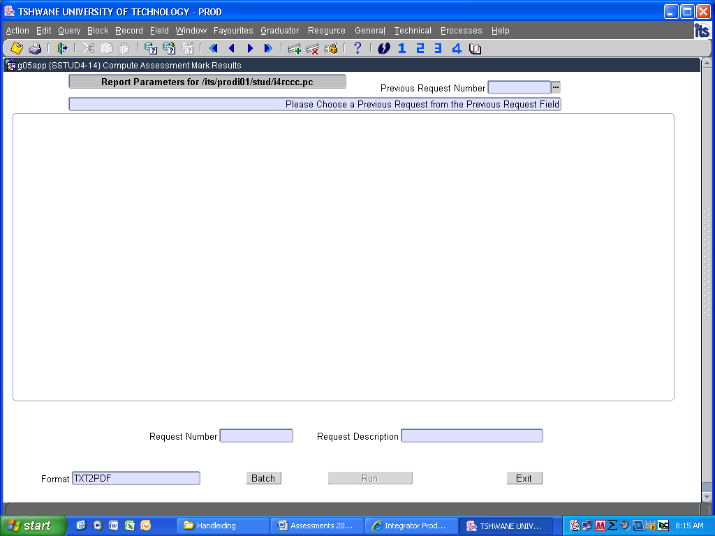

Press <ENTER> on your keyboard

1. Enter the academic year and press <Enter>
Every time you press <Enter>, another line(s) will appear

2. Enter the required information: Ensure that you specify the correct block code, campus code, subject code, Include records with final result: Y, and Is this a Trial or Update Run: U

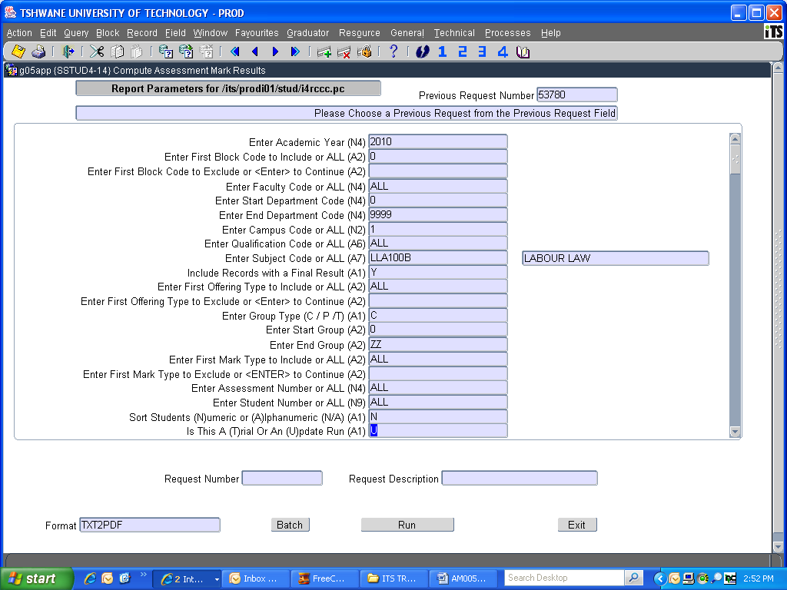

DID YOU SPECIFY YOUR CAMPUS AND SUBJECT CODE?

3. Click on Run

4. Click on Exit
STEP 2 COMPUTE MARK TYPE MARKS
(This program is used to compute Mark Type (MT) marks from Assessment marks according to the criteria)

Press <F1> (Quick menu)

Type in SSTUD4-11 and press <Enter>

The following screen will appear:

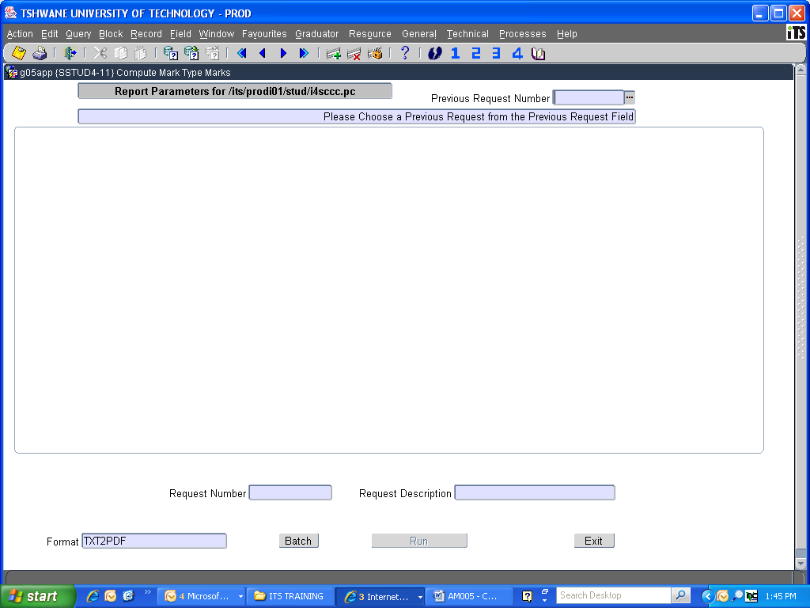

Press <ENTER> on your keyboard

1. Enter the academic year and press <Enter>
Every time you press <Enter>, another line(s) will appear

2. Enter the required information: Ensure that you specify the correct block code, campus code, subject code and Include records with final result: Y

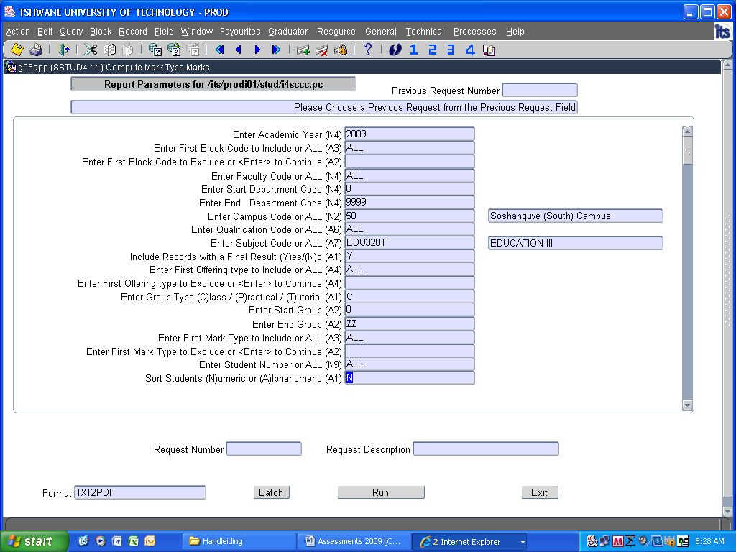

DID YOU SPECIFY YOUR CAMPUS AND SUBJECT CODE?

3. Click on Run

4. Click on Exit

STEP 3 COMPUTE MARK TYPE RESULTS
(This program is used to compute Mark Type (MT) Results based on the criteria)

Press <F1> (Quick menu)

Type in SSTUD4-13 and press <Enter>

The following screen will appear:

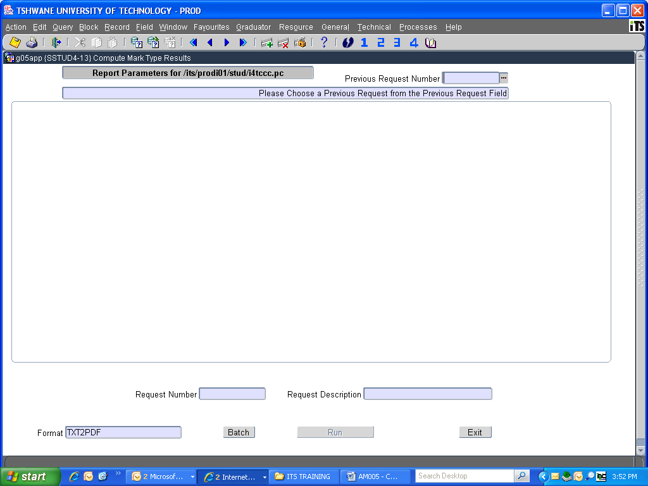

Press <ENTER> on your keyboard

1. Enter the academic year
Every time you press <Enter>, another line will appear

2. Enter the required information: Ensure that you specify the correct Block code, Campus code, Subject code and Include records with final result: Y

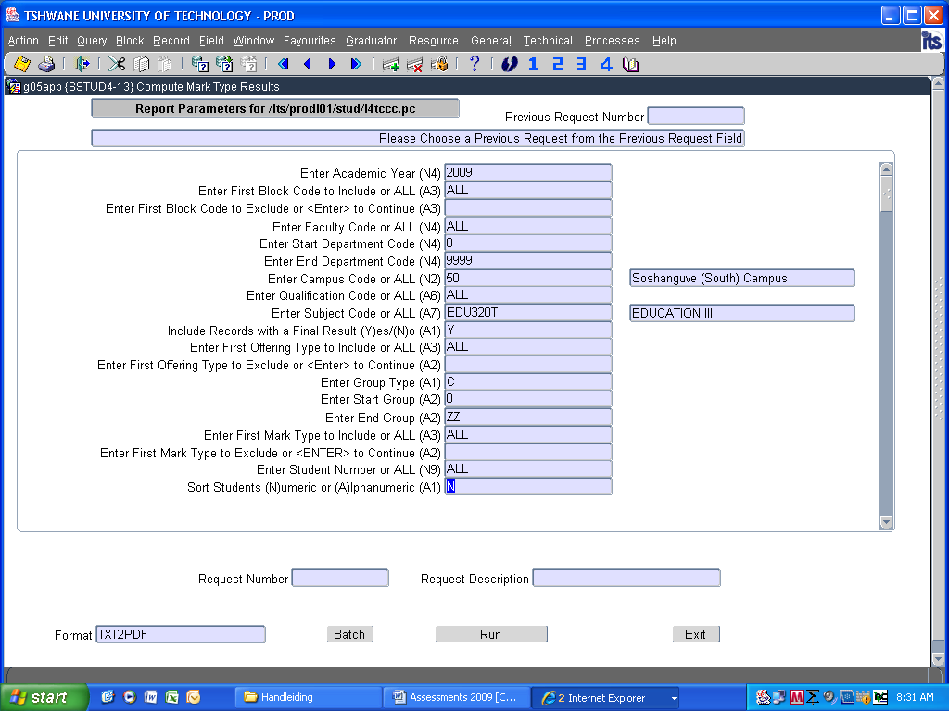

DID YOU SPECIFY YOUR CAMPUS AND SUBJECT CODE?

3. Click on Run

4. Click Exit

STEP 4 COMPUTE HALF/FULL PERIOD MARK

Always compute the Full Period mark for examination purposes. Half period marks are calculated for progress report purposes.

Press <F1> (Quick menu)

Type in SSTUD4-1 and press <Enter>

The following screen will appear:

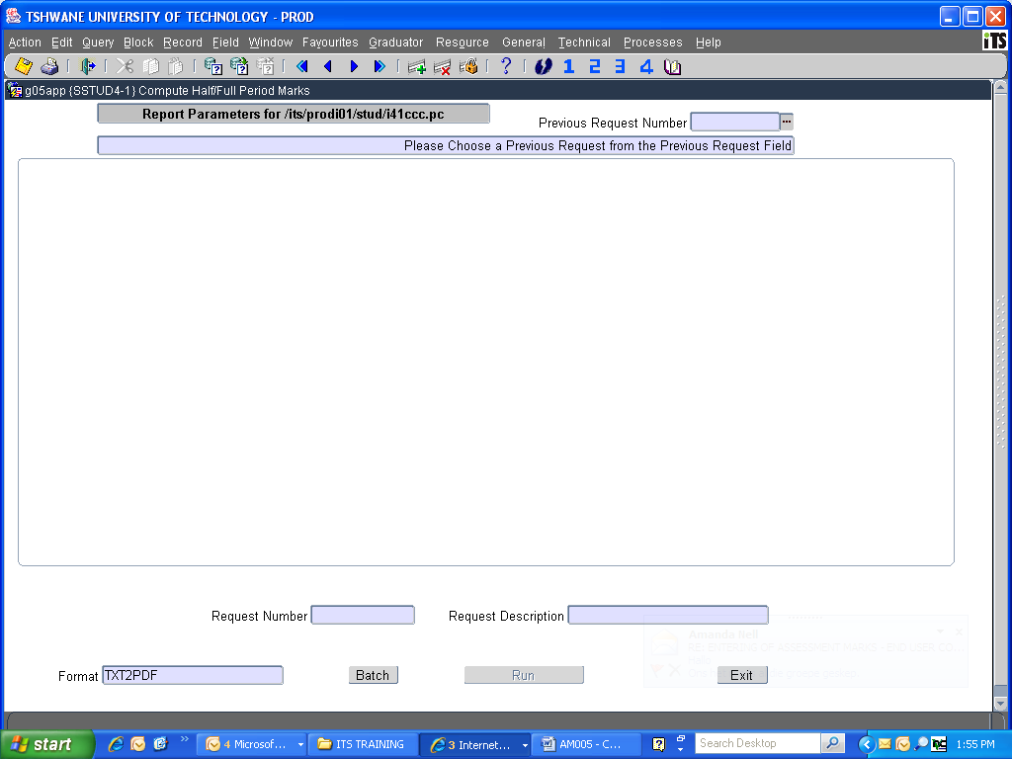

Press <ENTER> on your keyboard

1. Enter the examination year and press <Enter>

2. Update Half or Full Period Mark, enter F and press <Enter>
Every time you press<Enter>, another line will appear

3. Enter the examination month: JUNE = MONTH 5, NOV = MONTH 10

4. Specify the Campus code
5. Specify the Subject code

6. Include Records with a final result: Y

7. Press <Enter>

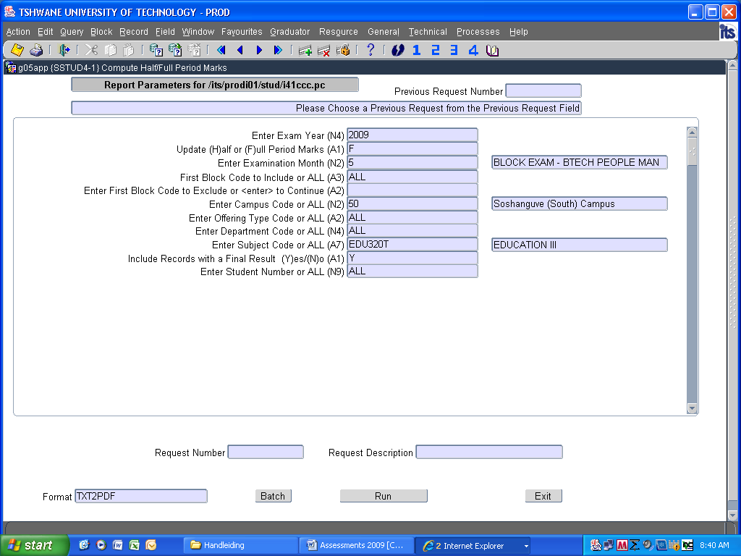

DID YOU SPECIFY YOUR CAMPUS AND SUBJECT CODE?

8. Click on Run

9. Click on Exit

10. Print a Class List to verify calculation

DETAILS OF REGISTRATION/RESULTS (QUERY STUDENT OR SUBJECT INFORMATION)
(SSTUDY-21)
(AM011)

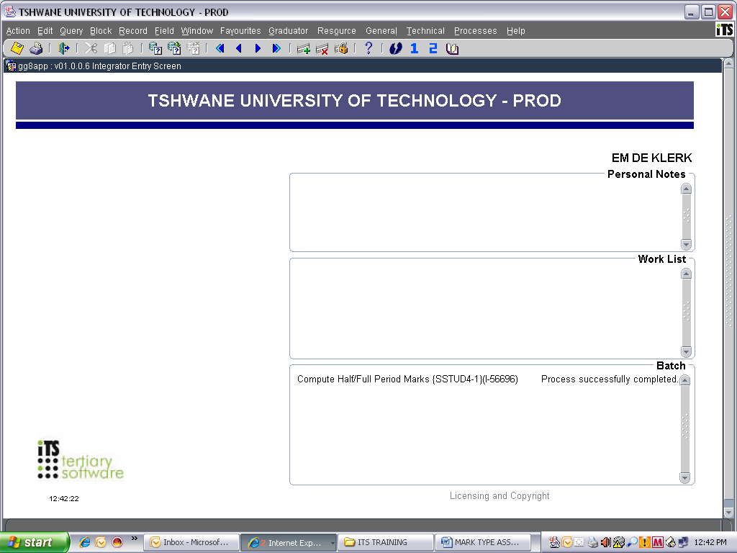
Click on Quick Menu icon or press <F1> on your keyboard

Type in SSTUDY-21

Press <Enter>

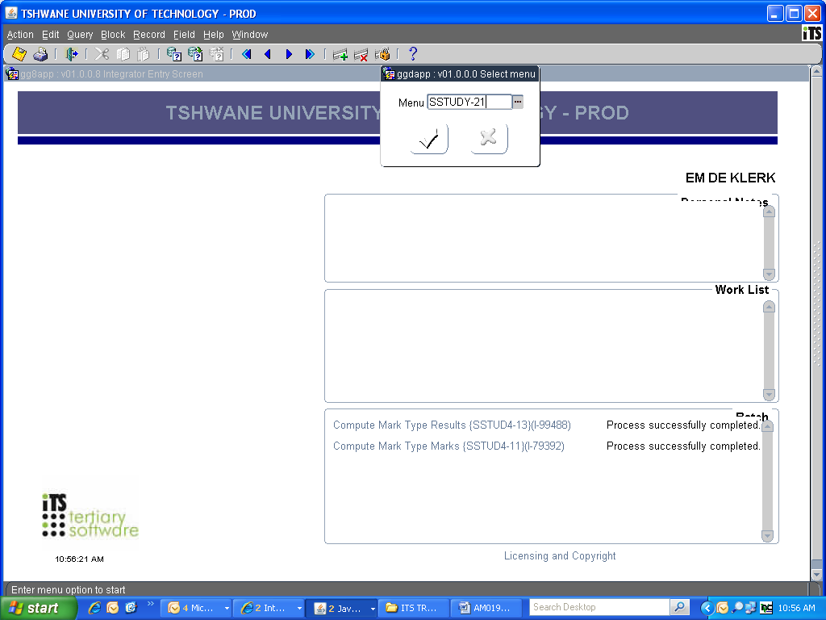

The following screen will appear:

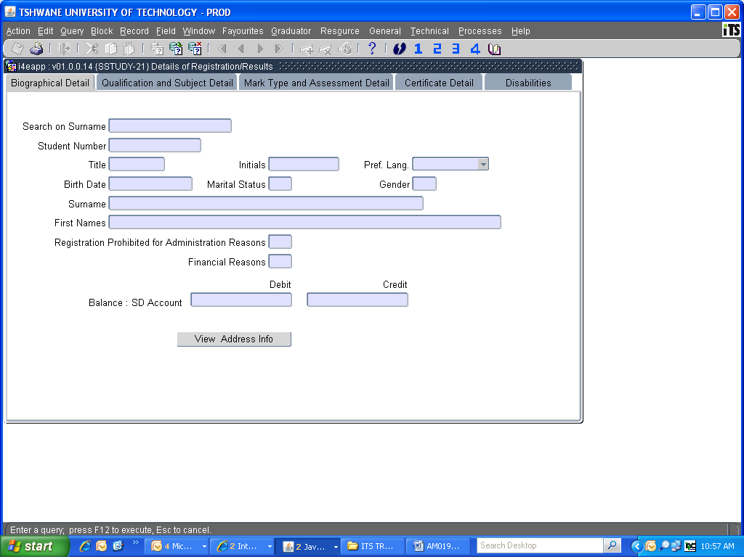

Press <Esc> on your keyboard to cancel the query

Click twice on the Next Block icon or press <Pg Down> on your keyboard twice

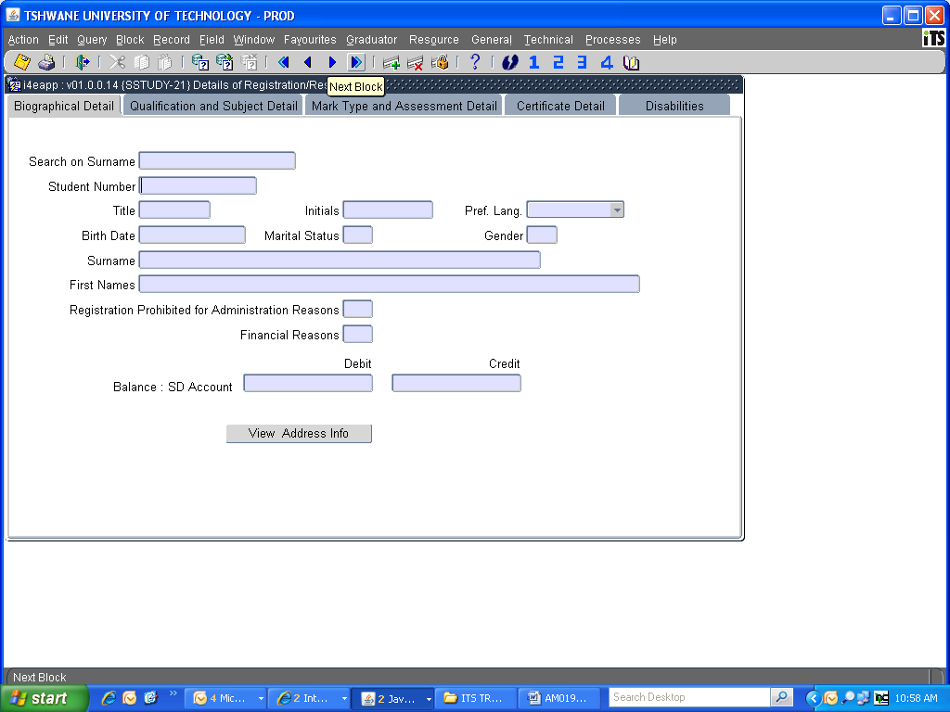
The following screen will appear:

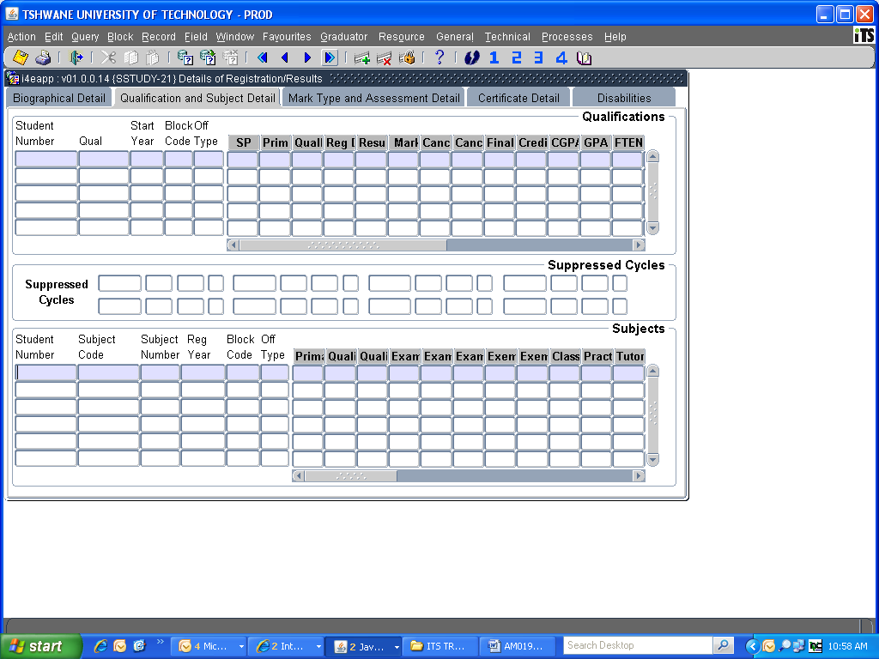

Your cursor will flash at the bottom block of your screen

Click on Enter a Query icon or press <F11> on your keyboard

Type the required information (eg. Student number and Registration Year or Subject code and Registration Year)
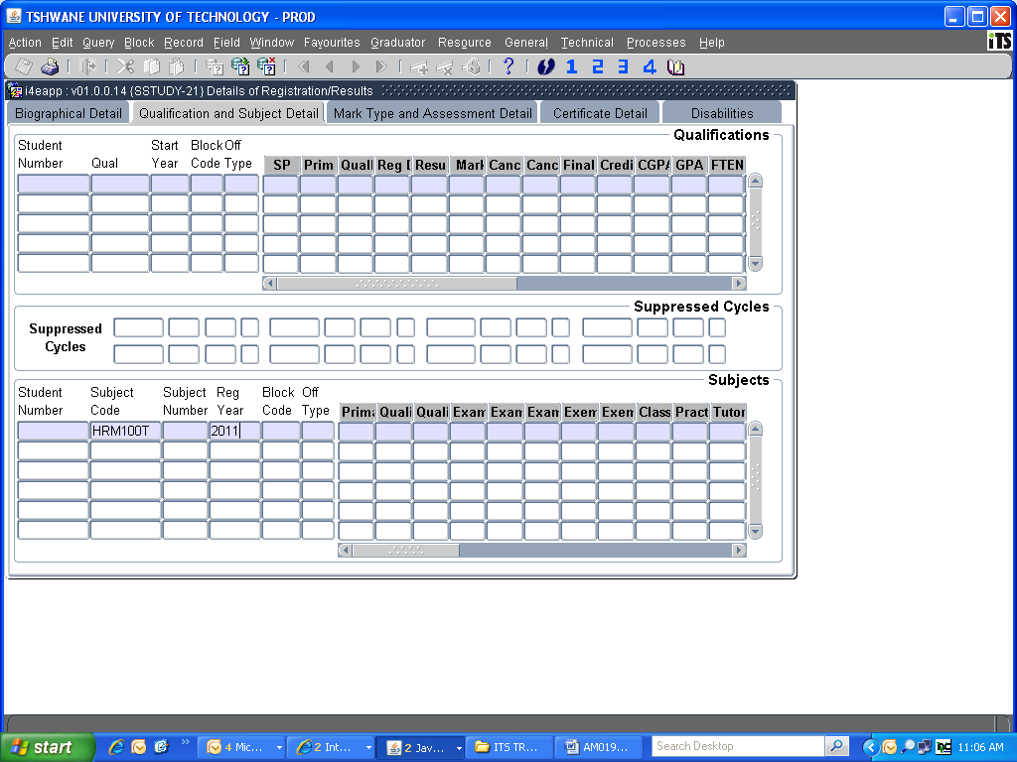

Click on Execute the Query icon or press <F12> on your keyboard

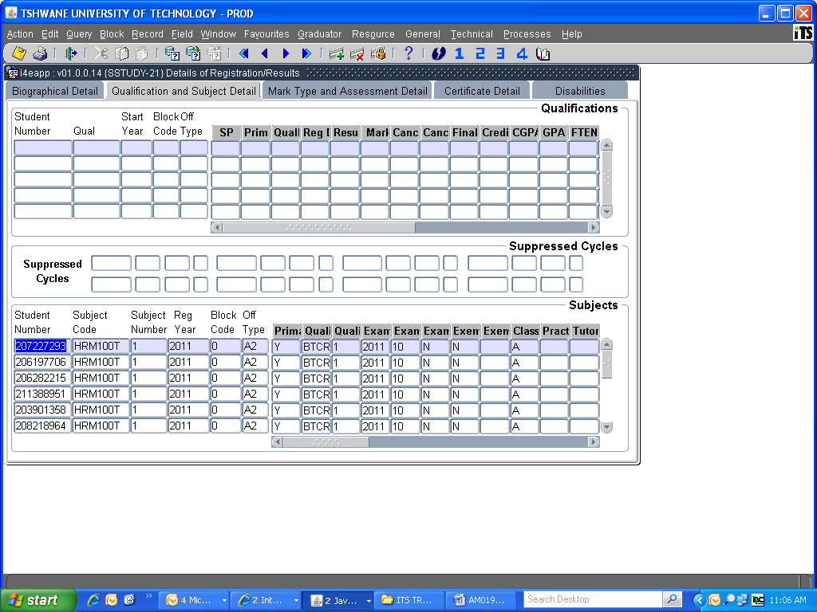
Drag the scroll bar to the right to see more information

To see the student’s individual marks, click on the Next Block icon or press <Page Down> on your keyboard

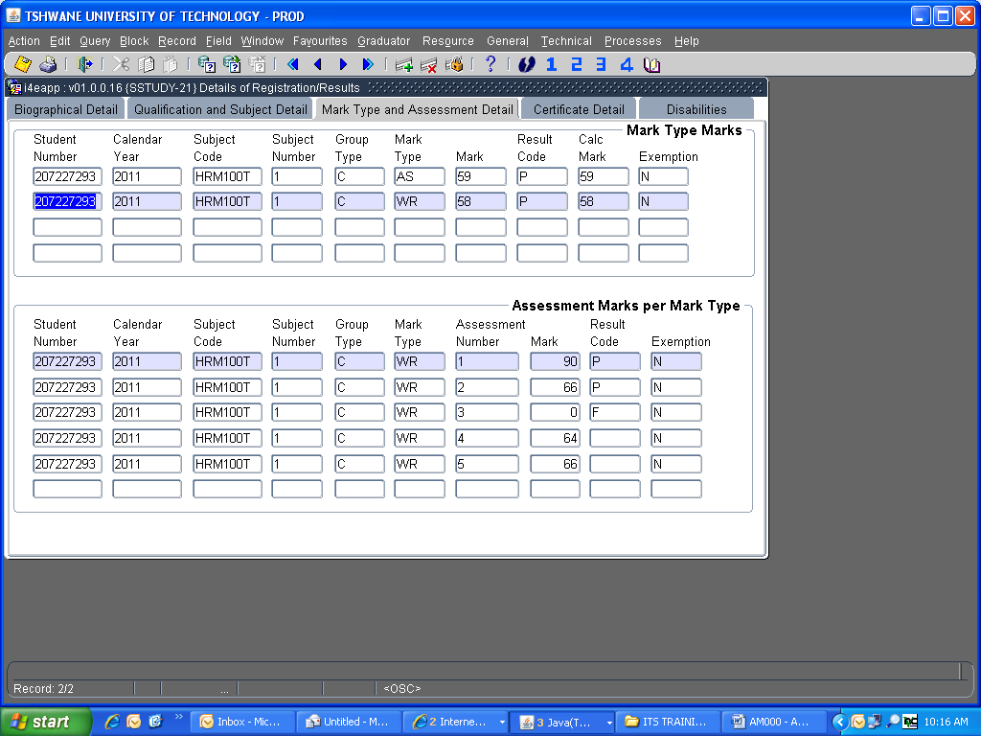

The Mark Type Marks is the calculated value of all assessment marks reflecting under the Assessment Marks per Mark Type block.

If no value appears under the Mark Type Marks block, the subject was not computed (SSTUD4-14, -11, -13 process).

This screen can be used for query purposes only. Any changes/corrections on assessment marks need to be made on SSTUD1-2.

ALLOCATE CLASS GROUPS
(SREGC-6)
(AM001)

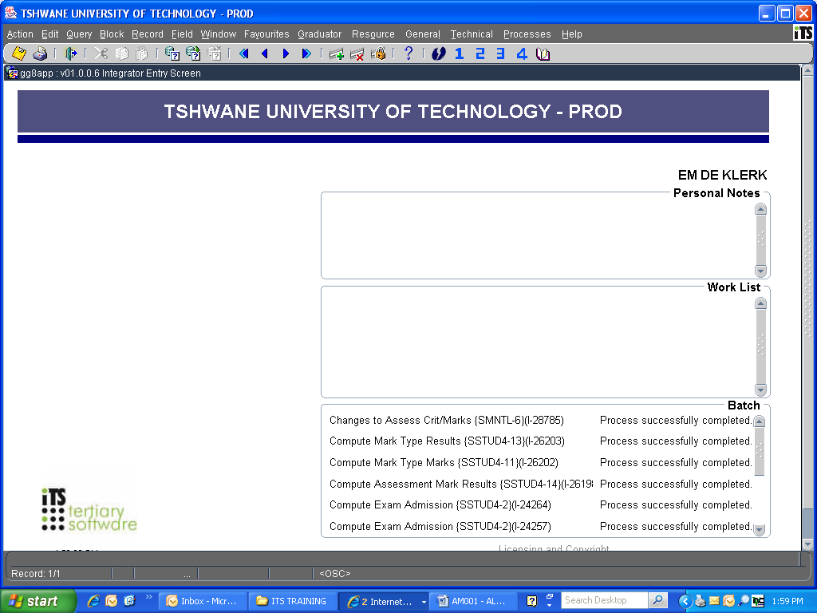

IMPORTANT INFORMATION

Before students can be allocated to class groups, the following information must be provided to the department Academic Qualification Structure:
- How many Class Groups? (A, B, C, D, E, F, G, H, I, etc)
- How many students per class group?
- Provide name and staff number of the responsible lecturer to be linked to each class group

Press <F1> (Quick menu)

Type in SREGC-6

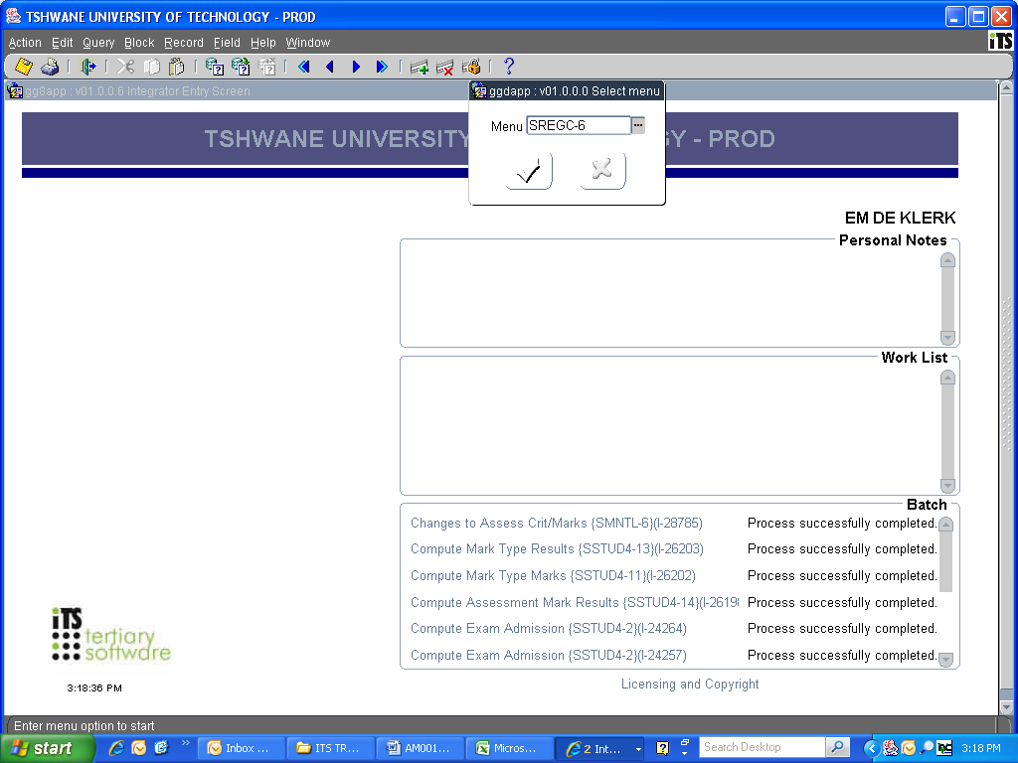

The following screen will appear:

*NEXT BLOCK ICON

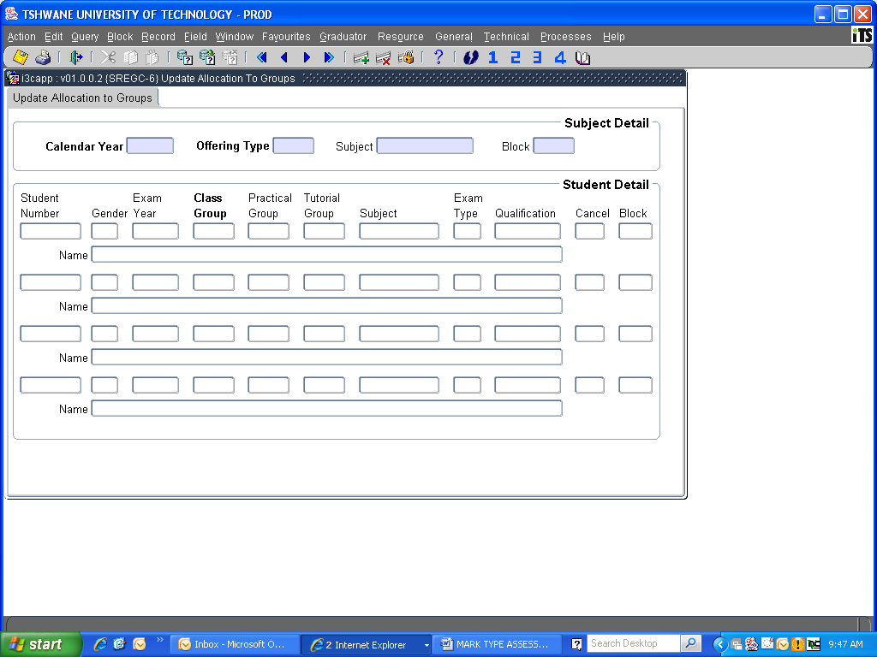

Type in Calendar Year
Type in the Offering Type
Type in the Subject Code
Type in the Block Code (e.g. 0 = year subject, 1 = 1st Semester, 2 = 2nd Semester)
Press <Page Down> on your keyboard or Click on the Next Block icon (* See above)

All students registered under the specific subject code will appear.
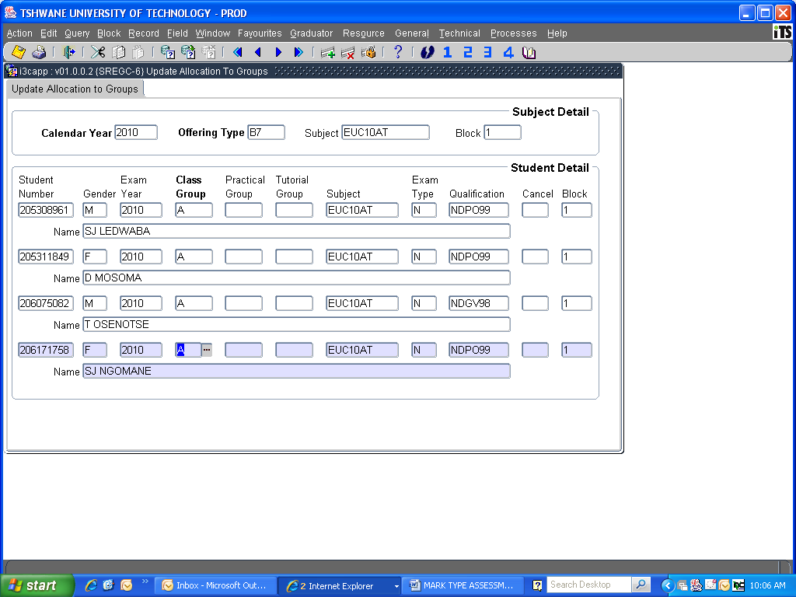

- To select all students registered under a specific qualification code …

Press <F11> (Enter a query)
Click inside the Qualification block or move forward by pressing the Tab key on your keyboard
Type the qualification code

OR

- To select all students registered under a specific class group …

Press <F11> (Enter a query)
Click inside the class group block or move forward by pressing the Tab key on your keyboard
Type the class group

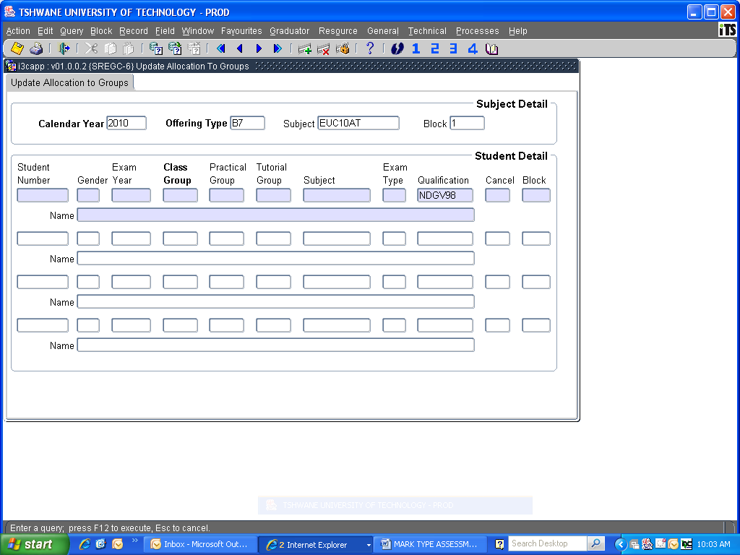

and Press <F12> (Execute a query)

All students registered for that specific qualification code/class group will appear.

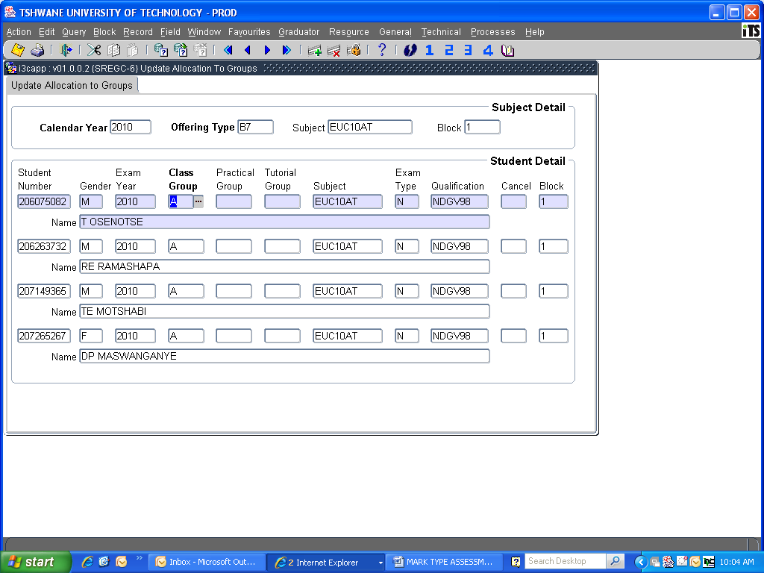

Change the Class Group to the new allocated class group. Move to the next student with the down arrow on your keyboard.

Press <F10> to save the changes or Click on the Save icon.

Click on the Exit icon.

