

Progress Report on the PQM-HEQF Alignment:
April 2009 – April 2010

Task Team on PQM-HEQF Alignment
April 2010
1. Introduction:

On April 15th 2009, the first institutional workshop to establish a process for PQM/HEQF alignment was held at Toppieshoek. At this workshop, hosted by Higher Education Development and Support (HEDS) and widely attended by delegates from all the faculties and academic support structures, the aim was to introduce the Higher Education Qualifications Framework (HEQF) and to establish a process which would help TUT to align its Programme and Qualification Mix (PQM) with the HEQF. The outcome of the workshop was the development of general principles for implementation of the HEQF at TUT. It was also resolved that the HEQF Task Team would refine these general principles for submission and approval by the Academic Committee and that the PQMs of the faculties should be analyzed in order to determine the size and shape of the institutional PQM.

2. First Round of PQM Proposals:

Following the workshop held at Toppieshoek and in accordance with phase 1 of the PQM/HEQF Alignment Project Plan, a process was initiated to allow for analysis of the current faculty PQMs and to provide an opportunity for faculties to propose preliminary PQMs that are aligned with the principles of the HEQF.

An analysis report was presented by the Director: SMS to the Academic Committee at a meeting on 28th October 2009 during which Deans were able to elaborate on their individual PQM proposals.

There was general consensus that faculties experienced difficulties to establish new PQMs and to align these with HEQF principles. It was resolved that a sub-team of the PQM/HEQF Task Team be established and that this team would develop an institutional PQM/HEQF alignment guideline document for use in the faculties for this purpose.

3. PQM-HEQF Alignment Guideline Document

The sub-team set to work immediately and a document entitled “Guidelines on the Development of an Institutional PQM” was finalized on 29th November 2009 and in principle approved by the Academic Committee in January 2010.

Deans were requested to:
- Discuss the institutional guidelines on the proposed PQM-HEQF alignment with Heads of Departments and staff.
- Re-work the previously submitted proposed PQM of the faculty in line with the guidelines within this document as well as earlier documentation that has been made available.
- Submit a reviewed proposed PQM for the faculty to SMS before 15 February 2010. (This date was later postponed to March 31, 2010 to afford faculties with sufficient time to submit proper PQM proposals)

The guidelines are also to be used in the development of the first round of submissions of new and revised qualifications and programmes. This process is envisaged to take place over the next 6-7 years as faculties also need to develop and expand their academic staff contingents in order to meet some of the criteria for offering certain types of qualifications as stipulated in the guideline document

4. Empowering Academia

In order to further empower academics in terms of PQM development and HEQF compliance, a workshop was organized as part of the Academic Leadership Programme with the specific aim to bring academic middle management to terms with the guideline document. The workshop took place on 10 March 2010 and was attended by all academic HoDs of the institution.

During the workshop academics agreed that the exercise was useful and that they were in a better position to make decisions regarding the PQM/HEQF alignment process. It was resolved that HoDs would take an active part in the faculties with regard the PQM proposals.

5. Second Round of PQM Proposals:

Feedback was received from the faculties towards the end of March and the first week of April 2010. These proposals were analyzed by the Directorate: SMS and the analysis are presented in the subsequent section.

Table 5.1: Suggested PQM per Faculty (As stated in the PQM-HEQF guideline document)
Faculty | H. Cert. | Adv. Cert. | Dip. | Adv. Dip. | PG Dipl. | B. Degree | Prof. B. Deg. | Hons | Masters | Doctoral | Total
Arts | 0 | 0 | 10 | 9 | 9 | 5 | 0 | 3 | 4 | 3 | 43
Econ. & Fin. | 2 | 2 | 5 | 2 | 1 | 3 | 1 | 2 | 3 | 2 | 23
Engineering. | 6 | 6 | 9 | 6 | 4 | 11 | 2 | 3 | 5 | 3 | 55
Humanities | 10 | 10 | 11 | 9 | 0 | 14 | 4 | 8 | 6 | 4 | 76
ICT | 0 | 0 | 8 | 5 | 0 | 4 | 0 | 3 | 3 | 2 | 25
Man. Sci | 0 | 0 | 21 | 18 | 17 | 0 | 0 | 0 | 8 | 4 | 68
Science | 5 | 3 | 22 | 21 | 19 | 13 | 3 | 6 | 11 | 7 | 110
Total | 23 | 21 | 86 | 70 | 50 | 50 | 10 | 25 | 40 | 25 | 400
% of Total | 5,8% | 5,3% | 21,5% | 17,5% | 12,5% | 12,5% | 2,5% | 6,3% | 10,0% | 6,3% | 100,0%

Table 5.2: Proposed PQM per Faculty (As provided by the Faculties)
Faculty | H.  Cert. | Adv.  Cert. | Diploma | Adv Dip. | PG Dipl. | B  Degree | Prof B. Degree | Hons | Masters | Doctoral | Total
Arts | 0 | 0 | 10 | 9 | 9 | 4 | 0 | 3 | 4 | 3 | 42
Econ. & Fin | 0 | 0 | 5 | 5 | 3 | 1 | 1 | 1 | 4 | 3 | 23
Engineering | 12 | 1 | 0 | 0 | 0 | 12 | 1 | 8 | 5 | 1 | 40
Humanities | 0 | 0 | 6 | 10 | 2 | 10 | 2 | 10 | 7 | 6 | 53
ICT | 1 | 1 | 8 | 1 | 0 | 8 | 0 | 8 | 1 | 1 | 29
Man. Sci. | 0 | 0 | 21 | 19 | 18 | 0 | 0 | 0 | 14 | 11 | 83
Science | 5 | 3 | 22 | 22 | 22 | 0 | 10 | 0 | 6 | 5 | 95
Total | 18 | 5 | 72 | 66 | 54 | 35 | 14 | 30 | 41 | 30 | 365
% of Total | 4,9% | 1,4% | 19,7% | 18,1% | 14,8% | 9,6% | 3,8% | 8,2% | 11,2% | 8,2% | 100,0%

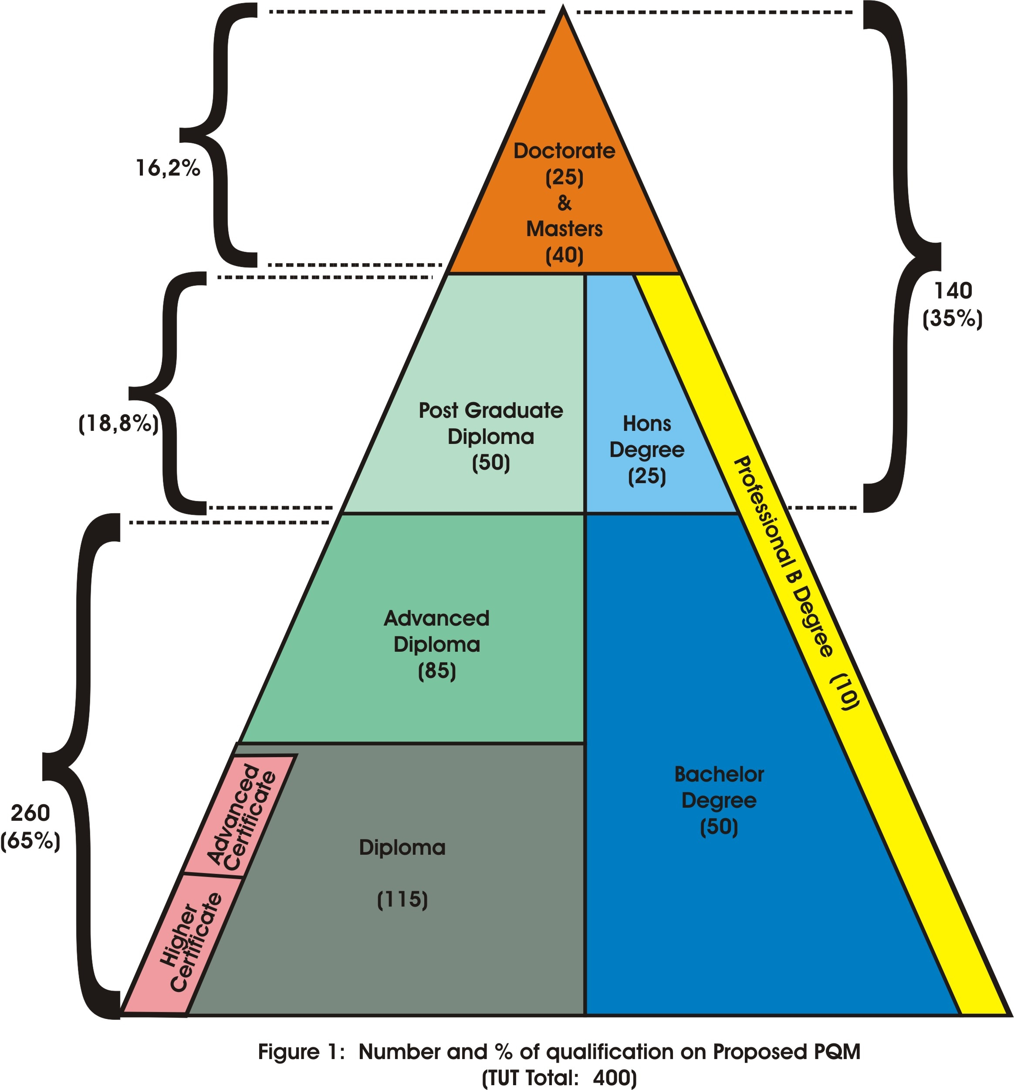

(As suggested in the PQM-HEQF guideline document of TUT)

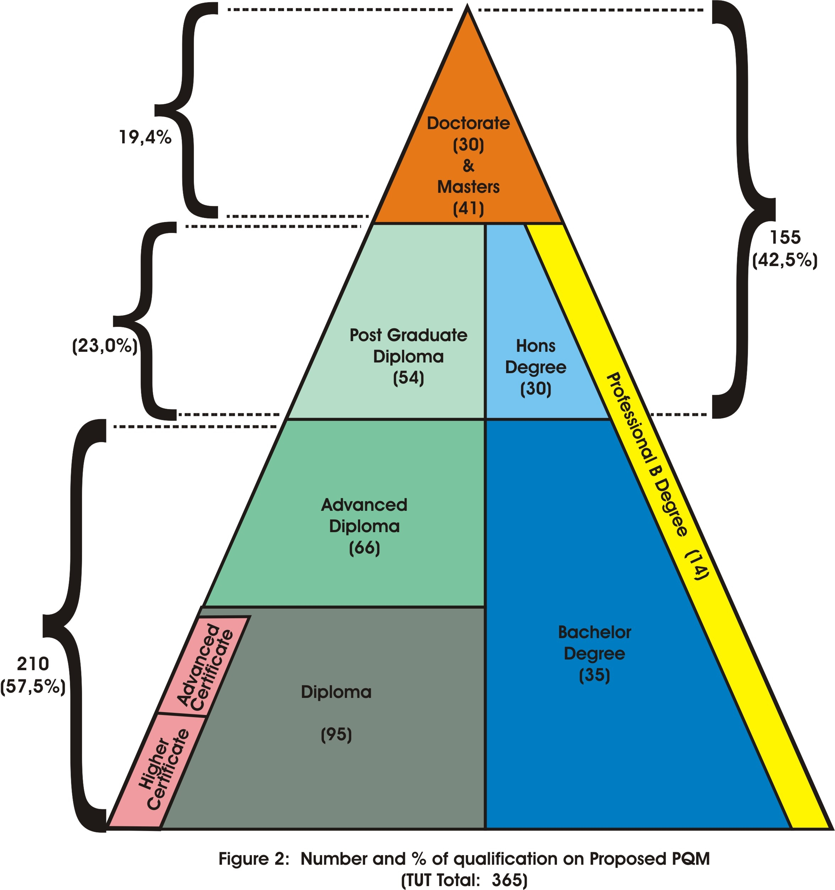

(Proposals received from Faculties, end of March 2010)

6. Conclusions:

- There is good correlation between the recommendations within the guideline document, and the proposals received from the Faculties.
- A phased in approach over time is an important feature of the PQM-HEQF alignment process.
- A cut down from 570 qualifications to 365 is excellent.
- The PQM-HEQF alignment process proves to be effective in streamlining and simplifying the PQM of TUT.

7. The way forward:

The Directorate: CDS will develop and implement a roll-out plan to help Faculties to start curriculation processes. It is envisaged that:

- The first round of submissions will start in 2010 for launching in 2012.
- Another progress report to Senate will be submitted for its last meeting of 2010.

Task Team:
Prof. Peter v Eldik
Prof. Ansu Erasmus
Prof. Pieter Marais
Prof. Sunday Ojo
Dr. Stanley Mukhola
Dr. Linda van Ryneveld
Mr. Jaco Pieterse

The task team wishes to thank Mrs. Debbie v. d. Watt for the graphics provided.

