DEPARTMENT OF EDUCATION



BUILDING AND SPACE INVENTORY AND CLASSIFICATION MANUAL

DRAFT REPORT
MARCH 2007
PREFACE

This Manual provides the necessary definitions and background for the HEMIS Building Space Module, more specifically the following documents published by the Department of Education:

Data Element Definitions for Elements in the Files Required in the Building Space Inventory Unit Record Collections.

File Structures for Files Required in the Building Space Inventory Unit Record Collections.

Scopes for Files Required in the Building Space Inventory Unit Record Collections.

This Manual is a revised edition of the Building and Space Inventory and Classification Manual published by the former Department of National Education in May 1982. This revised edition is based on the Postsecondary Education Facilities Inventory and Classification Manual published by the National Center for Education Statistics in the USA in 2006. The use of the latter material is gratefully and respectfully acknowledged.

This revision to a large extent reflects the continuing changes within higher education as regards the students being served, the technologies that are available to it, and the innovations institutions have begun to embrace.

The project team which has drafted this Manual consisted of the following members:

Department of Education: Ms Jean Skene (Convenor)
Prof Ian Bunting

Consultants: Mr Dennis Mokotedi (University of Johannesburg)
Dr Gert Steyn (University of Stellenbosch)
Dr Lucas Stoop (University of Johannesburg)

Finally, many practitioners throughout the country reviewed the draft of this edition of the manual as part of the field review process. All of their comments, suggestions, and ideas were considered and discussed. We would like to thank everyone who has made an input in this regard.
CONTENTS

Preface 2

SECTION 1: Buildings to be included in the inventory (Element 205) 3

SECTION 2: Building condition (Element 209) 5

SECTION 3: Gross square metres (Element 212) 7

SECTION 4: Rooms (Element 214) 10

SECTION 5: Assignable space 12

SECTION 6: Non-assignable space 14

SECTION 7: Structural space 18

SECTION 8: Number of stations (Element 218) 20

SECTION 9: Space use category (Element 216) 21

APPENDIX A: Definitions of the various Space Use Categories 25

SECTION 1 : BUILDINGS TO BE INCLUDED IN THE INVENTORY (ELEMENT 205)

Definition: A building is defined as a roofed structure for permanent or temporary shelter of persons, animals, plants, materials, or equipment. The building inventory may encompass many different types of structures, including marine structures; research vessels; aquarium structures; and trailers that are not on wheels and are used for offices, residences, or storage.

Description: The inventory should include buildings that are under the jurisdiction or control of the institution’s council, regardless of their location. Where the institution occupies space in buildings not owned by the institution or that is shared with other tenants, include in the inventory that portion of the building leased or controlled by the institution.

Institutions should consider using the following criteria as guidelines when having to decide on which roofed structures to include or exclude from the inventory. These guidelines are not compelling and exceptions will have to be dealt with on an individual basis by institutions. It is suggested that a roofed structure be included in the inventory if all of the following criteria are met simultaneously:

- It is attached to a foundation.
- It requires significant maintenance and repair activities as determined by the institution.
- It is serviced by at least two utilities. Utility in this regard refers to ICT services, electrical services, gas services, normal or special plumbing services, temperature control services, ventilating services, and water services. This could also include an electrical supply through solar cells.
For example, a minor structure to be included in a building inventory is a traffic control or information booth that is roofed, attached to a concrete pad, with lights and at least one other utility service such as a telephone, and on a regular maintenance schedule. An example of a separate structure not meeting the above criteria is a bus shelter, which is roofed and attached to the concrete sidewalk, but which has only lights as a utility service.

Limitation: The following types of buildings should be excluded from the inventory if they do not house functions considered part of the institution’s mission:

- Investment properties that are buildings used only for revenue generation and not for institutional purposes;
- Hospitals not owned by the institution, except for any space in the hospital used, leased, or controlled by the institution;
- Public schools not owned by the institution but used for practice teaching; and
- National research centers.

SECTION 2: BUILDING CONDITION (ELEMENT 209)
Definition: The condition of the building at the time of the inventory, based on the best judgment of those persons familiar with the physical characteristics and condition of the campus. Building condition is based on the estimated renovation costs required as a percentage of the so-called calculated replacement cost of the building.
A distinction should be made between ordinary maintenance and repair costs of a building which are regarded as recurrent expenditures, and renovation costs which are capitalizable costs directly attributable to bring the building to working condition for its intended use (fitness for purpose). It is commonly understood that buildings comprise certain primary elements which do not normally have to be renewed and secondary elements which must undergo periodic renewal in order to keep the building in a satisfactory and usable condition. In this context renovation includes both major repairs to and replacement of secondary building elements made necessary by normal use and deterioration and modeling to accommodate user requirements resulting from changes in occupancy, use or institutional requirements (fitness for purpose).
The calculated replacement cost of a building is defined to be equal to the number of standard cost units of the building times the Rand value of the cost unit at the time of the inventory.
Building Condition is defined through the following seven categories:
- Minimal Renovation (Good)
Suitable for continued use with normal maintenance. The estimated renovation cost is less than 5% of the calculated building replacement cost.
- Limited Renovation (Satisfactory)
Requires restoration to present acceptable conditions. The estimated cost of renovation is more or equal than 5% but less than 15% of the calculated building replacement cost.
- Moderate Renovation (Fair)
Requires updating or renovation. The estimated renovation cost is more or equal than 15% but less than 30% of the calculated building replacement cost. The physical conditions may have an affect upon building operations.
- Significant Renovation (Poor)
Requires significant updating or renovation. The estimated renovation cost is more or equal than 30% but less than 45% of the calculated building replacement cost. The physical conditions adversely affect building operations.

- Major Renovation (Unsatisfactory)
Requires major renovation with possible need to overhaul building subsystems. The estimated renovation cost is more or equal than 45% but less than 60% of the calculated building replacement cost. Consideration of actual renovation requirements may lead to classifying the facility as being in need of replacement.
- Replace/Demolition
Should be demolished or abandoned because the building is unsafe and/or structurally unsound, irrespective of the need for the space or the availability of funds for a replacement. Additionally, this category takes precedence over categories 1-5. If a building is scheduled for demolition, its condition is reported in this category, regardless of condition.
- Vacating building
Planned vacating of the building for reasons other than unsafeness or structural unsoundness, such as abandonment of temporary units or vacating of leased space. Additionally, this category takes precedence over categories 1-6. If a building is scheduled for termination, its condition is reported in this category, regardless of its condition.
SECTION 3: GROSS SQUARE METRES (ELEMENT 212)

The Gross Area of a building is the floor area of a structure within the outside faces of the exterior walls. This value is either physically measured or scaled from as-built drawings and expressed in terms of square metres. Hence the term gross square metres.

Gross Area

Assignable Area | Non-assignable Area | Structural Area

The Gross Area of a building consists of three different parts which will be discussed in Sections 5, 6, and 7: Firstly, the Assignable Area which is available for assignment to an occupant or for specific use. Secondly, the Non-assignable Area which is not available for assignment to an occupant or for specific use, but necessary for the general operation of a building. Finally, the Structural Area which is the floor area upon which the exterior and interior walls sit.

Definition: The sum of all areas on all floors of a building included within the outside faces of its exterior walls, including all vertical penetration areas, for circulation and shaft areas that connect one floor to another. This is computed by physically measuring or scaling measurements from the outside faces of exterior walls, disregarding cornices, pilasters, buttresses, etc., that extend beyond the wall faces. The result is expressed in terms of square metres.
Description: In addition to all the internal floored spaces obviously covered above, Gross Area should include the following: excavated basement areas; interstitial space (i.e., mechanical floor or walkways), mezzanines, penthouses, and attics; garages; covered porches, whether walled or not; inner or outer balconies to the extent of a drip line from a roof or balcony immediately above, whether walled or not, if they are utilized for operational functions; and corridors or walkways, whether walled or not, provided they are either within the outside face lines of the building to the extent of the roof drip line or, if covered, to the extent of their cover’s drip line. The footprints of stairways, elevator shafts, and vertical duct shafts are to be counted as gross area on each floor through which they pass.
Limitations: Exclude open areas such as parking lots, playing fields, pools, courts, light wells, and portions of upper floors eliminated by spaces or lobbies that rise above single-floor ceiling height. Exclude unexcavated basement areas.
The diagrammatic cross-section of a building (Figure 1) has been included to better illustrate the area measurement descriptions for less common situations such as exterior balconies, overhung egress areas and loading docks.

Figure 1. Illustrative cross-section of a building
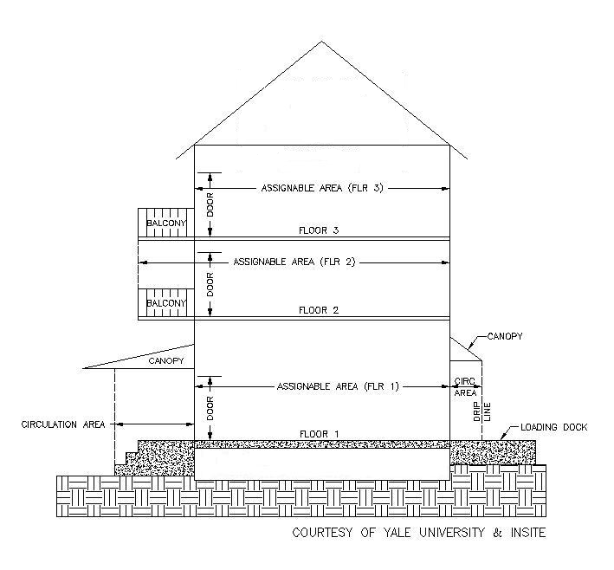

Figure 2 below summarizes the way in which the gross area of a building is to be calculated.

Figure 2. Gross Area of a building by floor
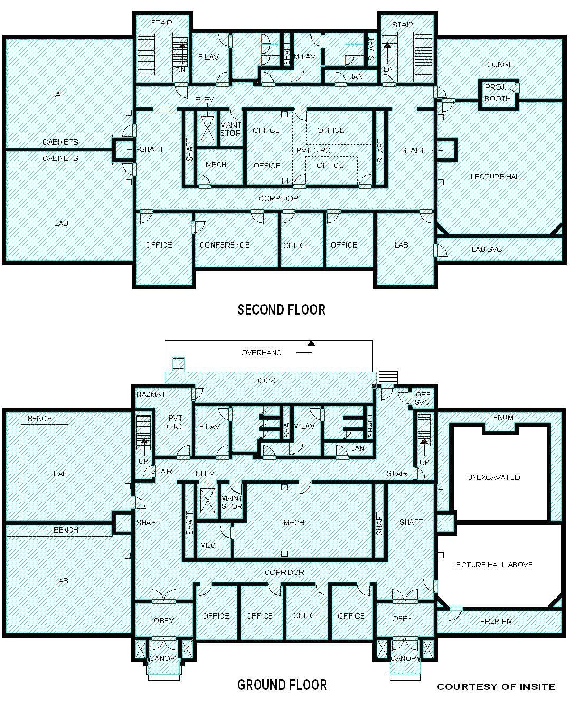
SECTION 4: ROOMS (ELEMENT 214)

Rooms to be included in this inventory pertain to both assignable space (discussed in Section 5) as well as non-assignable space (discussed in Section 6) in a building.

Definition: A room is defined as a contiguous area (assignable or non-assignable) bounded by walls and/or imaginary boundary lines.

Each room, whether it pertains to assignable space or non-assignable space, should be assigned a unique room number which would enable the area to be identified uniquely. Even in the case of non-assignable space, the room number should be recorded on a floor plan showing the demarcated area associated with the particular room number.

It sometimes happens that a room has multiple space uses of a material nature as provided for in the space use classification system. Material in this case is considered to pertain to the two most important space uses of a room at most, none of the uses selected being less than 25% of total uses selected. For example, from all the possible uses of a room: A(50%), B(20%), C(15%) and D(15%), one would reduce the four uses to two: A(71%), B(29%). On the other hand, the uses: A(60%), B(15%), C(13%) and D(12%), would first of all reduce to: A(80%), B(20%), leading to the retention of only A(100%).

In such cases the room has to be prorated into different parts or areas, and an appropriate space use code should then be assigned to each part of the room. The prorating of a room to reflect its multiple uses, should be dealt with on the basis of the following considerations:

- Spatial considerations: This is where different material parts of a room are used within different space use categories most of the time. For example, a room of which 50 m² is used as a departmental conference facility with 30 stations, and of which the remainder of 25 m² is used for a sizeable reference library containing 5 study stations, should be prorated into two parts through the insertion of an imaginary wall. Two records will then be entered into the Room File, the one pertaining to the use of the room as a departmental conference room with size 50 m² and the other to the use of the room as a reference library with size 25 m². It is advisable that the imaginary wall be shown on a floor plan. The number of stations in each of these spaces (30 and 5 respectively) should then be entered into the two records as appropriate.
- Temporal considerations: This is where a room has different material uses at different times. For example, a 100 m² room with 35 stations which for 30% of the year is used as a classroom and for 70% of the year as study space by students for learning at their convenience, should be prorated into two parts on a 30/70 basis. Clearly the station types required for these two space uses are indistinguishable from one another. Two records will then be entered into the Room File, the one pertaining to the use of the room as a classroom and the other to the use of the room as study space. The size attribute of the classroom part should then be set equal to 30 m² and the number of stations in that record to 10,5. In the case of the study space record, the size attribute should then be set equal to 70 m² and the number of stations in that record to 24,5.

After having divided or prorated a room into one or more material areas (and the order of this is important), the Room File also provides for a further proration of the said areas in terms of the PCS programmes (instruction, research, public service, academic support, etc) as well as the CESM study fields in the case of instruction or research. One of these areas with its unique space use, therefore, could give rise to multiple records within the Room File depending on whether this area has been used for more than one PCS programme activity or CESM study fields. Although the size of the area as measured in square metres will then be subdivided further, all the records will still have the same room number and space use code. Conversely, the square metres associated with each of these subdivisions will have to add up to the square metres associated with a particular area characterized by a unique space use code. This in turn can be added across all the different space uses of a room to obtain the square metres of the room. The same principles apply to the distribution of stations across the various records. This is explained further in Paragraph 3.3 of the document: Scopes for Files Required in the Building Space Inventory Unit Record Collections.

Areas that are permanently covered but not enclosed should be inventoried as assignable or non-assignable space depending upon the space use. Bounding the area with imaginary walls along the drip line of the “cover” defines the area to be measured and added to the building’s gross area as well as to the assignable or non-assignable area, depending upon the use of the space. This also forms the basis for counting the number of stations in an assignable area constituting part of a room. A space use, whether floored or not, that exists beyond the drip line of the covered area is not reported. Alternately, the area beneath a permanent cover that extends beyond a floored area is also not reported.

SECTION 5: ASSIGNABLE SPACE

The amount of space that can be used for people or programs is known as the Assignable Area of a building. The area of an assignable space is the area measured within its interior walls and is expressed in terms of square metres. The assignable area of a building (or all buildings in an inventory) is the sum of the space allocated to the ten major assignable space use categories: classrooms, laboratories, offices, study areas, special use space, general use areas, support rooms, health care, residential, and unclassified space. These categories are further described in Section 9.

Gross Area

Assignable Area | Non-assignable Area | Structural Area

Definition: Areas on all floors of a building assigned to, or available for assignment to, an occupant or specific use. This is computed by physically measuring or scaling measurements from the inside faces of surfaces that form the boundaries of the designated areas.
Description: Included should be space subdivisions of the ten major space use categories for assignable space—classrooms, labs, offices, study facilities, special use, general use, support, health care, residential, and unclassified—that are used to accomplish the institution’s mission.
Limitations: Deductions should not be made for necessary building columns and projections. These small areas are excluded as they represent an insignificant percentage of the total area of an average-sized space. Capturing their area would be unduly burdensome relative to the very small contribution they would make toward precision. Threshold areas of doors should also be ignored, unless the walls of the rooms are very thick in which case the threshold area is divided in half with equal allocation to the dividing rooms. Non-assignable areas defined as building service, circulation, and mechanical, as well as structural areas should not be included.
Figure 3 below summarizes the way in which the assignable area of a building is to be calculated.

Figure 3. Assignable Area of a building by floor
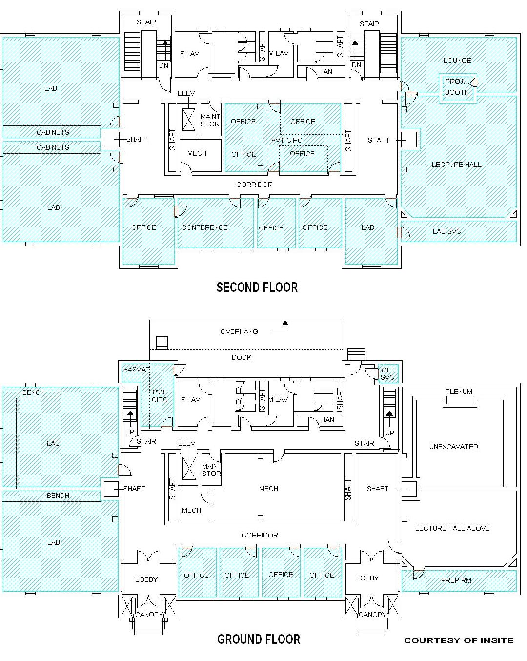

SECTION 6: NON-ASSIGNABLE AREA

The amount of space within a building that is essential to the operation of the building but not assigned directly to people or programs is known as the Non-assignable Area. The area of a non-assignable space is the area measured within its interior walls and is expressed in terms of square metres. The non-assignable area of a building is the sum of the space allocated to the one major non-assignable space use category: Enabling Areas comprising of building service area, circulation area, and mechanical area. These categories are further described in Section 9.

Gross Area

Assignable Area | Non-assignable Area | Structural Area

Definition: The areas on all floors of a building not available for assignment to an occupant or for specific use, but necessary for the general operation of a building. This is computed by physically measuring or scaling measurements from the inside faces of surfaces that form the boundaries of the designated areas.
Description: Included should be space subdivisions of the three non-assignable space use categories—building service, circulation, and mechanical—that are used to support the building’s general operation.
Limitations: Deductions should not be made for necessary building columns and projections. These small areas are excluded as they represent an insignificant percentage of the total area of an average-sized space. Capturing their area would be unduly burdensome relative to the very small contribution they would make toward precision. Areas defined as assignable should not be included.
Figures 4.1, 4.2 and 4.3 below summarize the way in which the non-assignable area of a building is to be calculated.

Figure 4.1. Building Service Area of a building by floor
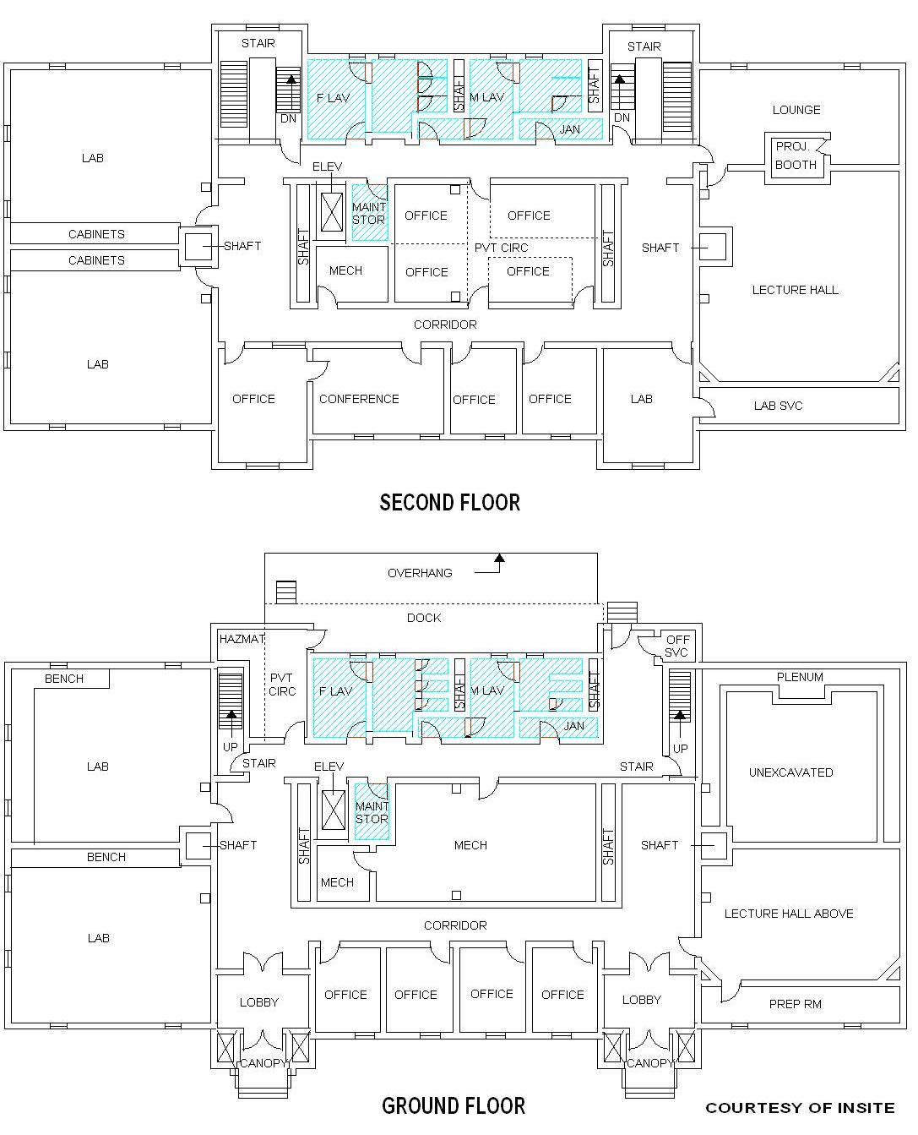

Figure 4.2. Circulation Area of a building by floor
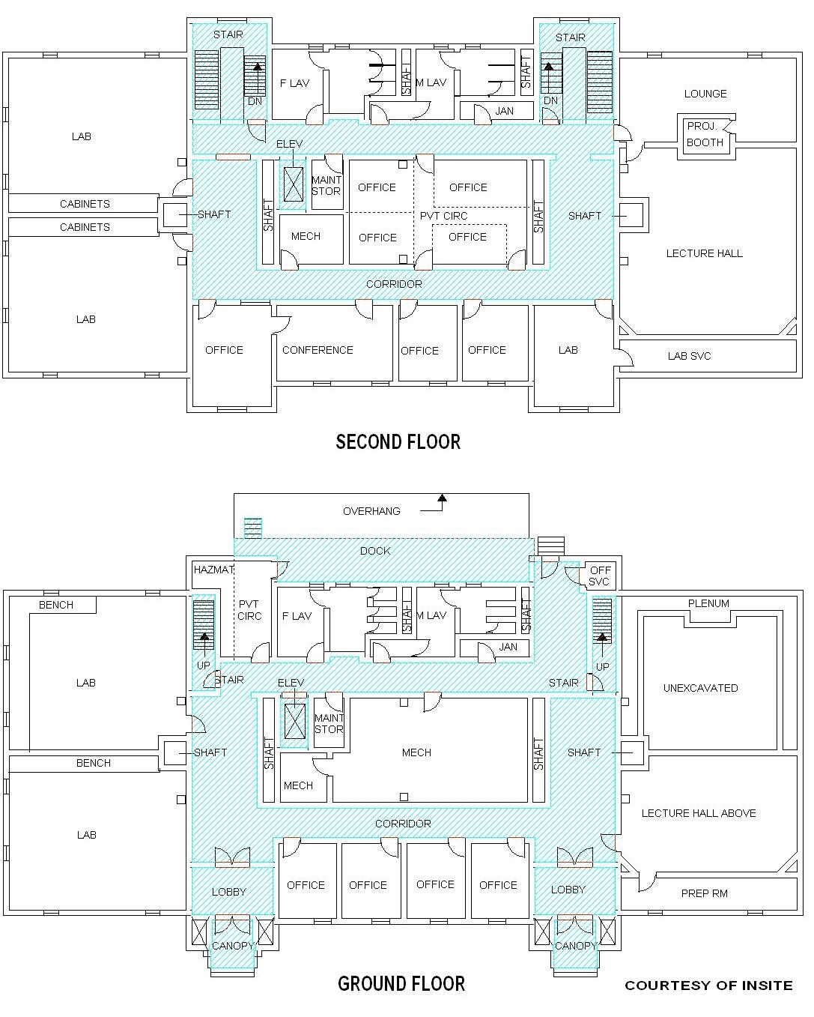

Figure 4.3. Mechanical Area of a building by floor
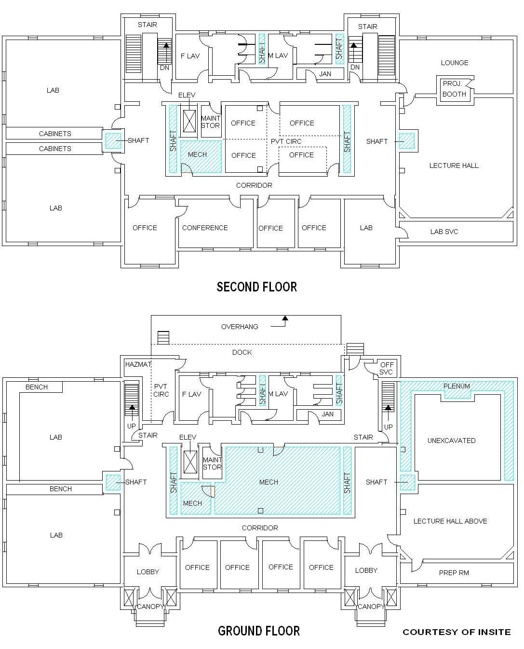
SECTION 7: STRUCTURAL SPACE
Definition: The areas on all floors of a building that cannot be occupied or put to use because of structural building features. Precise computation by direct measurement is not possible under this definition. It is determined by calculating the difference between the measured gross area and the measured assignable and non-assignable area.
Description: Examples of building features normally classified as structural areas include exterior walls, fire walls, permanent partitions, and unusable areas in attics or basements.
Figure 5 below illustrates which areas could possibly contribute to the structural area of a building.

Figure 5. Structural Area of a building by floor
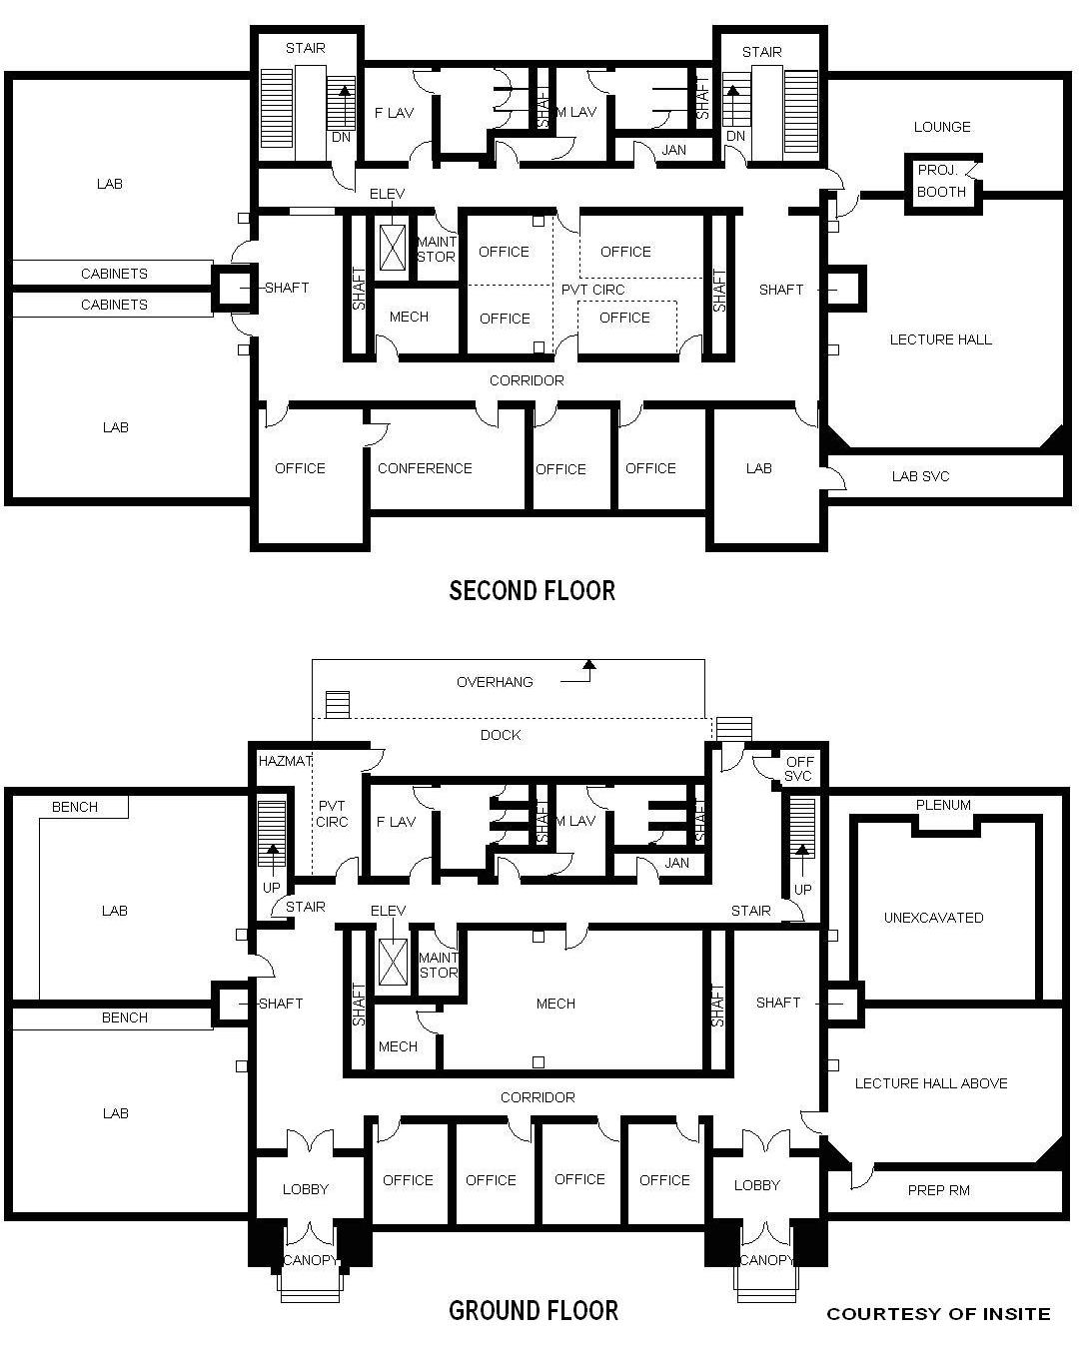
NOTE: Structural areas are indicated in solid black.
SECTION 8: NUMBER OF STATIONS (ELEMENT 218)

This Section provides the technical detail regarding the reporting of stations in the inventory. Like the area of a room expressed in terms of square metres, the number of stations in a room is also an important attribute especially in the case of classrooms, laboratories, assembly halls, and similar facilities.

Definition: A station is defined as the total facilities provided to accommodate one person during one time period, the reporting year.
Description: The word workstation is often used as a term synonymous to station. In a classroom with a number of loose desks and chairs, each desk and its chair would constitute a station for use by one student during one time period. The same considerations would apply to study space in a library, or a computer laboratory with a computer assigned to the station of each student. In a laboratory a station is often determined by the fixed equipment in the space, such as sinks and counter space, required to accommodate one person during one time period. The configuration of a space and the equipment used in general define the facilities constituting a station. Hence the type of station found in a particular space is to a large extent determined by the space use category of the space.
Limitations: The counting of stations is limited to stations found in assignable space.

The basis for the counting of the number of stations in a particular space, whether they are movable or fixed, is again the actual configuration of the stations at the time of the inventory. For instance, a space may be designed to hold 15 movable student stations but at the time of the inventory has only 12 movable student stations; the number of stations would then be 12. Conversely, if a space contains 15 fixed student stations, the station count should be 15.

Finally, in the case of a room with multiple material uses, the room is again prorated in terms of a number of areas and the number of stations for each area and space use category is determined. Furthermore, the principles for prorating the number of stations for a particular area when a division according to PCS codes and CESM categories is required, are similar to the prorating of the square metres size of an area. This has been discussed in Section 4.

SECTION 9: SPACE USE CATEGORIES (ELEMENT 216)

This Section provides the technical definitions and codes for the Space Use classification system. The space use codes pertain to all types and uses of assignable and non-assignable areas found in campus buildings. All assignable space should be classified into one of the ten major assignable space use categories, and all non-assignable space should be classified into one major non-assignable space use category as defined below. Each of these 11 major categories encompasses several subcategories of more specialized uses. Coding of individual spaces is done at the level of subcategories. The numerical codes along with the detailed uses are provided later in this Section.
The space use coding structure is intended to be used in combination with the PCS programme codes which would define the programme(s) within which a particular space is used, and the applicable CESM code if the programme pertains to instruction or research. The space use classification system should be seen as a system which exists independent from the PCS system, the latter detailing the programme within which the space has been used.
The space use codes in this Manual represent an update or modernization of the codes contained in the First Edition. Definitions have been made clearer, descriptions expanded, and limitations made more specific to delineate more clearly the differences among space uses. Despite this, few significant changes, additions, or deletions were necessary to keep the categories current. Every effort has been made to obviate the need for reclassifying spaces and to change the three-digit numeric codes.
Several of the basic concepts inherent in this classification structure require more detailed explanation, as provided below.

Actual use of space

The basis for the classification of the use of any space as part of the inventory is its actual use at the time of the inventory. Space intent, original architectural design, type, name, organizational unit assignment, or contained equipment should not be used as the basis for the classification of a particular space, unless it is compatible with actual use.

Hence, an accurate determination of the actual use of a space and its contained equipment should be made at the time of the inventory. A space’s actual use must meet the stated definition before a space use code can be assigned to the space. Thus, a space that is a laboratory by appearance or design but is currently being used primarily as a classroom is coded as a classroom rather than as a laboratory.

As a further example, a “learning laboratory” may be either an Open Laboratory or a Study Space, depending on whether the space contains discipline-restrictive equipment or configuration, as stated in the introduction to the Laboratory Facilities definition. If the learning laboratory contains computer stations, for example, the machines must be restricted by installed software or accessory devices to a particular discipline or discipline group before the space can qualify as a laboratory. If the machines are configured for general use by students in a variety of course subjects, the computers become synonymous with books as basic study tools and the Study Space code is more appropriate.

The entire focus of definitions is therefore on the actual space use at the time of the inventory (which may be different from the intended use at the time it was built). This principle of actual use as basis for space use classification, applies to a room with a single space use or any prorated part of it in the case of multiple material uses.

Material use of a room

If a room has multiple space uses of a material nature as provided for in the space use classification system, then the room has to be prorated on a spatial or temporal basis as explained in Section 4. Material in this case pertains to the two most important space uses of a room at most, none of the uses selected being less than 25% of total uses selected.

Service Codes

Service codes are used for associated support spaces. Many primary space use categories have minor supporting uses associated with them. For example, an office may have a supply room or a laboratory may have a stock room. These supporting rooms are coded as service spaces, and their space use will follow the coding of the major spaces to which they provide service.

Support or service codes are used to reduce the hundreds of support use categories to a small set of service codes. The use of a code ending in “5” to represent support space for a primary activity area, with a corresponding code ending in “0”, enhances both the analytic usefulness and flexibility of the space use coding structure.

Distinguishing primary activity areas from service areas may occasionally become difficult. For this reason the following principle is introduced to define a service area :

If the existence of an area depends on or is largely justified by the existence of the primary area and the area is in the proximity of the primary area, then the said area is a service area to the primary area

If the proximity and dependency criteria are not met simultaneously, then the area should not be classified as a service area, but as a primary area. For example, a printout or tape storage room adjacent to a space containing a mainframe computer or computer servers (coded as 1710), should be classified as a service area and coded 1715.

Changes in the cost and portability of technology have blurred the distinction between primary and service space. In many laboratory environments and multimedia classrooms, support instrumentation and equipment are now located inside the lab or lecture room. Primary use should be the determinant in classifying such spaces rather than the existence of specialized equipment. This is also true of offices and administrative service units.

Room Name

Room name, whether colloquial or part of a formally applied syntax, may be useful to institutional users of the facilities space inventory. On the other hand, however, reliance on local room names can cause problems in applying correct space use categories. Depending on the space it serves, a “balance room,” for example, can take any of three laboratory service codes; likewise, “storage” areas can fall into almost any service code category for the same reason and are only occasionally limited to the Central Storage (1730) category.

The space’s actual use must match the stated definition for an accurate coding to be made. A space that is called the “old physics lab” should be coded as a laboratory only if it is actually used as a laboratory; if it is used, however, as an office file area, then the space use should be coded Office Service. Determination of the actual use of a space at the time of the inventory is necessary for accurate coding.

Coding Structure for Space Use Categories

The coding structure for the space use categories is composed as follows:

1 |  | 2 | 1 | 5

The first digit is used to distinguish whether the space is assignable (code 1 is used) or non-assignable (code 2 is used). The other three digits correspond to the detail three-digit Space Use codes also used in the First Edition of this Manual.

If the last two digits are “00”, the code pertains to the so-called “first order” series, and automatically includes the “second order” series “10”, “15”, “20”, etc. For example, the first order code 1100 (Classroom Facilities) would include the separate second order codes 1110 (Classroom) and 1115 (Classroom Service).

Table 1 summarizes the various first order and second order codes used for the different assignable and non-assignable space use categories.
TABLE 1: OVERVIEW ON SPACE USE CATEGORIES

ASSIGNABLE AREA (Code 1 in front)
1100 Classroom Facilities
1110 Classroom | 1650 Lounge
1115 Classroom Service | 1655 Lounge Service
1200 Laboratory Facilities | 1660 Merchandising
1210 Class Laboratory | 1665 Merchandising Service
1215 Class Laboratory Service | 1670 Recreation
1220 Open Laboratory | 1675 Recreation Service
1225 Open Laboratory Service | 1680 Meeting Room
1250 Research/Non-class Laboratory | 1685 Meeting Room Service
1255 Research/Non-class Laboratory Service | 1690 Locker Space
1300 Office Facilities | 1700 Support Facilities
1310 Office | 1710 Central Computer/Telecommunications
1315 Office Service | 1715 Central Computer/Telecommunications Serv
1350 Conference Room | 1720 Workshop
1355 Conference Room Service | 1725 Workshop Service
1400 Study Facilities | 1730 Central Storage
1410 Study Space | 1735 Central Storage Service
1420 Stack | 1740 Vehicle Storage
1430 Open-Stack Study Space | 1745 Vehicle Storage Service
1440 Processing Space | 1750 Central Service
1455 Study Service | 1755 Central Service Support
1500 Special Use Facilities | 1760 Hazardous Materials Storage
1520 Sports/Physical Recreation | 1770 Hazardous Waste Storage
1523 Sports Spectator Seating | 1800 Health Care Facilities
1525 Sports/Physical Recreation Service | 1810 Patient Bedroom
1530 Media Production | 1820 Patient Bath
1535 Media Production Service | 1830 Nurse Station
1540 Clinic (Non-health Professions) | 1840 Surgery
1545 Clinic Service (Non-health Professions) | 1850 Treatment/Examination Clinic
1570 Animal Facilities | 1860 Diagnostic Service Laboratory
1575 Animal Facilities Service | 1890 Staff On-Call Facility
1580 Greenhouse | 1900 Residential Facilities
1585 Greenhouse Service | 1910 Sleep/Study Without Toilet/Bath
1590 Other (All Purpose) | 1919 Toilet/Bath
1600 General Use Facilities | 1920 Sleep/Study With Toilet/Bath
1610 Assembly | 1935 Sleep/Study Service
1615 Assembly Service | 1950 Apartment
1620 Exhibition | 1955 Apartment Service
1625 Exhibition Service | 1970 House
1630 Food Facility | 1000 Unclassified Facilities
1635 Food Facility Service | 1050 Inactive Area
1640 Day Care | 1060 Alteration or Conversion Area
1645 Day Care Service | 1070 Unfinished Area

NON-ASSIGNABLE AREA (Code 2 in front)
2100 Enabling Areas | 2000 Unclassified Facilities
2110 Building Service Area | 2050 Inactive Area
2120 Circulation Area | 2060 Alteration or Conversion Area
2130 Mechanical Area | 2070 Unfinished Area
APPENDIX A: Definitions of the various Space Use Categories

1100 Classroom Facilities

General

The Classroom Facilities series broadly pertains to classroom facilities as an institution-wide resource, even though these areas may be used for different purposes in terms of the PCS classification system. The distinguishing features for classroom facilities are that these facilities are used inclusively by virtue of their configuration and equipment for teaching/learning purposes in all subjects and disciplines (undergraduate and postgraduate – research and non-research) and on a scheduled basis.

Teaching/learning in this context pertains to both the subsidized programmes of the institution (classified in terms of the PCS programme “Instruction”) as well as all other non-subsidized programme offerings (short courses and other activities within the life-long learning paradigm, currently classified in terms of the PCS programme “Public Service”). The use of the term “teaching/learning” avoids using the terms “instruction” or “for instructional purposes” which may suggest a simultaneous classification already in terms of the PCS programme “Instruction”. Hence the use of the different term “teaching/learning”. This respects the fact that the space use classification system is a classification system completely separate from the PCS classification system.

A classroom usually contains various types of teaching/learning aids or equipment (for example, multimedia or telecommunications equipment) and the configuration of the space and its equipment should allow the room to be used inclusively for all subjects and disciplines. If, however, the configuration of the space and its equipment would restrict the use of the space exclusively for teaching/learning purposes in only a specific discipline or a closely related group of disciplines, then the space would be classified as part of the laboratory facilities. A room used for teaching/learning purposes inclusive of all subjects and disciplines on a non-scheduled basis, will be coded as Study Space (1410) – the typical computer laboratory used by all students as part of their teaching/learning activities would be an example of a room classified as Study Space.

The relationship between the Classroom Facilities, Laboratory Facilities and Study Facilities series can be explained by means of the following Table:

Teaching/learning | Inclusively | Exclusively
Scheduled | Classroom (1110) | Class Laboratory (1210)
Non-scheduled | Study Space (1410) | Open Laboratory (1220)

Classroom Facilities includes not only general purpose classrooms, but also lecture halls, recitation rooms, seminar rooms, and similar spaces used inclusively for teaching/learning purposes on a scheduled basis. Total classroom facilities include any support rooms that serve a classroom, namely Classroom Service (1115).

1110 Classroom
Definition: A space used inclusively by virtue of its configuration and equipment for teaching/learning purposes in all subjects and disciplines and on a scheduled basis.
Description: Includes spaces generally used for scheduled teaching/learning purposes that require no special, restrictive equipment or configuration. These spaces may be called lecture rooms, lecture-demonstration rooms, seminar rooms, and general purpose classrooms. A classroom may be equipped with tablet armchairs (fixed to the floor, joined in groups, or flexible in arrangement), tables and chairs (as in a seminar room), or similar types of seating. These spaces may contain multimedia or telecommunications equipment. A classroom may be furnished with special equipment (e.g., globes, pianos, maps, computers, network connections) appropriate to a specific area of study, if this equipment does not render the space unsuitable for use by students in other areas of study.
Limitations: This category does not include Conference Rooms (1350) which are mainly reserved for staff, Meeting Rooms (1680) to be used by the institution or the public, Auditoria (1610) to be used by the public (staff and students included), or Class Laboratories (1210) which have a restrictive use for a particular group of disciplines. The evolution of computers and instrumentation altered the restrictive nature of some equipment to a specific discipline or application.

1115 Classroom Service
Definition: A space that directly serves one or more classrooms as an extension of the activities in that space, to the extent that the existence of the space can be said to depend on or be largely justified by the existence of the primary area and that the space is in the proximity of the primary area.
Description: Includes projection rooms, telecommunications control booths, preparation rooms, coat rooms, closets, storage areas, etc., if they serve classrooms.
Limitations: Does not include projection rooms, coat rooms, preparation rooms, closets, or storage areas if such spaces serve other spaces than classrooms.

1200 Laboratory Facilities
General
Laboratory facilities first of all consist of class laboratories and open laboratories. These laboratories are used exclusively by virtue of their configuration and equipment for teaching/learning purposes in only a specific discipline or a closely related group of disciplines. Teaching/learning in this regard again pertains to both the subsidized programmes of the institution as well as all other non-subsidized programme offerings (short courses and other activities within the life-long learning paradigm). Class laboratories relate to scheduled teaching/learning whereas Open Laboratories relate to non-scheduled teaching/learning. These laboratories are used by students at both undergraduate and postgraduate levels (even for research degrees) alike. Students may use these laboratories individually or in groups, with or without supervision. Laboratories may be found in all fields of study including humanities, natural sciences, social sciences, vocational and technical disciplines, etc. The nature of laboratory experiences has changed in many disciplines with the introduction of computer simulation in combination with, or as replacement of, the old “wet lab” experience in both natural and social sciences.

Again, the relationship between the Classroom Facilities, Laboratory Facilities and Study Facilities series can be explained by means of the following Table:

Teaching/learning | Inclusively | Exclusively
Scheduled | Classroom (1110) | Class Laboratory (1210)
Non-scheduled | Study Space (1410) | Open Laboratory (1220)

The Laboratory Facilities series also includes research/non-class laboratories for use by staff (excluding staff enrolled as students) for research, experimentation, observation, research training, or structured creative activity that supports extension of a field of knowledge. Clearly the distinguishing feature between research/non-class laboratories and class or open laboratories is that the former is used by staff and the latter by students. This distinction will simplify the space use classification system in accordance with the fact that activities relating to teaching/learning of postgraduate research students are part of the PCS programme “Instruction”, whereas activities relating to staff research fall under the PCS programme “Research”.

In those very few cases where a research/non-class laboratory is simultaneously used by a staff member for his or her own research and postgraduate research students which are also working under the guidance of the staff member, this is clearly a case for the proration of the room into two different areas each having its own space use category as described in Section 4. Obviously, when the staff member is only guiding the non-scheduled research done by postgraduate research students, the room would be classified as an Open Laboratory (1220).

1210 Class Laboratory
Definition: A space used exclusively by virtue of its configuration and equipment for teaching/learning purposes in only a specific discipline or a closely related group of disciplines and on a scheduled basis.
Description: A class laboratory is designed for or furnished with equipment to serve the needs of undergraduate and postgraduate students in only a particular discipline or a closely related group of disciplines for teaching/learning purposes. The special equipment normally limits or precludes the space’s use by other disciplines. Included in this category are spaces generally called teaching laboratories, instructional workshops, computer laboratories, drafting rooms, band rooms, choral rooms, (group) music practice rooms, language laboratories, (group) studios, theater stage areas used primarily for teaching/learning, health laboratories used for teaching/learning, and similar specially designed or equipped rooms, if they are used for scheduled teaching/learning. Computer rooms used on a scheduled basis to instruct students in the use of computers (if the room is exclusively so equipped) are also classified as class laboratories.
Limitations: Does not include Classrooms (1110). Does not include informally scheduled or unscheduled laboratories - see Open Laboratory (1220). This category does not include spaces generally defined as Research/Non-class Laboratories (1250). It does not include gymnasia, pools, drill halls, laboratory schools, demonstration houses, and similar facilities that are included under Special Use Facilities (1500 series). Computer rooms in libraries used primarily for unscheduled study purposes should be classified as Study Spaces (1410).

1215 Class Laboratory Service
Definition: A space that directly serves one or more class laboratories as an extension of the activities in those spaces, to the extent that the existence of the space can be said to depend on or be largely justified by the existence of the primary area and that the space is in the proximity of the primary area.
Description: Includes any space that directly serves a class laboratory. Included are projection rooms, telecommunications control booths, coat rooms, preparation rooms, closets, material storage (including temporary hazardous materials storage), balance rooms, cold rooms, stock rooms, dark rooms, equipment issue rooms, etc., if they serve class laboratories.
Limitations: Does not include service spaces that support a Classroom (1110), Open Laboratory (1220), or a Research/Non-class Laboratory (1250). Animal Facilities (1570), Greenhouse (1580), and Central Service (1750) facilities are categorized separately.

1220 Open Laboratory
Definition: A space used exclusively by virtue of its configuration and equipment for teaching/learning purposes in only a specific discipline or a closely related group of disciplines and on a non-scheduled basis.
Description: An open laboratory is designed for or furnished with equipment that serves the needs of a particular discipline or discipline group for individual or group teaching/learning where use of the space is not formally or regularly scheduled, or access is limited to specific groups of students. Included in this category are spaces generally called music practice rooms, language laboratories used for individualized teaching/learning, studios for individualized teaching/learning, special laboratories or learning laboratories (e.g., speech, hearing, law, psychology, and health-related professions) if discipline restricted, individual laboratories, and computer laboratories involving specialized restrictive software or where access is limited to specific categories of students. For example, a computer laboratory with only engineering or CAD software, or a computer-based writing laboratory available only to English Composition students, would be classified as an open laboratory if used on a non-scheduled basis. Spaces containing computer equipment that is not restricted to a specific discipline or discipline group are classified as Study Spaces (1410) unless the primary intent is to function as a site for structured learning or group activities within a particular discipline rather than individual knowledge acquisition.
Limitations: Laboratories with formally or regularly scheduled classes are classified as a Class Laboratory (1210). This category also does not include spaces defined as Research/Non-class Laboratory (1250). A space that contains equipment (e.g., personal computers), which does not restrict use to a specific discipline or discipline group and which is typically used at a student’s convenience, should be classified as a Study Space (1410).

1225 Open Laboratory Service
Definition: A space that directly serves one or more open laboratories as an extension of the activities in those spaces, to the extent that the existence of the space can be said to depend on or be largely justified by the existence of the primary area and that the space is in the proximity of the primary area.
Description: Includes only those spaces that directly serve an open laboratory. Included are projection rooms, telecommunications control booths, coat rooms, preparation rooms, closets, material storage (including temporary hazardous materials storage), balance rooms, cold rooms, stock rooms, dark rooms, equipment issue rooms, and similar facilities, if they serve open laboratories.
Limitations: Does not include service spaces that support a Classroom (1110), Class Laboratory (1210), or Research/Non-class Laboratory (1250). Animal Facilities (1570), Greenhouse (1580), and Central Service (1750) facilities are categorized separately.

1250 Research/Non-class Laboratory
Definition: A space which by virtue of its distinctive configuration and layout is used by staff (excluding staff enrolled as students) for laboratory experimentation and research; professional research and observation; or structured creative activity within a specific program or for sponsored research (whether sponsored with state, private, or institutional funds).
Description: A research/non-class laboratory is designed or equipped for use by staff for the conduct of research and controlled or structured creative activities. These activities are applicable to any academic discipline. Activities may include experimentation, application, observation, composition, in a structured environment directed by one or more staff members. This category includes laboratories that are used for experiments or testing. The distinguishing feature between research/non-class laboratories and class or open laboratories is that the former is used by staff for research purposes and the latter by students for teaching/learning purposes.
Limitations: Space used by students (even if they are staff members) for non-scheduled teaching/learning, specifically at research postgraduate level, are classified as Open Laboratories (1220).

1255 Research/Non-class Laboratory Service
Definition: A space that directly serves one or more research/non-class laboratories as an extension of the activities in those spaces, to the extent that the existence of the space can be said to depend on or be largely justified by the existence of the primary area and that the space is in the proximity of the primary area.
Description: Includes only those spaces that directly serve a research/non-class laboratory. Included are projection rooms, telecommunications control booths, coat rooms, preparation rooms, closets, material storage, balance rooms, cold rooms, stock rooms, dark rooms, equipment issue rooms, temporary hazardous materials storage areas, and similar facilities, if they serve research/non-class laboratories.
Limitations: Does not include service spaces that support a Classroom (1110), Class Laboratory (1210), or Open Laboratory (1220). Animal Facilities (1570), Greenhouse (1580), and Central Service (1750) facilities are categorized separately.

1300 Office Facilities
General
Office facilities are individual or multi-person workstation spaces specifically assigned to the academic, administrative, and service functions of an institution.

1310 Office
Definition: A space used by staff or students working at one or more desks, tables, or workstations.
Description: An office is typically assigned to one or more persons as a station or work area. It may be equipped with desks, chairs, tables, bookcases, filing cabinets, computer workstations, microcomputers, or other office equipment. Included are faculty, administrative, clerical, graduate and teaching assistants, and student offices. A receptionist room that includes a waiting area should be coded as Office (1310).
Note that all offices are to be coded Office (1310) without regard to the PCS programme within which the particular office is used. This keeps the space use categories free from programme connotations. The use of the PCS classification structure allows offices used by auxiliary enterprises for example to be differentiated from offices assigned to instruction. An office used for instruction should be further classified by academic discipline in terms of the CESM categories.
Limitations: Any other spaces, such as glass workshops, printing workshops, study spaces, classrooms, research/non-class laboratories, etc., that incidentally contain desk space for a technician or staff member are classified according to the primary use of the space, rather than as an office. Office areas do not need to have clearly visible physical boundaries; examples include open reception areas and library staff areas that would not otherwise be classified as Processing Space (1440). In such cases if material, the space should be prorated as explained in Section 4. An office is differentiated from Office Service (1315) by the latter’s use as a casual or intermittent workstation or service room. For example, a space with a computer intermittently used by one or more people having a separately assigned office should be coded as Office Service (1315). A combination office, studio, or research/non-class laboratory should be prorated if the different uses are material.

1315 Office Service
Definition: A space that directly serves an office or group of offices as an extension of the activities in those spaces, to the extent that the existence of the space can be said to depend on or be largely justified by the existence of the primary area and that the space is in the proximity of the primary area.
Description: Includes file rooms, tea rooms, kitchenettes serving office areas, copy and fax rooms, vaults, closets, private rest rooms not available to the public, records rooms, office supply rooms, first aid rooms serving office areas, student counseling rooms and testing (assessment, non-health, non-discipline-related) rooms, and open and private (restricted/non-public) circulation areas.
Limitations: Waiting, interview, and testing spaces are included as Office Service if they serve a specific office or office area and not a classroom laboratory or clinic. A student counseling (non-health) testing room should be coded as Office Service (1315). A receptionist room that includes a waiting area should be coded as Office (1310). Lounges that serve specific office areas and that are not generally available to the public should be coded as Office Service (1315). Centralized mail rooms, shipping or receiving areas, and duplicating or printing workshops that serve more than one building (or department or school, etc.) or that are campus-wide in scope should be classified Central Service (1750).

1350 Conference Room
Definition: A space serving an office complex and used by staff for meetings and departmental activities.
Description: A conference space is typically equipped with tables and chairs and used for purposes as defined above. This category includes teleconference spaces.
Limitations: Does not include classrooms, seminar rooms, and lecture rooms to be classified as Classrooms (1110), auditoria to be classified as Assembly (1610), departmental lounges to be classified as Office Service (1315), open lounges to be classified as Lounge (1650), and Meeting Rooms (1680).

1355 Conference Room Service
Definition: A space that directly serves one or more conference spaces as an extension of the activities in those spaces, to the extent that the existence of the space can be said to depend on or be largely justified by the existence of the primary area and that the space is in the proximity of the primary area.
Description: Includes kitchenettes, storage spaces, telecommunications control booths, projection rooms, sound equipment rooms, etc., if they serve conference spaces.
Limitations: Excluded are service spaces that support meeting spaces to be classified as Meeting Room Service (1685) or Office Service (1315).

1400 Study Facilities
General
Study space is classified into five categories: study space, stack, open-stack study space, processing space, and study service. Offices used for library activities are coded as office facilities. A study space may contain equipment or materials that aid the study or learning process (e.g., computers, multimedia carrels, CD and DVD players, typewriters, records and tapes) and that do not restrict the space to a particular academic discipline or discipline group. Whereas a Study Space (1410) may appear in almost any type of building on campus (e.g., academic, residential, student service), Stacks (1420), Open-Stack Study Spaces (1430), and Processing Space (1440) are typically located in central, branch, and departmental libraries.

1410 Study Space
Definition: A space used by individuals to study at their convenience, the space not being restricted to a particular subject or discipline by contained equipment.
Description: Includes study or reading rooms located in central and departmental libraries, residential facilities, academic or student service facilities, study carrel and booth areas, and similar spaces that are intended for general study purposes. Study stations may be grouped, as in a library reading room, or individualized, as in a carrel. Study stations may include computers, typewriters, microform readers, CD and DVD players, or other multimedia equipment. The category Study Space includes spaces commonly termed “learning labs” or “computer labs” if they are not restricted to specific disciplines by contained equipment or software. Study spaces are primarily used by students for learning at their convenience, although access may be restricted by a controlling unit (e.g., departmental study room).
Limitations: Does not include Open Laboratories (1220) that are restricted to a particular discipline or discipline group. This category also does not include Lounges (1650) that are intended for relaxation and casual interaction.

1420 Stack
Definition: A space used to house arranged collections of educational materials for use as a study resource.
Description: Stacks typically appear in central, branch, or departmental libraries and are characterized by accessible, arranged, and managed collections. Collections can include books, periodicals, journals, monographs, micro-materials, electronic storage media (e.g., tapes, disks, slides, etc.), musical scores, maps, and other educational materials.
Limitations: Does not include general storage areas for such materials that serve a particular room or area; such spaces would take the appropriate service code. Examples of these service spaces include tape storage rooms for language laboratories to be classified as Open Laboratory Service (1225), book storage rooms for classrooms to be classified as Classroom Service (1115), and music for general listening enjoyment to be classified as Recreation Service (1675). Also does not include collections of educational materials, regardless of form or type (i.e., from books to soils collections), that are for Exhibition (1620) use rather than for study or reference.

1430 Open-Stack Study Space
Definition: A combination study space and stack, generally without physical boundaries between the stack and study areas.
Description: Seating areas include those types of station and seating arrangements described under Study Space (1410). The stack areas of these spaces may include any of the educational material collections described under Stack (1420).
Limitations: Does not include Study Spaces (1410) that have no stack areas. Those stack areas that have only a few incidental chairs or other seating, without a formally arranged study seating area, should be coded Stack (1420). As with Stack (1420) and Processing Space (1440), Open-Stack Study Spaces (1430) appear primarily in central, branch, and departmental libraries.

1440 Processing Space
Definition: A space devoted to processes and operations in support of library functions.
Description: Processing space is intended for specific library operations that support the overall library mission. Included are card and microfiche areas, reference desk and circulation desk areas, bookbinding rooms, multimedia materials processing areas, interlibrary loan processing areas, and other areas with a specific process or operation in support of library functions.
Limitations: Areas that serve both as office stations and processing rooms (if material) should be prorated as described in Section 4. This Category does not include typical support spaces that serve study and other primary activity areas, such as storage rooms, copy rooms, closets, and other service-type spaces included under Study Service (1455). Acquisitions work areas with a primary office use should be classified as Office (1310).

1455 Study Service
Definition: A space that directly serves study spaces, stacks, open-stack study spaces, or processing spaces as a direct extension of the activities in those spaces, to the extent that the existence of the space can be said to depend on or be largely justified by the existence of the primary area and that the space is in the proximity of the primary area.
Description: Includes storage spaces, copy rooms, closets, locker rooms, coat rooms, and other typical service areas that support a primary study facilities space (see Codes 1410, 1420, 1430, and 1440). With the increasing implementation of wireless technology, service areas are migrating into the primary study space and stacks. An example would be space occupied by routers, servers, or battery-charging equipment on the open floor of a library or student center.
Limitations: Does not include Processing Spaces (1440) that house specific library support processes and operations (e.g., bookbinding rooms, multimedia processing rooms).

1500 Special Use Facilities
General
This category includes several space use categories that are sufficiently specialized in their primary activity or function to merit a unique space code. Areas and rooms for sports/physical recreation activities, media production, clinical activities (outside of separately organized health care facilities), and animal and plant shelters are included here. Although many of these special use facilities provide service to other areas, their special use or configuration dictates that these areas not be coded as service spaces.

1520 Sports/Physical Recreation
Definition: A space used for sports/physical recreation activities.
Description: Includes gymnasia, basketball courts, volleyball courts, squash courts, wrestling rooms, weight or exercise rooms, indoor swimming pools, indoor putting areas, indoor ice rinks, indoor tracks, indoor stadium fields, and field houses. This category includes spaces used for dancing and bowling.
Limitations: This Category does not include Classroom Facilities (Code 1100 series), Laboratory Facilities (Code 1200 series), Office Facilities (Code 1300 series), even though these areas may be located in a sports/physical recreation building. Furthermore, a space configured and equipped in a very restrictive way for Physical Education students and used for non-scheduled teaching/learning activities, should be classified as Open Laboratory (1220). Permanent covered spectator seating areas associated with sports facilities are coded Sports Spectator Seating (1523). Recreational or amusement areas such as billiards rooms, game or arcade rooms, table tennis rooms, chess and card playing rooms, and hobby and music listening areas are classified as Recreation (1670).

1523 Sports Spectator Seating
Definition: The covered seating area used by spectators to watch sports events.
Description: Includes covered permanent or fixed seating areas in gymnasia, field houses, ice arenas, covered stadia, indoor swimming pools, and cycling arenas.
Limitations: Does not include temporary or movable seating areas. Uncovered permanent seating is not assignable space although space below it may contain assignable areas (e.g., locker rooms, offices, etc.).

1525 Sports/Physical Recreation Service
Definition: A space that directly serves a sports/physical recreation facility as an extension of the activities in that facility, to the extent that the existence of the space can be said to depend on or be largely justified by the existence of the primary area and that the space is in the proximity of the primary area.
Description: Includes locker rooms, shower rooms, non-office coaches’ rooms, ticket booths, and spaces for dressing, equipment, supply, storage, first aid, skate-sharpening, towels, etc.
Limitations: Does not include public rest rooms, which should be classified as non-assignable building service space. Spaces that directly serve offices, classrooms, laboratories, etc., are classified with the appropriate corresponding service code. Cashiers’ desks serving recreation facilities are classified as Recreation Service (1675). Central ticket outlets serving multiple facilities or services are classified as Merchandising (1660).

1530 Media Production
Definition: A space used for the production or distribution of multimedia materials or signals.
Description: Includes spaces generally called TV studios, radio studios, sound studios, photo studios, video or audio cassette and software production or distribution rooms, and media centers. These spaces have a clearly defined production or distribution function that serves a broader area (e.g., department, entire campus) than would a typical service room. Include electronic visualization studios or facilities in this category if the primary use is the production of media rather than a student-focused learning experience.
Limitations: Does not include spaces that merely store media materials and equipment. Such spaces would be coded as Media Production Service (1535) spaces if serving the primary production or distribution room, or the appropriate service category for space(s) they serve. Radio or TV broadcasting areas, simulation laboratories, and other media spaces used for teaching broadcasting to students in a scheduled way should be coded as a Class Laboratory (1210), or as an Open Laboratory (1220). This classification also does not include centralized computer-based data processing and telecommunications equipment facilities to be classified as Central Computer/Telecommunications (1710).

1535 Media Production Service
Definition: A space that directly serves a media production or distribution space as an extension of the activities in that facility, to the extent that the existence of the space can be said to depend on or be largely justified by the existence of the primary area and that the space is in the proximity of the primary area.
Description: The primary criterion here is that the space should serve a media production or distribution space and not another primary activity space. Examples include film, tape, or cassette libraries or storage areas; media equipment storage rooms; recording rooms; engineering maintenance rooms; dark rooms; preparation rooms; studio control booths; and other support areas that specifically serve a media production or distribution room.
Limitations: Those spaces containing media materials, equipment, or operations that serve other than a Media Production (1530) primary activity space should be assigned the appropriate corresponding service code.

1540 Clinic (Non-health Professions)
Definition: A space used for providing diagnosis, consultation, treatment, or other services to patients or clients or subjects in a discipline other than medicine (human or veterinary), dentistry, and student health care.
Description: Included are examination rooms, testing rooms, consultation rooms, and holding areas. Such spaces and their related uses are typically associated with such educational areas such as psychology, law, remedial reading, remedial writing, and speech and hearing.
Limitations: Does not include clinics associated with student health care or clinics for the medical or dental treatment of humans or animals. A space typically equipped as a clinic and used by students for scheduled teaching/learning activities, should be classified as a Class Laboratory (1210).

1545 Clinic Service (Non-health Professions)
Definition: A space that directly serves a clinic (non-health professions) as an extension of the activities in that space, to the extent that the existence of the space can be said to depend on or be largely justified by the existence of the primary area and that the space is in the proximity of the primary area.
Description: Included are waiting rooms, observation rooms, control rooms, records rooms, diagnostic laboratories, and similar supporting spaces.
Limitations: Does not include spaces that serve health care facilities (Code 1800 series). Also does not include first aid treatment rooms that serve other primary activity areas, e.g., Sports/Physical Recreation (1520), or Day Care (1640).

1570 Animal Facilities
Definition: A space that houses laboratory animals used for research and/or instructional purposes.
Description: Includes animal rooms, cage rooms, stalls, wards, and procedure, operating, recovery, isolation, quarantine, and similar spaces for instruction and research.

Limitations: Does not include areas that directly serve facilities used for the treatment of animals and which should be classified as Treatment/Examination Clinic (1850).

1575 Animal Facilities Service
Definition: A space that directly serves an animal quarters facility as an extension of the activities in that facility, to the extent that the existence of the space can be said to depend on or be largely justified by the existence of the primary area and that the space is in the proximity of the primary area.
Description: Includes feed storage rooms, feed mixing rooms, cage washing rooms, cage storage rooms, casting rooms, instrument rooms, and internal (non-public) circulation space.
Limitations: Does not include areas that directly serve facilities used for the treatment of animals and which should be classified as Treatment/Examination Clinic (1850).

1580 Greenhouse
Definition: A space, usually composed chiefly of glass, plastic, or other light-transmitting material, that is used for the cultivation or protection of plants or seedlings.
Description: The primary criterion here is the combination of structural design as a greenhouse and the use for cultivation or protection. This category includes any facility serving the greenhouse function (e.g., warehouse facilities equipped with special lighting controls for the cultivation or protection of plants).
Limitations: Does not include greenhouses used for teaching/learning purposes (Botany for example) which should be classified as Class Laboratory (1210) or Open Laboratory (1220). Does not include a greenhouse which serves as a Research/Non-class Laboratory (1250).

1585 Greenhouse Service
Definition: A space that directly serves a greenhouse facility as an extension of the activities in that facility, to the extent that the existence of the space can be said to depend on or be largely justified by the existence of the primary area and that the space is in the proximity of the primary area.
Description: Includes equipment or materials storage areas and rooms generally called headhouses.
Limitations: Excludes storage areas that do not directly serve greenhouses.

1590 Other (All Purpose)
Definition: A category of last resort.
Description: Included as a category of last resort to be used only for those spaces or facilities that cannot be described, even approximately, with other codes and definitions.
Limitations: Should have very limited use, if used at all.

1600 General Use Facilities
General
General use facilities are characterized by a broader availability to students, staff, or the public than are Special Use Facilities (1500 series), which are typically limited to a small group or special population. General use facilities comprise a campus general service or functional support system (e.g., assembly, exhibition, dining, relaxation, merchandising, recreation, general meetings, day care) for the institutional and participant community populations.

1610 Assembly
Definition: A space designed and equipped for the assembly of a large number of persons (students, staff and the public) for such events as dramatic, musical, devotional, livestock judging, or commencement activities.
Description: Includes theaters, auditoria, concert halls, arenas, chapels, and livestock judging pavilions that are used primarily for general presentations (speakers), performances (dramatic, musical, dance), and devotional services. Seating areas, orchestra pits, chancels, aisles, and stages are included in and usually aggregated into the assembly space. This category also includes chapels located in health care, residential, or other facilities.
Limitations: Stage areas used primarily for teaching/learning activities (dance, music, drama) are typically coded separately as Class Laboratory (1210) or Open Laboratory (1220) space. Assembly facilities that are used primarily for student teaching/learning are classified as Classroom (1110) space.

1615 Assembly Service
Definition: A space that directly serves an assembly facility as an extension of the activities in that facility, to the extent that the existence of the space can be said to depend on or be largely justified by the existence of the primary area and that the space is in the proximity of the primary area.
Description: Includes check rooms, coat rooms, ticket booths, dressing rooms, projection booths, property storage, make-up rooms, costume and scenery workshops and storage, green rooms, multimedia and telecommunications control rooms, etc.
Limitations: Entrance lobbies and other circulation areas outside of the primary assembly room are classified as non-assignable space within the Category Circulation Area (2120). A concession stand in an assembly facility is classified as Merchandising (1660). Lounge areas that are remote from the assembly area within an assembly facility are classified by the appropriate service code or the Lounge (1650) code.

1620 Exhibition
Definition: A space used for exhibition of materials, works of art, artifacts, etc., and intended for general use by students, staff, and the public.
Description: Includes both departmental and institution-wide museums, galleries, and similar exhibition areas that are used to display materials and items for viewing by students, staff and the public. Planetariums used primarily for exhibition are also included in this category.
Limitations: Displays that are intended only for teaching/learning purposes and not for general exhibitions (e.g., departmental instructional displays of anthropological, botanical, or geological specimens) should be classified as laboratory or laboratory service within the Laboratory Facilities series (1200). This Category does not include bulletin boards and similar temporary or incidental displays in hallways, student centers, etc. It also does not include collections of educational materials, regardless of form or type (e.g., books, tapes, soils collections), that are study resources and classified as Stack (1420) as opposed to exhibition use. Planetariums used primarily for staff research should be classified as Research/Non-class laboratory (1250).

1625 Exhibition Service
Definition: A space that directly serves an exhibition facility as an extension of the activities in that facility, to the extent that the existence of the space can be said to depend on or be largely justified by the existence of the primary area and that the space is in the proximity of the primary area.
Description: Includes preparation workrooms, storage rooms, vaults, etc., that serve general exhibition areas.
Limitations: Research areas in museums are classified as Research/Non-class Laboratory (1250) or Research/Non-class Laboratory Service (1255). Service areas for displays that are part of teaching/learning activities are classified as Classroom Service (1115) or Laboratory Facilities service areas within the Code 1200 series.

1630 Food Facility
Definition: A space used for eating.
Description: Includes dining halls, cafeterias, snack bars, restaurants, and similar eating areas, including such areas in residence halls, faculty clubs, etc. This category includes facilities open to students, and/or staff, and/or the public. The primary distinction of a Food Facility (1630) area is the availability of some form of accommodation (seating, counters, tables) for eating or drinking. This is, therefore, an area intended for the actual consumption of food and drink. Vending areas with seating, counters, or tables and sit-down lunch or vending spaces that serve a shop facility are included in this category.
Limitations: Vending areas not provided with seating, counters, or tables are classified as Merchandising (1660) or with the appropriate service code if the vending directly supports or is adjacent to a specific space for consuming the products e.g., a Code (1635) vending space serving a Code (1630) dining hall. Lounges (1650) are excluded from this Category. Tea rooms serving specific office areas are classified as Office Service (1315). Eating areas for children in day care facilities are classified as the primary activity category Day Care (1640) within these respective areas; staff-only eating or tea rooms in these facilities are classified as service areas within the Day Care Service (1645) category.

1635 Food Facility Service
Definition: A space that directly serves a food facility as an extension of the activities in that facility, to the extent that the existence of the space can be said to depend on or be largely justified by the existence of the primary area and that the space is in the proximity of the primary area.
Description: Includes kitchens and other preparation areas, cold storage and freezer refrigeration rooms, dishwashing rooms, food serving areas, cleaning areas, etc. Includes first aid and vending areas directly serving food facilities, or adjacent to an eating area.
Limitations: Does not include any type of food preparation space that does not serve a food facility or eating area. Kitchenettes in residence facilities that do not serve a dining area are classified as Sleep/Study Service (1935). Service areas for vending spaces are classified as Merchandising Service (1665). Kitchens and food preparation areas in day care facilities are classified as service areas for those facilities within the Day Care Service (1645) category.

1640 Day Care
Definition: A space used to provide day or night, child or elderly adult care as a non-medical service to members of the public, including students and staff.
Description: Includes all primary activity spaces that provide oversight, supervision, developmental training, and general personal care for assigned children or adults (e.g., play areas, non-staff eating areas, and child training spaces). This type of facility serves as a central service center for students and staff, with members of the community being served as needed. This is not a medical care facility (i.e., medical attention is strictly limited to maintaining prescribed medication schedules and providing first aid).
Limitations: Does not include those support spaces (e.g., storage rooms, closets, and pantries) typically used as service spaces within the Day Care Service (1645) Category. This category also does not include spaces for teaching/learning activities and which should be included within the Laboratory Facilities Series (1200).

1645 Day Care Service
Definition: A space that directly serves a primary activity space in a day care facility as an extension of the activities in that space, to the extent that the existence of the space can be said to depend on or be largely justified by the existence of the primary area and that the space is in the proximity of the primary area.
Description: Includes storage rooms, closets, kitchens or food preparation areas, pantries, private or staff-only eating areas and rest rooms, and other typical service spaces that support a primary activity area.
Limitations: Does not include those spaces e.g., child training spaces and playrooms where primary day care activities are conducted and which should be classified as Day Care (1640). Rest rooms designed for child training should be coded Day Care (1640). Eating or training areas for children are classified as primary Day Care (1640) activity space. Staff office areas should be coded as Office (1310).

1650 Lounge
Definition: A space used for rest and relaxation.
Description: A lounge facility is typically equipped with upholstered furniture, draperies, and carpeting, and may include vending machines. This general use lounge differs from an office area tea room classified as Office Service (1315) by virtue of the public availability of the former. If a space is equipped with more than one or two seats for a seating area and intended for use by people visiting or passing through a building or area, it is coded as a Lounge (1650). Such a space may have vending machines even though the primary use of the space is rest, relaxation, or informal socializing, not eating.
Limitations: A lounge facility is distinguished from a Conference Room (1350) and a Meeting Room (1680), both of which are intended for formal meetings, by its more informal function of rest, relaxation, or casual interaction and its public availability. A lounge area associated with a public rest room is included with the rest room as non-assignable space and classified as Building Service Area (2130). A space devoted to vending machines without accommodation (seating, counters, or tables) for local food or drink consumption is classified as Merchandising (1660). A lounge that directly serves a specific or restricted area is classified by the appropriate corresponding service code e.g., a lounge serving an assembly facility is classified as Assembly Service (1615). A lounge differs from a non-assignable lobby in placement, use, and intent. A lobby, classified as Circulation Area (2120), is generally located at a major entrance with openings to either hallways on more than one side or in front of elevator banks; and although it may have seating furniture, it is designed more for passing through (or having standing conversations) than for sitting and relaxing. Separate waiting rooms in other than health care facilities are classified with the appropriate service code according to the room or area they serve. A receptionist room that includes a waiting area should be classified as Office (1310).

1655 Lounge Service
Definition: A space that directly serves a general use lounge facility, to the extent that the existence of the space can be said to depend on or be largely justified by the existence of the primary area and that the space is in the proximity of the primary area.
Description: Includes kitchenettes, storage areas, and vending spaces that directly serve a general use Lounge (1650).
Limitations: This category does not include kitchenettes, storage rooms, and small vending areas that directly serve other space use types (e.g., a small vending area serving a dining hall eating area should be classified as Food Facility Service (1635).

1660 Merchandising
Definition: A space used to sell products or services.
Description: Includes product and service sales areas such as bookstores, student supply stores, barber or beauty shops, post offices, campus food stores, walk-away vending machine spaces, and central ticket outlets servicing multiple facilities or activities.
Limitations: Does not include dining rooms, restaurants, snack bars, and similar Food Facilities (1630). A vending machine space that directly serves a dining, lounge, or other primary activity area is classified with the appropriate service code; a vending machine area within a general use lounge is included in the Lounge (1650) space. Vending areas that include accommodations (seating, counters, or tables) for consuming the products are classified as Food Facility (1630). Meeting and conference rooms in hotels or motels are classified as Meeting Rooms (1680). Sleeping rooms in hotels or motels are classified in the appropriate category of Residential Facilities (Code 1900 series). Cashiers’ desks that serve a specific recreational facility or area, are classified as service space for that area (see Codes 1670 and 1675).

1665 Merchandising Service
Definition: A space that directly serves a merchandising facility as an extension of the activities in that facility, to the extent that the existence of the space can be said to depend on or be largely justified by the existence of the primary area and that the space is in the proximity of the primary area.
Description: Includes storage rooms and closets, sorting rooms, private rest rooms, and other support spaces if they directly serve a Merchandising (1660) facility.
Limitations: Storage rooms, sorting rooms, and private rest rooms that do not serve a merchandising area should be classified using the appropriate service code for the corresponding space use type.

1670 Recreation
Definition: A space used by students, and/or staff, and/or the public for recreational purposes.
Description: Includes exercise and general fitness rooms, billiards rooms, game and arcade rooms, table tennis rooms, chess rooms, card playing rooms, hobby rooms, TV rooms, reading (non-study) rooms, and music listening rooms that are used for recreation and amusement and not for teaching/learning purposes. Recreation rooms and areas are used for relaxation, amusement-type activities, whereas athletic facilities are typically used for the more vigorous pursuits within intercollegiate athletics, and intramural programs that typically require specialized configuration.
Limitations: Does not include gymnasia, basketball courts, weight rooms, racquetball courts, handball courts, squash courts, wrestling rooms, indoor swimming pools, indoor ice rinks, indoor tracks, indoor stadium fields, indoor golf and other areas primarily used for physical recreation, and intramural or intercollegiate athletic activities (see Code 1520). This category also does not include bowling alleys, dance rooms, or any other activity areas that are primarily used for teaching/learning. Reading or media use rooms that are designed and intended as study spaces are also excluded from this category (see Code 1410).

1675 Recreation Service
Definition: A space that directly serves a recreation facility as an extension of the activities in that facility, to the extent that the existence of the space can be said to depend on or be largely justified by the existence of the primary area and that the space is in the proximity of the primary area.
Description: Includes storage rooms, closets, equipment issue rooms, cashiers’ desks, first aid, and other support areas that directly serve a Recreation (1670) facility.
Limitations: Does not include kitchens, snack bars, or other Food Facilities (1630) and Food Facility Service (1635) areas. Locker rooms, shower rooms, ticket booths, dressing rooms, equipment rooms, and other areas directly serving Sports/Physical Recreation (1520) facilities are classified as Sports/Physical Recreation Service (1525) rooms. Central ticket outlets serving multiple facilities or services are classified as Merchandising (1660).

1680 Meeting Room
Definition: A space that is used by the institution or the public for a variety of non-class meetings.
Description: The key concept here is public availability. Conference Rooms (1350) are often confused with meeting spaces because they are both primarily used for non-class meetings. However, conference spaces are restricted service components of an office complex or used by office occupants of a specific area and are generally limited to staff meetings or other departmental non-class activities. Although it may be assigned to a specific organizational unit, a meeting space is more available and open to study groups, boards, governing groups, community groups, various student groups, non-employees of the institution, and various combinations of institutional and community members. Meeting spaces in institutional hotels or motels and other for-fee meeting spaces are included in this category. Meeting spaces may be configured like classrooms (i.e., with participant focus to the front of the room), or may be equipped with a variety of furniture types (e.g., tables and chairs, lounge-type furniture, tablet armchairs, or a large table) in various combinations and arrangements. This category should also be used to classify rooms used for the registration of students.
Limitations: Spaces serving an office complex and used primarily for staff meetings are classified as Conference Room (1350). Seminar and lecture rooms used primarily for scheduled classes are classified as Classroom (1110). Spaces designed and equipped for the assembly of many persons for such events as dramatic, musical or devotional activities, etc., should be classified as Assembly (1610).

1685 Meeting Room Service
Definition: A space that serves a meeting space as an extension of the activities in that space, to the extent that the existence of the space can be said to depend on or be largely justified by the existence of the primary area and that the space is in the proximity of the primary area.
Description: Includes kitchenettes, multimedia storage and control rooms, furniture storage rooms, and other support spaces that directly serve a meeting space.
Limitations: Does not include kitchenettes, storage rooms, and other support areas that serve a Conference Room (1350) or an Assembly (1610) facility.

1690 Locker Space
Definition: A space used for changing clothes and/or storing personal materials.
Description: Includes service rooms intended for student and/or staff use, principally for storage of clothing and/or individual materials, for example physical-plant locker rooms.
Limitations: Does not include physical recreation or interclub sports locker rooms and areas.

1700 Support Facilities
General
Support facilities, which provide centralized space for various auxiliary support systems and services of a campus, help keep all institutional programs and activities operational. While not as directly accessible to institutional and community members as General Use Facilities (Code 1600 series), these areas provide a continuous, indirect support system to students, staff, and the public. Support facilities are centralized in that they typically serve an area ranging from an entire building or organizational unit to the entire campus. Included are centralized areas for computer-based data processing and telecommunications, workshop services, general storage and supply, vehicle storage, central services (e.g., printing and duplicating, mail, shipping and receiving, environmental testing or monitoring, laundry, or food stores), and hazardous materials areas.

1710 Central Computer/Telecommunications
Definition: A space used as a data or telecommunications center with applications that are broad enough to serve the overall administrative or academic primary equipment needs of a central group of users, department, college, school, or entire institution.
Description: A Central Computer/Telecommunications room may be one of a group of spaces that constitute a center for delivering data processing or telecommunications services to various levels of user groups. Although the ongoing primary activity of this category is tied more closely to equipment than human activity, these areas require technical support staff, and physical access may be restricted to these personnel. These central equipment spaces appear most frequently at the campus-wide and large organizational unit levels and are generally subject to environmental and security controls and procedures limiting users to remote access. Includes central rooms housing a computer or computers (e.g., large mainframe, server farms, etc.), peripheral input (e.g., data entry terminals, tape or disk drives, data reading equipment, monitors, etc.), and output devices (e.g., printers, output tape or disk drives, etc.). This category also includes spaces in a central computer complex that are primarily or exclusively dedicated to data or program code entry or job submissions through one or more terminals. Computer-based telecommunications equipment rooms, including central spaces housing satellite signal reception or transmission equipment, should be assigned the 1710 code. This equipment may be dedicated to data, audio or telephone, video, or any combination of these electronic transmissions.
Limitations: Does not include Office (1310) space assigned to programmers, analysts, engineers, data entry personnel, and other technical staff, even though these spaces usually contain an access terminal. Also does not include teaching/learning laboratories and study spaces equipped with personal computers or terminals which should be classified as Class Laboratory (1210), Open Laboratory (1220), Study space (1410), or Offices (1310) with data processing equipment used as office tools. Personal computer or terminal work spaces and printer rooms that serve an office area should be coded Office Service (1315). Small closet areas housing telecommunications equipment and wiring that are not used by technical or support staff on a regular basis (i.e., repair or modification only) should be classified as non-assignable Mechanical Area (2130).

1715 Central Computer/Telecommunications Service
Definition: A space that directly serves a central computer/telecommunications facility as an extension of the activities in that facility, to the extent that the existence of the space can be said to depend on or be largely justified by the existence of the primary area and that the space is in the proximity of the primary area.
Description: Includes paper and forms storage, off-line tape and disk storage, separate control or console rooms or booths, tool and parts rooms, bursting and decollating rooms, areas used to store only inactive support equipment (e.g., multiplexers, modems, spoolers, etc.), and separate areas used for delivering tapes or picking up printouts. Also includes the repair and assembly rooms that directly serve the central computer or telecommunications facility.
Limitations: Does not include Office (1310) areas for personnel (technicians, engineers, analysts, programmers) assigned to the central computer facility, primary equipment (computer, I/O device) rooms, and office areas containing data processing or networking office service equipment or materials classified as Office (1310) or Office Service (1315). Also does not include spaces directly supporting study spaces classified as Study Service (1455) or laboratories (see Code 1200 series) that contain special computer equipment used for teaching/learning or research. A non-office workroom containing a remote printer or data/job entry terminal that is part of an office area, and not the central computer facility, should be coded Office Service (1315). A printer room serving a general purpose terminal room in a dormitory should be classified as Study Service (1455).

1720 Workshop
Definition: A space used for the manufacture, repair, or maintenance of products or equipment.
Description: Includes carpenter, plumbing, heating, ventilation and air-conditioning (HVAC), electrical, and painting workshops, and similar physical plant maintenance facilities. This category also includes centralized workshops for construction or repair of research or instructional equipment, and repair and maintenance of multimedia equipment and devices. Special purpose workshops (e.g., glass blowing, machining) supporting multiple spaces for scientific instruction and research are included in this category.
Limitations: Does not include teaching/learning workshops (i.e., industrial arts or vocational-technical workshops), which should be classified as Laboratory Facilities (1200 series). Facilities used for producing and distributing multimedia materials and signals are classified as Media Production (1530). Architectural and engineering drafting rooms serving the facilities management operation are classified as Office (1310). Blueprint storage rooms are classified as Office Service (1315). Small, incidental equipment repair, assembly, or cleaning rooms that directly serve an adjacent or nearby primary activity room should be classified according to the appropriate corresponding service code. This category also does not include areas used for the repair and maintenance of institution-owned vehicles classified as Vehicle Storage Service (1745) or spaces directly serving media production or distribution areas classified as Media Production Service (1535). Also excludes costume and scene workshops serving theater areas classified as Assembly Service (1615). Greenhouses used for campus physical maintenance or improvements should be coded as Greenhouse (1580).

1725 Workshop Service
Definition: A space that directly serves a workshop facility as an extension of the activities in that facility, to the extent that the existence of the space can be said to depend on or be largely justified by the existence of the primary area and that the space is in the proximity of the primary area.
Description: Includes tool storage rooms, materials storage rooms, and similar equipment or material supply or storage rooms. Locker, shower, first aid, and similar non-public areas that serve the workshop facility should be included.
Limitations: Does not include service areas for Class Laboratories (1210) or Research/Non-class Laboratories (1250). Also does not include vehicular repair facilities (i.e., garages) classified as Vehicle Storage Service (1745). Blueprint storage rooms should be classified as Office Service (1315). Spaces directly serving media production or distribution facilities are coded Media Production Service (1535). Sit-down lunch or vending spaces that serve a workshop facility are classified Food Facility (1630).

1730 Central Storage
Definition: A space that is used to store equipment or materials and that serves multiple space use categories, organizational units, or buildings, implying only occasional demand for the equipment or materials.
Description: Classification of a space as a storage space is limited to a central storage space (warehouse) and inactive departmental storage. Storage related to other types of space follows the classification of that type of space with a “service” designation. For example, a storage closet for office supplies is classified as Office Service (1315). The distinction between the “service” and “storage” classification rests on the possibility of physical separation of the materials stored. If the materials being stored could be placed in a warehouse, implying only occasional demand for the materials, then storage space is the appropriate classification. Storage that must be close at hand because of the nature of the materials stored and the demand placed upon them by their use should be classified in the appropriate “service” category.
The vast majority of storage spaces on a campus are service rooms that directly support a primary activity room or room group; for example, a paper storage room classified as Office Service (1315) can serve several Offices (1310) in an area. Service storage rooms are somewhat closer to the areas they serve and are used more than occasionally. Central storage areas include areas commonly called warehouses, surplus storage, central campus supply or storage, and inactive storage. A storage space used to store bulk janitorial supplies would be included in this category. It also includes storage rooms in a building or building area that serve multiple space use categories and that are used for general or surplus (e.g., furniture, equipment) collection or storage. The 1730 code can usually be used for all assignable storage areas that do not qualify as service spaces.
Limitations: Does not include a storage space directly serving a primary space use category or group of such spaces (i.e., a space that is clearly a service space). Also, this category does not include the non-assignable Building Service Area (2110) used to store small quantities of janitorial supplies, or space within the non-assignable Circulation Area (2120) category, or Mechanical Area (2130) category. Offices within warehouses or other central storage buildings are coded as Office (1310). Centralized food stores and laundries are classified Central Service (1750). Compact storage facilities for library materials are excluded from this category unless they are incorporated into a larger central storage facility serving multiple units and functions.

1735 Central Storage Service
Definition: A space that directly serves a central storage facility as an extension of the activities in that facility, to the extent that the existence of the space can be said to depend on or be largely justified by the existence of the primary area and that the space is in the proximity of the primary area.
Description: Central storage service spaces are typically limited to support rooms associated with the transporting of materials in and out of large central storage facilities and warehouses. Storage spaces for hand trucks and other moving equipment, shelving storage, and other spaces supporting the central storage function are included.
Limitations: Only those spaces directly supporting the (usually) larger Central Storage (1730) area should be classified with this code.
1740 Vehicle Storage
Definition: A space or structure that is used to house or store vehicles and meet the requirements set for a building as set out in Section 1.
Description: Includes spaces generally called parking decks, garages, boathouses, and airplane hangars. The definition of “vehicle” is broadly interpreted here to include forklifts, moving equipment, lawn equipment, and other powered transport devices or equipment, as well as automobiles and trucks.
Limitations: This category does not include unroofed surface parking lots.

1745 Vehicle Storage Service
Definition: A space that directly serves a vehicle storage facility as an extension of the activities in that facility, to the extent that the existence of the space can be said to depend on or be largely justified by the existence of the primary area and that the space is in the proximity of the primary area.
Description: Includes any areas or rooms directly serving a vehicle storage facility, such as storage rooms and areas used for maintenance and repair of automotive equipment, boats, airplanes, and other vehicles as defined in Vehicle Storage (1740).
Limitations: Does not include workshops as defined in Workshop (1720) (e.g., carpenter, plumbing, electrical, painting, etc.). Offices within a Vehicle Storage facility should be classified as Office (1310).

1750 Central Service
Definition: A space that is used for the processing, preparation, testing, or delivery of a institutional or campus-wide support service.
Description: The central service delivery may be provided by special equipment, human activity, the special availability of space, or any combination of these elements. Includes centralized food stores and laundries that typically serve the occupants or activities of more than one building. Also includes central facilities for printing and duplicating services, central mail facilities, central shipping and receiving areas, and central environmental testing or monitoring facilities, if they serve the occupants and activities of more than one building. Most of these centralized areas have a campus-wide service scope.
Limitations: Does not include those spaces providing the above listed functions if they support other primary activity spaces in the same building. For example, a food storage area in a cafeteria should be coded as Food Facility Service (1635); a laundry room in a residence hall should be coded as Sleep/Study Service (1935); a copy room or mail room in an office area is coded Office Service (1315). Media production or distribution facilities are coded separately as Media Production (1530); and computer-based data processing and telecommunications equipment centers are coded separately as Central Computer/Telecommunications (1710). Facilities used for the manufacture, repair, or maintenance of products or equipment should be coded Workshop (1720). Central Storage (1730) and Vehicle Storage (1740) facilities also have separate codes.

1755 Central Service Support
Definition: A space that directly serves a central service facility as an extension of the activities in that facility, to the extent that the existence of the space can be said to depend on or be largely justified by the existence of the primary area and that the space is in the proximity of the primary area.
Description: Central Service Support spaces are typically limited to extension storage rooms for supplies, parts, and moving or non-active equipment, and adjacent, directly supporting repair and maintenance areas.
Limitations: Offices within a central service area or complex should be coded Office (1310). Centralized physical plant repair and maintenance facilities that do not directly support a Central Service (1750) facility should be coded Workshop (1720).

1760 Hazardous Materials Storage
Definition: A space used for the storage of materials planned for future use or distribution that are considered hazardous by the physical, chemical, biological, or radioactive nature of the materials.
Description: Hazardous materials include those materials that are flammable, chemically aggressive (e.g., acids or bases), chemically unstable, biologically toxic, or radioactive. These materials are “new” in nature, in that they had been acquired for specific planned use and are not remnants or “leftovers” from other work activities. This category of space is separate from hazardous waste storage (1770). This also includes the service category to the Hazardous Materials Storage category.
Limitations: Does not include the storage of hazardous waste materials classified as Hazardous Waste Storage (1770). Also does not include areas which are service areas to other primary areas.

1770 Hazardous Waste Storage
Definition: A centralized storage facility used for the treatment and/or disposal of hazardous or toxic waste materials as defined, classified, and controlled under government environmental regulations.
Description: This includes facilities specifically devoted to the storage, treatment, and/or disposal of toxic or hazardous waste. Hazardous or toxic waste materials are those materials remaining in excess from any particular process or procedure and so represent waste, the disposal of which is regulated by government environmental regulations. This also includes the service category to the Hazardous Waste Storage category.
Limitations: Does not include centralized storage of hazardous materials classified as Hazardous Materials Storage (1760). Also does not include areas which are service areas to other primary areas.

1800 Health Care Facilities
General
This series provides the space use classifications for patient care areas that are located in separately organized and budgeted health care facilities: student infirmaries and centers, teaching hospitals, stand-alone clinics run by these hospitals, and veterinary and medical schools. Space codes and definitions apply to both human and animal health care areas; excluded are clinic facilities located outside of separately organized and budgeted health care facilities classified as Clinic (Non-health Professions) (1540). Although the codes in this series are confined to the settings listed, these facilities may also house areas that are classified using applicable codes from other classification series (e.g., classroom, laboratory, office, special use, general use, supporting facilities, etc.).

In order to simplify the classification system, the service spaces have all been incorporated with the primary areas being served.

1810 Patient Bedroom
Definition: A room equipped with one or more beds and used for patient care.
Description: This category includes general nursing care, acute care, semi-convalescent and rehabilitative adult or pediatric bedrooms, intensive care units, progressive coronary care units, emergency bed care units, observation units, infant care nurseries, incubator units, wards, etc. Stalls or cage rooms for animal patients are also included, although specific bedding areas may not be provided. Veterinary facility areas commonly called veterinary quarters, small or large animal ward, equine stall, bovine stall, etc., are included in this category.
This category also includes areas serving the primary area. Included are therefore linen closets, patient lounges, children’s play rooms, and any other service areas that are used primarily by patients rather than staff. Also includes small anterooms and closets connected to the patient bedrooms directly serving Patient Bedroom (1810) space. Veterinary facility areas commonly called ward storage and groom spaces should be classified within this category.
Limitations: Student residence quarters should be classified with the Residential Facilities (Code 1900 series) codes. Staff on-call spaces for resting and sleeping are coded as Staff On-Call Facility (1890). Does not include non-veterinary school laboratory animal shelters classified as Animal Facilities (1570).

1820 Patient Bath
Definition: A room containing patient bath and toilet facilities.
Description: Included in this category are toilet and bath facilities adjoining or in proximity to patient bedrooms. These rooms may contain various configurations of toilet, tub, shower, or commode facilities. Animal cleaning rooms in veterinary schools are included in this classification.
Limitations: Public rest rooms and private rest rooms serving areas other than patient bedrooms e.g., Office Service (1315), are excluded.

1830 Nurse Station
Definition: A space used by nurses or other patient care staff who are supervising or administering health care services.
Description. This is the primary workstation area used by nurses and other patient care staff; these personnel are typically assigned to a specific ward of the facility. Includes ward reception and admissions desks and records or charting work areas.
This category also includes areas serving the primary area. Included are therefore nurse lounges or tea rooms, locker rooms, private staff rest rooms, utility rooms, storage (e.g., medications, supplies, etc.), formula and medication preparation areas, equipment sterilization, and other work rooms directly serving the nurse station. Also includes special tub rooms, nourishment rooms, and separate storage rooms for records and charts. Animal or poultry maintenance service rooms in veterinary institutions, including tack rooms, horseshoeing rooms, food preparation, and feed storage rooms, are also included in this category.
Limitations: Spaces that are used as Offices (1310) should be so classified.

1840 Surgery
Definition: A space used for surgery.
Description: Included in this category are major and minor surgery rooms, delivery rooms, and special procedures operating rooms (e.g., OB-GYN, ophthalmic operating rooms). These spaces are typically equipped with operating room tables, sterile lights, anesthesia machines, and various types of monitoring equipment. Institutions may wish to distinguish specific types of surgery or operating rooms through extension coding. Also includes rooms in veterinary facilities typically referred to as large animal surgery, small animal (includes poultry) surgery, bovine surgery, bull surgery, etc.
This category also includes areas serving the primary area. Included are therefore recovery rooms, labor rooms, special support equipment rooms (e.g., anesthesia, heart, lung, x-ray, etc.), dictation booths, scrub-up rooms, gown rooms, locker rooms, instrument cleanup and storage rooms, sterile supply storage rooms, patient (surgery preparation) cleaning rooms, monitor rooms, gas and gurney storage areas, postoperative and operating room repair rooms, and clean and dirty utility areas, if these spaces directly serve the surgery facility. Animal holding rooms are also included here if they directly serve a veterinary surgery room.
Limitations: Does not include spaces used for the minor invasive procedures (e.g., blood withdrawal, cardiac catheterization) of the diagnostic examination process classified as Treatment/Examination Clinic (1850).

1850 Treatment/Examination Clinic
Definition: A space used for examinations, diagnosis, consultation, or treatment.
Description: Included are rooms used for radiology, fluoroscopy, angiography, physical and occupational therapy, dialysis, body (e.g., CAT, MRI, ultrasound) scanning, cardiac catheterization, pulmonary function and vascular testing, EEG, ECG, EMC, EMR, linear acceleration, dental examination, treatment, speech, hearing, and other similar activities. Also includes combined doctor’s office and treatment/examination clinic rooms. In veterinary institutions, rooms commonly called isolation treatment, small or large animal treatment, small or large animal x-ray, etc., are included.
This category also includes areas serving the primary area. Included are therefore dressing rooms, x-ray and film reading or viewing rooms, film processing rooms, dark rooms, work preparation areas, equipment and supply storage areas, soundproof rooms, patient dressing rooms, and clean and dirty utility rooms if these areas directly serve the primary activity treatment/examination clinic facility. Also includes spaces in veterinary institutions commonly called animal holding pens, or other similar services if these areas serve a treatment/examination clinic area.
Limitations: Does not include rooms used for the more radically invasive treatment procedures of surgery classified as Surgery (1840). Treatment/Examination Clinic (1850) diagnosis differs from Diagnostic Service Laboratory (1860) testing and diagnosis in that the former requires the presence of the patient.

1860 Diagnostic Service Laboratory
Definition: A space used to provide diagnostic support services to an entire health care facility.
Description: Includes pathology, pharmacy, autopsy, isotope rooms or labs, etc., providing such services as hematology, chemistry tissue, bacteriology, serology, blood bank, and basal metabolism. Also includes areas commonly termed “animal necropsy rooms” in veterinary institutions.
This category also includes areas serving the primary area. Included are therefore cadaver storage rooms, morgues, autoclave and centrifuge rooms, warm and cold rooms, lockers, scrub-up and gown rooms, special processing rooms, and supply and storage areas that directly serve one or more diagnostic service laboratories. Also includes carcass refrigerators and other areas with the above service functions in veterinary institutions.
Limitations: Laboratories used primarily for instructional purposes should be classified with the Laboratory Facilities (Code 1200 series). Rooms used for diagnostic and therapeutic examination or treatment of patients should be classified as Treatment/Examination Clinic (1850) facilities.

1890 Staff On-Call Facility
Definition: A space used by health care staff to rest or sleep while on call to assigned duties within a health care facility.
Description: Includes areas or rooms used by doctors, nurses, emergency medical technicians, night care crews, etc., to rest or sleep while on call to specific duties within the facility.
This category also includes areas serving the primary area. Included are therefore kitchens, baths, laundry rooms, lounges, closets, storage rooms, and other service areas that directly serve the on-call quarters.
Limitations: Staff on-call rooms or quarters differ from open and service area lounges in that specific provisions are made for sleeping, and use is restricted to staff who typically work a long shift. Bedrooms for patients should be coded as Patient Bedroom (1810); student residence quarters should be classified with the Residential Facilities (1900 series) codes.

1900 Residential Facilities
General
Residential facilities include housing for students, lecturers, staff, and visitors to the institution. Hotel or motel and other guest facilities are included in this series if they comply with the requirements for being included as buildings within this inventory.

Again, not all space in residential facilities is coded using the 1900 series. Conventional primary activity and service codes, as with libraries, apply to specific areas. Included are Offices (1310), Lounges (1650), Study Spaces (1410), dining areas classified as Food Facility (1630), Recreation (1670) rooms, and their corresponding service codes. Service rooms that typically appear in residential facilities are specified in the Sleep/Study Service (1935) or Apartment Service (1955) descriptions.

1910 Sleep/Study Without Toilet/Bath
Definition: A residential room for one or more individuals typically furnished with bed(s), wardrobe(s), closet(s), desk(s), and chair(s), without an internally connected bath or toilet.
Description: Includes single or multiple sleep/study rooms. A sleep/study facility may be a room for combined sleep/study, a room exclusively for sleeping, or a room for living and study. Connected closets are considered part of the room.
Limitations: Study spaces for general use, available and open to the dormitory residents at large, and not part of bedroom or sleeping room suites, should be classified as Study Space (1410). Residential quarters equipped with internal cooking facilities are coded Apartment (1950). Separate food preparation rooms serving sleep/study areas, including small kitchens used by the occupants, are coded Sleep/Study Service (1935) unless there is an accompanying eating area classified as Food Facility (1630) that the food preparation area directly serves. The appropriate service code of Food Facility Service (1635) would then be applied.

1919 Toilet/Bath
Definition: A toilet or bathroom intended only for the occupants of the residential facilities, rather than for the public.
Description: Includes common or shared bathroom facilities that may consist of full or half bath, shower, or toilet and shower combinations, used by the residents and accessible from a corridor or other general circulation area.
Limitations: Does not include public rest rooms. Bathrooms internal to a Sleep/Study With Toilet/Bath (1920), Apartment (1950), or House (1970) are included in those respective categories. Private rest room areas that serve offices are Office Service (1315).

1920 Sleep/Study With Toilet/Bath
Definition: A residential room for one or more individuals typically furnished with bed(s), wardrobe(s), closet(s), desk(s), and chair(s), with an internally connected bath or toilet.
Description: Includes single or multiple sleep/study rooms with bath facilities internal to the suite and not separately classified Toilet/Bath (1919). A sleep/study facility with toilet or bath may be a room for combined sleep/study, a room exclusively for sleeping, or a room for living and study, and includes connected closets. A sleep/study with toilet or bath facility, by definition, has a private toilet or bath that is accessible without having to go out to a hallway or other general circulation area. Suites may have a study and living room that is private to the residents of the suite area. These areas are included as part of the Sleep/Study With Toilet/Bath (1920) space.
Limitations: Study spaces for general use, available and open to the dormitory residents at large, and not part of bedroom or sleeping room suites, should be classified as Study Spaces (1410). Residential quarters equipped with cooking facilities are coded as Apartment (1950). Sleep/Study Rooms Without Toilet/Bath (1910) and their corresponding external Toilet/Bath (1919) rooms are coded separately.

1935 Sleep/Study Service
Definition: A space that directly serves the occupants of sleep/study rooms as an extension of the activities in that facility, to the extent that the existence of the space can be said to depend on or be largely justified by the existence of the primary area and that the space is in the proximity of the primary area.
Description: This is the service code for the Sleep/Study Rooms without Toilet/Bath (1910) and Sleep/Study with Toilet/Bath (1920) residential facility categories. Includes mail rooms, laundry and pressing rooms, linen closets, housekeeping rooms, serving rooms, trunk storage rooms, and telephone rooms that serve the occupants of sleep/study facilities. Kitchen or food preparation spaces that serve sleeping areas and do not serve an accompanying eating or dining area classified as Food Facility (1630) are also classified as Sleep/Study Service (1935).
Limitations: Does not include Offices (1310), Lounges (1650), Study Spaces (1410), eating or dining areas classified as Food Facility (1630), toilet/bath areas for occupants of Sleep/Study rooms classified as Toilet/Bath (1919), Recreation (1670) areas, or Meeting Rooms (1680) in any residential facility, including institutionally controlled hotels or motels.

1950 Apartment
Definition: A complete living unit, with private cooking facilities, that is not a separate structure.
Description: This is the basic module or group of rooms designed as a complete housekeeping unit (i.e., it contains bedroom(s), living room(s), kitchen, and rest room facilities). It is not intended that individual rooms be specifically identified within the apartment, but only that the total interior space be included. This Category includes apartments provided for students, staff, or visiting guests. Apartments need not be located in a residential building. Duplex units or townhouses should be classified as Apartments (1950) because they are not separate, freestanding structures.
Limitations: Does not include single, freestanding structures classified as House (1970) or any residential units that do not contain private cooking facilities such as Sleep/Study Rooms Without Toilet/Bath (1910) and Sleep/Study With Toilet/Bath (1920).

1955 Apartment Service
Definition: A space that directly serves an apartment or group of apartments as an extension of the activities in that facility, to the extent that the existence of the space can be said to depend on or be largely justified by the existence of the primary area and that the space is in the proximity of the primary area.
Description: Includes laundry rooms, mail rooms, linen closets, maintenance, housekeeping or security rooms, trunk storage rooms, telephone rooms, and weight or exercise rooms that serve apartment facilities. Service rooms (laundry, storage, etc.) that are internal to an apartment unit are included in the Apartment (1950) space.
Limitations: Does not include service rooms (laundry, mail, trunk, etc.) that directly serve residential facilities that have no internal cooking facilities such as Sleep/Study Rooms Without Toilet/Bath (1910) or Sleep/Study With Toilet/Bath (1920). This category also excludes service rooms within a separate, freestanding residential unit classified as House (1970).

1970 House
Definition: A complete living unit, with private cooking facilities, that is a separate structure.
Description: This is the basic module or group of rooms designed as a complete housekeeping unit (i.e., it contains bedroom(s), living room(s), kitchen, and toilet facilities). It is not intended that individual rooms be specifically identified within the structure, but only that the total interior area be accounted for. This Category includes houses provided for students, staff, or visiting guests. This should include student commune houses only if owned by the institution.
Limitations: Houses and other residential properties that are owned or controlled by an institution as commercial investments, and that do not serve the institution’s primary missions, are to be excluded. Does not include complete living units that are part of a larger structure classified as Apartment (1950). Houses used as office areas should be classified with the Office Facilities (1300 series) codes.

1000 Unclassified
General

Unclassified facilities include those assignable areas that are inactive or unassigned; in the process of being altered, renovated, or converted; or in an unfinished state.

1050 Inactive Area
Definition: Spaces available for assignment to an organizational unit or activity but not assigned at the time of the inventory.
Limitations: Spaces being modified or not completed at the time of the inventory are classified as Alteration or Conversion Area (1060) or Unfinished Area (1070).

1060 Alteration or Conversion Area
Definition: Spaces temporarily out of use because they are being altered, remodeled, or rehabilitated at the time of the inventory.
Limitations: Spaces inactive or not completed at the time of the inventory are classified as Inactive Area (1050) and Unfinished Area (1070), respectively.

1070 Unfinished Area
Definition: All potentially assignable areas in new buildings, shell space, or additions to existing buildings not completely finished at the time of the inventory.
Limitations: Intended only for the unfinished part or shell area of a new building or addition to a building; the parts that are in use should be appropriately classified.
2100 Enabling Areas

General

This single major category of non-assignable space pertains to areas that are essential to the operation of the building in contrast to assignable areas which are used for the accomplishment of the mission of the institution. Enabling Areas comprise of circulation area, building service area, and mechanical area as defined below. In order to simplify the classification system, service spaces have all been incorporated with the primary areas being served.

2110 Building Service Area

Definition: These are non-assignable spaces used to support a building’s cleaning and public hygiene functions. Included are custodial supply closets that houses limited quantities of custodial supplies for daily use by custodial staff; janitorial areas comprising clothes changing areas, clothes lockers, shower facilities, small eating and relaxing areas, desks for completing paperwork, sink rooms for wet mop activities, and temporary trash collection areas for non-hazardous waste materials; public rest room facilities, whether locked or not, that are made available for general public use, as well as accompanying rest areas that are contiguous to a public rest room; and trash rooms for the temporary storage of non-hazardous waste awaiting disposal or removal.

Limitations: Rooms or spaces that house hazardous waste should be coded as either Hazardous Waste Storage (1770) or Hazardous Waste Services (1775). Toilet facilities that by nature of their location or their door locks are reserved for certain staff within the building should be coded as Office Service (1315). All service areas which in terms of their definitions should be classified as such, should be excluded from this category.
2120 Circulation Area

Definition: These are non-assignable spaces required for physical access to floors or subdivisions of space within the building, whether directly bounded by partitions or not. This includes covered and walled connecting passageways for people to pass over or under the ground to gain access to another facility. It also includes structural shafts built to accommodate one or more elevator cabs (the entire cross-sectional shaft area is to be inventoried at each floor level through which it passes); escalators that carries passengers from one floor level to another, or along a level path over some distance (for a ramped escalator, the floor area taken by the entire length of each escalator at the lowest level is recorded at that floor level, whereas the area of each floor penetrated by that escalator is inventoried on each of those floors); stairways to which the same considerations would apply as in the case of escalators; covered loading dock platforms used to load or off-load goods or materials that are to be transported elsewhere within a reasonable amount of time such that the platform is not considered as a storage location; lobby areas used to transition from the floor’s external entrance to internal circulation space, to pass from one corridor to another, or to move to a different level such as a lobby area outside an elevator bank; and public corridors, whether walled or not, to transport people or goods from one location to another.

Description: In the case of two buildings connected by a covered passageway, institutions should include one-half of the passageway’s gross area and its non-assignable area to each of the two buildings. Alternatively, enclosed connectors that are clearly identified with one building by virtue of style, date of construction, etc., may be included in the gross area and non-assignable area of that structure.
Limitations: Any portion of the floor area of covered and walled bridges or tunnels used exclusively for housing utility services such as gas, steam, or water lines, should not be included in a space inventory as they are considered infrastructure and should be dealt with accordingly. Individual elevator cabs are considered as fixed equipment within the shaft space; thus, their area is not added to the space inventory. Escalator equipment itself is considered as fixed equipment and may be inventoried as a fixed asset. The overall dimensions of that equipment may be smaller than the floor area penetration inventoried for a space inventory. Any part of a loading dock platform area not covered is excluded from the building’s gross, assignable, and non-assignable areas. Any area of a loading dock that is used for central storage of non-hazardous materials should be regarded as assignable area and coded as Central Storage (1730). A lobby is designed to permit the movement of people or goods in contrast to an assignable Lounge (1650) where the focus is on sitting and relaxing.
2130 Mechanical Area

Definition: These are non-assignable spaces of a building designed to house mechanical equipment and utility services, and shaft areas. Included in this category are central utility plants such as steam plants, co-generation facilities, and electrical distribution facilities; fuel rooms in which fuel for the heating/cooling of the building is stored; accessible or non-accessible shaft spaces available to house utility pipes and cables, or to distribute air within or to the exterior of a building (the cross-sectional area of every shaft is to be inventoried at each floor level through which it passes); and utility/mechanical areas that house one or more utility and/or mechanical functions for the building. The latter areas range from large rooms co-located on a “mechanical” floor or basement area to small closet spaces distributed throughout the building. Such areas, while generally located within the exterior walls of a building or as an accessible roof structure, may be separately housed adjacent to the structure that they serve. They include such areas sometimes referred to as electrical, meter, network, or telecommunication spaces.

Limitations: Conventional space use types such as Offices (1310), Office Service (1315), Conference Rooms (1350), and the like are designated as such, even though they are located in a central utility plant for example. Underground fuel tanks adjacent to the building that do not fulfill the definition of a building should be excluded from the space inventory. Shafts that house elevator cabs are to be coded as Circulation Area (2120).

2000 Unclassified
General

Unclassified facilities include those non-assignable areas that are inactive or unassigned; in the process of being altered, renovated, or converted; or in an unfinished state.

2050 Inactive Area
Definition: Spaces available for assignment for a particular purpose or activity but not assigned at the time of the inventory.
Limitations: Spaces being modified or not completed at the time of the inventory are classified as Alteration or Conversion Area (2060) or Unfinished Area (2070).

2060 Alteration or Conversion Area
Definition: Spaces temporarily out of use because they are being altered, remodeled, or rehabilitated at the time of the inventory.
Limitations: Spaces inactive or not completed at the time of the inventory are classified as Inactive Area (2050) and Unfinished Area (2070), respectively.

2070 Unfinished Area
Definition: All potentially non-assignable areas in new buildings, shell space, or additions to existing buildings not completely finished at the time of the inventory.
Limitations: Intended only for the unfinished part or shell area of a new building or addition to a building; the parts that are in use should be appropriately classified.

This is a new addition to the revised space use classification system.
This replaces the concept “Effective Building Date” which has been difficult to apply and calculate in practice.
Preliminary information received from a few institutions point to the fact that the number of rooms where proration on the basis of space use has to be effected, are limited to less than say 20% of all rooms. If this is the case, then the error introduced into the database by limiting the word material to two major uses, is expected to be relatively small. If, however, most rooms will have to be prorated, and this is not believed to be the case, then the meaning of the word material would probably have to be extended to pertain to three major uses in order to increase the accuracy of the inventory. Institutions are kindly requested to share their experience in this regard with the Department.
This is also a new feature of the Revised Edition of the space use classification system. It establishes a common principle that will be carried over into all the service code definitions.
This differs from the approach followed in the First Edition.
In the revised space use classification system, this category replaces the old Special-Class Laboratory and Individual-Study Laboratory categories: the only distinction between the two being the fact that one relates to individual students and the other to groups of students. This serves to simplify the space use classification system.
A few of the former space use categories are proposed to be deleted in order to simplify the classification system. These are Armoury (1510) together with Armoury Service (1515) which pertain to space used for practical military training. It has become obsolete and therefore ought to be scrapped. Furthermore, Demonstration (1550) and Demonstration Service (1555) are also proposed to be deleted. These categories pertain to space used to practice the principles of certain subject matter areas such as education and home economics. The revised classification system would classify such spaces as class laboratories by definition. Also, Field-Service Space (1560) pertains to a barn or similar agricultural structure used for animal shelters or for the handling, storage, or protection of farm products, supplies, vehicles, or implements. These structures will in all probability not meet the definition of a building as set out in Section 1.
This is a new category, as well as its service category, within the revised classification system.
This replaces the former categories Central Food Storage and Central Laundry as a more generalised category including all other central services not explicitly listed in the revised series (1700).
This is a new category in the revised space use classification system.
This is a new category in the revised space use classification system.
A few of the former space use categories are proposed to be deleted in order to simplify the classification system. These are Supplies (1870) which pertains to space used to store supplies for health-care space. The revised classification system would classify such spaces as Central Storage (1730). Also, Public Waiting (1880) pertains to space used by the public to await admission, treatment, or information within a health care facility. The revised classification system would classify such spaces as Lounge (1650).
This differs from the approach followed in the first edition where only a single service category 895 (Health-Care Service) had been used.
This is a new category within the revised space use classification system.

