

GUIDELINES ON THE DEVELOPMENT OF

AN INSTITUTIONAL PQM

GUIDELINES ON PROPOSED INSTITUTIONAL PQM

INTRODUCTION

At the PQM-HEQF alignment workshop of 28 October 2009 it was resolved that a Task Team would be convened to draw up guidelines for the development of faculty PQMs. This document serves as a follow-up document of previous documentation in this regard, namely the documents “PQM-HEQF Alignment Concept” and “PQM-HEQF Alignment and Student Enrolment Planning (2011-2013) Working Document”.

Guidelines contained in this document are the recommendations of the Task Team and it should be borne in mind that these guidelines have not been formally approved by either the Academic Committee or Senate.

This document contains proposals on: the number and level of qualifications; the student enrolment shape linked to the PQM; possible timeframes for total compliance with the HEQF; and directives for postgraduate programmes. Minimum criteria in terms of academic staff qualifications to offer qualifications at different levels are also indicated. The document concludes with proposals for faculty PQMs and special considerations that should be adhered to when considering qualification changes.

REQUESTS TO FACULTIES

- Discuss the included institutional guidelines on the proposed PQM-HEQF alignment with Heads of Departments and staff.
- Re-work the previous submitted proposed PQM of the faculty in line with the guidelines within this document as well as earlier documentation that has been made available.
- Submit a reviewed proposed PQM for the faculty to Jaco Pieterse at SMS (E-mail: pietersedj@tut.ac.za) before 12 March 2010.
- Use the included guidelines in developing the first round of submissions of new and revised qualifications and programmes. The staff of Curriculum Development and Support will assist in this process.

1. The number and level of qualifications:

It is proposed that the new PQM of TUT contains the following qualifications and being phased in over a period of 3-5 years (Figure 1):

- 115 Certificates and Diplomas
- 85 Advanced Diplomas
- 50 Postgraduate Diplomas
- 50 Bachelor’s degrees
- 25 Honour’s degrees
- 10 Professional Bachelor’s degrees
- 40 Master’s degrees
- 25 Doctoral degrees

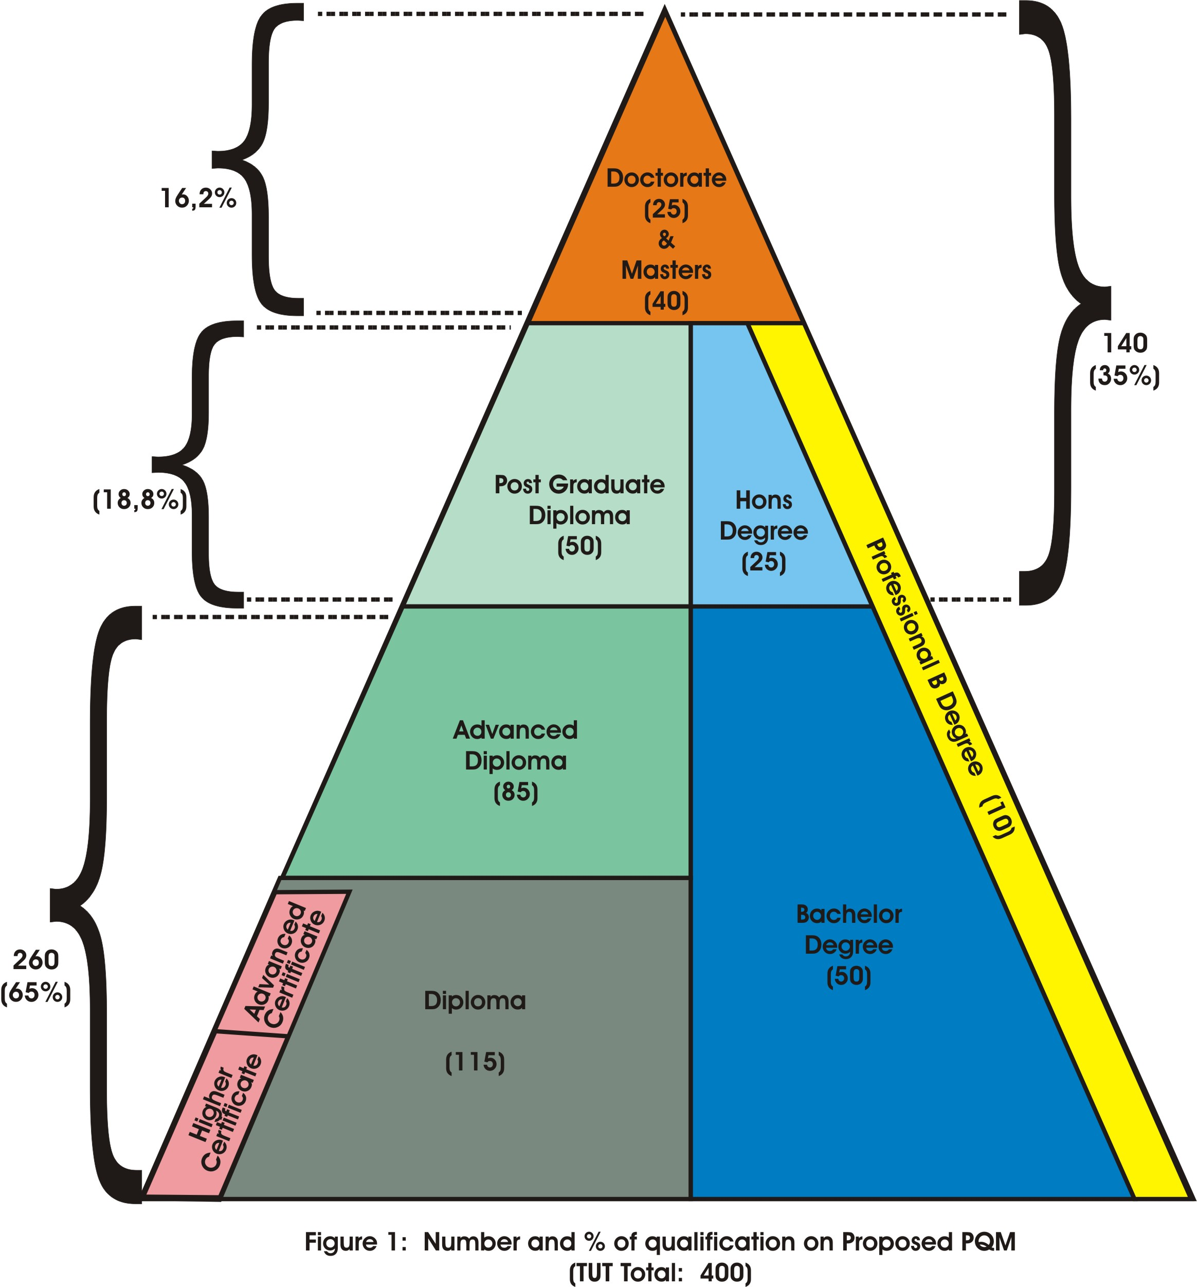

2. The enrolment shape linked to the proposed PQM:

It is proposed that the student enrolment be proportionally distributed to populate the PQM as per Figure 2, and to be reached over the next 4-6 years.

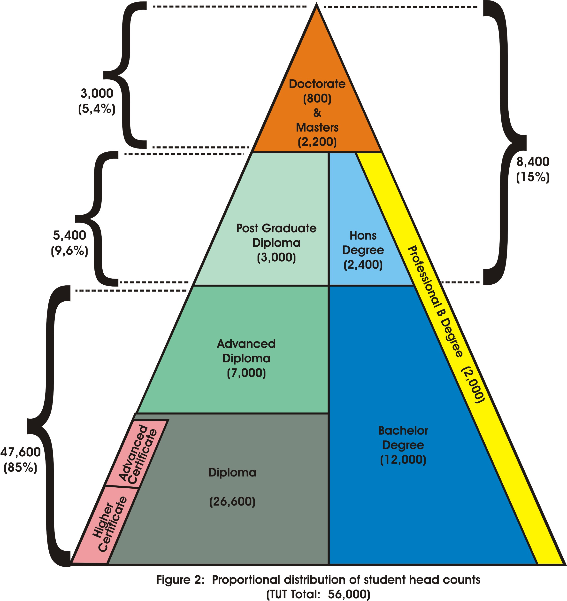

3. Advanced Diploma - articulation from Diploma to Postgraduate Diploma:
There is still uncertainty around the status of the Advanced Diploma, e.g the possible articulation from Diploma to Postgraduate Diploma. It is hence recommended that the current HEQF Act be used as the official view of DoHET.

4. Timeframe per faculty in becoming HEQF compliant & phasing-out of current PQM:

It is estimated that it will take TUT 5-6 years for total compliance, that is, from implementation of first new programmes to implementation of new PQM. In addition, departments must allow for extra 2 years for phasing-out of old programmes (Tables 1 & 2).
Table 1: Estimated timeline for a new qualification if the curriculum development is currently complete
CDS | DQP | Faculty Board | Senate | DHET | SAQA | CHE (HEQC) | Last intake  (Old qualification) | Changes in Prospectus | First intake  (New qualification)
3 months minimum |  | 3 months minimum |  | 6 months  minimum | 6 months minimum | 6 months minimum | Typically at the beginning of the year | Typically by July | Typically at the beginning of the year
February – April 2010 |  | May  2010 | June 2010 | July  2010 | January 2011 | January 2011 | January 2011 | July  2011 | January 2012

Table 2: Example of a possible timeline for a new Diploma
2010 | 2011 | 2012 | 2013 | 2014 | 2015 | 2016 | 2017 | 2018
Develop  - Business Plan  - DHET form  - SAQA form  - HEQC form  - Learning plan, and  - Study guides | Submit to  - CDS & DQP for recommendation  - Senate for internal approval  - DHET for approval  - SAQA for registration  - HEQC for accreditation  Await outcomes  Resubmit after revision (where needed)  Adjust the Prospectus accordingly  Last intake of the old diploma (2012) |  | First intake of the new diploma  *Phase out process begins for the old diploma | Offer new diploma normally  Continue phasing out the old diploma | First HEQF aligned diploma graduates  Continue phasing out the old diploma | Offer new diploma normally  Continue phasing out the old diploma | Offer new diploma normally  Phase out the old diploma completely | Offer new diploma normally
(*If phasing out a qualification: Allow at least double the minimum duration of the qualification.)

- Directives for postgraduate programmes:

5.1 General remarks

- The offering of postgraduate programmes is directly linked to the permanent academic staff profile of a department or faculty. Due to the fact that in many cases conditional appointments have been made, it is important to project the future situation of a department/faculty when planning the offering of postgraduate programmes over the next 4-5 years.
- The directives formulated below must be seen as generic guidelines which should be used during the planning phase. Exceptions and special situations need to be catered for, but departments/faculties are urged to use these guidelines as a baseline and a starting point for planning.
- Provision has to be made for departments that have recently made large investments in the appointment of Professors.
- There is general agreement that TUT should have fewer numbers of Master’s and Doctoral programmes, but larger numbers of students enrolled for each programme.
- It is essential that a substantial number of full time students enroll for these programmes in order to build capacity and to stimulate research.

5.2 Programmes at Master’s and Doctoral levels

- In order for a department/faculty to offer a Doctoral programme, it is essential that there has to be an active research group in the particular field of study in which the Doctoral programme is being offered.
- There should be at least one full Professor and, in addition, two (2) permanent staff members with D degrees available for the offering of a Doctoral programme.
- For the offering of Master’s and Doctoral programmes in a specific department, 80% of the permanent academic staff should have at least Master’s degrees.
- If a department wants to offer Master’s programmes only, there should be at least one permanent staff member with a D degree and at least 60% of the permanent staff should have Master’s degrees.

5.3 Programmes at Honor’s level, Postgraduate Diplomas and Professional 4 year degrees

- If a department wants to offer these types of programmes only, at least 50% of the permanent academic staff should have Master’s degrees.

6. Minimum criteria for a Department to offer a Bachelor’s degree programme:
- At least 3 permanent staff members with M degrees for every Bachelor’s degree programme
- All staff teaching in a 3 year degree programme should at least have an Honours degree or a Post Graduate Diploma (a qualification on level 8 in the new HEQF; level 7 in the old NQF.) The qualifications of part time and temporary staff cannot be considered.

7. Minimum criteria for a Department to offer a Diploma programme:
- All staff teaching in a diploma programme should at least have a first degree or an Advanced/Higher Diploma (a qualification on level 7 in the new HEQF; level 6 in the old NQF.) The qualifications of part time and temporary staff cannot be considered.

8. Faculty PQMs
The following PQM is proposed for TUT in line with the proportional distribution of qualification types as in Figure 1. The proportional distribution of qualification types per faculty is depicted in Table 3. In Figure 3, the proportional distribution of the entire proposed PQM of the institution is shown, which is very similar to the proposed distribution in Figure 1.

Table 3: Proposed PQM per Faculty
Faculty | H. Cert. | Adv. Cert. | Dip. | Adv. Dip. | PG Dip. | B. Degree | Prof. B. Deg. | Hons | Masters | Doctoral | Total
Arts | 0 | 0 | 10 | 9 | 9 | 5 | 0 | 3 | 4 | 3 | 43
Econ. & Fin. | 2 | 2 | 5 | 2 | 1 | 3 | 1 | 2 | 3 | 2 | 23
Eng. & B. Env. | 6 | 6 | 9 | 6 | 4 | 11 | 2 | 3 | 5 | 3 | 55
Humanities | 10 | 10 | 11 | 9 | 0 | 14 | 4 | 8 | 6 | 4 | 76
ICT | 0 | 0 | 8 | 5 | 0 | 4 | 0 | 3 | 3 | 2 | 25
Man. Sci | 0 | 0 | 21 | 18 | 17 | 0 | 0 | 0 | 8 | 4 | 68
Science | 5 | 3 | 22 | 21 | 19 | 13 | 3 | 6 | 11 | 7 | 110
TUT | 23 | 21 | 86 | 70 | 50 | 50 | 10 | 25 | 40 | 25 | 400

Figure 3: Qualification distribution

9. Other considerations

The following considerations should be observed before a department embarks on the process of PQM alignment with the HEQF:

9.1 Diplomas vs Degrees

Whilst Universities of Technology have the option to offer any of the qualifications on the Higher Education Qualification Framework (HEQF), it is primarily regarded as diploma-offering institutions
As such, the guideline is that all Departments should plan to offer diplomas as a point of departure. Departments wanting to offer under-graduate degree programmes instead, will have to strongly motivate their decision after carefully considering the criteria discussed below.

9.2 Purpose of the qualification

The HEQF Act is clear about the distinct difference between the purpose of a diploma and that of a degree. Departments wanting to offer degrees, will have to motivate why they opt to offer
- Well-rounded broad education that emphasises principles and theory (degrees), instead of
- Vocational / occupational or industry specific programmes that focus on applied knowledge and skills (diplomas).

9.3 Admission requirements

There is a significant difference between the admission requirements for diploma programmes and those of degrees. Should a Department wish to offer a degree programme, it would have to
- Provide concrete evidence that the Department will be able to attract students with the appropriate admission scores
- Supply compelling arguments to indicate why students with such a high admission score would prefer to study at a UoT (take into account that the purpose of a degree offered by a University is exactly the same as the purpose of a degree offered by a UoT)
- Indicate the alternative higher education options available to students with a lower admission score.

9.4 Success rates

In some cases, there may be a sufficient number of students that apply with admission scores appropriate for entry into a degree programme. If this is the case, Departments will have to demonstrate a proven track record with regards to their student success rates.

A low success rate may indicate that a large proportion of our students are unsuccessful and are forced to leave the higher education system without any formal qualification.

9.5 Regional relevance

The mandate of the Department of Higher Education and Training (DoHET) is to ensure equitable higher education provision to all South African Citizens in all regions. Therefore, a higher education landscape that only caters for high performers would be unacceptable given the county’s current national priorities. The new ministry is vociferous about opening access to the masses, and does not support the notion of academic elitism.

Each region has particular educational needs that could be addressed by a combination of certificate, diploma or degree programmes. The DoHET will therefore want to ensure access to all types of qualifications in any particular region.

Should a Department wish to offer a degree programme that is also offered by a traditional or comprehensive university in the same region, it would have to provide
- A detailed analysis of all the regional higher education institutions and their related qualifications
- Compelling reasons why they consider this duplication to be appropriate.

9.6 Industry needs

Departments often claim that their particular industry prefers students with degrees rather than diplomas. Should this in fact be the case, a department would have to
- Provide comprehensive written evidence to this effect,
- Demonstrate that industry understands the difference between the purpose of a diploma, and that of a degree, and
- Indicate that no traditional/comprehensive university in the region is offering a comparable degree programme. (If a particular industry does not have any need for diploma students whatsoever, this requirement would not be necessary.)

Should a particular industry indicate that they need both a degree and a diploma, TUT should opt to offer the diploma. Departments will only be allowed to offer a degree and diploma in parallel should
- All their permanent staff be suitably qualified,
- The research outputs of their permanent staff be satisfactory,
- They have the necessary infrastructure to do so,
- Their workload analysis indicate that staff is currently underutilised (as calculated using the workload norms).
Comprehensive evidence to this effect will be required.

10 Earlier Documentation

In the next round of PQM planning, faculties are requested to take into account the above stated guidelines as well as earlier information that has been made available by HEDS and SMS on the planned alignment of the PQM to the HEQF. Staff members of both HEDS and SMS are available to assist in this process.

Task Team on PQM-HEQF Alignment
24 November 2009

