

Tshwane University of Technology

ICT change management INVESTIGATION REPORT

Information and Communication Technology

Version: Draft V1.1

TABLE OF CONTENTS
Discussion 4
Introduction 5
Proposed processes. 7
Terminology 8
Configuration Management 10
Objectives 10
Benefits 10
Change Management 11
Objectives 11
Benefits 11
Steps to implement Configuration Management 13
Step 1: Agree on purpose 13
Step 2: Establish Standards for Configuration Management 13
Step 3: Discover IT Components 14
Step 4: Decide what needs to be managed 14
Step 5: Select Configuration Item Attributes 14
Step 6: Identify relationships and dependencies among Configuration Items 14
Step 7: Add Configuration Items to the Configuration Management Database 15
Step 8: Changing Configuration Items 15
Step 9: Review Configuration Items 15
Configuration Management: Assigning Roles & Responsibilities 16
Steps to implement the Change Management process 17
Step 1: Identify change 17
Step 2: Create Request For Change (Technical Assessment) 17
Step 3: Log change Requests on USD and future CRS (Change Request system) 17
Step 4: Pre-Approval of the Request for Change (Business Assessment) 17
Step 5: Test Change (if Required) 18
Step 6: Feedback of Test Results and Final Approval of the Change Request 18
Step 7: Communication 19
Step 8: Implementation of the Change 19
Step 9: Postmortem Meetings 19
Change Management: Assigning Roles & Responsibilities 20
Points to take into consideration when defining and implementing the Change- and Configuration Management Processes. 22
Possible solutions 25
Solution 1: UniCenter ServicePlus Service Desk 25
Change Management - main responsibilities: 25
System features 26
Functionality 26
Configuration Management - Main responsibilities: 27
System features 27
Functionality 28
Reports 28
Training 29
System Requirements 29
Possible Risks 29
Solution 2: CRM – Customer Relationship Management System 31
About the i5 Group (iBusiness Services & Applications) 31
What is Microsoft CRM? 31
System features 31
Functionality 32
Reports available 32
Training 32
System Requirements 33
Costs 35
Risks 35
Change Management Process Flow Summary 37
Change Management Process Flow Diagram 38
Configuration Management Process Flow Summary 38
Configuration Management Process Flow Summary 39
Configuration Management Process Flow Diagram 40
Planned Change Management Process (Current) 41
Planned Change Management - Current Process 43
Planned Change Management – Current Work Instructions 43
Emergency Change Management Process (Current) 45
Emergency Change Control Process – Current Scope 46
Emergency Change Control Process – Current Procedure 46
Emergency Change Control Process – Current Work Instructions 46
Proposed Planned Change Management Process Flow Diagram 48
Proposed Planned Change Management Workflow Diagram 49
Request for Planned Change – Process 52
Request for Planned Change – Work Instruction 52
Proposed Emergency Change Management Process Flow Diagram 55
Request for Emergency Change - Scope 58
Request for Emergency Change - Process 58
Request for Emergency Change – Work Instruction 58
Formal Request for Change Document Template 60
Purpose 60
Definitions 60
Template RFC 64
Recommendation 66
References 67

Discussion
A need for the development of a change management process and the implementation of such a system exists. The current process does not enforce a rule of completing necessary information for the proper documentation of the request for change by a Change Initiator. Documentation available on the SharePoint Server is not presented in a general format which complicates reporting to the auditors. The process for the development and implementation of a change management system needs to be documented, developed and implemented at ICT Department.

As part of the change control process, any unauthorised events (changes made without legal consent) that may impact services at TUT, as well as Policy Violations needs to be documented for audit purposes as well as ensuring compliance with TUT policies. It would also give the Change Control Committee reasons for requesting changes to existing policies. A formal process / document for capturing Issues and Policy Violations needs to be documented and implemented at ICT Department.

During the investigation various problems and loopholes with the current process where identified and documented.

Meetings were held with members of the Change Control Committee and the current process was documented. A revised process and a suggested Request for Change document template have been compiled. Documentation will be sent to all the Change Control Committee Members for approval.

Identified needs:
- The future system must preferably be a user friendly, web based system.
- The system should have built in notification to relevant stakeholders if the request is captured and approved.
- Sectional changes should be linked.
- Formal sign-off process for RFC’s should be documented.
- The future system should be linked to the Knowledge Management database.
- The future system should be linked to / necessary tickets should be logged at the UniCenter Service Desk system.
- The system should trigger the necessary Disaster Recover Plan section if the implemented change fails to roll back and has lead to a disaster condition, and notification must be sent to relevant stakeholders.
- The future system should initially be implemented in the ICT department, and on a later stage tie into all the other sections involved.

Introduction

What is Change Management?
Change Management – a process to control and coordinate all changes in an ICT environment. A change is defined as any modification that could impact the stability of responsiveness of an ICT production environment.

Change Management can be divided into two basic areas: planning for change and managing change. Change planning is a process that identifies the risk level of a change and builds change planning requirements to ensure that the change is successful. Managing changes is the process that approves and schedules the change to ensure the correct level of notification and minimal user impact. The overriding theme of effective Change Management is communication.

A need for change, whether it is an improvement to or phasing out of an existing service or the creation of a new one, drives the Change Management process. Within a controlled Change Management process, these needs all prompt the creation for a Request For Change (RFC).

The categories of assets that should be placed under change control are broad and include, but are not limited to, hardware, communications equipment and software, system software, applications software, processes, procedures, roles, responsibilities, and documentation that are relevant to the running, support and maintenance of systems in the managed environment (SLA’s).

The Change Control Committee is a cross-functional group of members set up to evaluate change requests for business need, priority, cost / benefit, and potential impacts to other systems or processes. Typically, the Change Control Committee will make recommendations for implementation, further analysis, deferment, or cancellation. Change Control Committee meeting frequency depends on the rate and number of changes in an organization. Short, frequent meetings prevent bottlenecks in implementing changes and decrease the number of emergency changes.

What is Configuration Management?

Configuration Management is a critical process responsible for identifying, recording, and tracking of configuration items, including the description, version, components, relationships to other configuration items, and status. These key ICT components (configuration items) should include hardware, system software, application software, and the policies, operations procedures, and other documentation that support the configuration items.

Configuration Management is intrinsically linked to Change Management. Items that come under the control of Change Management are entered into the Configuration Management Database. Change and Configuration Management work closely together to ensure that a clear and complete picture of the environment is always available.

Good Configuration Management ensures that only authorised components are used in the ICT environment and that all changes are recorded in a Configuration Management Database.

What makes Configuration Management so useful to the organization is that the relationships and dependencies between configuration items are recorded.

Configuration items are initially entered into the Configuration Management Database when RFC’s are approved for implementation by the Change Control Committee members.

From this point on, changes to and status of the configuration items are recorded in the Configuration Management Database. Therefore, the Configuration Management Database acts as a historical record of changes to the environment.

Configuration Management has proven to be very difficult to implement because of the manual effort needed and the constant changes to the IT environment, but is the key to successful managing the Change Management process.

Proposed processes.
The proposed processes have been created in line with the processes and best practice successes observed and investigated from external resources and the ITIL (Information Technology Infrastructure Library) best practices for IT Service Management.

Terminology
Change | Any new ICT component deliberately introduced to the ICT environment that may affect an ICT service level or otherwise affect the functioning of the environment or one of its components.
Emergency Change | Changes that, if not implemented immediately, will leave the organization open to huge risk. Emergency changes must be kept to an absolute minimum due to the increased risk involved in implementing them; their use should not replace good planning practices.
Change Control Committee | A set of cross-functional members set up to evaluate change requests for business need, priority, cost/benefit, and potential impacts to other systems or processes. Typically the Change Control Committee will make recommendations for implementation, further analysis, deferment or cancellation.
Change Initiator | A person who initiates the request for change.
Request for Change | This is the formal change request document, including a description of the change, components affected, business need, cost estimates, risk assessment and approval status.
Configuration Items | Objects that fall under the category of Change Management and are therefore subject to change.
Incident | Incidents can be described as any event that causes a reduction in the quality of the service or a failure in the IT infrastructure.
Request | Service requests can be described as a request from a user for support, information or assistance, and not being a failure in the IT infrastructure.
Problem | A group of related incidents that points to the source of the problem.
Risk Assessment | Evaluation of the impact and risk of the change to the environment.
Performance Assessment | Assessment of the overall impact to system performance of the entire production environment.
Backout Plan | Plan to be followed incase an applied change needs to be reversed/fails and the original state cannot be returned. The backout plan should return the system to the latest usable/working state with the relevant detail as to how users can recover irretrievable data. The plan should be of sufficient detail and include when and how it will be determined if a backout is needed to be performed.
Backup Plan | Plan to ensure all data/information/system state is properly backed up before a change is applied This backup would be available to be used in either Disaster Recovery or Rollback plans This could also apply to provision of standby equipment.
Test Plan | Plan indicating how the change request will be tested to establish the impact and severity of the change on the TUT environment.
Rollback | Plan to return systems to which a change is applied to their original state prior to the change being applied.
Disaster Recovery Plan | Plan that details steps to be taken to restore system and operational functionality (in case of disaster) to enable TUT to perform and render its normal operations and services.

Configuration Management

Objectives
The goal of configuration management is to ensure that only authorised components (configuration items), are used in the IT environment and that all changes to configuration items are recorded and tracked throughout the component’s life cycle.

Objectives of Configuration Management are:
- To identify configuration items and their relationships and add them to the Configuration Management database.
- To update and change configuration items following changes to IT components during the release management process
- To establish a review process that ensures that the Configuration Management database accurately reflects the production IT environment.

Benefits
Many of the main benefits of Configuration Management come from the relationships between configuration items defined in the structure of the Configuration Management Database. Getting these relationships correct is vital for successful Configuration Management. If you have a large number of configuration items, the relationships between them can be difficult to define. However, time spent here will produce benefit beyond the Change and Configuration process itself. It is very useful, for example, in Disaster Recovery scenarios. The Configuration Management Database will be able to show you the effect of a server going offline unexpectedly.

If the Configuration Management database is to be accurate and up to date, no aspect of change to configuration items may be carried out without that change also being recorded in the Configuration Management Database. For this reason, RFC’s are recorded in the Configuration Management Database and are the driving force behind change in the database.

Change Management can use the relationships defined within the Configuration Management Database to determine the impact of a change on other components within the IT environment.

Problem Management can use the Configuration Management Database as a resource to identify which configuration items are the root cause of incidents.
Change Management

Objectives
Objectives of Change Management are to:
- Implement changes in adherence with company policy
- Provide a system that reduces, or eliminates, disruptions due to change activities
- Implement changes on schedule
- Coordinate change activities
- Eliminate, or reduce, the number of change backouts caused by ineffective change planning or implementation

The Change Management process is designed to ensure that installation or modification of computing resources is implemented in an orderly and controlled fashion to minimise change failures and maximise productivity.

Management can assess the impact of changes through Configuration Management reports and regularly scheduled Change Management meetings.

Benefits
Some of the benefits are:
- Consistent planning for change - you use the same format to plan all changes, so changes become quicker to implement.
- Consistent planning in case of failure of change - all changes have a backout plan ready so that you can restore service quickly in case of failure.
- Communication with appropriate parties before change occurs - Affected end-users are aware in advance that changes are scheduled to take place so that they can plan their work accordingly.
- Approval received from appropriate parties before change occurs – the Change Control Committee members have the opportunity to approve changes before you have done too much work on them, so that you can limit the resources spent on inappropriate activities.
- Reduction in incidents and problems caused by unplanned change time spent on preparation and prevention rather than fire fighting and downtime - more attention to planning and preparation will reduce the number of incidents and problems.
- An enhanced business perception of ICT through an improved quality of service and a professional approach.

The results of implementing a controlled Change Management Process are to optimise system viability and minimise outages related to unsuccessful change activities.

The Change Management process covers all operating environments and is used to: define, justify, assess, schedule, implement, and validate change activity targeted for the data processing environment. The Change Management process produces reports that are distributed to management and technical personnel. These reports describe all changes planned for the data processing environment.

The Change Management reports are also utilised to support the Change Management meeting agenda; where change activities are discussed and change schedules established.
Do not expect to be doing closed loop Change Management from the start. Awareness is better than being oblivious, and managed is better than unmanaged. Start with a particular class of changes and constantly refine the process.
Steps to implement Configuration Management
The basic activities of configuration management are:
- Configuration Management planning
Plan and define the scope, objectives, policies, procedures, organizational and technical context for configuration management.
- Configuration identification
Identify CI’s and the owner of the CI’s, interrelationships, documentation structure, and versioning.
- Configuration control
Ensure CI’s are managed throughout their life cycle according to approved change control procedures.
- Configuration status accounting
Status and historical reports of events associated with the CI throughout its lifecycle.
- Configuration verification and audit
Periodic physical inspection of CI’s to verify adherence to change control and configuration management procedures.

Step 1: Agree on purpose
The first and most important step in any project leading to the deployment of Configuration Management is to reach an agreement on its purpose, articulated in terms of key aims and objectives.

When discussing aims and objectives, representatives from all parts of the organization that have a responsibility for IT components and services should be included.

Step 2: Establish Standards for Configuration Management
Configuration Management is only as good as the policies and procedures governing its activities. This includes the procedures that are used in the performance of such Configuration Management tasks as updating the Configuration Management Database, performing audits, reconciling the Configuration Management Database, and preparing management reports. All configuration process activities should be clearly defined and documented.

The policies and procedures that define the relationships and interaction between Configuration Management and Change Management must also be defined. Without proper planning and communication between these groups, the objectives of the Configuration Management process cannot be realised.

Definition and documentation of Configuration Management standards is a best practice, as is maintaining the standards as a single document in a secure location. An example of a best practice policy is: Only a few people and automated processes should have update privileges to the Configuration Management Database.

Step 3: Discover IT Components
All of the IT components must be identified before it can be determined which ones are important enough to be tracked and controlled using Configuration Management. An extensive audit is needed to identify the different types of hardware and software that supports the environment. The audit should also identify relationships between IT components, e.g. All workstations are build using Microsoft Windows XP client.

Step 4: Decide what needs to be managed
Managing and tracking change for every single component within an IT environment would be impractical. Over and above the challenge of obtaining and loading all of this information in the Configuration Management Database, the costs involved in maintaining and updating it would be expensive.

Therefore, choices need to be made concerning the subset of components to be managed. Best practice call for managing only those components that:
- Are necessary for the effective operation of the organization.
- Support the provision of ICT department.
- Can be seriously impacted by changes to other components within the environment.

Step 5: Select Configuration Item Attributes
For every configuration item identified, there is normally a great deal of information that could be recorded in the Configuration Management Database, ranging from the item’s name, description and location to technically detailed configuration settings and options.

If too many attributes are selected, keeping this information accurate and up-to-date can be costly and time consuming. It is far better to select only those attributes that are needed to manage and track changes of the configuration item.

Step 6: Identify relationships and dependencies among Configuration Items
Identifying some relationships is relatively easy, while others may come to light only as changes are made to components within the IT infrastructure. It is advisable to focus initially on identifying the key relationships – those that are essential to the successful operation of the component and the infrastructure in which it is deployed – then add additional relationships as needed.

Relationships between IT components are modeled by building links between configuration items in the Configuration Management Database. When changes are proposed to a configuration item, these links can be used to identify the other configuration items that may be impacted by the change.

Step 7: Add Configuration Items to the Configuration Management Database
The next major process to be conducted after identifying the configuration items and their attributes and relationships to other configuration items, is to add this information to the Configuration Management database.

Step 8: Changing Configuration Items
As approved changes are made to IT components, corresponding changes must be made to the configuration items and relationships that model them in the Configuration Management Database. If managed IT components in the live environment are changed without mirroring them in the Configuration Management Database, information within the database quickly becomes out-of-date or inaccurate, and the value of Configuration Management significantly reduces.

Step 9: Review Configuration Items
Because the accuracy of the information stored in the Configuration Management Database is crucial to the success of the Change Management process, a review process should be set up to ensure that the database accurately reflects the production IT environment.

At regular intervals, Configuration Management staff should perform an inventory of managed components within the production environment and compare the information retrieved with that stored in the Configuration Management Database.

Configuration Management: Assigning Roles & Responsibilities
Below is a list of roles and responsibilities of the configuration manager and the configuration management staff. It is important to note that these are roles, not job descriptions.

The configuration manager defines the processes and procedures that govern management of the Configuration Management Database. Configuration management staff might each be responsible for managing configuration tasks for specific areas of the IT environment.
Configuration Manager | - Establishes the policies and procedures to govern the Configuration Management process.  - Determines the scope and granularity of the Configuration Items recorded in the Configuration Management database.  - Performs audits.  - Promotes and distributes the Configuration Management policies throughout the organization  - Selects, assigns responsibilities to, and trains the configuration management staff  - Establishes Configuration Management database policies, including configuration item-naming conventions.  - Automates Configuration Management Database updating systems, if possible.  - Generates and distributes management reports.  - Provides the Change Initiator with a baseline report for assessing the impact of a change request (if required)  - Updates the Configuration Management Database with all changes to the target environment when both pilot and the full release have been completed.
Configuration Management staff | - Update the Configuration Management Database with new configuration item information and status information.  - Control access to and distribution of documents from document repositories.  - Make changes to the Configuration Management Database structure.  - Prepare management reports.  - Conduct audits and reconcile the Configuration Management database.  - Assist the service desk, incident management, and problem management in using the Configuration Management Database to facilitate the resolution of incidents and problems.  - Perform any other role that the configuration manager needs to delegate.
Steps to implement the Change Management process

Step 1: Identify change
A change is the result of:
- A problem requiring a change for resolution and that is affecting more than one user, such as a server hardware failure.

- A new requirement as a result of advances in technology or needs, such as a software upgrade with new functionality.

Step 2: Create Request For Change (Technical Assessment)
A new Request For Change (RFC) should be created for each change. The Change Initiator is responsible for creating a RFC and prepares additional information needed to submit the request.

The documentation submitted with the Request For Change form includes plans and activities required for modifying the environment and must describe the change’s:

- Impact
- Risk
- Complexity
- Change priority
- Steps required implementing the change
  - Estimated date of implementation
- Level of testing
- Rollback- and backout plan.

A formal Request For Change (RFC) form should be completed and submitted with the documentation to the Change Control Committee for approval thereof.

Step 3: Log change Requests on USD and future CRS (Change Request system)
The Change Control Committee chairman logs a call on the UniCenter Service Desk and future Change Request system. A change record with all the data and information associated with the change is created.

Step 4: Pre-Approval of the Request for Change (Business Assessment)
Perform a business assessment of a change from the risk, impact and installation timing perspective. The purpose of a business assessment is to confirm that the change is consistent with business objectives. The following should be kept in mind during this assessment:
- Ensure that the timing is not creating conflicts
- Ensure that compliance requirements are met
- Ensure all affected users is identified and will be notified of the change
- Ensure that change plans are compatible with and meet the plans and goals of the organization
- Ensure that business audit requirements are met
- Formalizing any additional recommendations or requirements prior to the approval of the RFC

Pre-Approval or rejection of the change will be based in of the merits of the business assessment.

Step 5: Test Change (if Required)
Testing reduces the risk of failure and must be considered when approving changes. After reviewing all elements, the intent of the Change Control Process is to minimise impacts and maximise productivity of all resources involved.

The Test Change process is responsible for testing the change to the resource(s) to ensure that it functions as intended. Testing has four basic steps, which are:
- Unit Test – ensuring owner requirements are complete.

- Integration or Function Test – ensuring nothing has been broken because of the change

- System / Performance Test – test under a working load to ensure stability

- User Acceptance / Installation Test – ensuring the procedures are accurate for installing the change.

Step 6: Feedback of Test Results and Final Approval of the Change Request
Upon completion of the test phase, the Change Initiator submits the test results in the Change Control Committee meeting. Based on the technical assessment, business assessment and test results the Change Control Committee members give a final approval / rejection of the change request. In addition, it may be determined that the change be rescheduled for a later date/time when any risks and/or negative impacts associated with the change could be minimised.

Step 7: Communication
It is important to communicate relevant details of the change to affected users. It is not necessary to distribute full technical details of the change, but those dependent upon ICT services affected will appreciate a brief outline of the user impact.

A change communication should include:
- A simple description of the change, for instance installation of anti-virus software
- Date and time of the change
- Services affected
- Users affected
- Nature of impact, such as complete outage
- Duration of impact
- Contact name and details for further information

It is good practice to present such changes in a positive light by highlighting the benefits of the change. It is also good practice to have a standard method for communication so that users can come to expect a similar format for everything related to the IT environment.

Step 8: Implementation of the Change
Implement the approved change on the agreed date. This phase includes monitoring the installation, which is defined as; tracking, documenting, and communicating the installation progress and results, along with identification of problems or concerns.

It is important to monitor and document this phase. Results of the process (problems and concerns inclusive) should be tracked and communicated. Problem records should be generated in any / all instances where unscheduled outages and / or impacts were encountered as a result of the implementation phase.

Step 9: Postmortem Meetings
These meetings must be scheduled for the purpose of determining process compliance and effectiveness of the implemented change. In case of failure the following questions may be asked:
- Were testing procedures appropriate for the type of change being made?
- Was there an appropriate backout plan in place for the change?
- Were the proper approvals required and received?
- Was the risk of success or failure properly established for the change?
Change Management: Assigning Roles & Responsibilities
A Change Management Process is as effective as its participants and must be administered with a degree of flexibility and clear definition of responsibilities to ensure effective results. It is not the organization which is important, but the effective execution of the Change Management Process responsibilities.

Change Initiator | - Review and understand the Change Management Process  - Understand and concur with the nature of the change to be implemented  - Ensure change records have proper documentation  - Fully understand the business impact of the change  - Attend required meetings  - Present changes in the change control meetings  - Notify the Change Control Committee chairman of potential exposures  - Responsible to inform affected customer / user areas of the proposed change  - Ensure proper testing and test results (if required)  - Provide backout and rollback information for each change  - Obtain proper approval of the change request  - Sign-off on changes owned by them – Concur with the requested installation date, the nature and impact of the change and the test results  - Ensure training is provided to the customer / user community (when required)
Change Control Committee chairman | - Review and update the Change Management process, as needed  - Facilitate Change Control meetings – prepare and distribute meeting information and reports  - Review all change requests to ensure clarity of information  - Identify potential exposures  - Ensure changes are approved prior to implementation  - Provide leadership to the change Implementer  - Review and close installed changes  - Develop and distribute Change Management reports and measurements  - Assist departments in the change process
Change Control Committee members | - Review and understand the Change Management Process  - Understand and concurs with the change and its impact  - Understand the nature of the requested change  - Ensured that there are no outstanding conflicts or issues with the change  - Ensured that the change will be installed as indicated by the change installation date  - Review, approve and schedule change requests  - Identify and communicate to the requester any concerns / exposures  - Ensure all up-front cross team / function activities are complete  - Communicate to the Change Control Committee chairman any unresolved concerns  - Assist in resolving any identified concerns / exposures  - Understand how change errors can be detected

Points to take into consideration when defining and implementing the Change- and Configuration Management Processes.

For successful management of the Change Management process, Configuration Management must first be implemented. It is recommended that:
- The purpose, scope, objectives, policies and procedures to implement configuration management must be defined and documented.
- Configuration Items (including their “owner”), attributes and relationships between configuration items should be defined and documented.
- Only authorised and identified Configuration Items must be recorded and tracked in a Configuration Management database throughout its life cycle.
- After approval of change requests, the identified Configuration Items must be changed and maintained in the Configuration Management Database.
- Configuration Items that is recorded in the Configuration Management Database should be audited and verified of physical existence frequently (e.g. every six months or annually).
- Security is a vital component of configuration management. A Configuration Manager must be appointed to ensure that only authorised personnel change configuration items and only authorised personnel can make the corresponding changes to the Configuration Management Database.
The following is recommended regarding the Change Control Process:
- A change control policy for ICT Department needs to be created. The foundation of effective change control within an enterprise is the change control policy.
  - This policy must be developed specifically for the operating enterprise and requires input from all groups that are stakeholders in ICT operations.
  - These stakeholders include functional business units, end users, developers and engineers, systems and network administrators and ICT management.
  - Senior management’s endorsement and enforcement of this policy is mandatory to successful implementation.
  - To ensure that the Change Control policy adhere to the TUT standards, Quality Promotion Directorate should be actively involved when setting up the policy.
- An Emergency Change Control Committee needs to be formed for handling Emergency change requests.
  - A maximum of 3 people should be identified.
  - The Emergency Change Control Committee members must be able to meet on short notice to review and approve emergency change requests.
- The formal Request for Change document template should be stored in a centralised location (SharePoint Server) to be accessible for all Change Initiators.
- Change Control Committee meetings should be re-scheduled to take place on Mondays.
  - Benefits:
- Change Initiators involved in changes that took place during the weekend will report back on these matters while the subject is still fresh in their minds.
- This will provide more sufficient and effective reports.
- The closing date to submit the Request for Change (RFC) document should be determined and implemented.
- Major planned change requests should be submitted to the ICT Exco meetings for approval, and major emergency change requests should be submitted to the ICT Director for approval.
- Significant and minor change requests should be reviewed and approved by the Change Control Committee members.
- Post mortem meetings should be held to determine whether the change succeeded or not.
- Track the change success rate. Use the change success rate to learn and avoid making historically risky changes.
- Do not authorise changes without rollback plans that everybody reviews. Changes do fail, so be proactive and think ahead about how to recover from a problem rather than attempting to do so during the heat of firefighting.
- Do not let any system changes off the hook - someone made it, so understand what caused it.
General
The Change Management and Configuration Management processes should be the responsibility of the newly appointed ICT Security Officer.
- A new menu (link) must be set up in the Change Management Communities of Practice (Cop) site which will be used to upload new Change for Requests (RFC) and additional documentation related to the RFC, thus achieving the Knowledge Management database requirement.
- A new folder must be created for each RFC (Folder name = RFC’s title).
- Formal Change For Request and additional documents should be uploaded on the SharePoint Server (Change Management CoP site) and after the change order was logged on the new system, the RFC and additional documentation (action plan, backout and rollback plan) must be attached to the call.
- The level of tracking policy violations must be defined and discussed with
Mr. Marco Lanza.
- The SharePoint 2007 version includes InfoPath. This tool can be used to create and publish forms on the web. We recommend that the Request For Change template must be developed in InfoPath after the SharePoint 2007 is installed. This will enable the Change Initiator to complete the RFC online. After submitting the request, the RFC information will be stored in a database and an email message will be sent to the identified responsible person for notification of the new RFC.
- It is recommended that a Release Management policy and process in addition to the Change and Configuration Management process are determined and documented. The reasons being:
- The goal of Release Management is to ensure quality within the production environment through a managed rollout of new versions within the managed infrastructure.
- Although Release Management is part of the Change Management process, it should be documented as a separate process. Release Management is focused on the actual implementation of the approved changes.
- Release Management also works with Configuration Management to ensure that the Configuration Management Database is kept up to date and that all new software releases is stored in the Definitive Software Library.
- The business scope needs to be determined and documented. This document must be handed over to ESI for obtaining a quotation.

Possible solutions

With the first meeting held with Mr. Sundaram Chatty who initiated this Change Management Process Investigation, two possible solutions were identified by him for investigation. Some functionality of both these two solutions is already implemented at TUT.

Solution 1: UniCenter ServicePlus Service Desk

The UniCenter ServicePlus Service Desk system is a comprehensive, integrated solution for the total automation and management of external and / or internal service desks.

It is based on the ITIL (Information Technology Infrastructure Library) best practices for IT Service Management, which is gaining worldwide acceptance as the standard for IT Service Management.

ITIL describes best practices that can be utilised to best suit an organisation. At the core of the library are two volumes of the Service Management discipline, Service Support and Service Delivery. Of the five Service Delivery disciplines, UniCenter ServicePlus Service Desk specifically addresses Incident, Problem, Change, and Configuration Management.

Change Management - main responsibilities:
- Raising and recording change requests
- Assessing the impact, cost, benefit and risk of a change
- Obtaining proper approval for changes
- Managing the implementation of the change
- Monitoring and reporting on the implementation
- Reviewing and closing change requests

- Increased visibility and communication of Changes to both business and service-support staff.
- Improved risk assessment.
- A reduced adverse impact of Changes on the quality of services and on SLA’s.
- Better assessment of the cost of proposed Changes before they are incurred.
- Improved Problem and Availability Management through the use of valuable management information relating to changes accumulated through the Change Management process.
- Increased productivity of User - through less disruption and higher quality services.
- Increased productivity of key personnel through less need for diversion from planned duties to implement urgent Changes or back-out erroneous Changes.
- Greater ability to absorb a large volume of Changes.

System features
- The system provides the means to record and track change requests. These can be entered directly of flow from incidents or problems.
- Supports the approvals process, enabling the change procedures to be track and accounted.
- Change orders are a type of tracking document designed to manage changes to the supported business infrastructure.
- The system contains information about the configuration items being managed in its Repository, which lets them be used in the other ITIL processes.
- It permits integrated access to diagnostic tools such as UniCenter Asset Management, Remote Control, Network and Systems Management, as well as UniCenter Argis for contracts and licenses for accurate service information or financial details.
- Customise user authentication to view only information that they are qualified to view.
- It provides required management reporting.
- Customise Change Order Information Scoreboard specific to the environment.
- Customise format of the unique change order number.
- Attach documents to change orders.
- Create or update a change order in an email if your administrator has set up your site to support this feature.
- Notification messages can be sent automatically when change order activities occur.
- Attached documents can be uploaded and stored in a document repository or a link can be created to retrieve the attached document.
- Monitoring of change orders using the Change Order List window to ensure that changes are responded to promptly.

Functionality
- When creating a new change order, the category field on the change detail form can be selected to categorise the change for ease of reporting as well as providing automated assignment and escalation functionality.
- The change detail form information can be used as a Request for Change (RFC) by selecting a status of “RFC” from the list of statuses in the update change form.
- A specific Incident, Problem or Request can be attached and removed from a change order.
- Locating changes, the Scoreboard or the Change Order Search facility can be used.
- A change order can be created from a request on the UniCenter Service Desk “Requests” menu option, or created directly on the “Change Order Detail” window.
- When a change order is created, an automated number is assigned to the order.
- A change order template can be used to define common changes which will save time because the fields you filled in on the template are automatically filled in for you on the change order.
- Link asset numbers of the systems affected by the change to the change order.
- Parent relationships – where a single change impacts many users, this approach lets you group all related change orders with a sing change order resolution plan in the change order that is defined as the parent.
- Attach service types to a change order – provide automated support of the service levels you have established with customers or internal users.
- Attach service type events to a change order to identify service level violation conditions and send notification messages.
- Calculate the estimated cost and amount of time needed to complete the change if the appropriate information is entered.
- Create composite change orders which enable you to create a custom workflow for a change order based on existing change categories.
- Updating change orders on the Change Order Detail window under the Activities page. This list acts as an audit trail for all work accomplished to resolve the change order.
- Other updating activities that can be performed on a change order:
- Callbacks (call the user again)
- Perform research on the change
- Log comments
- Transfer to another user or group
- Manually notify someone about the change
- Escalate the change
- Attach events for monitoring
- Update status codes
- View summary information for all change orders or a subset of change orders based on your specific selection criteria.
- View summary information of change order and workflow task counts for the logged-in user and open change order counts by priority. This lets you focus on the highest-priority change orders first.

Configuration Management - Main responsibilities:
- Identify all relevant configuration items
- Maintain control over the configuration items
- Account for the status of the configuration items
- Provide audit information on the configuration items
- Enable planning

System features
- An asset record uniquely identifies assets and indicates its precise location.
- On the Configuration Item detail form, the key elements that are specific to the ITIL configuration are the Incidents and Problems tab, as well as the additional fields on the Log tab.
- On the Configuration Item Search form, the key elements that are specific to the ITIL configuration are the columns containing the counts for the number of open Incidents and Problems, in addition to the Requests and Changes for each configuration item.
- Locating Configuration Items, the Scoreboard and Configuration Items Search facility can be used.
- Asset records can be referenced in change orders, issues and requests.
- Link assets to assist in identifying potential problems associated with failed assets.

Functionality
- Assigning configuration item classes and families to an asset record. (Pre-defined classes are linked to pre-defined families)
- Indicate if the configuration item is active / inactive.
- Capture detailed information on the resource in the Inventory window, e.g. asset number, license number, warranty start & end date, serial number etc.
- Provide the configuration item’s System ID/IP address, MAC address, operating system, processor speed etc. in the Properties window.
- Detail history information can be logged regarding comments and / or notes of modifications applied to the asset record in the Log window.
- Detail information on where the asset is located can be captured in the Location window. (Floor, room, building etc.)
- Link personnel / person responsible for the asset.
- Define hierarchical relationships between assets. This lets you group assets that are related to one another. (Parent – child relationships).
- Attach change orders, issues and requests to the asset.

Reports
- Detail or summary reports can be generated in the Reports menu under either Change Order Detail menu or from the Change Order Search menu.
- Detail or summary reports can be generated using specific search criteria in the Change Order List window.
- Detail or summary reports can be generated in the Reports menu under either Configuration Item Detail menu or from the Configuration Item Search menu.
- Standard Reports supplied by CA (Additional):
- Active Change Orders at Weeks End (Graph)
- Active CO's Aging by Priority (Graph)
- Active CO's Aging by Priority for Categories (Graph)
- Active CO's Aging by Priority for Groups (Graph)
- Active CO's Aging Report (Graph)
- Active CO's Aging Report for Categories (Graph)
- Active CO's Aging Report for Groups (Graph)
- Active CO's Aging Report for Status (Graph)
- Change Categories Currently Active (Graph)
- Change Order Status Duration Report by Assignee (Text)
- Change Order Status Duration Report by Group (Text)
- Change Order Totals (Text)
- Change Orders by Failed SvcType for Category (Graph)
- Change Orders by Failed SvcType for Groups (Graph)
- Change Orders by Failed SvcType for Status (Graph)
- SLA Results Based on 24 hours (Text)
- Total Volume of Change Orders (Graph)
- Total Volume of Change Orders by Agent Type (Graph)
- Violated SLA Report for Groups (Graph)
- Violated SLA Report for Status (Graph)
- Workflow Task Aging Report (Text)
- Workflow Task Pending Report (Text)

Training
Formal training can be provided. 2 day Course.
Informal training can be arranged that includes morning sessions or one-on-one training.

System Requirements
Hardware - (Tambotie) Server Capacity will have to be revisited.
Software – For a seamless integration with NSM & Asset Management upgrade the UniCenter Suite to R11. (No cost)

Costs
The Change & Configuration Management modules are part of the Standard UniCenter Service Desk system.

A cost estimate for building in business processes etc. will only be possible after the business scope was determined and documented.

Training costs for formal training: 2 day course @ R2 200.00 per person per day.

Possible Risks
- Conducting regular independent audits to check that Change Management staff, other Service Management staff and Users are adhering to the Change Management procedures.
- Instituting management controls over the activities of in-house and contractors’ support staff and engineers.
- Implementing Configuration management control of all CI’s and versions.
- Detecting User access to equipment or software that is unknown to the Configuration Management system via the Service Desk.
- Training new and existing staff in IT Service Management.
- The BSI publication A Code of Practice of IT Service Management – PD0005 –also lists points to consider as possible problems. Clearly addressing these points will transform the problems into benefits.
- From PD0005: Possible problems with Change Management.
- The scope of a Change is too wide for the resources available, over-stretching the staff and causing delays.
- Ownership of the impacted systems is unclear, resulting in delays and incomplete assessments.
- If Change Management is implemented without Configuration Management, the solution will be much less effective.
- The process is too bureaucratic giving excuses for not following it.
- Inaccurate configuration data may result in poor impact assessments leading to the wrong people being consulted about the Change.
- Poor synchronization of upgrades between platforms and across locations makes Changes difficult or impossible to schedule.
- Back-out procedures are missing or untested.
- Progressing Change requests is manually intensive, it is advisable to start with a simple database or and automated system.
- Lack of backing from senior and middle managers will lengthen implementation times; staff will resist the controls that they would prefer to avoid unless they can see the commitment from manager.
- The process frequently fails when emergency Changes should be done.

Solution 2: CRM – Customer Relationship Management System

About the i5 Group (iBusiness Services & Applications)
Most businesses are keen to harness the rewards gained through the application of information technology and increase their competitive edge, but find this a daunting task and are wary of solutions that are long on promises and short on delivery.

The i5 Group helps such businesses successfully navigate these challenges by means of a holistic approach to their organization and change.

The i5 Group ensures that every technological intervention is assessed from the five key perspectives of: strategy; people; skills; systems, and infrastructure.

What is Microsoft CRM?
Microsoft CRM is a comprehensive CRM solution that helps mid-market businesses increase sales success, provide superior customer service, accurately forecast sales, and analyze business performance.
Microsoft CRM features leads and opportunity management tools, a complete view of customer history, automated incident management, and comprehensive reporting tools for accurate forecasting and measurement of business activity and employee performance.

System features
- Improved process – An improved, defined and unified process for handling Change Management. The workflow is major component allowing escalations as well as automating required functions.
- Accountability – With full auditing (and i5 component) the system ensures those responsible remain so.
- Accessibility – Available through the web as well using the Outlook add-in and a custom web portal the system is easily accessible to all.
- System integration:
  - SharePoint integration – the ability to integrate to SharePoint allows exposing the document management features as well as leveraging InfoPath forms for the submission of information suited to templates.
  - Active Directory integration – integration to AD in order to synchronise contacts so the additional parties etc. are available directly with the system.
  - Third Party integration – the ability to integrate with third party applications, using open Application Programming Interfaces (API) and Microsoft BizTalk Server tools and services.
- Virtually eliminates redundant data entries. Centralised information storage and viewing let users easily share, manage and update information across the Sales and Customer Service modules and across other business solution applications.
- Microsoft CRM can be tailored to meet any business needs, processes, and environment. The solution can be Customised using and extensible data model, UI, and open API’s. Built-in settings and forms are easily configurable, and the workflow engine allows you to create and automate processes for support, routing and notifications.
- Microsoft CRM offers both a rich client (accessible through MS Outlook) and a thin client (accessible from anywhere through a Web browser).
- Set up, configure and customise easily – Microsoft CRM is designed for rapid implementation, with centralised installation that ensures facet deployment, easy maintenance and straightforward upgrades.
- Some of the key features that exist in the change control interface are:
  - Adding a configuration item for a specific server.
  - Ability to add additional incidents and problems or linking to existing.
  - Ability to add required and optional approvers that need to approve a change control.
  - Ability to control the change control process via the monitoring of all change requests through a central change control coordinator.
  - Ability to add multiple users that might be required to assist with the implementation of the change control.

Functionality
- Change Request management - this can involve relationships to the incident initiating the change request. A framework to manage problems (these can then be related to an incident). The net result being many problems (e.g. No access to email) to one incident (e.g. Exchange server down) related to a Change Control (e.g. Exchange upgrade).
- The Change Request entity covers the following functions:
- Approval tracking
- Activity tracking (emails etc)
- Document management
- Third party involvement
- A Web portal which allows the logging of incidents and requesting of change controls through the web.

Reports available
- Standard reports available to cover the basics.
- Further SQL reports can be designed to meet the exact business requirements.
- The system has the standard ability to export to MS Excel; this includes live pivot tables on the data and typically meets basic slice & dice requirements.

Training
Training is provided on the Customised system and there is also standard Microsoft training available although not always suitable.

System Requirements
Microsoft CRM Software Requirements
- Microsoft Windows 2000 Server (or Advanced Server) with Service Pack 3 or later. Also install the following services:
- Microsoft Message Queuing (MSMQ)
- Indexing Service
- Internet Information Services
- Microsoft Data Access Components (MDAC) 2.7 SP1
- The following components are required and are installed during Microsoft CRM installation.
- Microsoft XML Core Services 4.0 with Service Pack 1
- Microsoft .NET Framework with Service Pack 2.
- The computer running Microsoft CRM must also have access to computers in the same Active Directory Domain running:
- Microsoft SQL Server 2000 with Service Pack 2 or later.
- Microsoft CRM may co-exist on the same computer as either Microsoft SQL Server or Microsoft Exchange Server, but this configuration is not recommended.

Microsoft CRM Browser Client Software Requirements
- Microsoft Windows 98 Second Edition, Microsoft Windows 2000 (Server or Professional), or Microsoft Windows XP (Professional or Home).
- Microsoft Internet Explorer 5.5 with Service Pack 2 or later.

Microsoft CRM Sales for Outlook Software Requirements
- Windows 2000 (Server or Professional) with Service Pack 3, or Windows XP Professional with Service Pack 1.
- Microsoft Office 2000 with Service Release 1, or Microsoft Office XP.
- Microsoft Office 2000 has the following additional requirements. Service Pack 3 and the additional patches are on the Microsoft CRM Supplemental CD for Office 2000.
- Microsoft Office 2000 SP3
- Microsoft Outlook 2000 patch post-SP3
- Microsoft Office 2000 patch for Microsoft CRM
- Microsoft Internet Explorer 5.5 with Service Pack 2 or later. (If a version of IE less than 5.5 is present, Internet Explorer 6.0 will be installed.)

Microsoft CRM-Exchange E-Mail Router
- Microsoft Windows 2000 Server (or Advanced Server) with Service Pack 3 or later. Also install the following services:
- Microsoft Exchange 2000 Server with Service Pack 3.
- Microsoft Internet Explorer 5.5 with Service Pack 2 or later.
- The following components are required and are installed during Microsoft CRM-Exchange E-mail Router installation.
- Microsoft XML Core Services 4.0 with Service Pack 1
- Microsoft .NET Framework with Service Pack 2.
Hardware Recommendations
Servers

Large Deployment (Dedicated Servers)
Recommended for up to 150 Users (Supports up to 300 Users)

SQL Server 2000 Server
Hardware Requirements (minimum)
- Processor: Single 700 MHz Xeon PIII
- RAM: 512 MB
- Controller: SCSI with Hardware RAID 5 (3 drives minimum)
- Network Card: 10/100 Mb Network Card

Hardware Requirements (recommended)
- Processor: Dual 1.8 GHz Xeon P4
- RAM: 1 GB
- Controller: SCSI (second controller preferred) with Hardware RAID 5 (3 drives for RAID 5 – 2 for RAID 1)
- Network Card: 10/100 Mb Network Card

Active Directory Server
Hardware Requirements (minimum)
- Processor: Single 500 MHz Xeon PIII
- RAM: 512 MB
- Controller: SCSI with Hardware RAID 5 (3 drives minimum)
- Network Card: 10/100 Mb Network Card

Hardware Requirements (recommended)
- Processor: Single 1.8 GHz Xeon P4
- RAM: 512 MB
- Controller: SCSI (second controller preferred) with Hardware RAID 5 (3 drives for RAID 5 – 2 for RAID 1)
- Network Card: 10/100 Mb Network Card

Exchange 2000 Server
Hardware Requirements (minimum)
- Processor: Single 500 MHz Xeon PIII
- RAM: 512 MB
- Controller: SCSI with Hardware RAID 5 (3 drives minimum)
- Network Card: 10/100 Mb Network Card

Hardware Requirements (recommended)
- Processor: Dual 1.8 GHz Xeon P4
- RAM: 512 MB
- Controller: SCSI (second controller preferred) with Hardware RAID 5 (3 drives for RAID 5 – 2 for RAID 1)
- Network Card: 10/100 Mb Network Card
Clients
Browser Client
Hardware requirements (minimum)
- Processor: Pentium III — 500 MHz
- RAM: 64 MB
- Network Card: 10/100 Mb Network Card

Hardware requirements (recommended)
- Processor: Pentium III — 500 MHz
- RAM: 128 MB
- Network Card: 10/100 Mb Network Card

Microsoft CRM Sales for Outlook Client
Hardware requirements (minimum)
- Processor: Pentium III — 800 MHz
- RAM: 256 MB
- Hard Disk: 100 MB free space
- Network Card: 10/100 Mb Network Card

Hardware requirements (recommended)
- Processor: Pentium 4 — 500 MHz
- RAM: 512 MB
- Hard Disk: 100 MB free space
- Network Card: 10/100 Mb Network Card

Costs
See Annexure A for Pilot release

Additional costs on customization of the Configuration and Change Management modules according to the business requirements can only be determined during the analysis phase.

Additional licenses needs to be purchased per user.

Risks
- Due to the fact that the CRM system will be purchased by Student Support Services, and the available licenses will be used by them, additional licenses must be purchased to make use of the Change and Configuration Management modules.
- The CRM pilot was scheduled for March 2007, but put on hold due to financial reasons. Implementation may only be finalised in three year’s time.
- The CRM costs for configuration and customization of the system can only be determined during the analysis phase when the business requirements for configuration and / or customization of the system can be determined.
- CRM system will not be integrated with the UniCenter Service Desk system, thus incidents and problems logged on the Service Desk cannot be linked to the change requests logged on the Change Management module.

Change Management Process Flow Summary
In the context of change management, change is defined as anything – hardware, software, system components, services, documents or processes – that is deliberately introduced into the ICT environment and may affect the ICT Service Level Agreement (SLA) or otherwise affect the functioning of the environment or one of its components. Changes can be either permanent or temporary. Changes can completely replace a current version of a component; either with a new component or a changed version of the component or it can involve the installation of a completely different component or the removal of an outdated one.

Whether permanent or temporary, new or revised, all changes falling under this definition must be managed by the change management process.
This is important because changes may:
- Affect multiple users
- Potentially disrupt mission- or business-critical services
- Involve hardware (such as servers or networking equipment) or software modifications
- Affect data stored in ICT systems (depended on the type of data)
- Involve operational and process modifications that affect multiple users.

Key tasks that need to be performed in order to successfully deploy a change are shown in the process flow diagram. This high-level diagram can be further organised to provide detailed end-to-end process descriptions.

Process Flow:
  - Initiate a change
  - Complete and submit a formal Request For Change.
  - Review and prioritise the change request.
  - Authorization of the change request.
  - Implementation of the approved change request.
  - Post-mortem meetings of the implemented change.

Change Management Process Flow Diagram
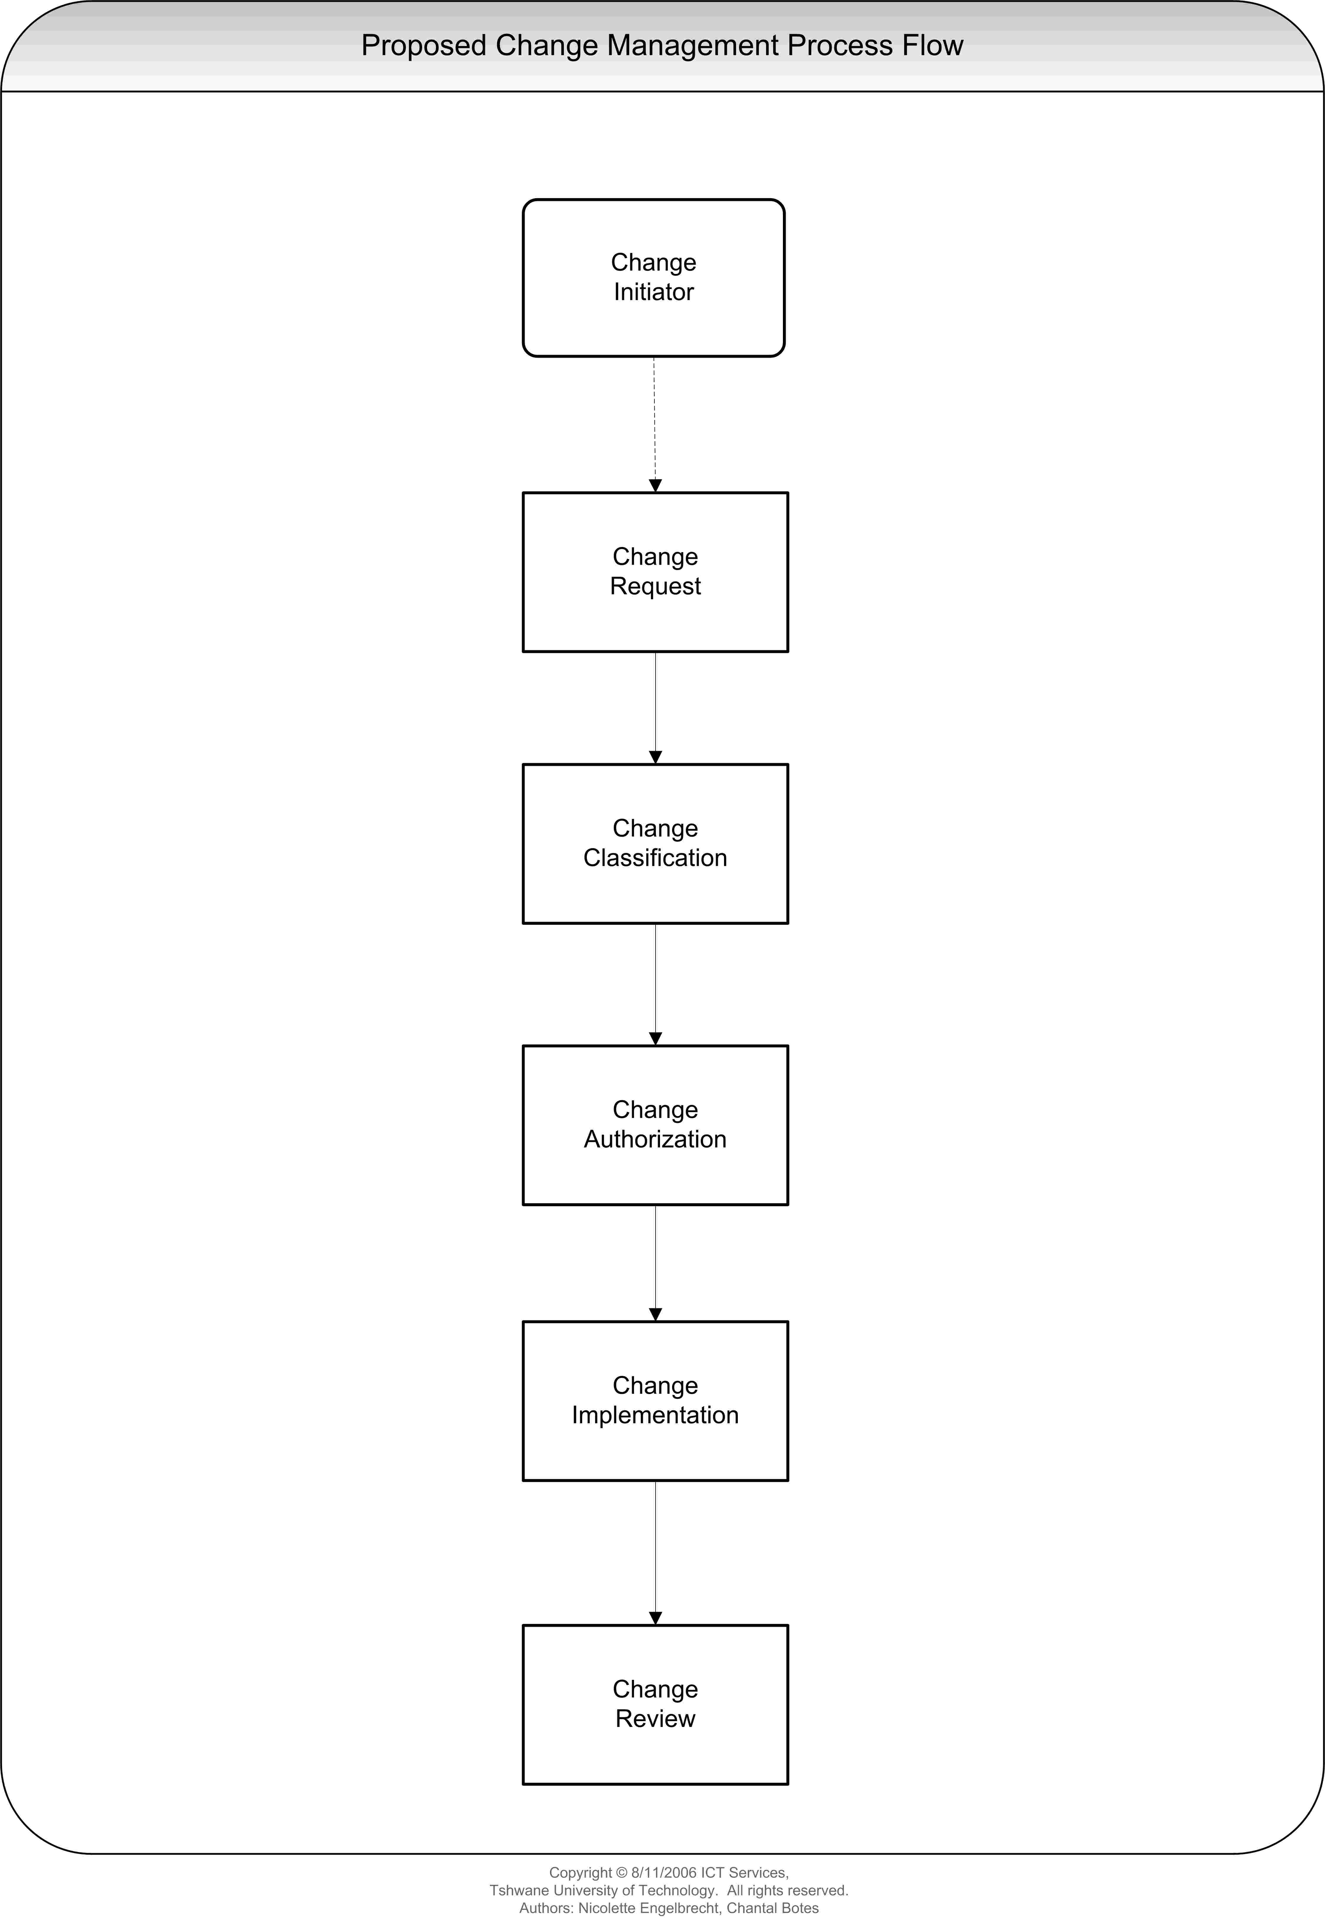

Configuration Management Process Flow Summary
Configuration management is graphically represented in the form of a process flow diagram that identifies the activities needed to successfully manage and control key components of an ICT infrastructure. This high-level overview can be further broken down into a number of detailed activities and process flows, which are summarised below. Together these detailed activities and process flows provide a comprehensive blueprint for the configuration management process.

Prior to initiating the configuration management process flow activities described below, a number of detailed setup and planning activities must be completed in order to use configuration management effectively.

Process Flow:
- Establish Configuration Items (CI’s)
Configuration items are created in the Configuration Management database to permit management of components at this level.
Identify relationships between IT components and build connections between configuration items in order to model the real-world situation.

E.g. A workstation is made up of a desktop computer, operating system, and applications. The workstation is connected to and uses the network.

The proper understanding and documentation of relationships between IT components makes it possible to perform detailed impact analysis on a proposed change.

- Access Configuration Items (CI’s)
After adding the information about IT components, and adding relationships between the CI’s, it can be used by other functions:
- Change Management – to determine the level of impact on other components
- Problem Management – to identify which CI’s are the root cause of incidents etc.

- Change Configuration Items (CI’s)
After approved RFC’s was implemented and changes was made to IT components, corresponding changes must be made to the Change Management database. Without accurate and up-to-date information, the value of configuration management is lost. This process should be done automatically, wherever possible.

- Review Configuration Items (CI’s)
The accuracy of the information stored in the Change Management database is crucial to the success of the Change Management and Incident Management functions. A review process that ensures that the database accurately reflects the production environment needs to be established.

Configuration Management Process Flow Diagram
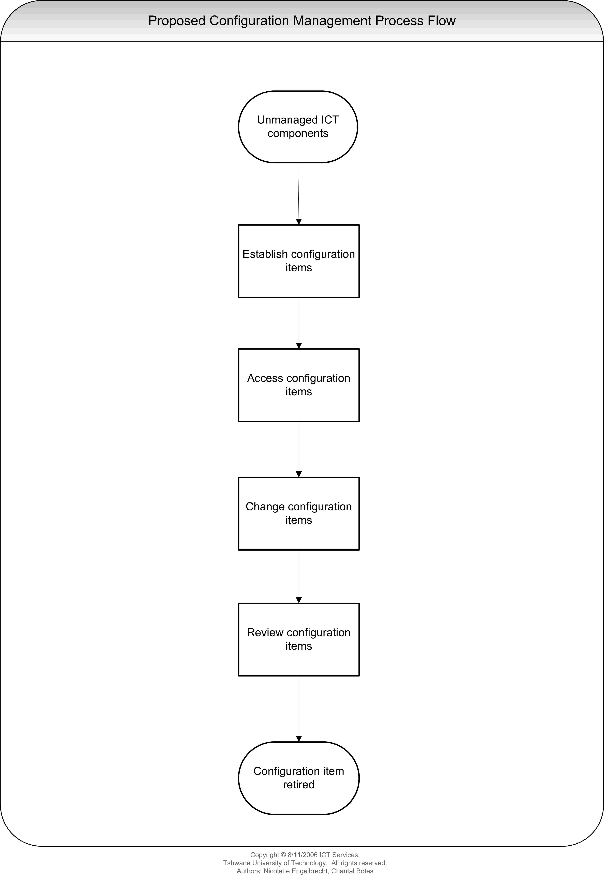

Planned Change Management Process (Current)
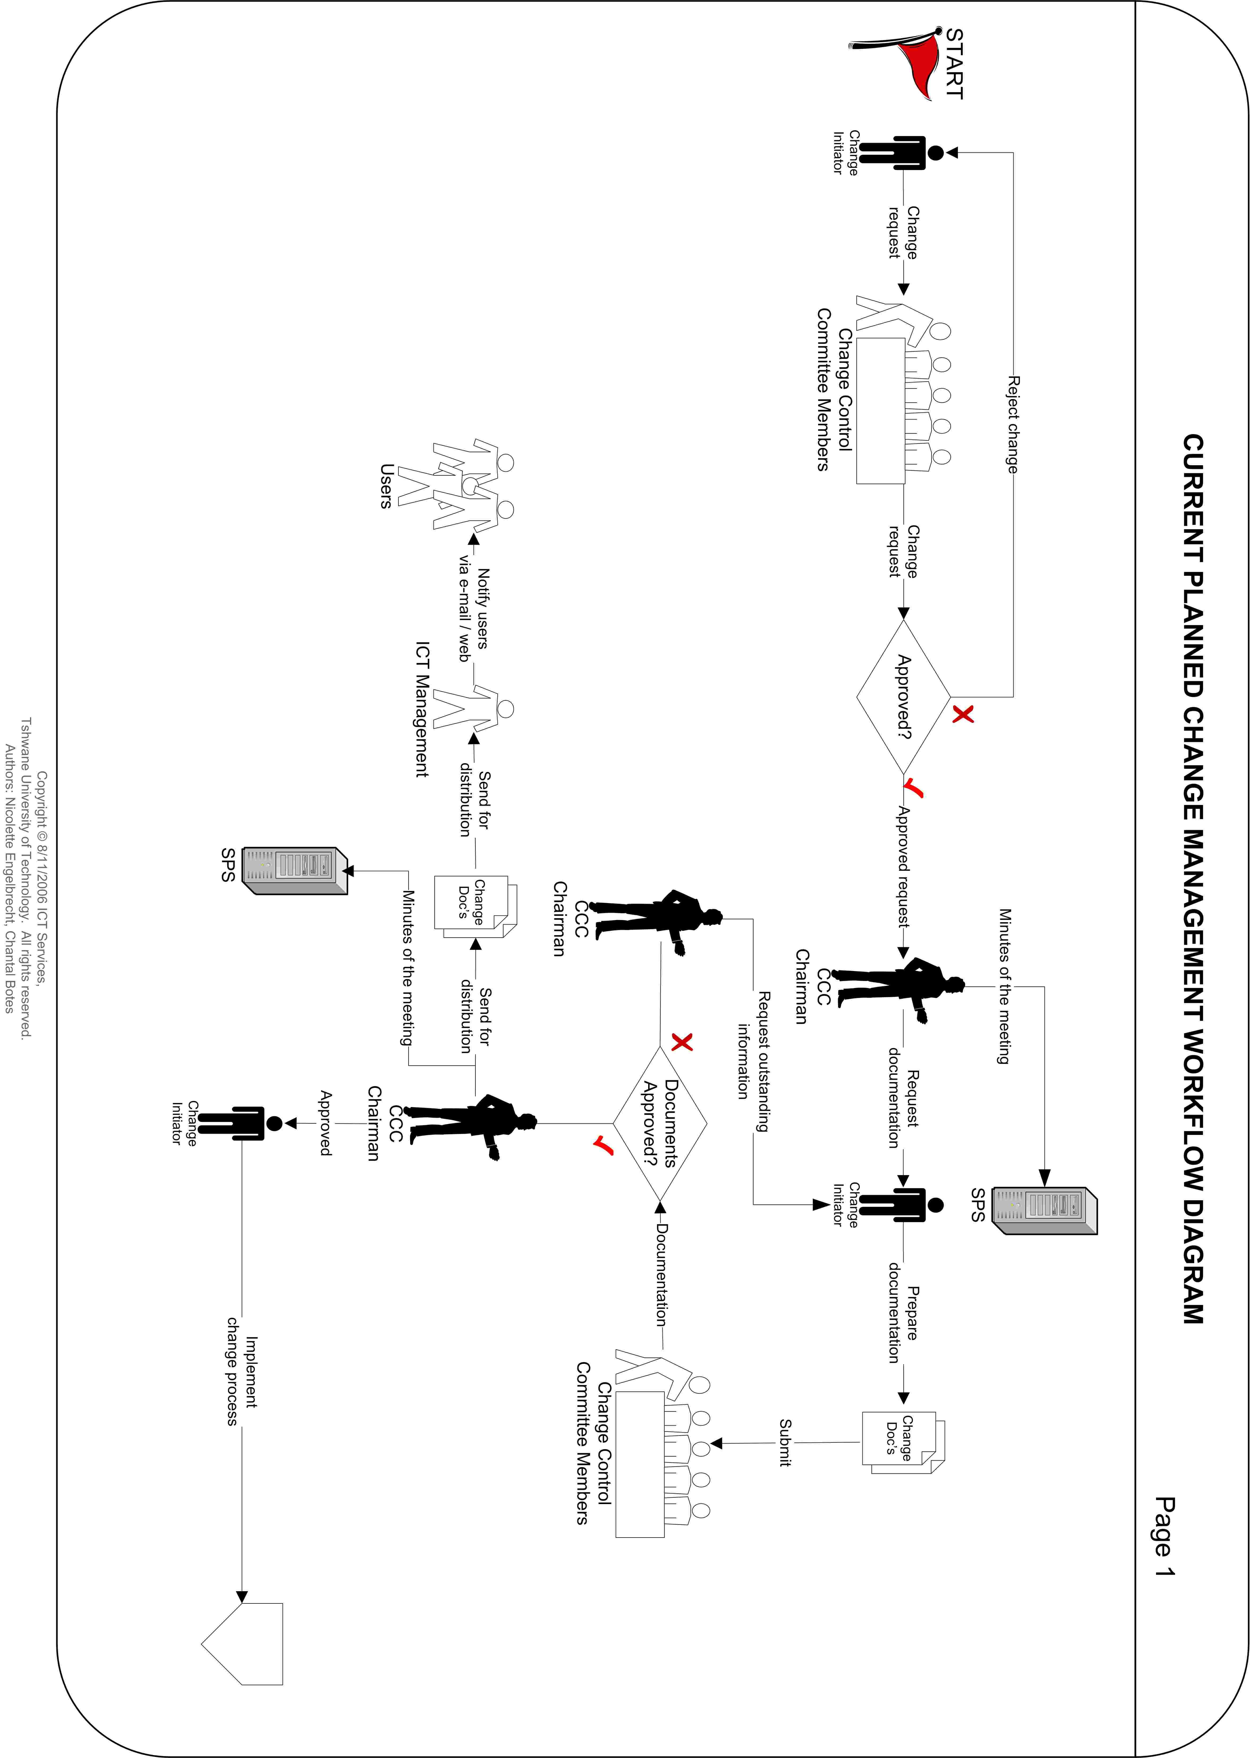
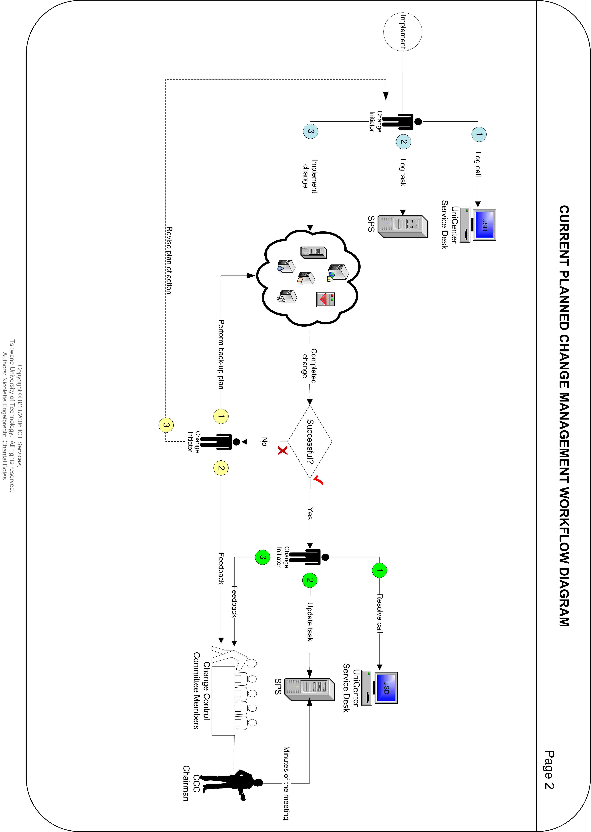
Planned Change Management – Current Scope
Change Initiator requests the Change Control Committee to perform a planned change.
A planned change to the production environment is scheduled at least 24 hours in advance.

Planned Change Management - Current Process
- Request a change.
- The Change Control Committee members approve / reject the change request.
- The Change Initiator prepares and submits the required documentation.
- Members of the Change Control Committee approve / reject the proposed documentation submitted by the Change Initiator.
- Implementation of the approved change.
- The Change Initiator provides feedback on completed change at the next Change Control Committee meeting.

Planned Change Management – Current Work Instructions
- The Change Initiator requests to perform a change from the Change Control Committee members in the Change Control Committee meeting.
- The Change Control Committee members approve or reject the change request.
- If the change request is rejected the Change Control Committee members informs the Change Initiator in the Change Control Committee meeting.
- If the change request is approved:
  - The Change Control Committee chairman notes the outcome in the minutes of the meeting.
  - The Change Control Committee chairman requests the required documentation from the Change Initiator.
  - After the meeting the Change Control Committee chairman uploads the minutes of the meeting on the SharePoint Server.
- The Change Initiator prepares the required documentation and submits the documentation to the Change Control Committee members for approval.
- The Change Control Committee members review and approve / reject the proposed documentation in the next Change Control Committee meeting.
- If the proposed documentation has insufficient information:
  - The Change Control Committee chairman notes the outcome in the minutes of the meeting and requests the outstanding information.
  - The Change Initiator revises the proposed documentation and adds the outstanding information.
  - The Change Initiator submits the revised documentation to the Change Control Committee members for approval.
- If the proposed documentation is approved:
  - The Change Control Committee chairman notes the outcome in the minutes of the meeting.
  - After the meeting the Change Control Committee chairman uploads the minutes of the meeting on the SharePoint Server.
  - The Change Control Committee chairman sends the approved documentation for distribution to ICT Management.
  - ICT Management notifies affected TUT users of the change via e-mail and / or the intranet.
- The Change Initiator logs a change request call on the UniCenter Service Desk via the intranet / Service Desk Operator and a task is logged on the SharePoint Server.
- The Change Initiator implements the approved change.
- If the completed change was successful:
  - The Change Initiator resolves the call on the UniCenter Service Desk via the intranet / Service Desk Operator and updates the task logged on the SharePoint Server.
  - The Change Initiator provides feedback at the next Change Control Committee meeting.
  - The Change Control Committee chairman documents the successful outcome of the change in the minutes of the meeting.
  - The Change Control Committee chairman uploads the minutes of the meeting on the SharePoint Server.
- If the completed change failed:
  - The Change Initiator performs back-up plan.
  - The Change Initiator provides feedback at the next Change Control Committee meeting.
  - The Change Control Committee chairman documents the outcome in the minutes of the meeting.
  - The Change Initiator revises the plan of action.

Emergency Change Management Process (Current)
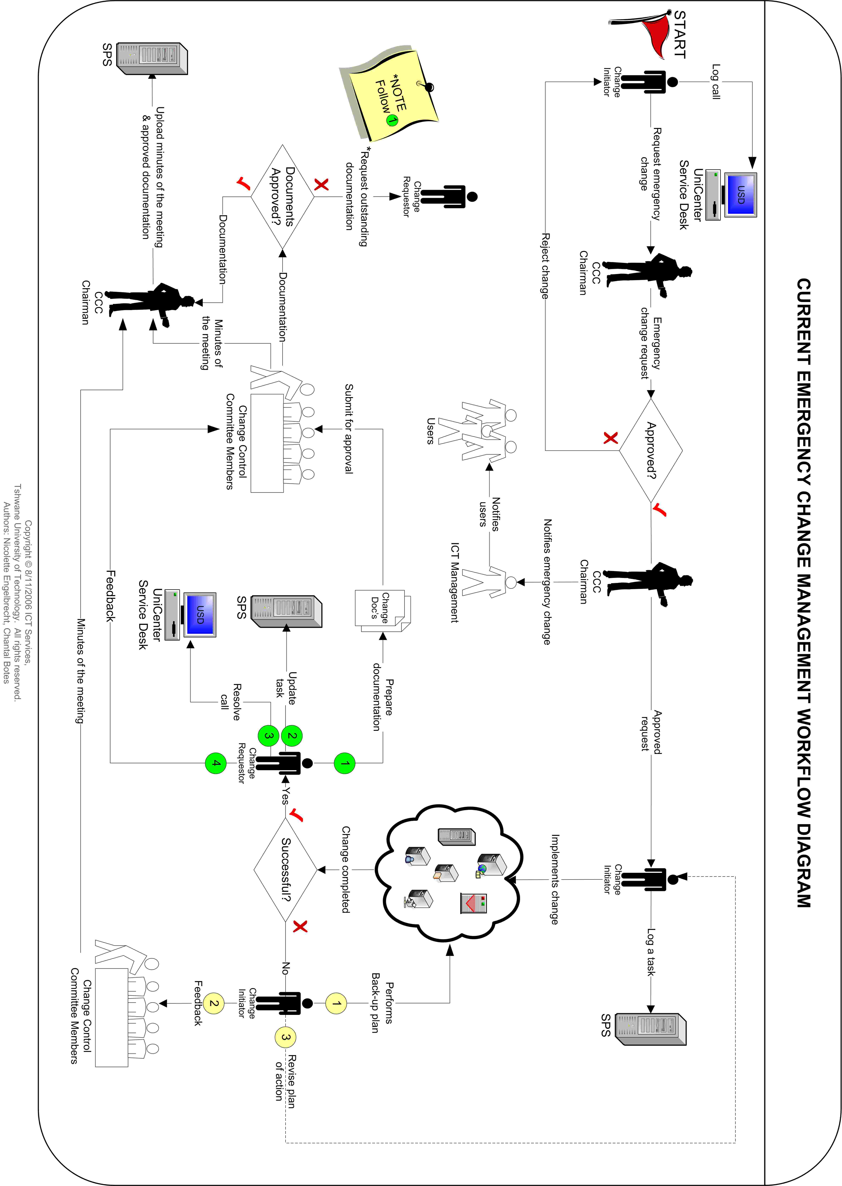

Emergency Change Control Process – Current Scope
Change Initiator requests the Change Control Committee chairman to perform an emergency change.
An urgent, mandatory change requiring manual intervention within 2 hours to restore or prevent interruption of accessibility, functionality, or acceptable performance to a production application or to a support service.

Emergency Change Control Process – Current Procedure
- Request an emergency change.
- Obtain approval from the Change Control Committee chairman.
- Notification of the emergency change to ICT Management.
- Perform the approved emergency change.
- The Change Initiator prepares the outstanding documentation.
- The Change Initiator submits the documentation and gives feedback on completed emergency change at the next Change Control Committee meeting.
- Members of the Change Control Committee approve / reject the documentation submitted by the Change Initiator.

Emergency Change Control Process – Current Work Instructions
- Change Initiator logs an emergency change request call on the UniCenter Service Desk via the intranet / Service Desk Operator.
- The Change Initiator notifies the Change Control Committee chairman that an emergency change needs to be performed.
- The Change Control Committee chairman approves the emergency change and determines the actual time the emergency change may take place.
- The Change Control Committee chairman notifies ICT Management of the emergency change.
  - ICT Management notifies affected TUT users of an emergency change via e-mail and / or the intranet.
- The Change Initiator logs a task on the SharePoint Server.
- The Change Initiator implements the emergency change.
- If the completed emergency change was successful:
  - The Change Initiator prepares the documentation of the completed emergency change and submits the documentation to the Change Control Committee members.
  - The Change Initiator resolves the call on the UniCenter Service Desk via the intranet / Service Desk Operator and updates the task logged on the SharePoint Server.
  - The Change Initiator provides feedback at the next Change Control Committee meeting.
  - The Change Control Committee chairman documents the successful outcome of the emergency change in the minutes of the meeting.
- Change Control Committee members review and approve / reject the proposed documentation in the Change Control Committee meeting.
- If the proposed documentation has insufficient information:
  - The Change Control Committee chairman documents the decision in the minutes of the meeting and requests the outstanding information.
  - The Change Initiator revises the proposed documentation and adds the outstanding information.
  - The Change Initiator submits the revised documentation to the Change Control Committee members for approval.
- If the proposed documentation is approved:
  - The Change Control Committee chairman documents the decision in the minutes of the meeting.
  - The Change Control Committee chairman uploads the documentation on the SharePoint Server.
- If the completed emergency change failed:
  - The Change Initiator performs a back-up plan.
  - The Change Initiator provides feedback at the next Change Control Committee meeting.
  - The Change Control Committee chairman documents the outcome in the minutes of the meeting and uploads the minutes on the SharePoint Server.
  - Change Initiator revises the plan of action.

Proposed Planned Change Management Process Flow Diagram
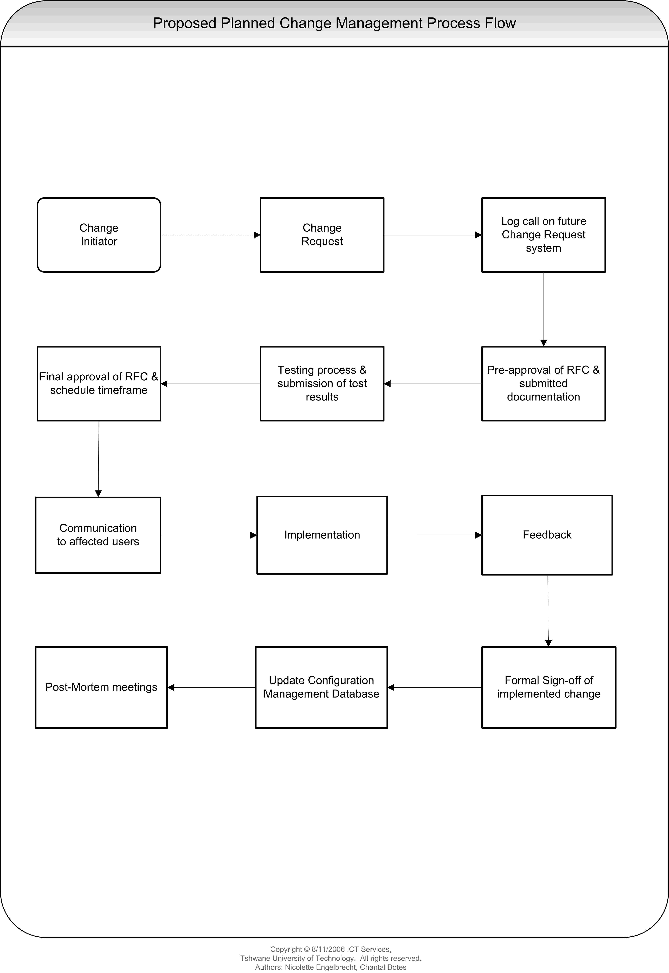

Proposed Planned Change Management Workflow Diagram
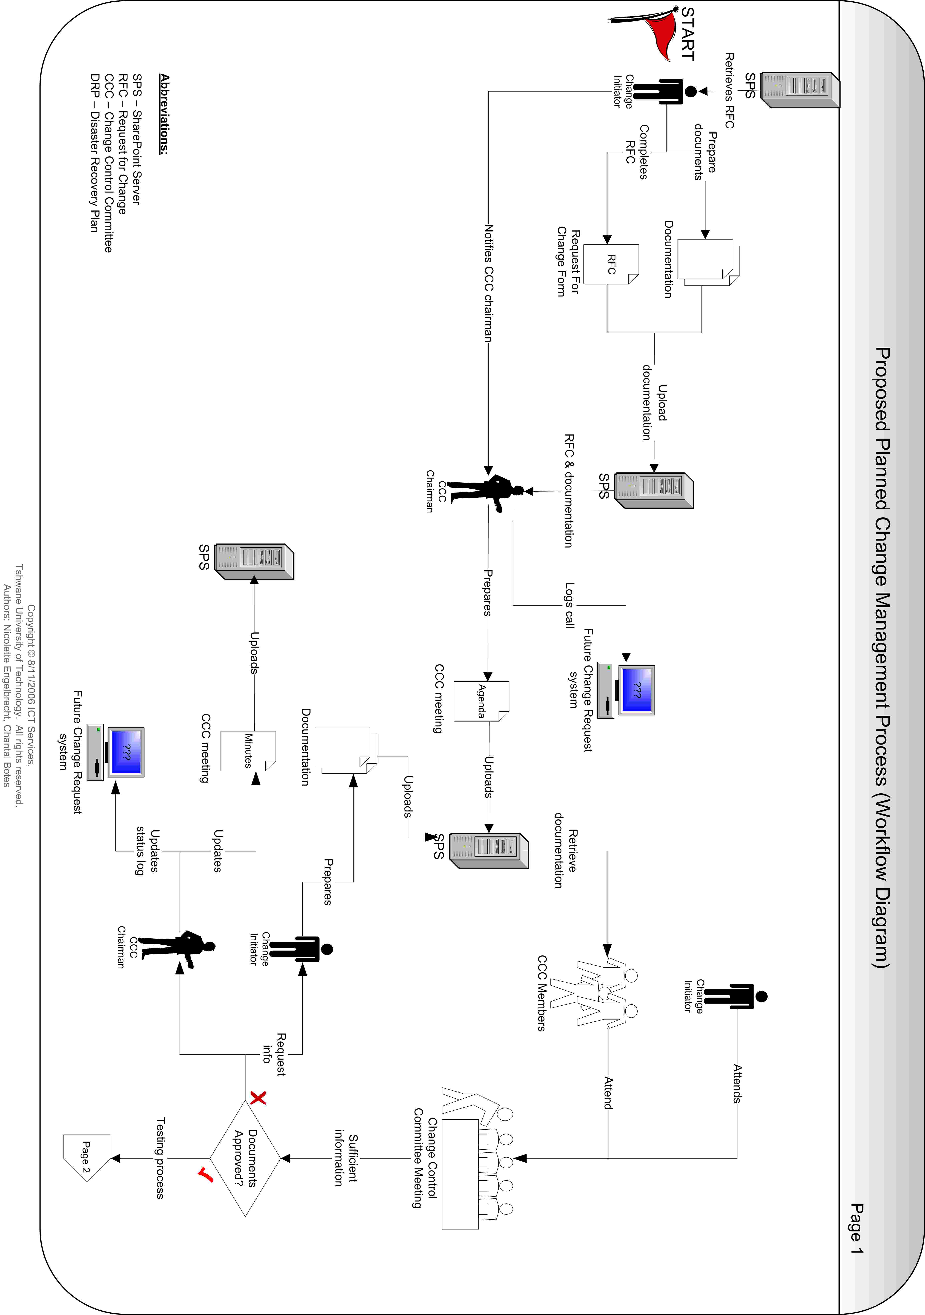
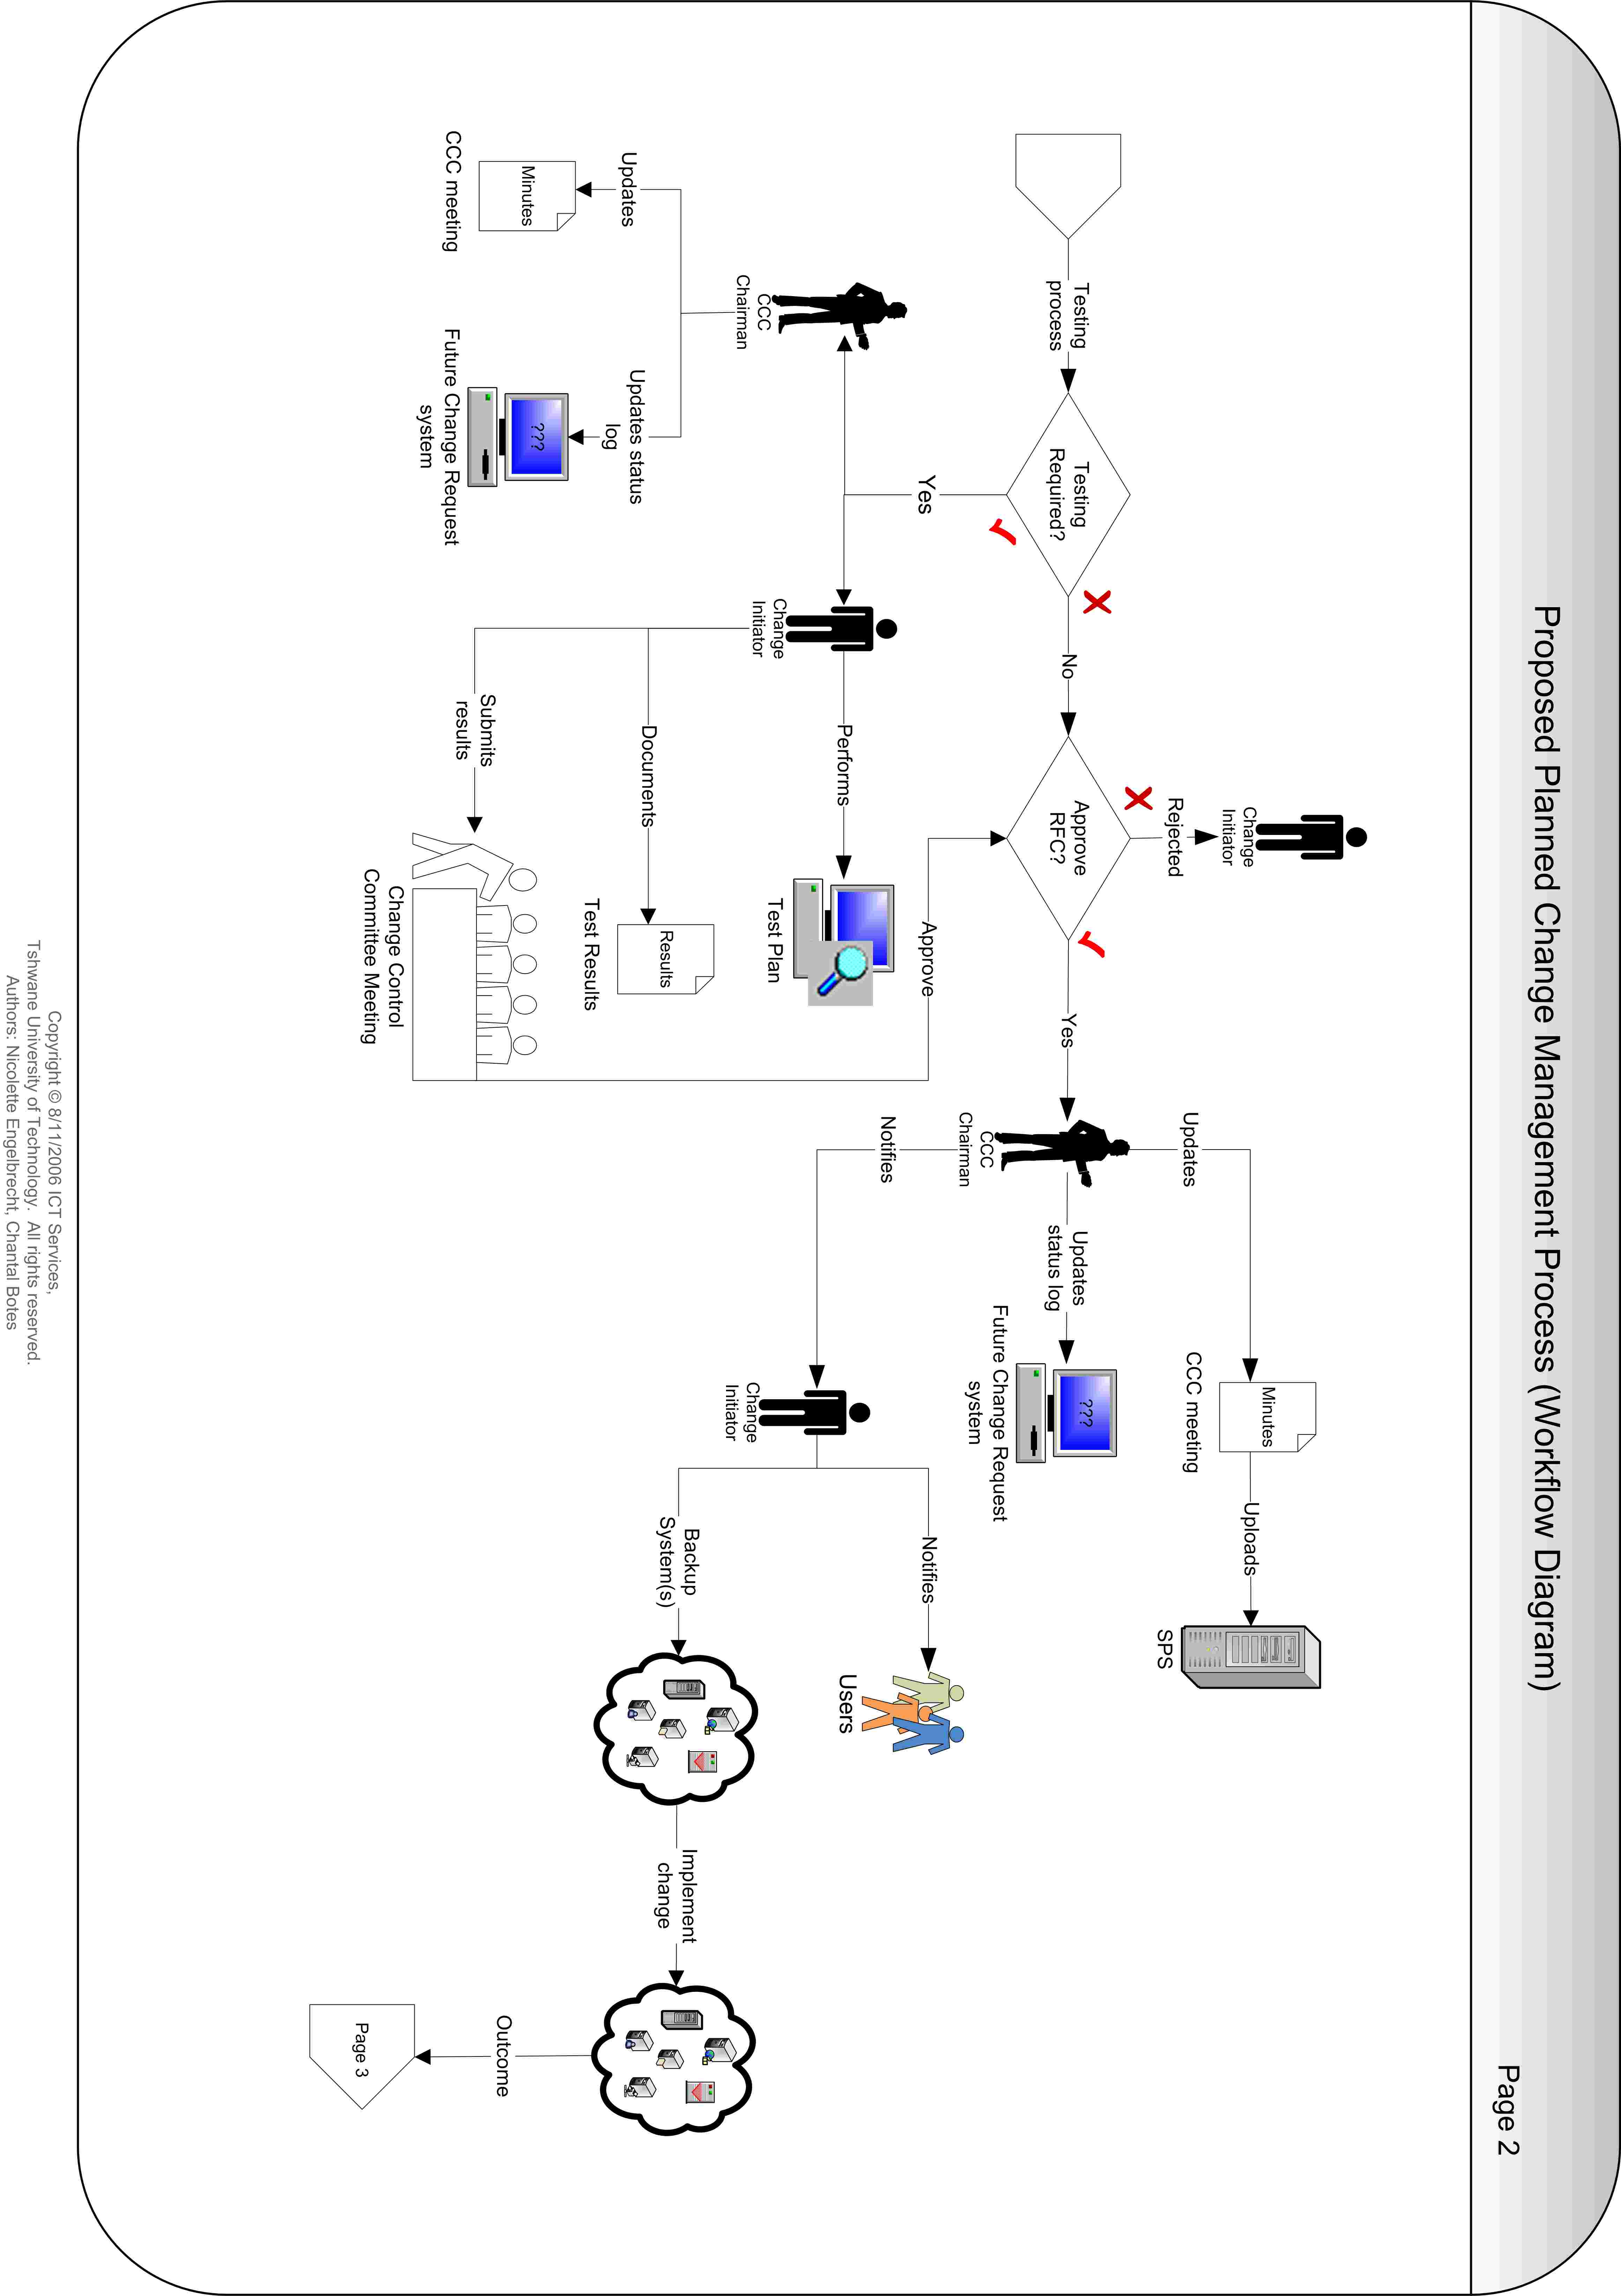

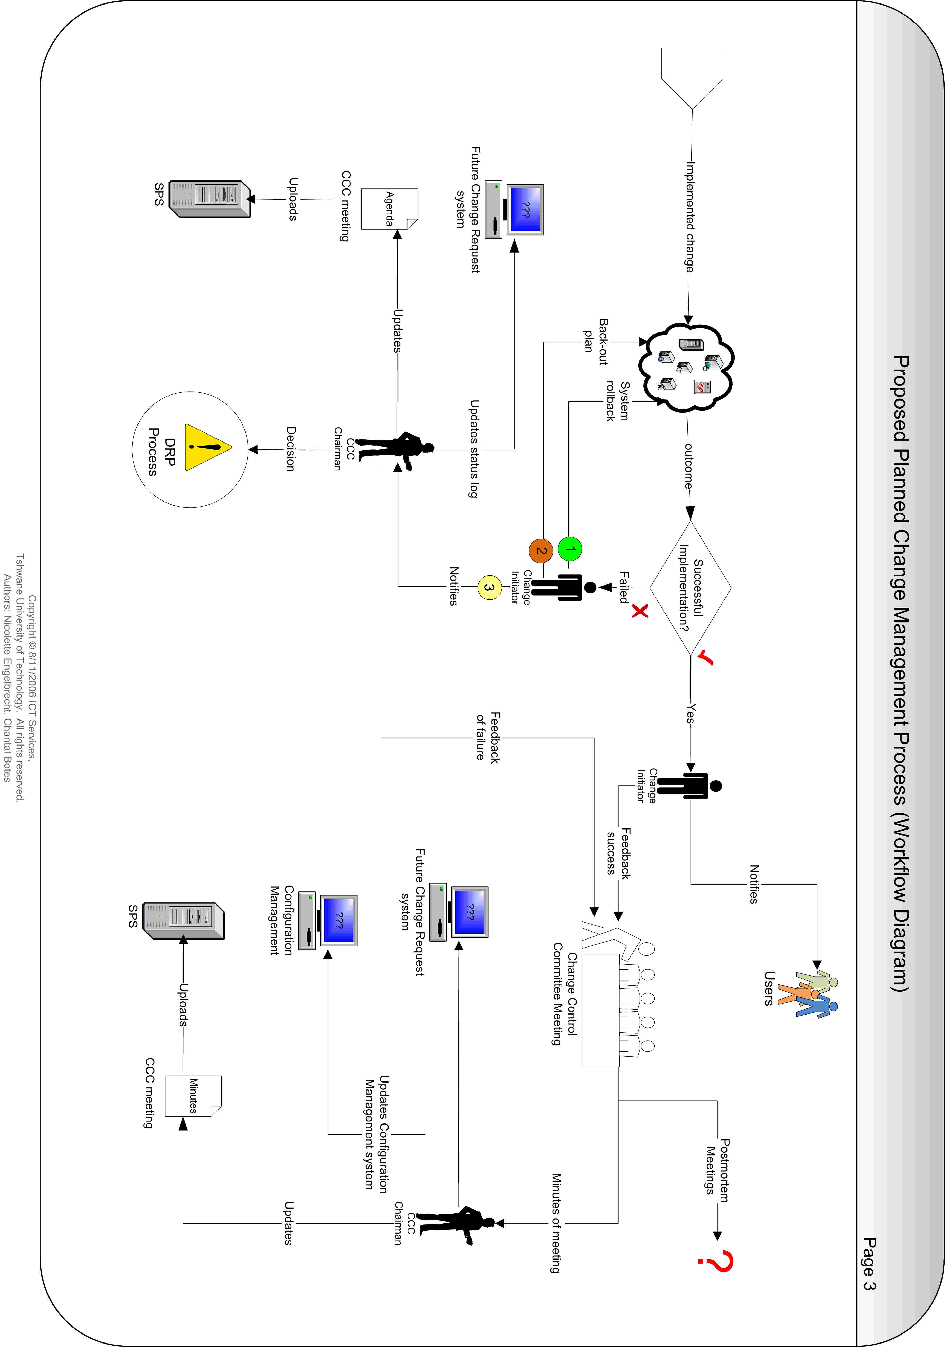
Request for Planned Change – Scope
The goal of a formal request for change process is to provide a disciplined process for introducing required changes into the ICT Department with minimal disruption to ongoing operations.

Request for Planned Change – Process
- Initiate a change.
- Apply for Request for Change (RFC).
- Logs a call on the future Change Request system.
- Pre-approval of the RFC and submitted additional documentation.
- Proper testing process of the pre-approved change and submission of test results for final approval of the change request (if required).
- Final approval of the RFC and scheduling of timeframe for implementation of the approved RFC.
- Proper communication / notification to affected users and Service Desk Operators.
- Implementation of the approved RFC.
- Feedback of the success / failure of the implemented change.
- Formal sign-off of the implemented change.
- Updating of the Configuration Items in the Configuration Management Database.
- Post-mortem meetings for unsuccessful implementation of approved changes.

Request for Planned Change – Work Instruction
- Initiate a change.
  - Change Initiator has 1 week to submit formal RFC form and additional documentation.
- Change Initiator prepares additional information / required documentation.
  - Determine the complexity and priority of the requested change.
  - Identify and document steps required to implement the change.
  - Determine estimated date of implementation of the change based on who is affected and how long it will take to complete the change.
  - Identify and document level of testing (if required), rollback- and backout plan.
- Change Initiator completes a formal RFC form and uploads the RFC and additional documentation (2.1 – 2.4) on the SharePoint Server.
  - Notifies the Change Control Committee chairman (CCC chairman) of the new change request via email / phone.
- The CCC chairman retrieves the RFC and additional documents from the SharePoint Server.
  - Logs a change request on the future Change Request system.
    - Assigns the call to the initiator’s name.
    - Captures the RFC information.
    - Uses the generated call number as the reference number on the RFC.
  - Documents the new change requests and links to the additional documentation of the change requests in the agenda of the next Change Control Committee meeting (CCC meeting) and uploads the agenda on the SharePoint Server.
  - The Change Control Committee members (CCC members) retrieve and read the agenda and additional documentation before the next CCC meeting.
- Pre-approval of the RFC by the CCC members.
  - Change Initiator attends the CCC meeting.
  - CCC members hold meetings to review and determine the risk level (severity) and the level of impact of the requested change.
  - Approve / reject the RFC information and / or additional documentation submitted by the Change Initiator.
  - If the CCC members request additional information for the change request:
    - The change request is placed in a pending state until the information is submitted.
    - Request Change Initiator for outstanding information.
  - The CCC chairman updates the minutes of the meeting and uploads the minutes on the SharePoint Server.
  - The CCC chairman updates the status and log of the future Change Request system.
- Proper testing process of the pre-approved change (if required).
  - Upon pre-approval of the change request and if testing is required, proper testing should be done by the Change Initiator to ensure successful implementation of the change to eliminate failure percentage.
    - Tracking, documenting and communicating test progress and results
    - Identification of problems and concerns
    - Successfully completing testing
    - Submits the test results to the CCC members with the next CCC meeting for final approval of the RFC.
- Final approval / rejection of the RFC by the CCC members.
  - If the RFC is approved, schedule the timeframe for implementation of the change.
  - The CCC chairman updates the minutes of the meeting and uploads the minutes on the SharePoint Server.
  - The CCC chairman updates the status and log of the future Change Request system.
- Proper communication / notification of the approved change.
  - Change Initiator needs to make sure that notification of the planned change is sent in advance to all affected users and Service Desk Operators via e-mail or web notification.
- Change Initiator implements the change on the agreed date.
  - Make a full backup of the system(s) involved.
  - If issues arise during change implementation, do a system rollback.
  - If the system rollback fails, the backout plan must be implemented.
  - If all fails, the CCC chairman must be notified of the outcome of the change.
- CCC chairman updates the log of the future Change Request system.
  - Determines if the Disaster Recovery Committee should be contacted and declare a disaster situation.
- Change Initiator notifies all affected users and Service Desk Operators of the outcome of the implemented change via e-mail or web notification.
- Change Initiator attends the next CCC meeting and gives feedback of the success / failure of the implemented change.
- CCC chairman sign-off of the implemented change.
  - Updates the log and resolve the RFC on the future Change Request system.
  - Uploads necessary documentation on SharePoint Server.
- CCC chairman updates the identified Configuration Items in the Configuration Management Database.
- Hold post-mortem meetings for implemented changes to determine success rate and or the root cause of change failure.

Proposed Emergency Change Management Process Flow Diagram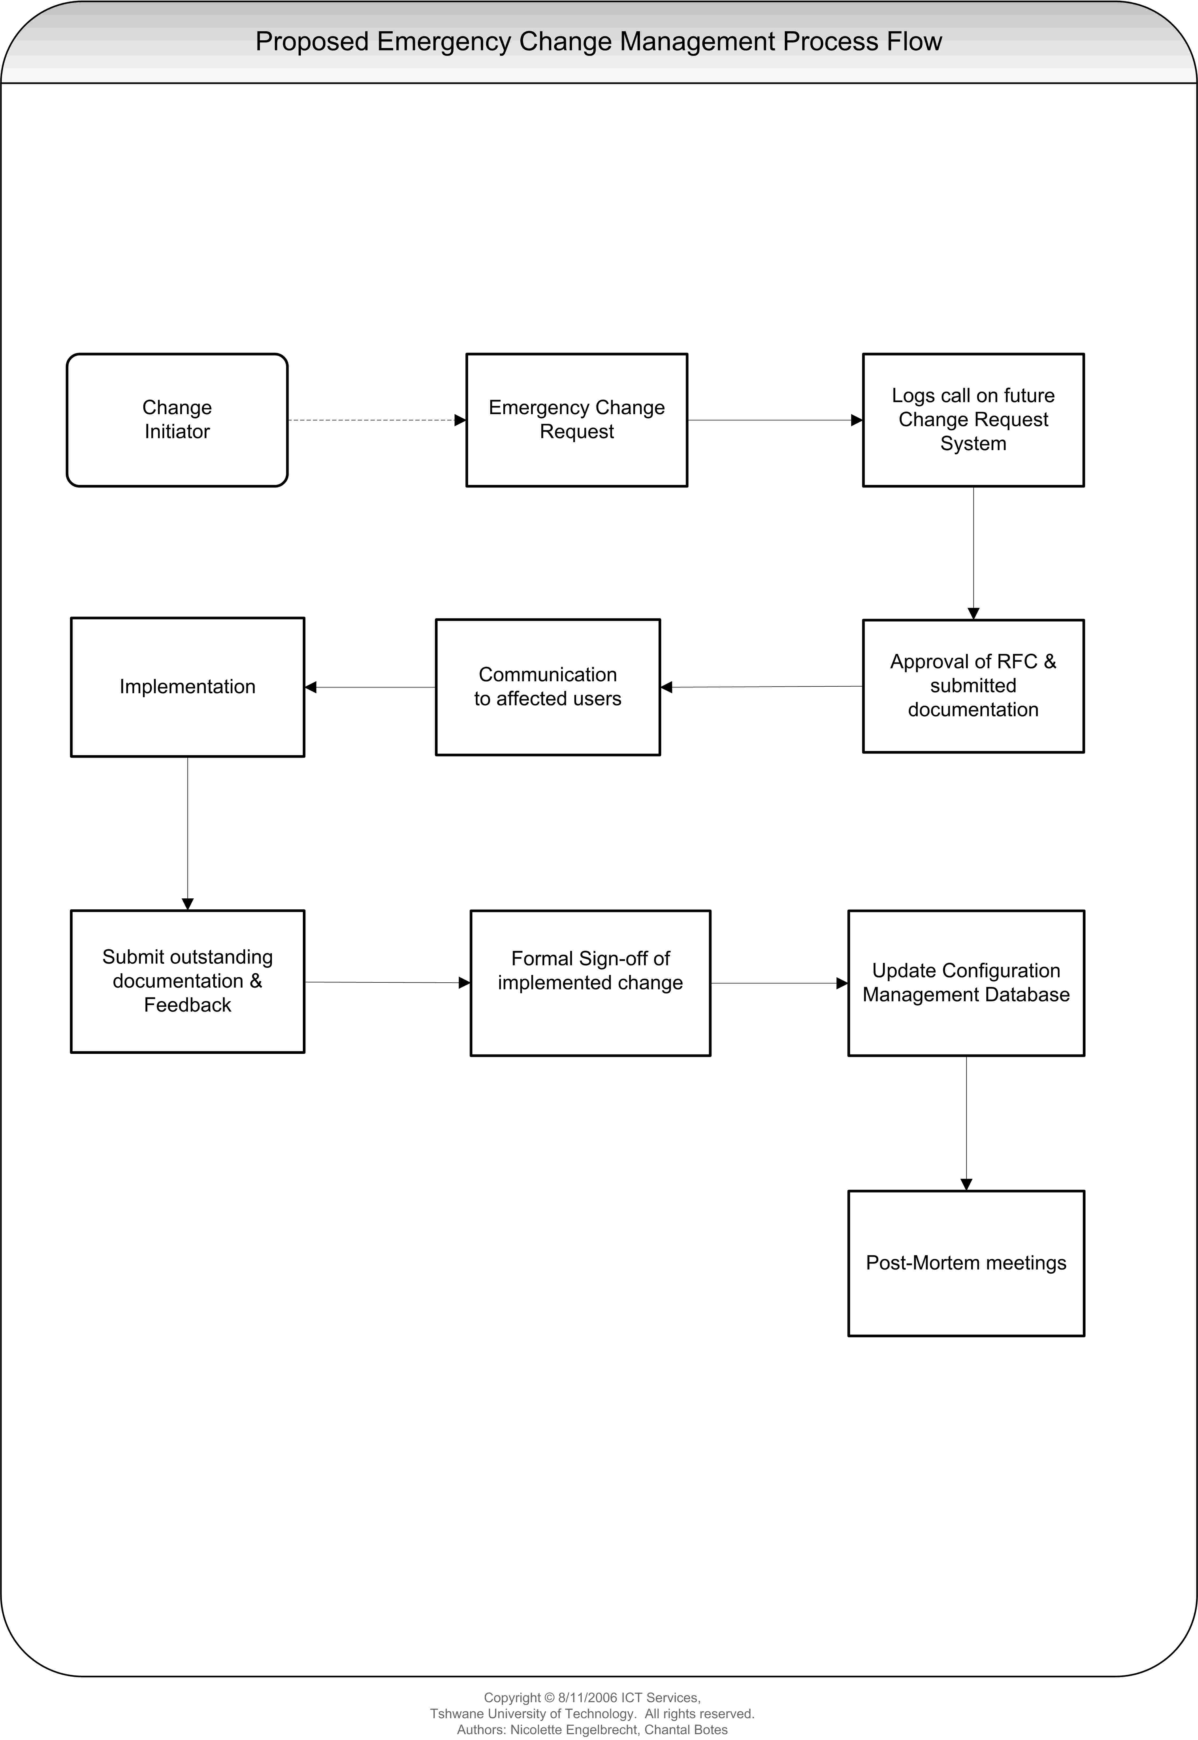
Proposed Emergency Change Management Workflow Diagram
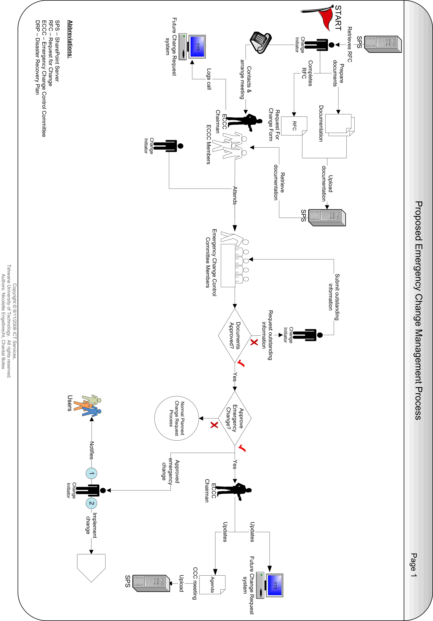
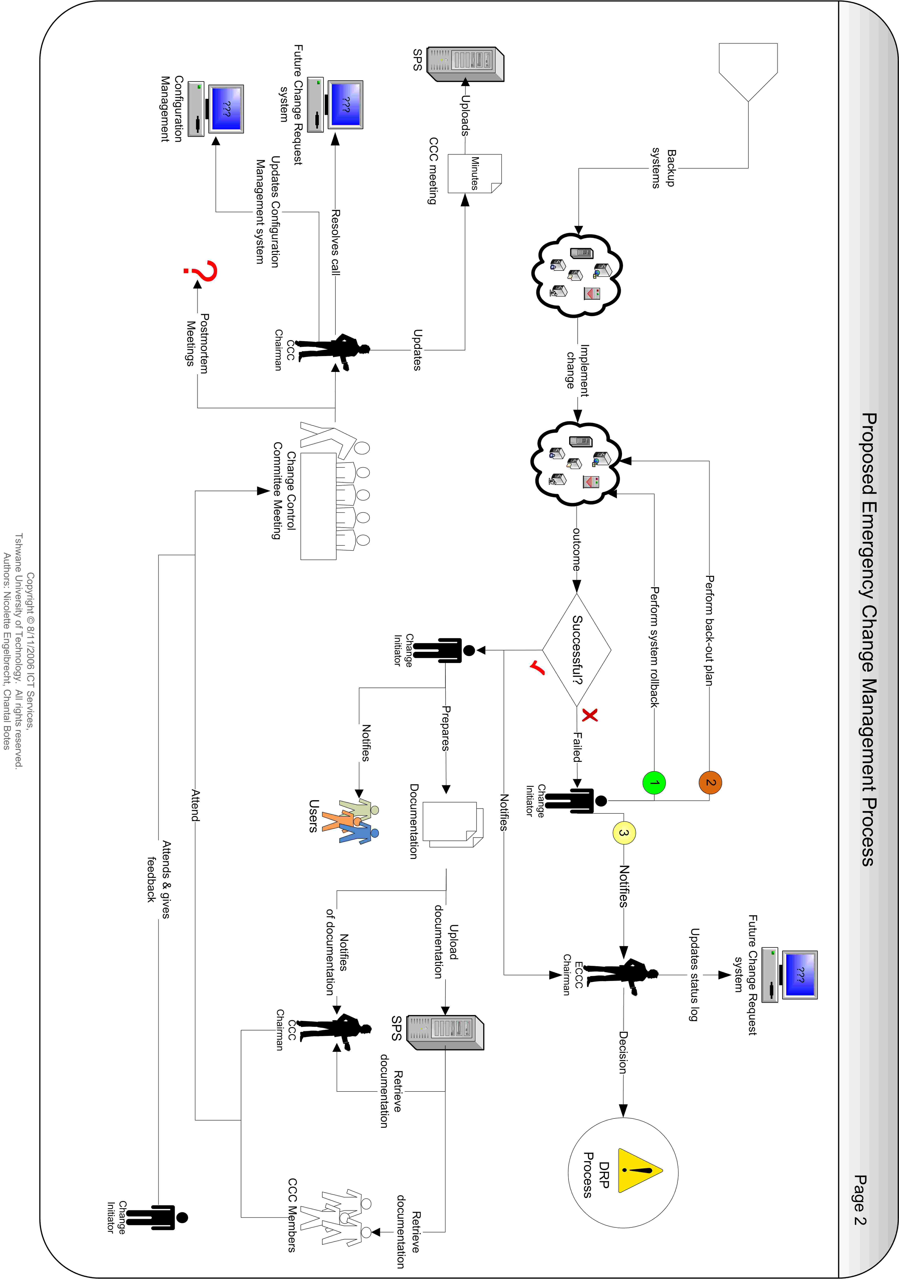

Request for Emergency Change - Scope
The goal of a formal request for change process is to provide a disciplined process for introducing required changes into the ICT Department with minimal disruption to ongoing operations.

Request for Emergency Change - Process
- Initiate the emergency change.
- Apply for emergency Request for Change (RFC).
- Contact the Emergency Change Control Committee chairman (ECCC chairman) and members of the Emergency Change Control Committee (ECCC).
- Logs a call on the future Change Request system.
- Approval of the RFC.
- Proper communication / notification to affected users and Service Desk Operators.
- Implementation of the emergency change.
- Prepare and submit outstanding documentation.
- Feedback to the CCC of success / failure of the implemented emergency change.
- Formal sign-off of the implemented emergency change.
- Updating of the Configuration Items in the Configuration Management Database.
- Post-mortem meetings for unsuccessful implementation of approved changes.

Request for Emergency Change – Work Instruction
- Initiate the emergency change.
- Change Initiator prepares critical / emergency information / required documentation.
  - Determine the complexity of the emergency change.
  - Identify and document steps required to implement the change.
  - Identify and document rollback- and backout plan.
- Change Initiator completes a RFC form and uploads the RFC and additional documentation on the SharePoint Server.
- Contacts the ECCC chairman and members of the Emergency Change Control Committee (ECCC) to arrange an ECCC meeting.
- The ECCC chairman & members retrieves the RFC and additional documents from the SharePoint Server.
  - The ECCC chairman logs an emergency change request on the future Change Request system.
    - Assigns the call to the initiator’s name.
    - Captures the RFC information.
    - Uses the generated call number as the reference number on the RFC.
- Approval of the emergency change by the ECCC members.
  - Change Initiator attends the meeting.
  - ECCC members review the RFC and determine the risk level and the level of impact of the emergency change.
  - If the ECCC members request additional information for the emergency change:
    - The request is placed in a pending state for a very short time (e.g. one hour).
    - The Change Initiator collects the outstanding information and re-presents the RFC to the ECCC members.
    - ECCC members approve / reject the RFC.
- If the RFC is rejected, the request must be handled as a normal planned Request For Change process.
- If the RFC is approved, the ECCC chairman:
  - Updates the status and log of the future Change Request system.
  - Updates the agenda with the relevant information of the approved emergency change request and uploads the agenda on the SharePoint Server for discussion in the next CCC meeting.
- Proper communication / notification of the approved emergency change.
  - Change Initiator needs to make sure that notification of the emergency change is sent in advance to all affected users and Service Desk Operators via e-mail or web notification.
- Change Initiator implements the approved emergency change.
  - Takes a full backup of the system(s) involved.
  - If issues arise during change implementation, do a system rollback.
  - If the system rollback fails, the backout plan must be implemented.
  - If all fails, the ECCC chairman must be notified of the outcome of the change.
- ECCC chairman updates the status and log on the future Change Request system.
  - Determines if the Disaster Recovery Committee should be contacted and declare a disaster situation.
- Change Initiator prepares and submits all outstanding documentation to the CCC members.
  - Documents the steps taken to implement the emergency change
  - Documents actual date and duration of the emergency change
  - Documents problems and concerns identified during implementation of the emergency change
  - Uploads the documentation on the SharePoint Server
  - Notifies the CCC chairman of the uploaded documentation
- Change Initiator notifies all affected users and Service Desk Operators of the outcome of the implemented change via e-mail or web notification.
- Change Initiator attends the next CCC meeting and gives feedback of the success / failure of the implemented emergency change.
- ECCC chairman sign-off of the implemented change.
  - Resolves the call on the UniCenter Service Desk.
  - Updates the log and resolve the RFC on the future Change Request system.
  - Uploads necessary documentation on SharePoint Server.
- CCC chairman updates the identified Configuration Items in the Configuration Management Database.
- Hold post-mortem meetings for implemented changes to determine success rate and or the root cause of change failure.

Formal Request for Change Document Template

Purpose
The RFC is a standard document in which all relevant information about the proposed change is recorded, ranging from basic facts about the change to more detailed information, such as the wider-reaching effects of the change.

The RFC must answer the what, why, who, when, where and how questions of the proposed change. It must describe the change, the effort it will take to implement the change and by whom, the method of implementation and the configuration items involved. It also includes supporting information about the purpose of the change, its impact on the organization, the backout plan in case of failure, the cost of the change and the urgency of the proposed change.

The form also needs to be easily accessible to users, preferably through the intranet or in a public email folder or on a shared drive. Change requests should be stored in a database, preferably a relational database for subsequent tracking and analysis.

Definitions
Field | Description
RFC Number | UniCenter Service Desk number of call logged / auto number generated by future Change Request system.
Date | Format (DD/MM/YYYY).  Date submitted the Request for Change form.
Initiator’s Name | Name & surname of person who initiates a request for change.
Contact Number | Contact number of the Change Initiator.
Department & Location | Department, Campus, Building and room number of the Change Initiator.
Priority | Level of urgency to implement the change. A change classification that determines the speed with which a requested change is approved and implemented. The urgency of the need for the solution and the business risk of not implementing the change are the main criteria used to determine the priority.
- Emergency | Changes that, if not implemented immediately, will leave the organization open to huge risk – for example, applying a security patch.
- High | A change that is important for the organization and must be implemented soon – for example, an upgrade in line with new legislation requirements.
- Medium | A change that should be implemented to gain benefit from the changed service – for example, between versions upgrade to a customer feedback service.
- Low | A change that is not pressing but would be advantageous – for example, a “nice to have” addition to a user profile.
CHANGE REQUEST
Change Title | Assign a meaningful title to the change request.
Detailed Description of Change | Detailed description of the change that needs to be implemented. This should include steps required to implement the change.
Reason for Change & Benefits | Detailed discussion of why the change is being proposed, including a cost benefit analysis.  Reasons may include:  New function  New hardware  Performance Tuning  Technology  Fix Problems  Prevent Problems
Impact if proposed change is not implemented | Describe the adverse impact within TUT / users / systems / network / servers / external partners should the requested change not be implemented.
Change Type | Type of change to be made.
- Hardware
- Software
- Network
- Application
Change Category  - Infrastructure  - Operations  - Partner  - Release  - Security  - Support  - Service | New systems and improvements to existing systems and infrastructure.  Changes that affect or improve day-to-day operations of the technology.  Third-party and supplier-related changes – for example, changes to an outsourced partner system affecting in-house systems.  Changes to the change, configuration, and release management systems and processes.  Changes to security processes – for example, authentication or network security improvements.  Changes enabling incident and problem resolution and changes to the helpdesk system.  Changes driven by new service level requirements, service improvement projects, or business strategy.
RISK LEVEL
Severity | The impact the requested change will have on the user.
- Low | The change does not affect more than a few users with minimum downtime.
- Medium | The change affects a small group of users with minimum downtime.
- High | The change affects a large group of users and requires significant downtime.
External Partners Impact | Name the external partners that will be affected by the requested change.
Systems Impact | Name the systems that will be affected by the requested change.
Configuration Items &  Version | Detail list of configuration items affected by the change and version of components to be changed.
IMPLEMENTATION SCHEDULE
Expected Start Date of Change
- Scheduled Date | Start date of the change as proposed by the Change Initiator.
- Scheduled Time | Proposed time the change will occur as proposed by the Change Initiator.
Estimated Duration | Estimated time the change will affect users / external partners / systems.
Actual Date & Time of Change
- Actual Date | Actual date scheduled for the change to be done.
- Actual Time | Actual time scheduled for the change to start.
Actual Duration | Actual duration the change affected users / external partners / systems.
Downtime Required  (Yes / No) | Will downtime of any system be required to perform the requested change?
If Yes, how long? | If downtime of any system is required indicate the duration of downtime in hours.
FINANCIAL IMPLICATION
Estimated Cost | Estimated cost involved should the required change be approved (if any).
ADDITIONAL DOCUMENTATION REQUIRED
Backout Plan | Change Initiator needs to create a back out plan and describe actions that will be taken if issues associated with this change are experienced in the production environment. This should include:  - what needs to be done to restore the service to its original state before the change was attempted  - what equipment or other resources are needed to be available to implement the backout plan  - at what point the backout plan will be invoked
Test Plan | Describe how this change will be tested to ensure that it works as designed and does not degrade system functionality or performance.
End-user Communication | Communication surrounding the proposed change to the affected divisions within TUT.
Back-up Plan | Change Initiator needs to create a back up plan if the proposed change fails.
APPROVAL
Approval Status  - Approved  - Pending  - Rejected | Implicates the following statuses:  The change can be implemented  Additional information is required before decision can be made  The change cannot be implemented
If Pending, until when | Format (DD/MM/YYYY).  Date until when request will remain pending.
Reason for pending request | Short description of why the CCC meeting decided to put the request for a change on hold.
Approved by | Name and Surname of the authorised person that accepts and approves the request for a change.
Date of Approval | Format (DD/MM/YYYY).  Date the request for change is approved.
Signature | Signature of the authorised person that accepts and approves the requested change.
Initiator Signature | Signature of Change Initiator who initiates a request for change.
Additional Recommendations | Additional recommendations suggested by the Change Control Committee members.

Template RFC
RFC Number: |  |  |  |  |  |  |  |  |  |  | Date:
Initiator Name: |  |  |  |  |  |  |  |  |  |  | Priority:  (Select appropriate option) |  |  |  |  |  | Emergency  High  Medium  Low
Contact Number:
Department & Location:
CHANGE REQUEST
Change Title:

Detailed Description of Change:

Reason for Change & Benefits:

Impact if proposed change is not implemented:

Change Type:  (Select appropriate option) |  | Hardware  Software |  |  |  |  |  |  |  | Application  Network
Change Category:  (Select appropriate option) |  | Infrastructure  Release  Service |  |  |  |  |  | Operations  Security |  |  |  |  |  |  | Partner  Support
RISK LEVEL
Severity:  (Select appropriate option) |  |  |  | Low |  |  |  | Medium |  |  |  |  |  |  | High
External Partners Impact:

Systems Impact:
Configuration Items & Version:
IMPLEMENTATION SCHEDULE
Expected Start Date & Time of Change: |  |  |  |  |  |  |  |  |  |  |  |  | Estimated Duration:
Actual Date & Time of Change: |  |  |  |  |  |  |  |  |  |  |  |  | Actual Duration:
Downtime Required? |  | Yes No |  |  |  |  | If yes, how long?
FINANCIAL IMPLICATION
Estimated Cost: |  |  |  |  |  | R 0.00
ADDITIONAL DOCUMENTATION REQUIRED (Select appropriate option with “x”)
 |  |  |  |  | Not Started |  |  |  | In process |  |  |  |  | Completed |  |  |  |  | Approved
Backout Plan
Test Plan
End-user Communication
Back-up Plan
APPROVAL
Approval status: |  |  | Approved Pending Rejected  If pending, until when: ________________ (date)  Reason for pending request?
Approved by: |  |  |  |  |  |  |  |  |  |  |  | Date of approval:
Signature:
Initiator Signature:

Additional Recommendations:

Recommendation

Considering all the information acquired, we recommend that the UniCenter Service Desk Change and Configuration Management modules will be the most feasible option.

Reason for Recommendation:
- The entire Microsoft CRM system will not be fully utilised if purchased by ICT Directorate, since only the Change and Configuration Management modules will be used.
- The Change and Configuration Management modules are included in the Service Desk system, thus no costs involved for purchasing these modules.
- Minimal costs and time involved for implementing business processes and workflow.
- All the UniCenter modules are web based and fully integrated.
- Policy violations can be detected with the UniCenter Asset Management module and notification can be sent via email, sms or a call can automatically be logged on the UniCenter Service Desk.
- Automatic Email notifications to appropriate users will be sent when logging change orders.
- The system accommodates built-in workflow processes.
- The UniCenter Service Desk system has been successfully implemented at TUT, and users are familiar with the environment.
- Incidents and problems logged on the Service Desk with relevant additional documentation can be linked to change orders and configuration items.
- All UniCenter Service Desk modules are developed according to ITIL standards, thus ensuring that Audit reports adhere to these standards.

References

- Beta ICT Advice – Framework for ECT Technical Support Change Management
- Microsoft Solutions for Management (TechNet): Change Management
- Data Center Assistance Group, Inc (DCAG) – Thomas Bronack’s Change Management document
- Change Management: Best Practices White Paper – Document ID: 22852
- The Project Perfect White Paper Collection - Operational Change Control Best Practices, Byron Love, MBA, PMP, CEC, IT Project+, MCDBA
- Change Management Do's and Don'ts (June 12, 2005) - By Kevin Behr, Gene Kim and George Spafford

