
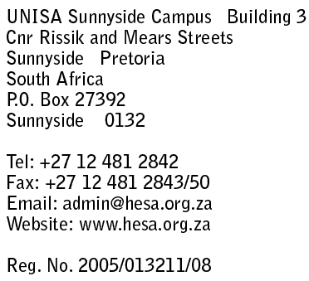

8 August 2006

CIRCULAR 44/2006

TO: EXECUTIVE DEANS, DEPUTY DEANS, VICE-DEANS AND ASSISTANT DEANS

HIGHER EDUCATION LEADERSHIP AND MANAGEMENT (HELM): PROGRAMME FOR EXECUTIVE DEANS

Please be advised that the next HELM Programme for Executive Deans has been scheduled from Sunday 17 September (14h00) until Tuesday, 19 September 2006 (14h00) at the Spier Country Estate in Stellenbosch, Western Cape.

THEME

Developing effective leaders for the University of the 21st century

AIMS AND OBJECTIVES

HELM’s mission is to explore and create dynamic leadership solutions that address organisational and individual capacity needs in South African higher education. Its underlying aim is to guide, assist, and support higher education leaders and managers to navigate successfully the constant challenges of change and effectively interpret the operational impact of internal and external drivers.

The objectives of the Deans Programme are to provide participants with an opportunity to:

- Develop an informed perspective of the challenges facing academic leaders in a complex and changing higher education environment.

- Promote the development of creative problem solving through expert input, self-reflection and group interaction.

- Acquire new skills that would contribute towards effective, proactive leadership and management in higher education institutions.

- Formally and informally engage with other participants, exchange ideas and share experiences that support personal and institutional development

TOPICS

This Programme will focus specifically on understanding the notion and practices of ‘Executive Deans’ in South African higher education under the following rubrics:

- Genesis and revelation
- Context and challenges
- Capacity and competencies

The facilitators and presenters will be drawn from higher education and other experts specialising in the areas identified above. Various methodologies and approaches will be used, such as international and local case studies, large and small group discussions and individual exercises. As far as possible, the cases, exercises and readings used will reflect actual local and international experiences within an institutional context.

WHO SHOULD ATTEND

Executive Deans, Deputy Deans, Vice Deans and Assistant Deans

REGISTRATION

The registration fee for this programme is R5 250.00 (five thousand two hundred and fifty rand) and it includes:

- Accommodation (bed and breakfast)
- Meals (lunch, dinner and teas)
- A social function
- Programme file
- Group photograph

This fee excludes:

- Travel to and from the venue (e.g. flights, car hire, shuttle service etc.)
- Room service
- Telephone and internet use
- Laundry
- Bar orders

In order to secure a place on this programme, kindly complete the attached Registration Form and forward it with the registration fee to Tania Davids at Exel Millennium Travel before end of business on Friday, 1 September 2006. Her contact details are as follows:

Tel: 021 590 7900
Fax: 021 590 7979
Email: taniad.millennium@galileosa.co.za

Please note registration will be confirmed once payment has been made on a first come first served basis. There will be no refunds for cancellations of registrations made within 7 working days of the first day of this event. Queries on the programme (e.g. content, presenters etc.) should be addressed directly with Oliver Seale at 012 481 2861 or oliver@hesa.org.za.

We look forward to your participation in this exciting national initiative that builds capacity and provides a crucial leadership development opportunity for universities.

With best wishes


OLIVER SEALE

PROGRAMME DIRECTOR

